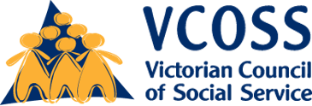
FEBRUARY 2020
VCOSS submission to the Victorian Energy Upgrades Targets Consultation.

Introduction
The Victorian Council of Social Service (VCOSS) is the peak body for the community services sector in Victoria. VCOSS support the social services industry, represent the interests of Victorians facing disadvantage and vulnerability in policy debates, and advocate to develop a sustainable, fair and equitable society.
VCOSS welcome the opportunity to provide input to the Victorian Energy Upgrades Targets consultation. Energy efficiency upgrades contribute to emissions abatement, reduce household energy bills and can make houses healthier and more comfortable.
VCOSS support the preferred option four in the Regulatory Impact Statement (RIS), which sets a high target for the number of Victorian energy efficiency certificates (VEEC) that will be delivered from 2021 to 2025. In addition we recommend the introduction of a sub-target for upgrades delivered to a priority group that would include low-income households and renters.
This would ensure that energy bill savings and thermal comfort is provided to the vulnerable Victorians who would benefit most from the program. A similar sub-target has been successfully implemented in South Australia and the ACT.
Low-income households will also need assistance accessing any high-cost, high-savings activities introduced to the program, which could be facilitated by appropriating non-compliance penalties.

Provide assistance where it is needed most
Households that engage with the Victorian Energy Upgrades (VEU) program by 2025 are expected to save $123.29 annually over the next ten years. The households who would most benefit from these savings, however, are unlikely to participate.
The RIS acknowledges that low-income Victorians are most vulnerable to price rises and proportionally spend more disposable income on energy than other households. Disadvantaged groups are also more likely to live in energy inefficient homes, and less able to afford the costs of operating coolers or heaters to maintain a healthy thermal comfort.
Upgrading energy efficiency and saving money on electricity bills would be a welcome relief for these low-income households, yet many are unable to participate in the program. As recognised by the RIS, the barriers to their participation include up-front costs and renting rather than owning.
Home Energy Assist is the Victorian Government’s main program to deliver energy efficiency upgrades to low-income households but total participation is currently capped at 3,300 homes. There are over 770,000 Victorians living in poverty, so greater action is required through other mechanisms until the scheme is substantially expanded.

Introduce a sub-target that enshrines fairness and equity
RECOMMENDATIONS
- Introduce a sub-target for upgrades delivered to a priority group.
- Add low-income households to the priority group.
The Retailer Energy Efficiency Scheme (REES) and Energy Efficiency Improvement Scheme (EEIS) in South Australia and the ACT are similar programs to the VEU. Both these programs include a sub-target for upgrades delivered to a priority group, including low-income households. In 2020, the sub-targets represent 21.7 per cent and 30 per cent of the total schemes respectively.
The VEU program should adopt a similar sub-target.
In South Australia, the REES delivered $155 million in energy bill savings for low-income households from 2015-2020, which represents 47.3 per cent of the total savings created by the program. A review of the scheme found that the sub-target was an efficient and effective method of providing energy savings to low-income households. This mechanism also does not distort the relationship between VEECs and emissions abatement, unlike proposals such as bonus credits or credit multipliers.
Introducing a sub-target would involve an administrative cost for determining which households classify as low-income, but the eligibility criteria specified by REES and EEIS utilise simple and readily available data, including:
- State and Commonwealth concession cards
- participation in retailer hardship programs
- public and community housing.

Ensure renters don’t miss out
RECOMMENDATIONS
- Add renters to the priority group.
Renters are less likely to live in energy efficient homes, yet spend a greater proportion of their income on utility bills. Half of all households living below the poverty line are renting.
Pending the final Residential Tenancies Regulations 2020, renters also rely on landlords to upgrade rental properties with little financial incentive to do so, and depend on approval for modifications if they want to improve their temporary housing out of their own pockets.
Adding renters to the priority group would ensure the 31 per cent of Victorians who rent are not left behind.

Reduce out-of-pocket costs for low-income households
RECOMMENDATIONS
- Introduce further subsidies and no-interest loans for low-income households to access high-cost activities.
The RIS recommends adding new activities to the program because low-cost lighting upgrades are approaching exhaustion. The suggested activities include optimising home solar panels, installing charging infrastructure for electric vehicles, and switching appliances from gas to electric.
The new range of activities are expensive and risk excluding low-income households from the program further since up-front costs are a major barrier to participating. This is especially problematic when the new targets may increase the energy bills of non-participants.
VCOSS recommend reducing the out-of-pocket costs for low-income households to improve their program participation. This includes further subsidies and no-interest loans paid off by the resulting bill savings.
The South Australian Department for Energy and Mining is considering similar assistance for low-income households to access high-cost upgrades that are currently out of reach.

Put the penalties to good use
RECOMMENDATIONS
- Use VEEC shortfall penalties for assistance for low-income households.
Energy retailers are penalised $50 per certificate fallen short by, which can result in fines as substantial as EnergyAustralia’s $2.99 million infringement in 2018.
The fines collected by such penalties in South Australia and the ACT are directed towards energy efficiency programs.
A similar model could be adopted in Victoria, where penalties are used to assist low-income households access high-cost VEU activities, such as replacing inefficient appliances and retrofitting windows.
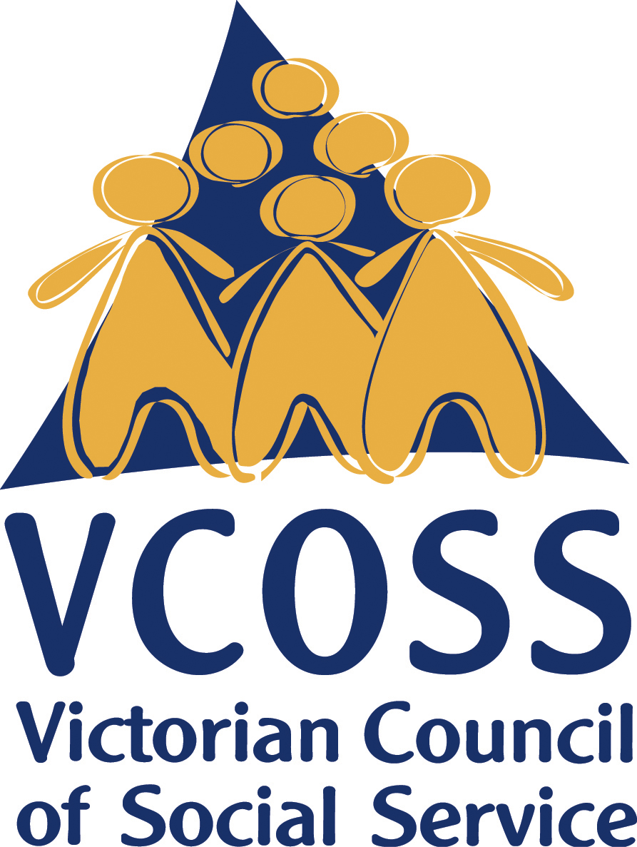
Alternatively, the funds could also be added to the Home Energy Assist program, allowing more vulnerable Victorians to access the scheme beyond the 3,300 low-income households planned.

/vcoss
@vcoss
ChannelVCOSS
vcoss.org.au

Victorian Department of Environment, Land, Water and Planning, Regulatory Impact Statement: Victorian Energy Efficiency Target Amendment (Prescribed Customers and Targets) Regulations 2020, December 2019.
Ibid.
COAG Energy Council, Report for Achieving Low Energy Existing Homes, November 2019.
VCOSS, Battling On: Persistent Energy Hardship, November 2018.
DELWP, RIS, 2019.
Victorian Department of Environment, Land, Water and Planning, Home energy assist program, https://www.victorianenergysaver.vic.gov.au/get-help-with-your-bills/concessions-and-rebates/home-energy-assist-program , accessed 9 January 2020.
VCOSS, Every Suburb, Every Town: mapping poverty in Victoria, November 2018.
ACT Environment, Planning and Sustainable Development Directorate (EPSDD), How the scheme works, https://www.environment.act.gov.au/energy/smarter-use-of-energy/energy-efficiency-improvement-scheme/how-the-scheme-works , accessed 29 January 2020; South Australian Department for Energy and Mining (DEM), Review into the South Australian Retailer Energy Efficiency Scheme, October 2019.
ACT Environment, Planning and Sustainable Development Directorate, Priority Household Target, https://www.environment.act.gov.au/energy/smarter-use-of-energy/energy-efficiency-improvement-scheme/how-the-scheme-works/priority-household-target , accessed 29 January 2020; Essential Services Commission of South Australia, Targets, https://www.escosa.sa.gov.au/industry/rees/targets , accessed 29 January 2020.
SA DEM, Review, 2019.
Common Capital, Past performance and future policy options for the Retailer Energy Efficiency Scheme, July 2019.
VCOSS, Setting Victorian Energy Efficiency Targets, May 2015.
ACT EPSDD, Priority Household Target, 2020; Essential Services Commission of South Australia, FAQs, https://www.escosa.sa.gov.au/industry/rees/faqs , accessed 29 January 2020.
COAG Energy Council, Report, 2019.
Ibid.
ABS, Housing Occupancy and Costs 2017-18, July 2019.
DELWP, RIS, 2019.
Ibid.
Common Capital, REES, 2019.
Essential Services Commission, Energy retailers in the VEU program, https://www.esc.vic.gov.au/victorian-energy-upgrades-program/participating-veu-program/energy-retailers-veu-program , accessed 29 January 2020; Essential Services Commission, EnergyAustralia shortfall statement 2019, https://www.esc.vic.gov.au/victorian-energy-upgrades/how-we-regulate-veu-program/our-veu-audit-and-compliance-functions/energyaustralia-shortfall-statement-2019 , accessed 29 January 2020.
Essential Services Commission of South Australia, REES Compliance Framework, June 2014.

