September 2020
VCOSS response to the Review of Real Estate Education Regulations

Introduction
The Victorian Council of Social Service (VCOSS) welcomes this opportunity to respond to the Regulatory Impact Statement for the Proposed Estate Agents (Education) Regulations 2020.
Housing is the foundation for a good life. One in three Victorians live in private rental homes – a fair market is an essential condition for living a good life in a rental home.
VCOSS supports the Victorian Government’s rental reform agenda. We believe that the changes promised under the Residential Tenancies Amendment Act 2018 (RTAA 2018) better reflect the reality of renting in Victoria, and the community’s expectation that the rental market can provide housing that is affordable, safe and secure.
A vast and complex array of issues can emerge at the commencement of a tenancy, during a tenancy or when a tenancy is ending. Many renters will only deal with their landlords via a real estate agent and their representative. VCOSS supports regulating educational requirements for real estate agents and their representatives. An appropriate level of training will help to ensure that they have the necessary knowledge and skills to practice ethically and with care, and assist to prevent bad practice and poor conduct in the market.
Fair and ethical practice across the real estate industry is critical to delivering on the promise of the Victorian Government’s rent reform agenda.

Acting in an imperfect market
The Regulatory Impact Statement (RIS) acknowledges that the real estate services industry is an imperfect market. It notes that consumers usually have limited or narrow knowledge of the market, and no capacity to choose a different agent when faced with a substandard agent. In this environment, renters have little choice but to rely on agents to practice fairly and ethically when managing tenancy matters.
The implementation of the COVID-19 Emergency Measures has demonstrated the importance of good practice to deliver on the intent of government policy – in this case, to keep renters safe at home and protected from unnecessary rental stress during the course of the pandemic.
A key measure is the right to rent reductions if a renter is experiencing COVID-19 related financial hardship. The renter makes a request for a rent reduction to their property manager, and private negotiations are conducted, usually with the landlord represented by the property manager. Private negotiations are intended to enable parties to make agreements that are suitable to their unique circumstances.
To achieve fair and equitable outcomes, the process relies on parties negotiating in good faith, with equal bargaining power and understanding of their rights and responsibilities coming to an agreement.
The imperfect market means that this is not the reality in most circumstances. Renters have less knowledge of their rights than their property manager and landlord and have been less confidence to assert them. This is worse for renters who have language or communication needs, or those who cannot access information, advice, and support.
VCOSS members report poor conduct in the private negotiation process, such as the property manager not responding to requests in a timely manner or at all, requesting unnecessary and intrusive personal and financial information, and providing unsolicited or incorrect legal and financial advice.
Consequently, many renters, despite being eligible for rent reductions, have chosen not to pursue them, have accepted limited or unfavourable terms, such as deferrals or extended arrears periods, or have chosen to leave their tenancy.
Unfortunately, such poor conduct is common across the private rental market. This is especially true for renters who are vulnerable for any reason, and who are at greatest risk of homelessness in the event of a tenancy ending.
VCOSS supports improving the quality of real estate agent and representative service provision via regulated education requirements. Ensuring that agents and representatives act fairly and ethically with renters can reduce the risks to renters arising from this imperfect market.

Best practice reduces risks to vulnerable renters
The RTAA 2018 will introduce a number of welcome reforms intended to empower renters who have historically been vulnerable in the private rental market, including people experiencing family violence, people with disabilities or other access or support needs and people on low incomes or on income support. At the same time, other legislation and government policy – such as the Charter of Human Rights and Responsibilities Act 2006, the National Disability Insurance Scheme, and the Royal Commission into Family Violence – intersect with the Residential Tenancies Act 1997 to provide safety and security in the private rental market.
To ensure these measures benefit renters as intended, training should include both familiarisation with new rights and obligations under the RTAA 2018, as well as in skills to respond effectively to renters vulnerable in the market for any reason. For example, VCOSS believes there would be benefit in introducing training requirements for identifying and responding to family violence risks, responding to circumstances involving financial hardship, preventing discrimination, and communicating with cultural awareness and safety.
Community organisations have deep and broad knowledge of the challenges and barriers faced by renters who may be vulnerable or experiencing disadvantage, and established, trusted relationships with community. We stand ready to assist the real estate services industry in developing their skills in this area.
Further, VCOSS recommends that continued professional development be made mandatory for all real estate agents and their representatives. This includes those with previous industry experience or training, whom the draft Regulations currently exempt. Continued professional development enables best practice across the industry.

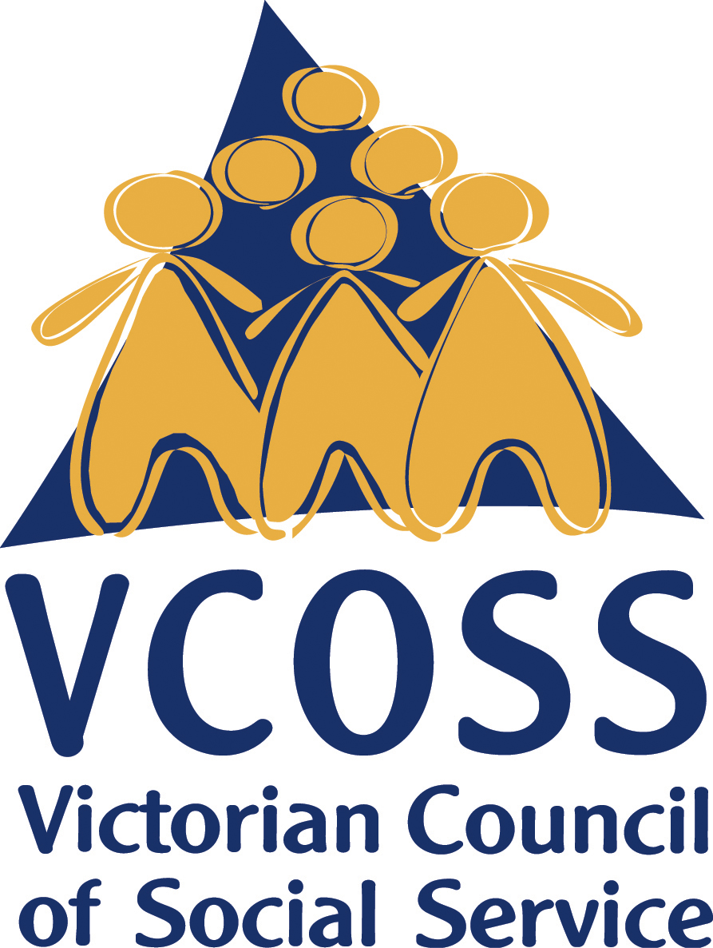

/vcoss
@vcoss
ChannelVCOSS
vcoss.org.au

Due to be implemented upon the expiry of current COVID-19 emergency measures on 28 March 2021 (or 27 April 2021, if extended).

