Issues Paper: NDIS access, eligibility and independent assessments
Submission to the Joint Standing Committee on the NDIS Inquiry into Independent Assessments

March 2021

The Victorian Council of Social Service is
the peak body of the social and community sector in Victoria.

VCOSS members reflect the diversity of the sector and include large charities, peak organisations, small community services, advocacy groups and individuals interested in social policy.
In addition to supporting the sector, VCOSS represents the interests of Victorians experiencing poverty and disadvantage, and advocates for the development of a sustainable, fair and equitable society.
/vcoss
@vcoss
ChannelVCOSS
vcoss.org.au

This submission was prepared by Rhiannon Wapling and authorised by
VCOSS CEO Emma King.
For enquiries please contact Deborah Fewster at deborah.fewster@vcoss.org.au
A fully accessible version is available
online at vcoss.org.au/policy/

VCOSS acknowledges the traditional owners of country and pays respect
to past, present and emerging Elders.

This document was prepared on the
lands of the Kulin Nation.

About this paper
The Victorian Council of Social Service (VCOSS) supports over 40 Victorian disability advocacy organisations to undertake collaborative systemic advocacy through the Empowered Lives network.
This Issues Paper is specifically prompted by our network’s concerns that the NDIA’s proposed model of mandatory independent assessments will reinforce the growing inequalities in the Scheme. In addition to concerns, our Issues Paper outlines proposed alternative solutions.
We urge the Committee to explore these issues with rigour and to provide opportunities for people with disability, their families and carers, advocates and allies to share their views and be part of the development of a solution.
This Issues Paper is endorsed by the following VCOSS and Empowered Lives members and allies:
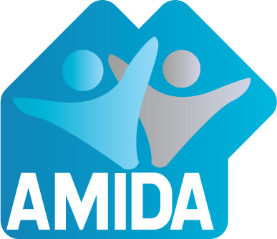
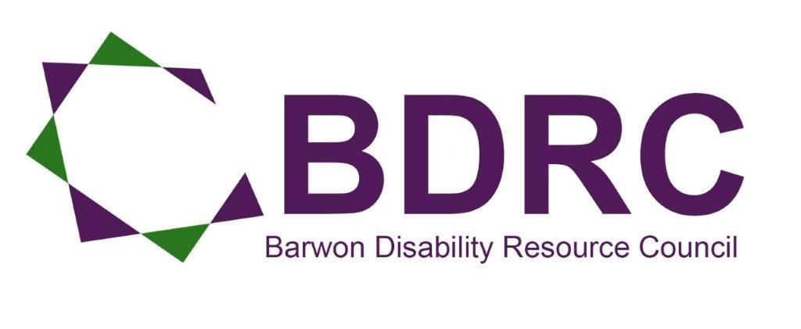
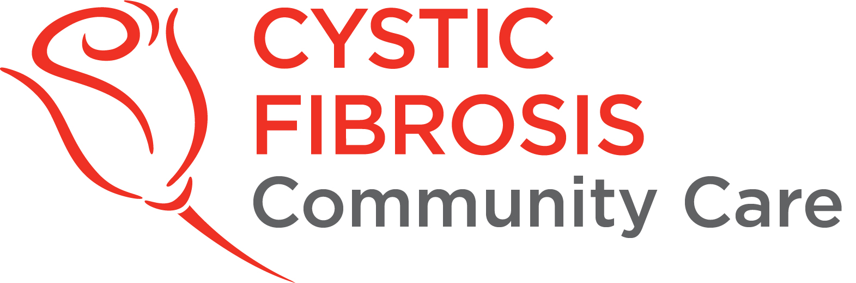
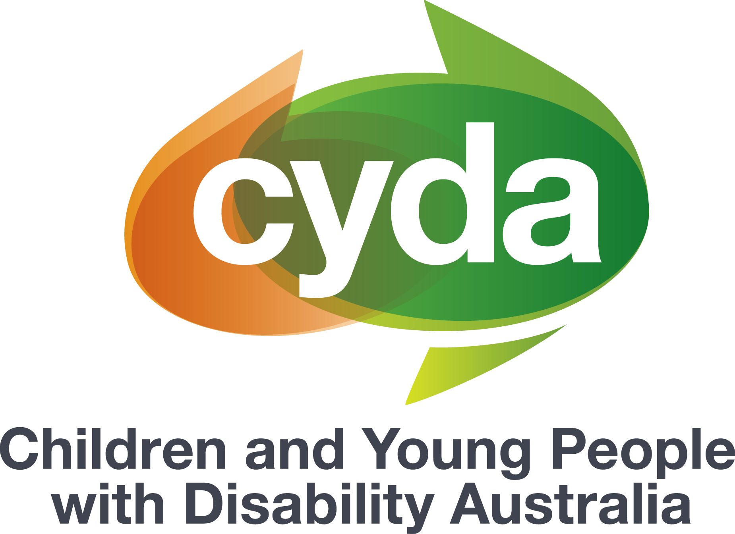
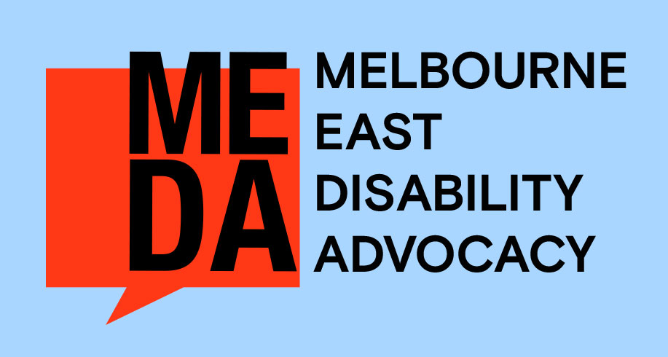
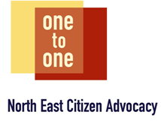
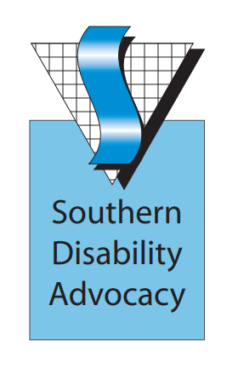
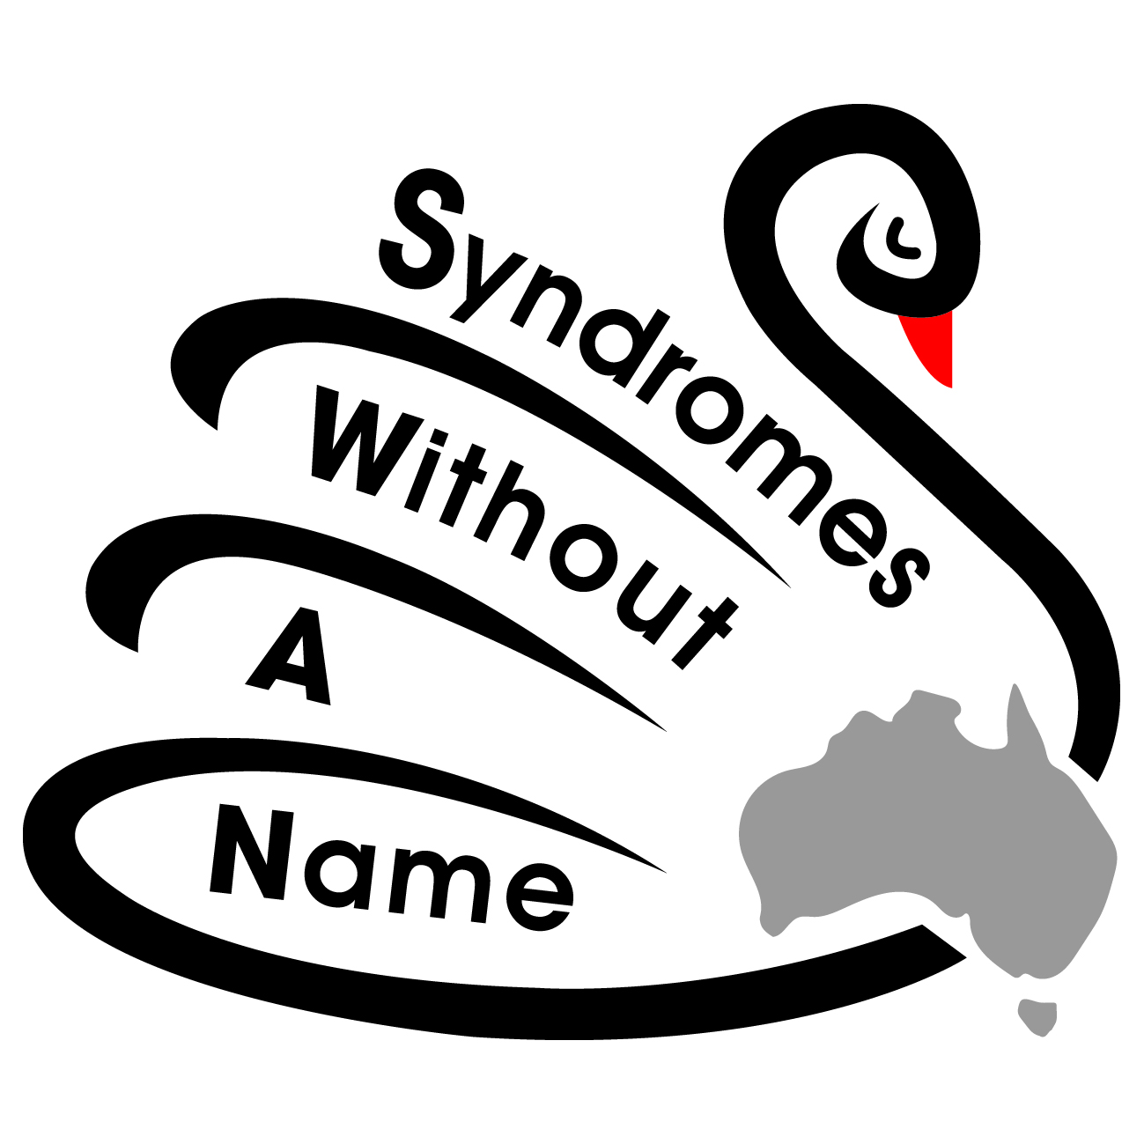
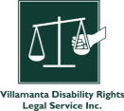
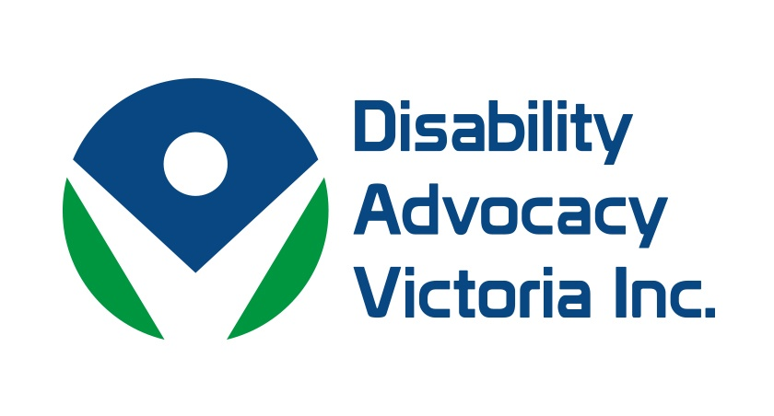

Introduction
The original vision of the National Disability Insurance Scheme (NDIS) was to deliver a person-centred, rights-based approach to disability support. Through a scheme based on insurance principles, people with disability, their families and carers were promised a new funding approach that focused on supporting people’s independence and participation in social, economic and community life, and promoted choice and control.
The Victorian Council of Social Service (VCOSS) and many of our allies fear the fabric of the NDIS is being eroded and the original vision for the Scheme is being lost. We hold concerns that the NDIA’s proposed model of mandatory independent assessments will reinforce the growing inequalities in the Scheme. Instead of improving access and reducing out-of-pocket expenses, independent assessments will present another hurdle for people with disability. This hurdle will be higher and harder for people who experience multiple and intersecting forms of disadvantage, and will add another layer of stress, complexity and anguish for people with disability seeking support.
The NDIS is often described as the largest social policy reform in a generation. It is right that, as the NDIS matures, we continue to identify and address implementation challenges to ensure the NDIS delivers on its promise and fulfils its goals. However, it is our position that the NDIA’s proposal to introduce mandatory independent assessments is the wrong solution to a complex implementation challenge. This Issues Paper sets out our key concerns and proposed alternative solutions.
The NDIS Participant Service Charter commits the NDIA to include people with disability and the community in developing and testing processes, and to listen to feedback to find better ways of doing things. Participants, families, carers and advocates should be engaged as equal partners with the NDIA to identify Scheme challenges and co-design fair and practical solutions. Our network – along with others – stands ready to assist in this vital work.

Issue: The proposed Access and Eligibility Policy will perpetuate barriers to access

Our concerns at a glance
The NDIA’s proposed Access and Eligibility Policy does not recognise or address the preliminary barriers that prevent access in the first place – low awareness, complex information and a lack of support.

Context
Learning about and accessing the NDIS continues to be difficult for the very people it is intended to support. Access to the NDIS relies heavily on an individuals’ agency, supports, social and financial capital. Being literate, including digitally literate; knowing about and understanding the NDIS; having the skills and confidence to self-advocate, identify support needs and goals, and exercise choice and control; and having a strong support network are all pre-requisites to access the NDIS.
The NDIS is a complex support system and, as the Scheme has evolved, a sea of key terms, acronyms and ‘magic words’ have flourished.
“You have to have the special code words to go through their programme, you’ve got to say it’s – oh, what is it they told me? Someone told me ‘psychosocial disability’ or something… so you can’t even say what it is as a mental illness, you have to know these special code words, which makes it hard for anyone to get through because, if you don’t know the special code words, you can’t even get through the front door, so to speak.”
The prevalence of cheat sheets, blogs and resources that aim to explain the NDIS and NDIS-related phrases demonstrates just how murky the messages have become. The information overload, and conversely the absence of information, presents an overwhelming barrier for people commencing the access process and navigating the participant pathway. Gathering evidence and completing the Access Request and Supporting Evidence Forms is time and resource intensive. The process is inaccessible and overwhelming for many people with disability and their support network, and many people need dedicated support for this process.
People who do not have easy access to identification documents, and people who do not have an ongoing relationship with a GP, allied health professional or specialist, are likely to face difficulties in completing their access request. Expenses to gain reports, to travel to specialists and find private providers – especially where there are long wait lists in the public system – are exorbitant and out of reach for many participants and families. These challenges are particularly pronounced for people experiencing intersectional disadvantage and isolation, who may contend with additional social, financial and cultural barriers.

First Nations people with disability
While prevalence of disability is high among First Nations people, participation in the NDIS remains lower than projected by the NDIA. Data from the NDIA shows a larger proportion of First Nations people with disability have their access requests cancelled due to their form not being returned, or because the NDIA was unable to contact them. After completing the access process, over 40 per cent of First Nations NDIS participants do not know what happens next.

Culturally and linguistically diverse people with disability
People with disability from culturally and linguistically diverse backgrounds are significantly less engaged with the NDIS than anticipated across every age group. Migrants and refugees with disability, their families and supporters face challenges due to language and cultural barriers, a lack of information and resources, and problems applying for and receiving services. Cultural beliefs, stigma and shame surrounding disability in some cultures can also make people and families fearful or wary of seeking support.
Research by the Ethnic Communities’ Council of Victoria found almost 80 per cent of research participants reported they and their family did not have good knowledge about disability supports and the NDIS, and 90 per cent believe there is not enough information and help available. A lack of supporting evidence is the leading cause of cancelled access requests for culturally and linguistically diverse NDIS applicants.

People with psychosocial disability
One of the first barriers to accessing the NDIS for people with psychosocial disability is that many do not identify as having a disability or are wary of stigma. Psychosocial disability can be episodic and fluctuating. On a good day, symptoms could be easily masked or misunderstood; on a bad day, intensive support from known and trusted specialists is vital. Over one-third of people with psychosocial disability who apply for the NDIS have their application rejected.

Young people with disability
Young people with disability often find it hard to understand and engage with the NDIS and to have their voice heard. The forms and resources are complicated, and sometimes the supporters and professionals young people turn to and trust are not confident in their own knowledge of the NDIS. Young people with disability who are not living with their family or carers, or who do not have stable housing, face additional challenges collecting paperwork and evidence to support their application.

People experiencing poverty, isolation and disadvantage
People experiencing poverty, isolation, socio-economic disadvantage and homelessness find it hard to learn about and access the NDIS. A study into the experiences of people facing socio-economic disadvantage who were likely to be eligible for the NDIS found 72 per cent of interviewees were either unaware of, or had distorted views about, the purpose and the eligibility criteria of the NDIS. A lack of assistance, uncertainty about eligibility criteria, discouragement from or limited access to medical professionals and social isolation all present significant barriers for people seeking to apply for the NDIS. People without stable accommodation and people experiencing financial hardship are not able to prioritise the NDIS access process when their focus is on their basic and immediate needs.

People with complex and co-existing needs
People living with episodic or fluctuating disabilities, or co-existing health issues, often find it hard to prove the ongoing and permanent nature of their disability and to identify the right service system for their needs. The interface with the health system, and battles over which system is responsible for what supports, is an ongoing concern for people with progressive diseases that impact their daily functioning.
People experiencing drug and alcohol issues, including many who are highly likely to be eligible for the NDIS, and frontline clinicians in this sector often find NDIS processes overwhelming and time-intensive. There are no dedicated groups or resources to support people and clinicians to understand and navigate the NDIS, so accessing the Scheme often comes down to capacity, commitment, connections and luck. People with co-existing substance dependence and disability, from falls, accidents or acquired brain injury, find the wall of engagement with the NDIS too hard and high to climb, meaning many miss out on the opportunities available through the NDIS.

Rural, regional and remote communities
People with disability living in rural and regional areas often have reduced access to health professionals due to a lack of local services, long waiting lists, lengthy travel times and transport issues. These delays and service gaps mean it can often take far longer for people with disability in rural and regional communities to collect the required evidence for their NDIS access request.

Issue: A stark shift from the principles and vision of the NDIS

Our concerns at a glance
The introduction of mandatory independent assessments, and the ways in which assessments will be used, is a worrying departure from the vision and principles of the NDIS.

Context
The NDIS was promised as a game-changer for people with disability and all Australians – a once-in-a generation opportunity to replace inefficient, stretched and rationed state-based systems with a fair, timely and reliable national system Our members fear the introduction of mandatory independent assessments will take away choice, control and independence that was intentionally placed at the heart of the Scheme.
Instead of taking a person-centred approach, and ensuring participants’ voices, dignity and agency are prioritised, independent assessments place power and influence in the hands of assessors who may not have skills and expertise in specific disabilities, functional impacts and fluctuating needs. The potential return to deficit-focused language and a renewed emphasis on the medical model of disability is a big step backwards.
“We want a scheme that provides reasonable and necessary supports for people with disability. Support so they can live an ordinary life and enjoy the same kinds of opportunities as other Australians. A fair go. No more and no less.”
We urge the NDIA to not lose sight of the original vision of the NDIS and to build on the strengths of the Scheme by listening to the voices and expertise of people with disability, advocates, organisations and the wider community.

Issue: A cherry-picked solution for a complex, unsolved problem

Our concerns at a glance
The selective interpretation and use of the Productivity Commission inquiry and Tune Review reports to introduce a significant change to the Scheme is deeply concerning for many people with disability, families, carers, advocates and allies. The disparity between what was recommended and what is being proposed has contributed to confusion, concern and lack of confidence in this policy change across the disability community.

Context
The concept of independent assessments for the NDIS was initially proposed in the Productivity Commission’s Disability Care and Support inquiry in 2011. The inquiry report proposed a system that would deliver individual funding “determined by the independent assessment of need, rather than the present arbitrarily rationed amount.”
The Productivity Commission suggested independent assessments, conducted by allied health professionals approved or appointed by the NDIA, could be made using a ‘toolbox’ of assessment tools. The results of assessments would then inform eligibility for the Scheme and the development of an individual plan that considers support needs and the role of informal supports. Independent assessments were not included in the design of the Scheme roll-out, in part due to the absence of the right tools.
The 2019 Tune Review, in its commentary on independent assessments, noted potential benefits including a decreased financial burden for participants; however, it also highlighted a range of considerations for the implementation of any assessment changes.
The correlation between the recommendations of the Productivity Commission and the Tune Review, and the NDIA’s proposed model for introducing mandatory independent assessments, is limited. Caveats and commentary in these reports about implementation considerations are not recognised or represented in the proposed model for independent assessments.

For example, the NDIA's proposed approach fails to reflect the following advice from the Productivity Commission and Tune Review that:
- where possible (and with the individual’s permission), the Scheme should make use of existing medical reports
- assessments should be portable across the system — subject to protection of privacy — so people do not have to repeat information for different providers or government agencies
- assessments and re-assessments should occur when people join the Scheme, and again at key life stages or when circumstances change
- where an informal carer provides substantial care, they should receive their own assessment if they wish
- the power to require prospective participants or participants to undertake an assessment be discretionary
- at least in the short term, the NDIA should not implement a closed or deliberatively limited panel of providers to undertake functional capacity assessments
- key protections would need to be embedded into the approach, in particular:
  - the right to choose which NDIA-approved provider to conduct the assessment
  - the right to challenge the results of an independent assessment
  - the need for uniform accreditation requirements, designed and implemented jointly by the NDIA and disability representative organisations
  - the availability of clear, accessible publicly available information about independent assessments.

Issue: Limited evidence base from pilots or community engagement

Our concerns at a glance
The narrow nature of the pilots to date and the absence of detailed evaluation does not provide sufficient evidence to support the sweeping introduction independent assessments.

Context
The first pilot of independent assessments was deployed in nine areas across New South Wales by one service provider, primarily to existing participants across three disability groups. 513 people voluntarily participated in the pilot – of this cohort, 65 per cent were aged 7-14 and 71 per cent were male. Just 7 per cent were from a culturally and linguistically diverse background, and 1 per cent were First Nations people.
A survey completed by 145 participants found a 91 per cent satisfaction rate with the experience; however, it is not clear whether survey participants are representative of the cohort. Additionally, the survey was completed by only 35 NDIS participants themselves with the remaining responses from family members or carers.
A second pilot, which was delayed due to COVID-19, recently recommenced with a view to engaging 4000 existing participants. Senate Estimates figures show that as of 11 November 2020, just 215 participants accepted the invitation to participate in the pilot, 185 declined and 4496 have not yet responded.
NDIS participants and the broader disability community feel they have not been listened to or provided with fair and authentic opportunities to share their thoughts and co-design solutions. The lack of information and limited transparency about proposed NDIS reforms continues to fuel fear and anxiety.

Issue: Goals and aspirations are relegated and restricted

Our concerns at a glance
The NDIA’s proposed Planning Policy flips the current participant-led, goal-oriented process and places participant planning conversations after an independent assessment and after the development of a draft plan and draft budget.

Context
Goals are highly individual, personal and empowering. From moving out of home to getting a job or making new friends, the nature and scope of goals varies for every NDIS participant. Nurturing aspirations, expanding expectations and establishing a path to goal achievement takes time, commitment, systemic change and targeted support.
Placing goal conversations after the development of a draft plan and budget, informed by a brief independent assessment, will limit the pursuit of goals and see participants’ aspirations restricted by funding decisions. This change in process means people will have to fit their goals, needs and ambitions within a defined budget, and potentially present a strong argument for why they need more funding and support. There are concerns this process will not facilitate full and fair consideration of a participant’s personal circumstances. Functional capacity is not the only reason a participant may need support. Two people with similar functional needs ‘on paper could be living vastly different lives and it is not clear how social, environmental and cultural factors will be comprehensively captured by the assessment process and the subsequent plan.
In its commentary on assessments, the Productivity Commission’s 2011 report noted, “while the assessment process would primarily be about assessing an individual’s needs, it should not disregard their aspirations.” Devaluing and demoting goals in the planning process reduces participants’ choice, control and agency, and does not align to the objects and principles of the NDIS Act 2013. Any assessments, where necessary, would be better placed after conversations with participants. The NDIA should invest in Planner training and capacity to have respectful, strengths-based conversations with participants about what is important to them and practical ways to pursue their goals.

Issue: Emotional impact for participants, families and carers

Our concerns at a glance
Independent assessments perpetuate – rather than resolve – participants’ concerns about Scheme access. They present a new hurdle for participants to pass – one that requires people to share personal details with a stranger who has the power to make life-altering decisions. This process creates additional and unnecessary stress and anxiety for people with disability seeking support and has the potential to be traumatic and confronting.

Context
As part of the Tune Review, people with disability, families, carers and advocates raised their concerns about access to the NDIS. People shared their personal difficulties and frustrations about navigating the bureaucracy, finding information, getting appropriate assistance, and of the evidentiary burden of accessing the NDIS.
NDIS participants are rightly afraid about independent assessments. The concept of independent assessments as proposed creates a situation where participants need to re-tell their story to another stranger and prove that it is true. The power of assessors to influence the outcomes of their NDIS access request and plan budget based a snapshot in time is significant.
Participants may feel pressure both to perform for the assessor or to illustrate what their worst day looks like to ensure their needs are understood and captured. Children who are being assessed by people they are unfamiliar with may respond or behave differently than they would with a person they know and trust. Likewise, there is a risk some participants with complex needs could mask or downplay their needs, or that their responses to questions may not be fully understood. Participants who have had had poor experiences with other government assessment processes, such as the Disability Support Pension job capacity assessment, may be especially anxious about undertaking an independent assessment. People who may have faced additional barriers to finding out about and applying for the NDIS in the first instance may be confused about and traumatised by having to re-tell their story.
Participants are able to have a support person with them for their assessment, and it is important his person knows them well and is able to contribute to the assessment where needed; however, not everyone has someone in their life who could fulfil this role.

Issue: Continued equity issues regarding evidence costs

Our concerns at a glance
The model for introducing independent assessments does not achieve the objective of reducing costs to access the Scheme.

Context
One of the key messages promoted to support the introduction of independent assessments is the need to deliver fairness and equity, particularly for people from low-income households or facing additional barriers to accessing the NDIS. The NDIA estimates Australians with disability are currently spending between $130 million and $170 million on assessments associated with accessing the NDIS.
Visits to GPs and medical specialists can be expensive and wait lists are often lengthy, particularly in regional and rural communities. The cost of a private autism assessments can easily run into thousands of dollars. While some people may seek private services at their own cost, or travel long distances to see a specialist, this is not an option for participants and families on fixed or low incomes, and those without reliable support and transport.
The NDIA’s independent assessment framework itself states:
“At present, an individual is required to gather evidence of their functional capacity, prior to Scheme access, either through publicly funded services or through the private health sector. For many, obtaining this information through the private health sector is financially prohibitive and waiting lists in the public sector can be extensive. There may also be gap fees even with Medicare funded services which are prohibitive for some people. In addition, other cultural and social barriers may make access to the Scheme problematic for some. Changes to the assessment process should seek to level the playing field so that financial, cultural, social, education and literacy factors do not contribute to delays or barriers to accessing the Scheme.”
Under the proposed access process, independent assessments are available after a participant has met the NDIS eligibility requirements - to meet eligibility, prospective participants will still need to provide evidence of their disability. This barrier is not removed or reduced for people experiencing disadvantage, marginalisation and hardship, and the change in policy will not improve the equity of experiences and outcomes.
The anticipated costs to introduce independent assessments, or alternative options, have not been made publicly available. This is unusual given the NDIA’s focus on Scheme sustainability.
Cost modelling for a range of assessment options and measures to increase equity (see page 24) should be conducted to ensure the most efficient, effective and fair option is selected.

Issue: Communication and advocacy barriers

Our concerns at a glance
The NDIS ‘assumes empowerment’. While we applaud a strengths-based approach, an assumption of empowerment fails to consider the long-tail effects of entrenched systemic discrimination of people with disability and required mitigation.

Context
The NDIS requires participants to self-advocate to have their needs met. This is predicated on an assumption that all participants have the skills, knowledge, confidence and opportunity to do so. NDIS participants are not one homogenous group. There is a diversity of lived experience.
This assumption about self-advocacy capacity can unwittingly hinder the participation of diverse communities who may face barriers in accessing and understanding the system and in articulating and advocating for their goals and needs, while people who feel confident and empowered to articulate their needs are likely to receive greater support from the Scheme.
The assessment tools, which collect evidence through interviews, questionnaires and observation, are likely to be more accessible and beneficial for people who can confidently self-advocate for their rights, interests and needs. People who speak English as a second language, who communicate with the support of an interpreter and people with complex communication needs may find it harder to participate and be heard in these assessment processes. People with psychosocial disability may also find this process challenging due to the impact of their condition. For example, people who experience auditory hallucinations or delusions of grandeur, or find it hard to trust and communicate with new people, may have difficulty expressing their needs during assessments.
Participants will be able to have a support person with them during their assessment, and under the proposed policy, the NDIA will help to find a support person for people who request one. However, it is not clear who the NDIA anticipates will undertake this role. Any resulting increase in demand for individual advocacy, which is already under considerable pressure, will need to be supported by appropriate, timely and ongoing funding.

Issue: Inconsistencies in the use and interpretation of assessments

Our concerns at a glance
Despite the focus of independent assessments being on delivering consistency, the window for varied interpretation of assessments remains wide open.

Context
Under the current and proposed models, people with disability must provide evidence to support their access request and the planning process. An ongoing and outstanding issue with supporting evidence that is not addressed by the proposed Access and Eligibility Policy is the variable interpretation of reports by NDIA delegates, Planners and Partners in the Community.
Feedback provided to the Tune Review indicated some Planners are either not fully considering the reports participants provide, or are not sufficiently taking into account the recommendations of experts.
These findings were echoed in the NDIS Joint Standing Committee’s NDIS Planning Inquiry, which heard Planners may be ignoring or changing expert recommendations provided by allied health professionals about participants’ personal needs, recommending cheaper supports or asking participants to choose between supports.
Under the proposed planning process, NDIS delegates will develop a budget based on the outcomes of an independent assessment, but it is not clear if or how delegates will be trained in understanding and interpreting assessments for this purpose. Our members hold concerns that assessment results will be used to generate an arbitrary amount of plan funding.

Issue: Independence of assessors

Our concerns at a glance
Assessors contracted by the NDIA will face unavoidable conflicts of interest and challenges to their genuine ‘independence’.

Context
The NDIA has already progressed work to establish a panel of assessors through a tender process. The tender was opened in March 2020, before the pilot of independent assessments was completed, before an evaluation of the pilot was completed and made publicly available, and without any targeted communication to participants, their families, carers and supporters.
In 2011, the Productivity Commission recommended assessors be drawn from an approved pool of allied health professionals, who do not have an existing connection to the person being assessed, to reduce the potential for ‘sympathy’ bias. However, the more recent Tune Review in 2019, informed by the reality of the Scheme roll out and participant experiences, recommended the NDIA should not implement a closed or deliberatively limited panel of providers to undertake functional capacity assessments, at least in the short term. The Tune Review notes risks related to the introduction of a closed panel, including disengagement and the potential for disproportionate impact for First Nations people with disability, culturally and linguistically diverse people with disability and people with psychosocial disability.
In choosing a panel approach, whereby assessors are engaged and paid by the NDIA, conflicts of interest are not removed; they are displaced. Assessors contracted by the NDIA will face unavoidable conflicts of interest and challenges to their genuine ‘independence’ – delivering the desired outcomes to the structures, timeframes and priorities of the NDIA will be vital to assessors’ ongoing employment. The NDIA’s 2019-2020 Annual Report and Corporate Plan 2019–2023 pay considerable attention to delivering a financially sustainable Scheme and managing cost drivers. These aspirations may impact the work and decision-making of independent assessors, who hold considerable power in relation to the supports participants receive.

Issue: Quality and expertise of assessors and assessments

Our concerns at a glance
Under the proposed model to introduce independent assessments, the expertise of health professionals and the value of existing clinical relationships is diminished.

Context
Through the transition to the NDIS, participants and health professionals have navigated significant confusion about the evidence required by the Scheme. The Tune Review heard:
“…that it is unclear what evidence is needed to support decisions about a person’s functional capacity, and there is no actively promoted or standard format for prospective participants, participants and their health professionals in which to provide that evidence. This has resulted in people submitting evidence that is not always fit for purpose, varying in quality and consistency and requiring back-and-forth interaction to obtain what is needed for the NDIA to be satisfied in discharging its functions under the NDIS Act.”
Reports and other supporting evidence are often rejected or dismissed by the NDIA if they do not use particular language or ‘magic words’. This remains the case even where the evidence provided is substantial, carefully considered and completed by experienced and qualified professionals with deep understanding and rapport with participants.
The core problem has been a lack of clarity about evidence requirements. This has given rise to frustration, expense and wasted time for people with disability and health professionals alike. However, the NDIA’s proposed model for mandatory independent assessments is not the right solution to this problem.

GPs, specialists and allied health professionals play an important role in the lives of many people with disability. Over time, through building trust, rapport and understanding, health professionals get to know people with disability well.
The assessments made by independent assessors, who do not have deep knowledge of participants, will take precedence in determining access to the Scheme and the provision of funding. It is not clear how, and to what extent, existing evidence from other health professionals will influence access and planning processes and decisions.
People with disability have a diverse range of experiences and histories with medical and health professionals. Forcing people with disability to ‘prove’ their disability to a stranger in a matter of hours is likely to be traumatic, intrusive and ineffective. The time-limited nature of the proposed independent assessments, which can take place for as little as 20 minutes, is highly concerning for many people with disability and their supporters. People who have difficulties in speaking up about their rights and needs, for a range of social and cultural reasons, are likely to be more disempowered by this approach.
Independent assessments will not have the scope to capture how people function in different settings, times and days. For example, one-on-one interactions may be manageable for a person who is Deaf or hard of hearing to communicate without support, however, group situations or other environments may be more difficult. Likewise, a participant’s needs in work, home or social settings is likely to vary.
A recent case in the Administrative Appeals Tribunal (AAT) highlights the disparities in the depth and quality of assessments by known, trusted health professionals versus an unknown independent assessor. The tribunal found the observations made by the existing treating health professional across 50 to 60 occasions in a variety of environments to be more reliable and accurate than a single, three-hour assessment in one environment.

Issue: Workforce considerations

Our concerns at a glance
The availability of allied health services and the strength of the allied health market, particularly in regional and remote areas, was already a chronic issue prior to the introduction of the NDIS. There is currently a shortage of allied health professionals working in the disability care sector, and providers find allied health roles the most difficult to recruit and retain. Placing a new, additional demand on the stretched allied health sector to deliver independent assessments may further constrict access to treatment and care.

Context
Under current NDIS processes, where participants may be required to seek an additional assessment at the NDIA’s request and cost, workforce challenges are contributing to significant delays. In some instances when alternative, local therapists cannot be found, allied health professionals from other regions travel long distances to the participant, or the participant’s initial treating health professional is eventually engaged for the assessment.
Allied health professionals with past negative experiences of completing NDIS assessments, where their professionalism is questioned or advice ignored, may be even more reluctant to participate in this new process.
VCOSS members believe the implementation of independent assessments will be unachievable, or detrimental to the market, unless workforce development and retention strategies are developed. Recruiting trained and experienced assessors will be a difficult and long process, particularly in rural and remote areas, and the need to create a large, additional workforce quickly raises concerns about the experience and expertise of assessors.

Issue: Right to pursue grievances and seek exemptions

Our concerns at a glance

Under the NDIA’s proposed approach, the findings of an independent assessment can only be challenged in limited circumstances.

Context
The NDIA consultation paper states:
“Disagreeing with the results of an otherwise sound and robust independent assessment is not sufficient for the NDIA to fund another assessment. Applicants can only seek a second assessment where the assessment was not consistent with the independent assessment framework, or if the applicant has had a significant change to their functional capacity or circumstances.”
Placing tight parameters on participants’ rights to request a review of an independent assessment denies access to fairness and justice. Under the principles of the NDIS Act 2013, people with disability have the right to pursue grievances, to determine their best interests, exercise choice and control, and engage as equal partners in decisions that affect their lives to the full extent of their capacity.
The process for determining inconsistencies with the independent assessment framework, and the supports available for current and prospective participants to seek a second assessment, are yet to be defined or publicly released.
As with NDIS review and appeal processes, many people with disability, families and carers will need support to pursue these options. Demand for individual disability advocacy support is already under pressure across Australia and would need a significant boost to meet this need.

Exemptions from independent assessments are available in exceptional circumstances, but these circumstances are not defined.
VCOSS members are concerned that the participants who are most likely to need an exemption may face greater barriers in seeking one, because they may not have the resources, capacity and confidence to pursue this avenue. The proposed policy also states that requests for exemptions that are rejected cannot be appealed.
These policy provisions run the risk of deepening disadvantage and accelerating Scheme exits for people who do not know how to interact with the access and assessment processes.

Solutions: A reasonable and necessary approach to evidence requirements
VCOSS members believe the hasty introduction of independent assessments is the wrong answer to a complex and multi-faceted problem. NDIS participants and the communities they live in are diverse. Applying a one-size-fits-all approach to gathering evidence is unlikely to promote equity. Ensuring all participants have access to assessments is one means to address access and planning inconsistencies, but it is not a silver bullet.
The NDIA should work in partnership with people with disability, their families and carers, advocates and allies to carefully and transparently explore all options for improving the NDIS.

Adopt a human rights based approach to co-design a solution
Under the UN Convention on the Rights of Persons with Disabilities (CRPD), Australia is obliged to closely consult and actively involve people with disability in decisions that affect their lives and rights, particularly the development and implementation of legislation and policies.
People with disability, their families and carers, advocates and allies know more than anyone what it is like to navigate the NDIS and are well placed to share their expertise and ideas for change.
To respect and abide by the CRPD, the objects and principles of the NDIS Act 2013, and uphold commitments made under the NDIA Participant Service Charter, the NDIA must undertake open-minded, meaningful and substantial stakeholder engagement and consultation to co-design practical, fair and impactful solutions to key Scheme challenges.
Recent research into the disability assessment practices of 34 European countries and compatibility with the CRPD identifies key features of best-practice, rights-based assessment processes and policies.
Analysis by Waddington and Priestly suggests public authorities should:
- Consult with and involve disabled people’s organisations and human rights bodies in design and regular review processes
- Embed the social and human rights model of disability in the design and implementation of assessments
- Support people with disability to actively participate in generating evidence for their individual assessments, for example, through peer-supported self-assessment
- Involve multidisciplinary expertise within the disability assessment system, including human rights expertise
- Provide accessible and user-friendly information about application processes, eligibility criteria, appeal and support options, and supports available after an assessment is completed
- Eliminate duplicative or multiple methods of assessments, to increase consistency and transparency in processes and reduce administrative burden.
Additional CRPD articles the NDIA’s approach to assessments should specifically abide by include:
- The right to dignity, respect, participation, inclusion and opportunity
- Respect for the autonomy and independence of people with disability, including the freedom to make choices
- The right to access information and access justice – including the right to review or appeal the contents and outcomes related to assessments
- The right to an adequate standard of living and social protection.
People with disability, families, carers, advocates and allies are ready and willing to support the NDIA and the Department of Social Services to design fair and equitable solutions to the address the barriers and challenges experienced across the NDIS pathway.

Explore and cost alternative options
To ensure NDIS reforms and initiatives target the true barriers to access and equity, the NDIA should explore multiple options and strategies. While independent assessments may work for some participants, in some circumstances, the process may be traumatising, unnecessary or a waste of time for others.
VCOSS and Empowered Lives members readily identified a range of alternatives that may be more cost-effective, beneficial, and respectful of existing care relationships. Enabling participants to access local, culturally safe and gender-sensitive options, through approaches that integrate with existing systems and workforces, would be practical and sustainable option.
Suggestions to improve the access and eligibility pathway include:
- Better resourcing pre-access communications and engagement initiatives to help people to understand the NDIS, consider whether they are eligible and prepare for applying by:
  - Strengthening the capacity of the Information, Linkages and Capacity Building stream to deliver targeted and ongoing early engagement activities through Partners in the Community and grant-based programs
  - Partnering with existing, trusted organisations and networks to provide information, advice and soft entry points for communities, ages and life stages
  - Investing in research to explore the prevalence of disability across a range of cohorts and service systems to inform action to address specific NDIS access barriers.

- Developing clearer guidance and templates for health professionals completing reports, noted as a potential driver for inconsistency and an area for improvement by the Tune Review and the NDIS Joint Standing Committee inquiry into NDIS Planning.

- Addressing financial barriers to collecting evidence by funding access to early, free and optional assessments to support participants’ NDIS applications:
  - Assessments should be conducted by the participants’ chosen local provider
  - Assessment costs could be offset by a Medicare rebate or similar financial support
  - Assessments should be targeted to assist people who are new to adapting to their disability, people who do not have a history with or access to an existing provider or assessor, and people whose support needs are unclear.

- Honouring the integrity and value of existing expert advice, reports and assessments, and only seeking additional assessments where necessary.

- Improving capacity and skills of Planners and delegates to understand, interpret and apply the findings of reports and assessments to access and planning processes.

- Increasing employment of people with disability across the NDIA and Partners in the Community to deliver experience-informed support across every step of the NDIS journey.

- Working with Governments and sectors to address systemic issues that impact access to the NDIS, including health and allied health workforce challenges and waiting lists.
Given the heightened focus on the financial sustainability of the Scheme, it is important that a range of options and pathways to are identified, modelled, costed and tested. Without this detailed analysis, there cannot be confidence that the selected approach is the best approach – for participants, their carers and families, or the Australian Government.

/vcoss
@vcoss
ChannelVCOSS
vcoss.org.au

Mavromaras et al, Evaluation of the NDIS: Final Report, National Institute of Labour Studies, February 2018, p.191.
NDIA, Aboriginal and Torres Strait Islander participants, 30 June 2019, p.18.
Ibid., p.23.
Ibid., p.83.
NDIA, Culturally and Linguistically Diverse participants, 30 June 2019, p.20.
ECCV, ‘It’s Everybody’s Business’: Multicultural Community Perspectives on Disability and the NDIS, June 2019, p.8
Federation of Ethnic Communities’ Councils of Australia et. al., Barriers and exclusions: The support needs of of newly arrived refugees with a disability, February 2019, p.24-25; ECCV, ‘It’s Everybody’s Business’: Multicultural Community Perspectives on Disability and the NDIS, June 2019.
Ibid., p.10.
NDIA, Culturally and Linguistically Diverse participants, 30 June 2019, p.23.
NDIA, NDIS Quarterly Report to disability ministers Q2 2020-2021, December 2020, p.96.
C Cortese, F Truscott, M Nikidehaghani & S Chapple, Hard-to-reach: the NDIS, disability, and socio-economic disadvantage, Disability & Society, June 2020, p.13.
Ibid.; K Paterson, Homelessness and the National Disability Insurance Scheme – Challenges and Solutions, Council to Homeless Persons, May 2017, p.2
Every Australian Counts, ‘The politics of distraction…’, 5 February 2021, accessed 15 February 2021.
Productivity Commission, Disability Care and Support: Inquiry Report Volume 1, July 2011, p.257.
Ibid., p.334.
Ibid., p.314.
Ibid., p.326.
Ibid., p.340.
D Tune, Review of the National Disability Insurance Scheme Act 2013, December 2019, p.67.
Ibid.
Ibid, p.66.
NDIA, Independent Assessments: Pilot learnings and ongoing evaluation plan, September 2020.
Ibid.
Ibid.
R Clun, 'Just not OK': Only 6 per cent of NDIS trial participants completed survey, Sydney Morning Herald, 23 December 2020. accessed 23 December 2020.
NDIA, The second independent assessment pilot, accessed 22 December 2020.
Senate Community Affairs Legislation Committee, Budget Estimates – 29 October 2020: Answer to questions on notice, Social Services Portfolio, National Disability Insurance Agency, Reference NDIA SQ20-000342, 16 December 2020.
NDIA, Consultation paper: Planning Policy for Personalised Budgets and Plan Flexibility, November
Productivity Commission, Disability Care and Support: Inquiry Report Volume 1, July 2011, p.308.
NDIA, Independent Assessment Framework, August 2020, p.27.
Ibid., p.8.
NDIA, Consultation paper: Access and Eligibility Policy with independent assessments, November 2020, p.10.
Ibid., p.13.
Federation of Ethnic Communities’ Councils of Australia et. al., Barriers and exclusions: The support needs of of newly arrived refugees with a disability, February 2019, p.19-20.
D Tune, Review of the National Disability Insurance Scheme Act 2013, December 2019, p.62.
Commonwealth Joint Standing Committee on the NDIS, NDIS Planning Final Report, December 2020, p.xxi, 48-49, 55-56, 115-124.
NDIA, Consultation paper: Planning Policy for Personalised Budgets and Plan Flexibility, November 2020, p.9.
Australian Government, Aus Tender - Closed ATM View - RFT 1000724626, accessed 22 December 2020.
Productivity Commission, Disability Care and Support: Inquiry Report Volume 1, July 2011, p.327.
D Tune, Review of the National Disability Insurance Scheme Act 2013, December 2019, p.67.
Ibid., p.66.
D Tune, Review of the National Disability Insurance Scheme Act 2013, December 2019, p.60.
Villamanta Disability Rights Legal Service Inc and Gippsland Disability Advocacy Incorporated, Joint media release: AAT rejects NDIS Independent Assessment, 9 September 2020, accessed 23 December 2020.
Commonwealth Joint Standing Committee on the NDIS, NDIS Planning Final Report, December 2020, p.202.
Department of Social Services, Building the Local Care Workforce: Allied health, accessed 24 December 2020.
National Disability Services, State of the Disability Sector Report 2020, December 2020, p.48.
NDIA, Consultation paper: Access and Eligibility Policy with independent assessments, November 2020, p.23.
Australian Government, National Disability Insurance Scheme Act 2013, s.4(7) and (8).
NDIA, Consultation paper: Access and Eligibility Policy with independent assessments, November 2020, p.20-21.
Ibid., p.21.
UN, Convention on the Rights of Persons with Disabilities Article 4.3, 2006.
L Waddington and M Priestley, A human rights approach to disability assessment, Journal of International and Comparative Social Policy, 1–15, October 2020.
Ibid., p.10.
D Tune, Review of the National Disability Insurance Scheme Act 2013, December 2019, p.73; Commonwealth Joint Standing Committee on the NDIS, NDIS Planning Final Report, Recommendation 17.

