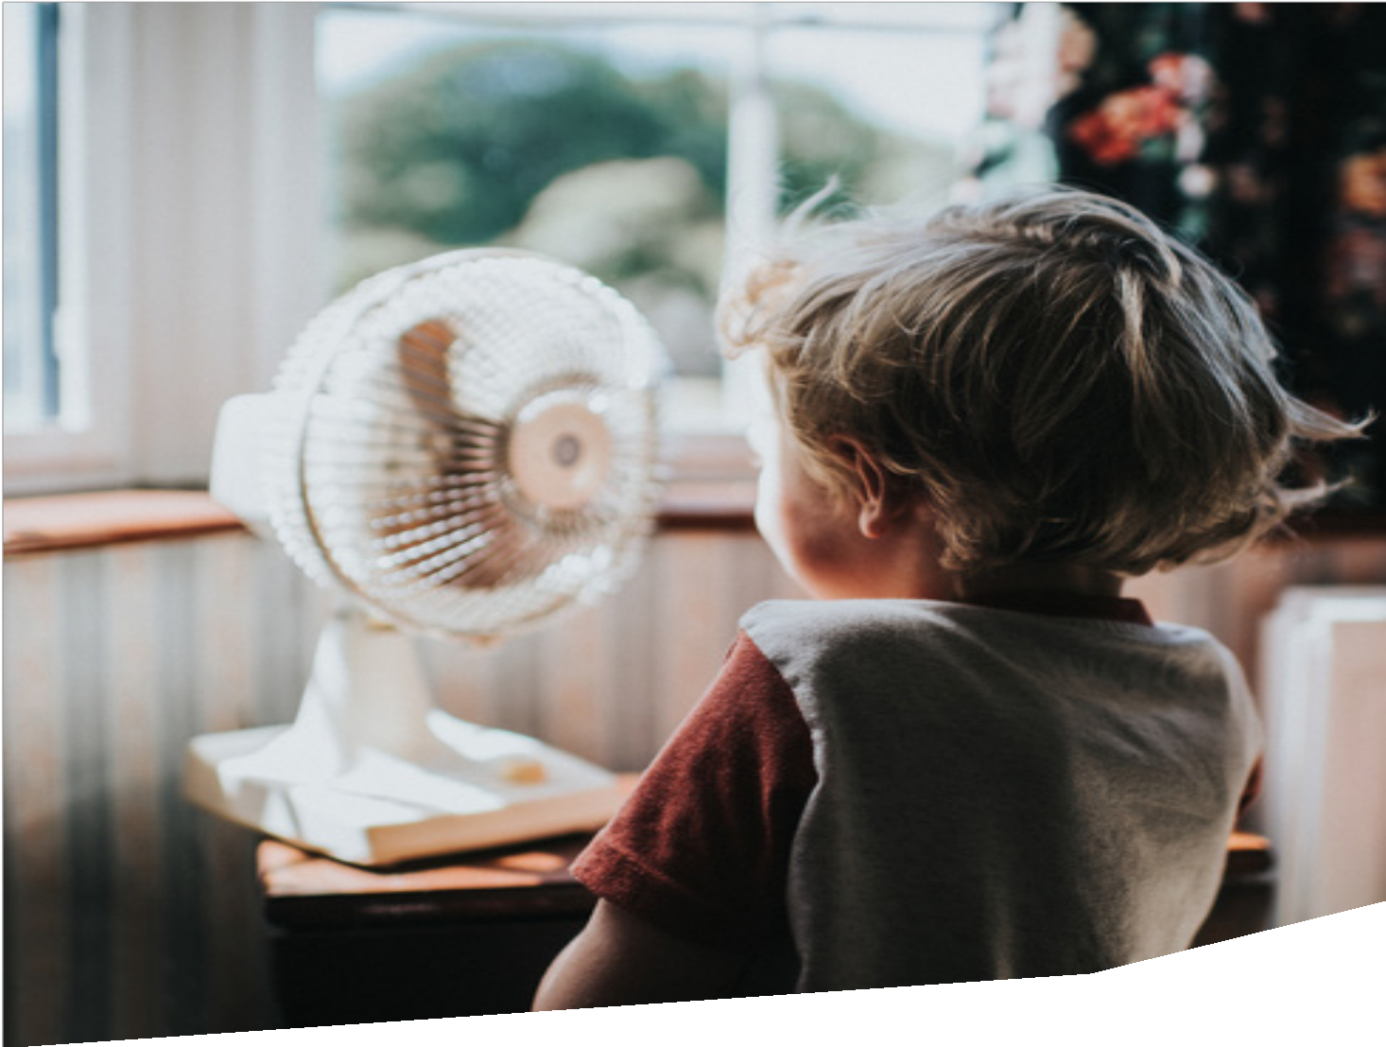
Feeling the Heat

May 2021

Introduction 1
Heat harms health and wellbeing 4
Heat affects people differently 8
Income 9
Housing 11
Location 14
Age 16
Disability 18
Cultural and linguistic diversity 19
Employment 20
Gender 22
Health 23
We can prevent heat-related harm 24
Fund the community sector to help people cope with heat 26
Increase residential energy efficiency 28
Improve access to air-conditioning 30
Expand access to cool community spaces 34
Reduce the urban heat island effect 37
Improve transport infrastructure 38
Provide best-practice health information 40
Protect the people most susceptible 42
Empower workers 44
Measure the problem 44
References 46

The Victorian Council of Social Service is the peak body of the social and community sector in Victoria.
VCOSS supports the sector and its members, represents the interests of Victorians experiencing disadvantage, and advocates for the development of a sustainable, fair and equitable society.
This report was prepared by Policy Advisor Ben Latham and approved by CEO Emma King.
For more information, visit: www.vcoss.org.au/extremeheat

VCOSS acknowledges the Traditional Custodians of the land and pays respect to their Elders past and present. This document was prepared on the lands of the Kulin Nation.

Introduction

Extreme heat kills more Australians than any other form of natural disaster.1
The 2014 Victorian heatwave contributed to 167 excess deaths and caused more than 600 hospitalisations for dehydration, heat stroke, and other heat-related illnesses.2
But the impacts of extreme heat are not felt equally.

For some Victorians, hot days just mean blasting an air-conditioner, or taking a dip at the local pool, or driving to work instead of catching a train. It can be an inconvenience but it is rarely life threatening.
But for others, heatwaves mean sweltering in a poorly insulated home, or sleeping outside in the garden, or working in the hot sun. They are crises that can lead to sickness, financial insecurity and even death.
Heat vulnerability differs
from person to person and is influenced by a range of individual circumstances including how much we earn, where we live, how old we are and how well we speak English. For example, people are more vulnerable to extreme heat if they cannot afford air-conditioning, but less vulnerable if they get
the right health advice about keeping cool.
For the households most at risk, coping with extreme heat is a balance between multiple threats. Illness and fatigue can
result from sleeping in a hot home, but napping outside in the cool
is a safety hazard. Working in the hot sun can lead to heat exhaustion, but skipping a shift can lead to financial hardship.
Victoria is heating up
Climate change is warming Victoria in line with the global average.3 The state can expect a temperature increase of up to 2.4ºC by 2050 and up to 4.3ºC by 2090 if greenhouse gas emissions remain high.3
Heatwaves are becoming longer and hotter and the frequency of very hot days is on track to double across Victoria by 2050.3 This means 16 days over 40ºC for Mildura every year as the hot and dry conditions in the northwest worsen.3

For the households most at risk, coping with extreme heat is a balance between
multiple threats. Illness and fatigue can result from sleeping in a hot home, but napping outside in the cool is a safety hazard. Working in the hot sun can lead to heat exhaustion, but skipping a shift can lead to financial hardship.
It is estimated there will be an additional 402 deaths in Victoria by 2050 due to heatwaves unless action is taken.4 Heat is already impacting Victorians’ health and wellbeing but the unprecedented number of hot days and hot nights is becoming more disastrous.

The community sector is on the frontline
The community sector works closely with Victorians experiencing disadvantage and is embedded in communities throughout the state. Services provided by organisations include accommodation and housing, alcohol and other drugs support, disability advocacy, financial counselling, support for victims of family violence, and more.
Workers in the sector witness the impact of extreme heat firsthand and take an active role in reducing their clients’ vulnerability to heat. VCOSS surveyed community organisations in March and April 2021 about the impacts of extreme heat and hosted a consultation
in February 2021.

FEELING THE HEAT 1

INTRODUCTION

Most of the organisations consulted by VCOSS help community members cope with extreme heat by pivoting and providing additional services.
This includes calling vulnerable clients on hot days to check on their welfare, communicating targeted information about keeping cool, and opening air-conditioned office space to local residents.
What this report covers
This report explores the impact of extreme heat and outlines the risk factors that exacerbate heat vulnerability. It reflects current research, consultation with the Victorian community sector, a survey of community organisations about their experiences of heatwaves, and interviews with clients across the state.
Recommendations have also been proposed to reduce the harm caused by extreme heat and strengthen the services provided to people experiencing disadvantage:

Specific funding for these activities is rare but the sector steps up because the health and wellbeing of their clients is at risk. Almost two thirds of respondents to the survey felt that most of their clients could not stay safe and cool during heatwaves, while more than three quarters felt that their clients are being impacted more now than
10 years ago.
Staff members themselves
can be impacted by heat just as much as their clients, and personal circumstances can increase a worker’s own vulnerability to heat.
For example, VCOSS heard from
a staff member who has a disability that impedes their body’s ability to regulate temperature, and another who experiences anxiety about vulnerable family members at home on hot days.
Fund the community
sector to help people cope with heat

Improve access to
air-conditioning

Reduce the urban heat island effect

Provide
best-practice health information

Empower workers
Increase
residential energy efficiency

Expand access
to cool community spaces

Improve transport infrastructure

Protect the people most susceptible

Measure the problem

2 FEELING THE HEAT

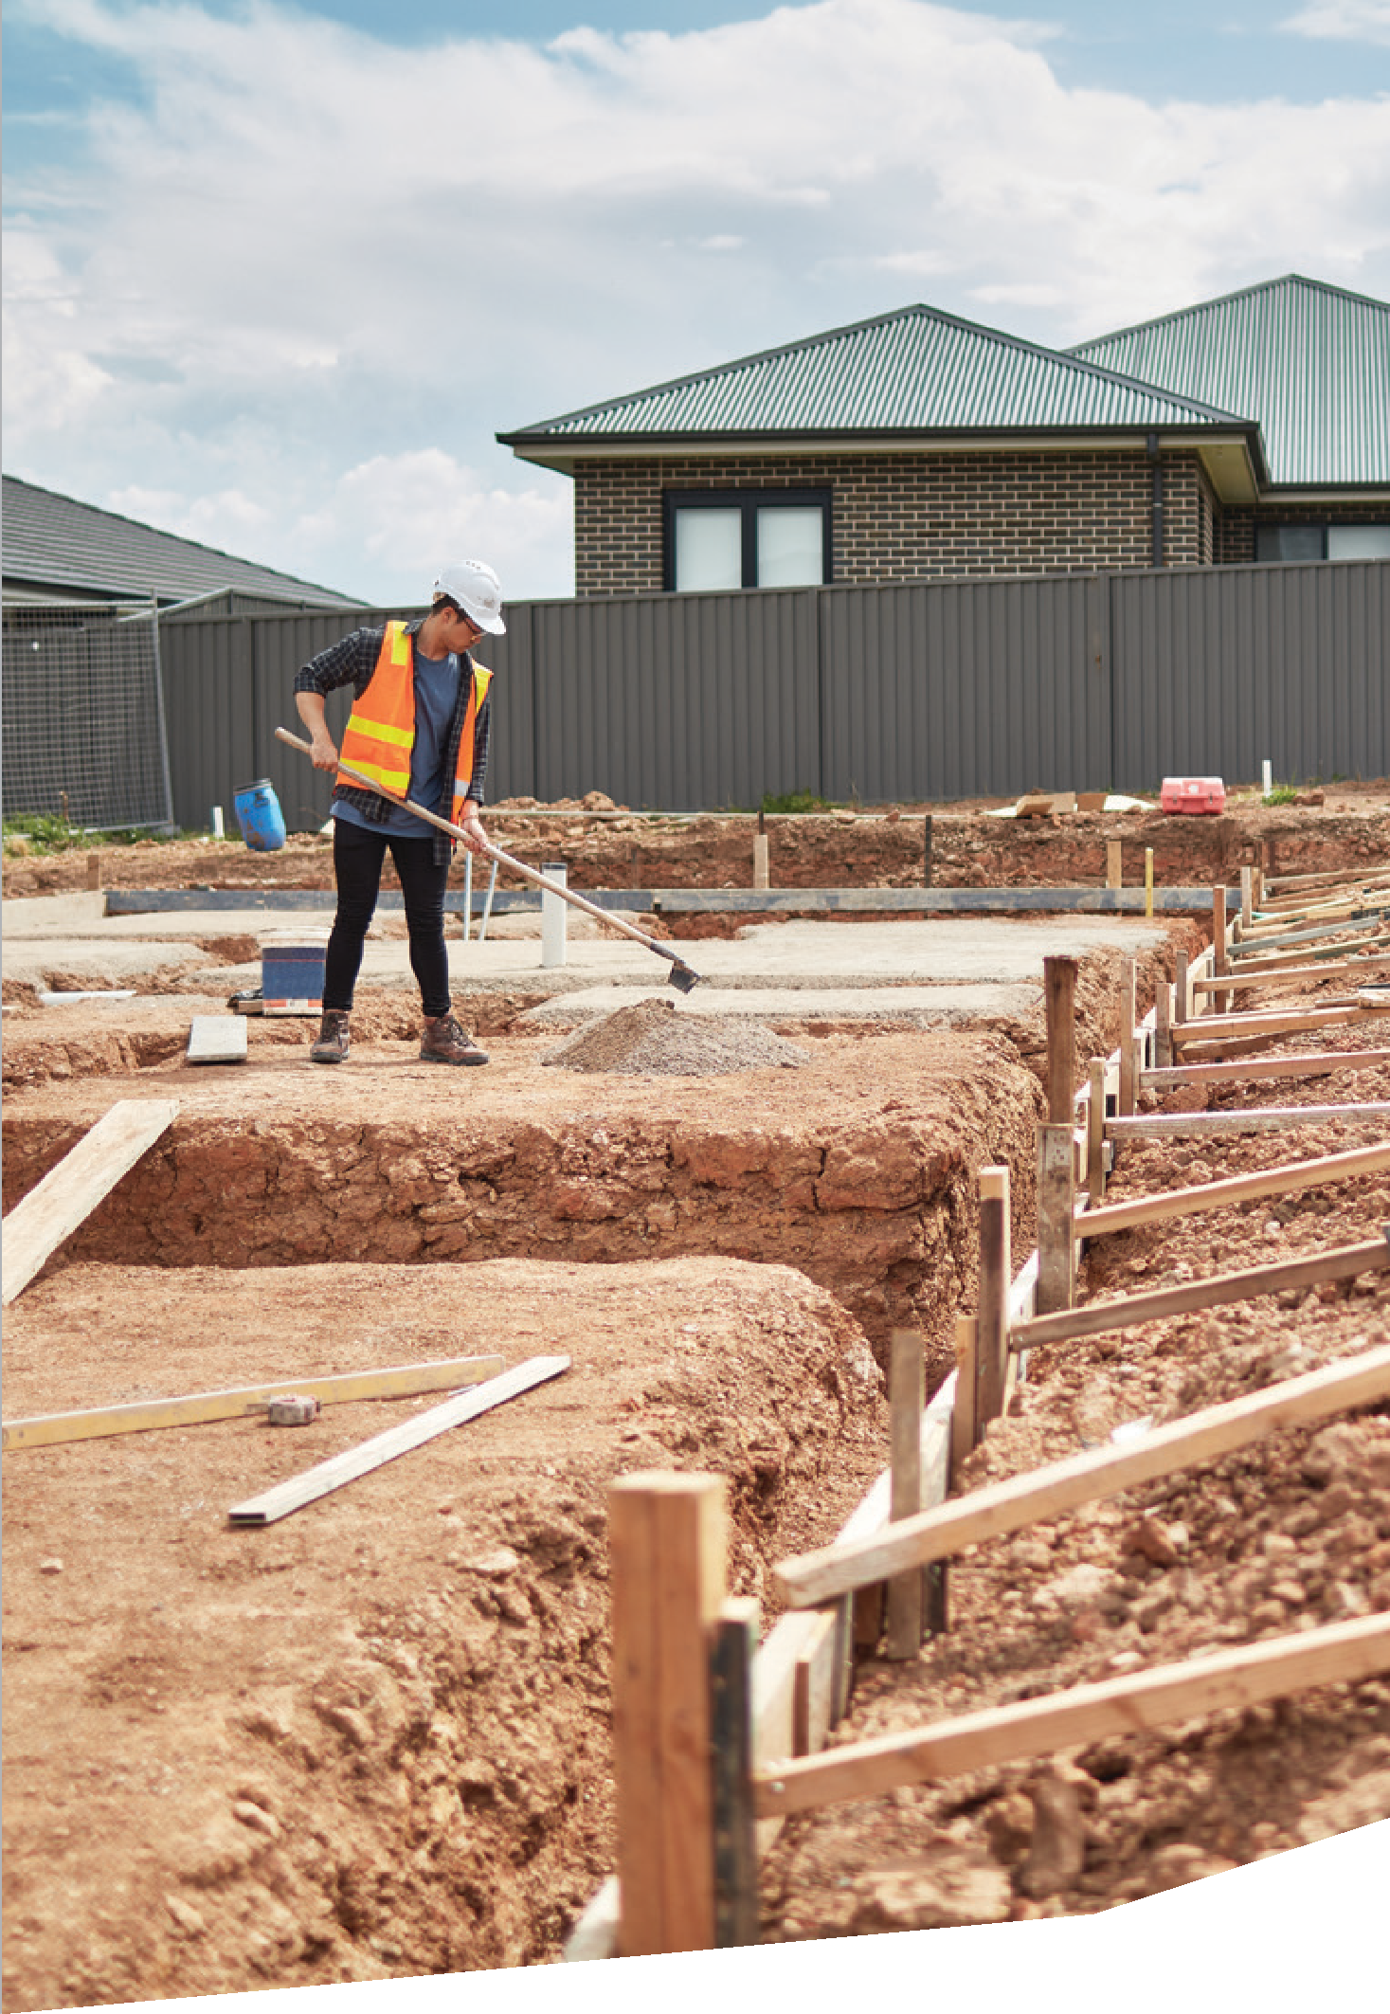

FEELING THE HEAT 3

Heat harms health and wellbeing

I don’t mind spring. I don’t mind winter. Summer brings nothing but restlessness. You’ve got a lot of people who suffer from heatstroke within their own home. But a lot of people don’t like to tell you how hard they’re doing it. I suffer with the heat.”

4 FEELING THE HEAT

Extreme heat can impact every aspect of our lives. It can directly affect our physical health and mental wellbeing but it can also cause flow-on effects such as financial stress, family violence and social isolation.
The consequences of heat become more severe as risk factors compound and can even result in death. The people most affected are those who are most exposed, most susceptible, and least able to keep cool.

Causes sickness and death
RESEARCH SPOTLIGHT
Victorian Department of Health
The health impacts of the January 2014 heatwave in Victoria2
South eastern Australia experienced a heatwave between 14 and 17 January 2014 that resulted in the hottest four-day period on record in Victoria. Melbourne was hit by temperatures over 41ºC each day while other parts of the state were above 45ºC for three consecutive days.
During the week of the heatwave there were:
- 167 excess deaths
- a 7 per cent increase in presentations at public hospital emergency departments
- 621 heat-related presentations – a five-fold increase
- a 25 per cent increase in ambulance callouts
- a 56 per cent increase in after-hours doctor consultations.
“I don’t mind spring. I don’t mind winter. Summer brings nothing but restlessness. You’ve got a lot of people who suffer from heatstroke within their own home. But a lot of people don’t like to tell you how hard they’re doing it. I suffer with the heat.”5
Extreme heat can cause heat cramps, heat exhaustion, heat stroke, dizziness, and dehydration.6 It also exacerbates chronic medical conditions such as heart disease and asthma and plays havoc with medication.6 The impact worsens when heat stress is prolonged by high night-time temperatures that prevent people from cooling down and recovering.7
Extreme heat can also kill. The January 2009 heatwave contributed to 374 excess deaths in Victoria and the January 2014 heatwave led to 167.2 In Australia between January 2006 and October 2017, heat caused or contributed to 36,765 deaths.8 This is about 3,107 deaths every year.

FEELING THE HEAT 5

HEAT HARMS HEALTH AND WELLBEING

Contributes to mental illness
“I’ve lived in Mildura all my life and it’s really hot. Inside the house it can get over 50 because of the heat. With three kids under three and no air-con, it’s really hard. It makes you not want to do anything. When you’re hot and bothered, you can’t be bothered doing anything.”5
People unable to keep cool
during heatwaves can feel stressed about being trapped in a hot home, fearful about approaching summers, and hopeless about their situation.9 Extreme heat
also exacerbates existing mental illnesses such as depression and anxiety. Hospital admissions for mental health conditions increase during heatwaves.1
Mallee Family Care investigated the impact of extreme heat on public housing tenants in Mildura
and observed an increase in alcohol consumption and illicit drug use.10 Community members struggled
to sleep on hot nights, leading to severe fatigue and exhaustion.
Social isolation also increases during heatwaves because people susceptible to heat are forced to cancel appointments and social activities.11 Mental health can worsen during these extended periods trapped at home without contact with friends, family, or welfare services.
“My mum’s got an air-conditioner at her place but it’s really old and she struggles a bit with the heat. If it gets too hot, she doesn’t go out anywhere. She just stays home and doesn’t do anything.”5

Increases the risk of violence
The irritability and frustration caused by unrelenting heat is a dangerous mix, especially when combined with alcohol and drug use.10 Family violence increases during heatwaves due to high household tension and women and children being forced to spend more time at home with a perpetrator.
Mallee Family Care also reported spikes in antisocial behaviour outside the home.10 Violent altercations were more frequent because tempers were flared and many community members would wander the streets at night while their home cooled down.

Exacerbates financial stress
“Our energy bills are through the roof. I’m behind on my bills, god knows how much. I can’t afford to pay. But we have to use the air-conditioner in the night. My daughter can’t sleep when it’s hot, and can’t go to school the next day. So we have to use it.”5
Air-conditioning is vital for keeping most homes cool during
heatwaves but the resulting energy bills can be a source of hardship for low-income households.
This causes significant stress
and increases the risk of food and housing insecurity if sacrifices are made on other essential needs.
People who cannot afford the costs of cooling their home may seek refuge in cool places such as shopping centres or pubs. Costs may be incurred here as well, such as buying refreshments or sinking money into a poker machine. Other financial impacts include medical expenditure and lost workdays due to illness and lack of sleep.

6 FEELING THE HEAT

Our energy bills
are through the roof. I’m behind on my bills, god knows how much. I can’t afford to pay.
But we have to use the air-conditioner in the night. My daughter can’t sleep when it’s hot, and can’t go to school the next day. So we have
to use it.”5

Increases the likelihood of power outages
“A major risk is losing power.
It impacts everything including the people we support on a hot day who come for relief using our air-conditioning.”12
Blackouts are more common during heatwaves because household air-conditioner usage skyrockets and increases the demand on the electricity grid. Market operators can be forced to shed load by cutting power to
certain areas completely, while grid infrastructure can break down under higher temperatures.
Power outages shut off
air-conditioning and lead to soaring indoor temperatures, particularly in homes that are thermally inefficient. Blackouts also impact hospitals and increase the risk of food poisoning by affecting fridges and freezers.

Disrupts public transport
Extreme heat buckles train and tram tracks causing vehicles
to travel at slower speeds or to stop completely. Delays and
cancellations spike on hot days and disruptions are exacerbated if there are power outages as well.
For example, trains were slowed down and trams were replaced by buses on Friday 20 December 2019 because the forecast in Melbourne was 44ºC.13 During the
January 2009 heatwave, more than 750 public transport services were cancelled of the 2,400 scheduled.14

Reduces air quality
Nitrous oxide is an air pollutant that breaks down into ozone at high temperatures.15 Ozone is harmful and can cause respiratory and cardiovascular damage.
Households can protect themselves from air pollution on hot days by closing all doors and windows, but this can lead to higher indoor temperatures without adequate ventilation. Car exhaust is a common source of nitrous oxide, which means people living in areas with high traffic pollution are most at risk.

Disrupts vital services
“Extreme heat makes it dangerous and often impossible to deliver effective services.”12
Extreme heat impacts the community sector and can harm staff members just as much as the clients who depend on them. Almost half of the respondents to VCOSS’s survey referenced occupational health and safety procedures to protect employees when the forecast reaches a certain threshold.
Automatic processes include rescheduling appointments to earlier times of the day when it is cooler, postponing appointments to another day, or cancelling programs completely. The services most impacted are home visits, outdoor activities and exercise classes.
More than three quarters of the survey respondents confirmed that services are disrupted on very hot days. Protecting staff welfare is paramount but there can be
flow-on effects to community members who rely on vital services.
“There is a significant impact on services. All vulnerable client appointments are cancelled to
prevent them travelling in the heat. All exercise groups are cancelled. Outreach work is cancelled. We spend significant time contacting vulnerable clients.”12

FEELING THE HEAT 7

Heat affects people differently
People’s vulnerability to extreme heat depends on three factors:
2
3

Exposure to heat
1
Sensitivity to heat
Ability to keep cool

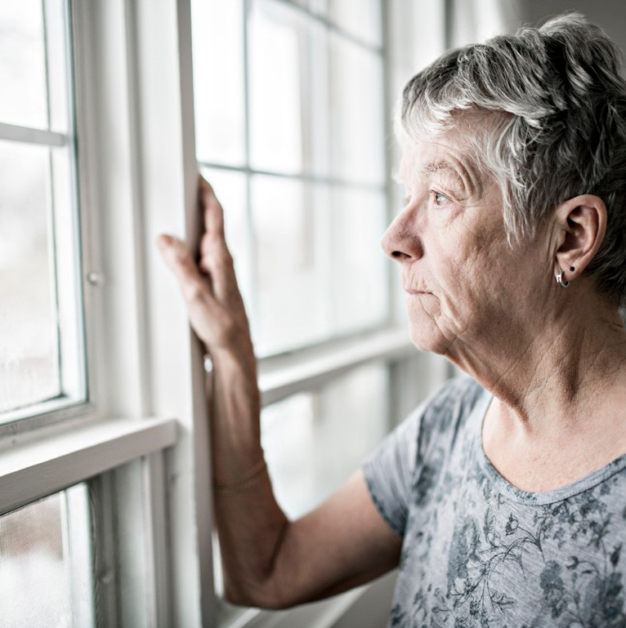
The Victorians most vulnerable to extreme heat are more exposed, more sensitive, and less able to keep cool. These are the people already facing disadvantage,
such as living on a lower income or experiencing homelessness. The drivers of heat vulnerability cover every aspect of our lives and show that reducing harm during heatwaves is a complex issue that depends on our individual circumstances.

8 FEELING THE HEAT

Income

Our disposable income influences the quality of the home we live in and how we shelter on hot days. Blasting an air-conditioner all day is not an option if you are experiencing financial hardship, and nor is buying a movie ticket so you can relax in an air-conditioned cinema.

People are more vulnerable to heat if they ...

… cannot afford air-conditioning
RESEARCH SPOTLIGHT
Centre for Urban Research, RMIT University Heatwaves, Homes & Health: Why household vulnerability to extreme heat is an electricity policy issue11
A survey of workers in health and social services about energy hardship found that:
- 88 per cent of respondents were aware
of at-risk clients who limited air-conditioning usage during heatwaves due to electricity cost
- most respondents were aware of households experiencing adverse health impacts due to restricted air-conditioner usage
- 75 per cent of respondents said it was very or fairly common for households to be experiencing financial stress as a result of using air-conditioning.
“When I got my air-con it was really great. It kept the whole place nice and cool. But no-one told me the electricity bill would be high. My electricity bill was astronomical. You’re damned if you do, damned if you don’t.”5
Low-income households are more vulnerable to energy costs and spend up to five times more of their disposable income on electricity.16 180,000 or
7.3 per cent of Victorian households have persistent difficulty with paying their power bills.17
This comes to a head during heatwaves when air-conditioning is often the only way to keep homes at a safe and comfortable temperature.
Some households will limit their use of air-conditioning to avoid high energy bills, while others cannot afford an air-conditioner at all. The problem is compounded in homes with poor energy efficiency and a cheaper, older model of air-conditioner that is more expensive to run.
“We grew up in a dingy house in Sunshine and did the best we could to survive. There’s only so
much you can do when you don’t have the money. The air-conditioners didn’t work and we couldn’t get them fixed. In heatwaves, you’d feel like the walls are closing in on you. It was hotter inside than outside.”5

HEAT AFFECTS PEOPLE DIFFERENTLY

… have fewer places
to shelter
“On pay day we’d always go to the shopping centre to get out of the heat for a few hours. But then there was that painful thing of coming home. I’d wish we could stay there all day out of the heat but some things are
so expensive.”5
People who cannot afford to cool their home may rely on public places to shelter from extreme heat. Popular locations
include shopping centres, libraries, cinemas, RSL clubs and swimming pools, but financial hardship can limit these options and force people to stay at home.
Admission at cinemas and swimming pools can be expensive, while shopping centres may employ security guards to remove people who are not shopping.
It can also be costly to purchase food and drink throughout the day or to pay for activities to keep children entertained.
“I stay in the shopping centre just to stay cool. I spend the whole day there.”5

… cannot afford to
own a car

When you’ve got a
car full of kids and your air-con’s not working too good, it’s very hot. People have fainted because of the hot heat. My mum did once.
She got a taxi home in summer and she pulled up in our driveway and she collapsed. She was dripping in sweat. Too hot to walk, too hot to drive. You can’t win.”5
“When you’ve got a car full of kids and your air-con’s not
working too good, it’s very hot. People have fainted because of the hot heat. My mum did once. She got a taxi home in summer and she pulled up in
our driveway and she collapsed. She was dripping in sweat.
Too hot to walk, too hot to drive. You can’t win.”5
Low-income households are less likely to own a car due to the up-front cost of purchasing a vehicle and the ongoing costs of running it. This means they are more dependent on public transport and therefore more exposed to extreme heat when travelling on hot days.
For example, walking between home and a train station increases heat exposure, as does waiting on a platform in the sun. Commuters can also be stuck inside a hot train for extended periods during delays.
Not all trains are fitted with
air-conditioning in Victoria and cooling systems can malfunction under heat stress, particularly
in older stock and when the temperature is above 42ºC.14
When low-income households do own a car, it is more likely to be an older vehicle that is more expensive to run than newer, efficient models. The car’s air-conditioning may also
be dysfunctional and ineffective.

Housing

Whether we are renters or homeowners influences the quality of the home we live in and what steps we can take to improve our thermal comfort.
There is also a strong correlation between some housing types and financial hardship, which limits the options for keeping cool inside. The percentage of Victorian renters living in poverty is 20.8 per cent, and a staggering 51.4 per cent for public housing tenants.18
But Victorians experiencing homelessness are by far the most impacted by extreme heat. These people are also more likely to experience addiction and mental illness, which further exacerbates heat vulnerability.19

People are more vulnerable to heat if they ...

… live in a poor quality home
“In this building, there’s no insulation. It’s just concrete. Each room has two windows but they’re permanently shut. You can’t open them. I’ve never been to prison, but this would be close.”5
When asked about the impacts of extreme heat, the greatest concern for staff in the community sector is homes with low thermal comfort. This includes rental properties, public housing, and cheaper homes owned by low-income households who cannot afford expensive retrofits.
Energy efficient homes protect residents from extreme heat because they are better at keeping cool in summer without an air-conditioner. On the other hand, homes with low thermal comfort can get hotter than the temperature outside due to poor insulation and no draught sealing.

But upgrading energy efficiency can be expensive and out of reach for low-income households. A full retrofit including insulation,
draught sealing and double-glazed windows costs around $25,000.20 This results in ‘retrofit poverty’; i.e., inequitable opportunities to improve the energy performance of the home.21
Private rental properties are generally less energy efficient than owner-occupied homes, however, due to a split incentive whereby neither the landlord nor tenant
is motivated to invest in thermal upgrades.22 The former does not live in the property and will not experience the benefits, while the latter does not own the property and will not gain from capital improvements.

Meanwhile the energy efficiency of Victoria’s public housing is poor because these homes are often old and run-down with significant maintenance backlogs.23
Amongst public housing tenants, 45 per cent have left their homes during heatwaves due to thermal discomfort.24
“After sundown everyone in the high-rise goes downstairs.
We go to the park and stay there. It’s too hot inside. We stay outside until we’re tired enough to go home and sleep.”5

HEAT AFFECTS PEOPLE DIFFERENTLY

RESEARCH SPOTLIGHT
Centre for Sustainable Infrastructure, Swinburne University, Submission to the Environment and Communications
References Committee’s Inquiry into current and future impacts of climate change on housing, buildings and infrastructure25
The Nationwide Home Energy Rating Scheme (NatHERS) is a measure of household energy efficiency. The minimum requirement for new homes is 6 Stars but the average rating for homes built in Victoria before these standards is only 1.81 Stars.20
Modelling the January 2009 heatwave on homes with different NatHERS ratings showed that:
- the heatwave would have resulted in 37 deaths instead of 374 if the average
rating of Victorian housing was 5.4 Stars, not 1.8 Stars
- occupants of a 0.9-Star home would have experienced extreme heat stress conditions for 17 to 25 hours, while it was three to
six hours for those in a 5.4-Star home
- the probability of experiencing six heat stress hours in a 0.9-Star home was 58 per cent, but only 4 per cent for a 5.4-Star home.
RESEARCH SPOTLIGHT
Mallee Family Care and the University of Sydney, Extreme heat driven by the
climate emergency: impacts on the health and wellbeing of public housing tenants in Mildura10
Most public housing in Mildura does not have air-conditioning despite the region experiencing severe periods of extreme heat.
There were 64 days over 34ºC between November 2018 and March 2019.
Interviews with public housing residents in Mildura without an air-conditioner found that:
- some tenants were hospitalised due to dehydration, heat stroke, and chronic conditions exacerbated by the heat
- financial hardship was entrenched by higher water bills from extra showers and higher petrol costs from sitting in a car with the
air-conditioner blasting
- heatwaves caused spikes in antisocial behaviour due to increased alcohol consumption and drug abuse
- children skipped school and parents missed work because they were unable to sleep
- residents slept by the river or in their backyard because their homes were too hot during the night.

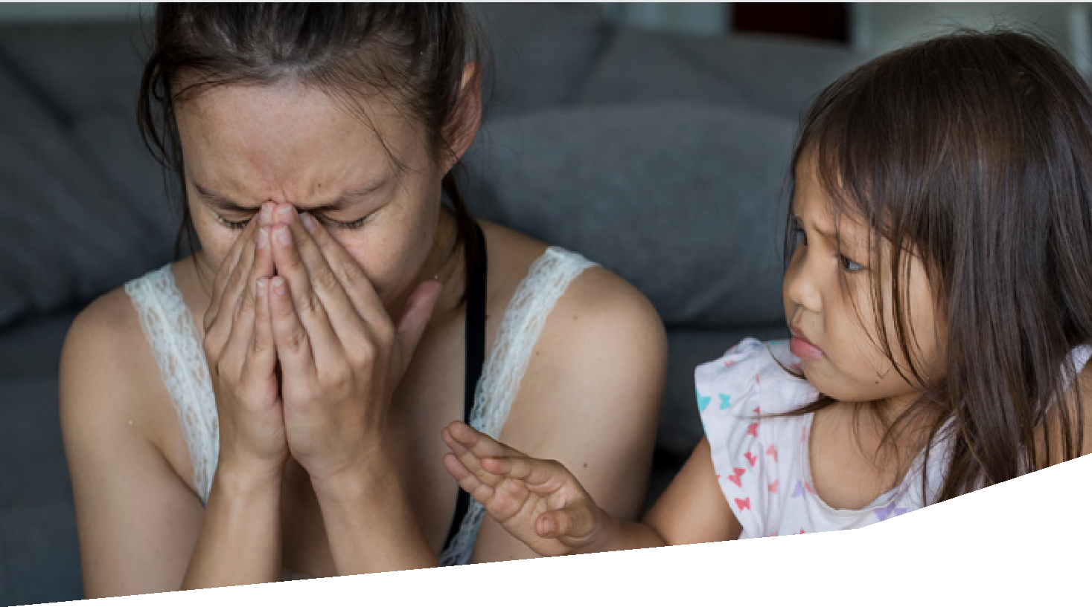

… have no air-conditioning
“The unit doesn’t have
air-conditioning. I couldn’t afford a portable one but I was dying in there. Luckily my social
worker bought a portable air-con for the lounge room. Every summer, we sleep on the
floor in the lounge room.”5
The split incentive between landlords and private renters means that rental properties are less likely to have an air-conditioner than owner-occupied homes.23 Although heating is a minimum rental standard in Victoria, the installation of a cooling system
is not.
When a rental property does include an air-conditioner, it is also more likely to be an older evaporative model.23 These are more expensive to run than efficient reverse-cycle systems, which may discourage renters from cooling down their home during a heatwave.
Air-conditioning is not a minimum requirement for public housing
in Victoria and is only installed if a tenant has a health issue that meets a strict set of criteria.
Air-conditioning is only present in 60 per cent of public housing dwellings.23
When air conditioners are installed, the costs to run them can contribute to ongoing financial hardship for public housing tenants. Tenants interviewed by cohealth reported bills as high as
$500 that caused distress and discouraged future cooling.9
“We had air-conditioners in the house but they didn’t work
and we couldn’t get them fixed. It got really claustrophobic.
So in heatwaves, you’d feel like the walls are closing in on you. It was hotter in our apartment than it was outside.”5

… sleep rough
Participants at VCOSS’s community sector roundtable identified people experiencing homelessness as the most vulnerable to heat.19 Exposure
to the elements can be so severe that attendees recommended that the threshold temperature for activating emergency responses during a heatwave be lowered
for this cohort.
Shelter is the best protection
from extreme weather but a lack of secure housing results in extended periods of time out in the heat.
People sleeping rough are also more likely to be targeted by security in public places and forced to leave. This can limit their access to cool spaces such as shopping centres and libraries.

HEAT AFFECTS PEOPLE DIFFERENTLY

Location

Our experience of extreme heat is dependent on our local climate. For example, in-land regions are generally hotter than coastal areas: a hot day is classified as over 40ºC in Mildura, over 38ºC in Bendigo, and over 35ºC in Melbourne.3
The suburbs of Melbourne also experience significant variations in temperature. The Brimbank local government area is the hottest while the Mornington Peninsula is the coolest.26

People are more vulnerable to heat if they ...

… live in an urban hot spot
RESEARCH SPOTLIGHT
Clean Air and Urban Landscapes Hub, National Environmental Science Program Urban Vegetation, Urban Heat Islands and Heat Vulnerability Assessment in Melbourne26
The urban heat island effect increases the average temperature in three local government areas in Greater Melbourne by over 10ºC: Brimbank, Melton and Casey.
The three coolest local government areas are Mornington Peninsula, Yarra Ranges and Nillumbik.
Urban heat can also be measured against the heat sensitivity and socioeconomic status of residents to determine overall heat vulnerability.
The local government areas with the highest heat vulnerability in Greater Melbourne are Melton, Brimbank, Darebin, Casey and Wyndham, due to socioeconomic disadvantage and a high proportion of older people, young children, and people requiring care.
The urban heat island effect raises surface temperatures and is driven by concrete and a lack of green space. It can turn a warm day into an
unbearably hot day: the impact can be as substantial as 10.75ºC in the Brimbank local government area.26
In Melbourne, low-income households and renters are disproportionately located in hotter suburbs with a high urban heat island effect.27 Urban hot spots are defined as 10ºC warmer than the norm and their location in Melbourne is correlated with socioeconomic disadvantage.28

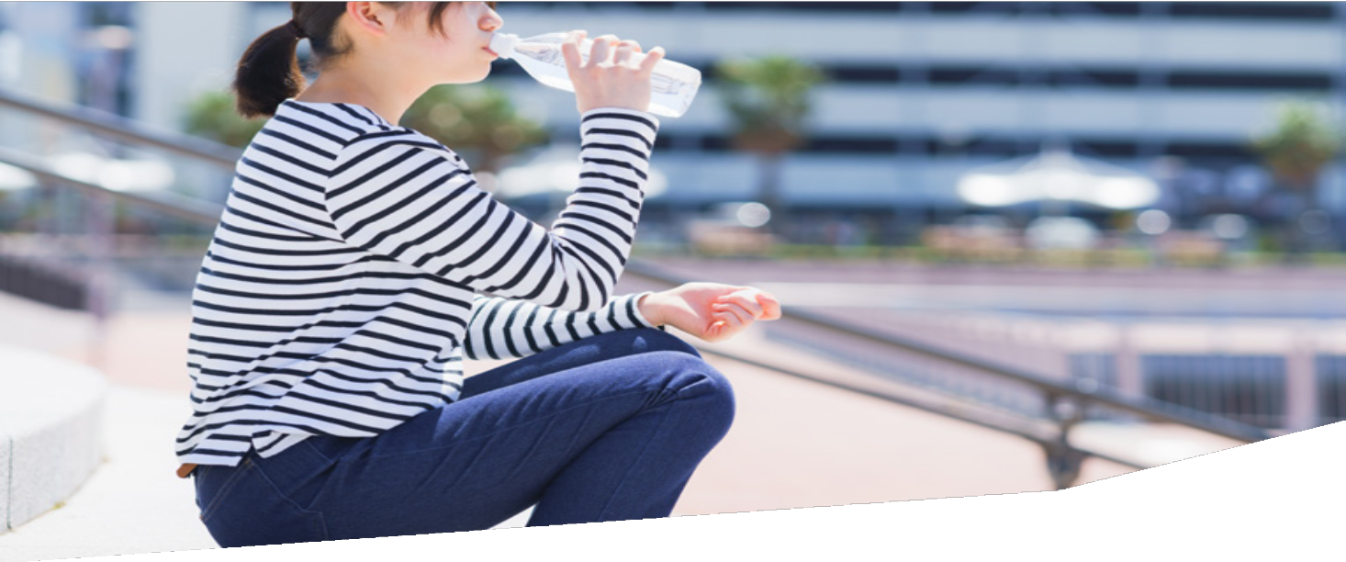

… have limited access
to transport and services
People without essential services nearby are more exposed to extreme heat because they are forced to travel further on hot days for food or appointments. Typically, suburbs prone to this isolation are located in outer Melbourne and regional Victoria.29 Socioeconomic disadvantage is also higher in these areas, where housing is cheaper due to the poor access to local amenities.30
The problem is exacerbated in communities with limited transport options because residents are often forced to travel by foot if they don’t own a car, and need to walk further to access public transport. This kind of transport disadvantage is again concentrated in outer Melbourne and regional Victoria.31
People in these households risk their health when leaving their home on hot days, which limits their access to cool public places to shelter. People might also be forced to skip grocery shopping or cancel important appointments. This increases food insecurity for low-income families who cannot afford to stock up, and can lead to health complications for people who require frequent medical check-ups.

… live in an area with
poor air quality
Extreme heat worsens air quality, and is particularly problematic in communities with high levels of nitrous oxide from traffic pollution. There are 12 air pollution hot spots in Australia, and a quarter are located in Victoria: the Latrobe Valley in Gippsland, and Yarraville and Brooklyn in western Melbourne.32
Transport emissions contribute to the poor air quality in western Melbourne.33 The area is a hub of factories and warehouses and serves as a thoroughfare for commuters and diesel trucks between the CBD, the Port of Melbourne and surrounding suburbs.

HEAT AFFECTS PEOPLE DIFFERENTLY

Age

Young children and older people are more sensitive to heatwaves because age changes the way our bodies respond to heat. Where we spend our time on hot days also changes at different life stages, such as school when we are growing up and aged care later in life.

People are more vulnerable to heat if they ...

… are older or very young
Children’s body temperature is more sensitive to heat due to a higher surface area-to-mass ratio and less effective sweating.34 Children might also be unaware how to recognise signs of heat stress or how to cool down.
Older people are susceptible to extreme heat due to lower cardiovascular fitness, which impedes the regulation of body
temperature.2 They are also more likely to have health conditions that increase heat sensitivity or be taking medications that interfere with how the body reacts to heat.
Social workers who visit clients’ homes often see older people living in unsafe environments with poor insulation and no air-conditioning. Older people may also underestimate their vulnerability and limit their use of air-conditioning due to bill stress exacerbated by limited pension payments.

… are stuck in a hot
environment
Schools are often designed without heat in mind and only some schools and
classrooms are required to have air-conditioning. For example, the non-air-conditioned classrooms at Brunswick South-West Primary School can rise above 30ºC and
students have reported headaches and nosebleeds on hot days.35
Aged care facilities vary in how effectively they prepare residents for heatwaves, such as providers developing a heat plan or training staff members about heat issues.36 Residents might not have
air-conditioning in their bedrooms and common issues include faulty units, repair delays and restricted power supply.

… have limited access
to transport
Young people are vulnerable
to heatwaves because they are unable to drive and more reliant on public transport. Older people are similarly affected if they fail
a medical review of their fitness to drive and lose their licence.
Young people and older people rely on family members for safe car transport on hot days for study, work or social activities. This heightens the risk of being stuck inside a hot home and unable to access a community facility to keep cool.

RESEARCH SPOTLIGHT

Western Sydney University and Macquarie University for the NSW Government, School Microclimates34
Temperature was monitored throughout a school in Western Sydney during the 2019–20 summer and showed that:
- unshaded asphalt was the dominant material in the school yard and could reach 70ºC
- the highest temperature was measured on artificial grass
- tree shade lowered temperature by about 20ºC.

FEELING THE HEAT 17

HEAT AFFECTS PEOPLE DIFFERENTLY

Disability
Transport disruptions and power outages are flow-on impacts of heatwaves that disproportionately affect people with a disability in a variety of ways.
People are more vulnerable to heat if they ...

The public transport delays and cancellations caused by heatwaves disproportionately impact people with a disability because common
back-up options are often inaccessible or unavailable. For
example, people who use a wheelchair can easily be left in the lurch by an inaccessible replacement bus service, alternative routes that are not wheelchair-friendly, and over-booked taxis and rideshares.

… do not have back-up
transport options
The public transport delays and cancellations caused by heatwaves disproportionately impact people with a disability because common back-up options are often inaccessible or unavailable. For example, people who use a wheelchair can easily be left in the lurch by
an inaccessible replacement bus service, alternative routes that are not wheelchair-friendly, and
over-booked taxis and rideshares.
Difficulty understanding updated travel information can also prevent people from adapting to last-minute delays
and cancellations on hot days. People with a visual or hearing impairment may not have access to urgent updates about disruptions unless it is communicated in an inclusive manner online and in-person,
while plain and easy-to-understand English is required for people
with an intellectual disability.

It should be noted that public transport can be more dangerous for people with a disability on hot days. For example, people with limited mobility are disadvantaged by a lack of shade at accessible boarding points and the high competition to rush for a spot under cover.

… are harmed by
power outages
Blackouts caused by heatwaves disproportionately affect people with a disability due to greater reliance on electricity.17 This includes charging communication and mobility devices, higher usage of air-conditioners, and greater amounts of washing and cleaning. Heat can also cause assistive equipment to malfunction.

Cultural and linguistic diversity

English language proficiency impacts our understanding of health advice about coping on hot days, while our experience dealing with heatwaves is affected by how long we have lived in Australia.
However, not all culturally and linguistically diverse people experience high heat vulnerability, and many are better equipped due to skills learnt during their time in other countries.

People are more vulnerable to heat if they ...

… are not provided with
in-language health advice
English language barriers are a major driver of heat vulnerability in culturally and linguistically
diverse communities because most health resources in Victoria are only available in English. People with low English language proficiency may not understand heatwave alerts or practical advice about keeping cool, particularly when household energy usage
is complex.
Issues also arise when health information is mistranslated into a language other than English. Errors can occur when auto-translators are used or when translations do not take cultural nuances into account. This confusion can increase heat vulnerability and cause mistrust in future alerts.

… are unfamiliar with
the climate
“Everything is extreme in Australia. Like extreme heat, extreme cold, extreme flood. It’s really hot here compared to the country I came from.
I grew up in a tropical climate so heatwaves are different here.”5
People who have recently moved to Australia can be less knowledgeable about their local climate and may not understand the dangers of heatwaves.
This includes people who have relocated from a cold climate with few hot days, or from a hot climate where homes are better equipped to withstand heat.
A lack of awareness about heatwaves can put recent migrants at greater risk. For example, people may not understand that tap water is safe for staying hydrated on hot days, or that children should never be left
inside cars.

“In India there’s a different kind of heat. You definitely feel that it’s hot, but it’s not unbearable. But then coming to Australia, Melbourne weather is known for being seven seasons in one.
Your body gets cold, but then it has to adjust again.”5

FEELING THE HEAT 19

HEAT AFFECTS PEOPLE DIFFERENTLY

Employment
Jobs can be the difference between sitting inside an air-conditioned office during a heatwave or labouring outside in the scorching sun. Conditions of employment also influence how comfortable employees might feel about turning down a shift, or telling their employer they need to stop work if they don’t feel safe.
People are more vulnerable to heat if they ...

People with unstable employment are less able to enact their legal rights by stopping work on paid time
if their workplace becomes dangerously hot. For example, casual staff members may fear that their employer will reduce their shifts in retaliation.

… work in a hot and
physical environment
“We do a lot of travel and home visits. It’s uncomfortable and tiring on hot days. We’re in
and out of hot cars all day.”12
People who work outside are more exposed to heatwaves because they are unshielded from the weather. There are also fewer ways to protect outdoor workers from heat, such as turning on
air-conditioning or improving insulation. Affected industries include agriculture, forestry and fishing.
However, people who work indoors can also be at risk, if their work environment is hot with poor ventilation and limited temperature control. For example, manufacturing workers often spend extended periods of time near hot machines, furnaces, and ovens.
Jobs that require physical
exertion exacerbate heat sensitivity because strenuous activities increase body temperature
and make metabolising heat more difficult.37 Workers in the
construction and mining industries are at high risk because their jobs are labour-intensive in hot and humid environments.

In the community sector, outreach workers are frequently identified as high risk due to extreme
temperatures inside homes without air-conditioning or proper insulation and extended travel time in and out of hot cars. Staff who organise outdoor activities and exercise classes are also often referenced.
“It is draining on them especially with concerns for clients who are unable to have access to air conditioning and alike. The drain
is both physical and emotional.”12

… have an insecure job
People with unstable employment are less able to enact their legal rights by stopping work on paid time if their workplace becomes dangerously hot. For example, casual staff members may fear that their employer will reduce their shifts in retaliation.
Workers without leave entitlements might also feel obliged to take a shift during a heatwave regardless of health concerns. People experiencing financial disadvantage feel particularly pressured to work on hot days and risk their health to avoid slipping further into hardship.

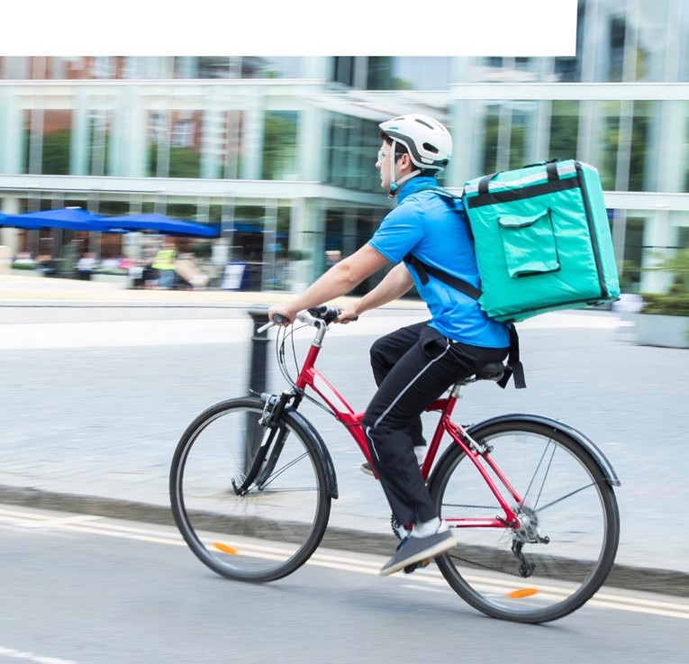
RESEARCH SPOTLIGHT

Climate Justice Research Centre, University of Technology Sydney, Heat Stress and On-Demand Work: The Experience of Food Delivery and Courier Cyclists37
Outdoor council workers and on-demand food delivery cyclists were surveyed about their experiences with extreme heat during a two-week period in March 2019.
The subcontracted cyclists were exposed to greater heat stress than the permanent council staff, illustrating how workplace autonomy and employment arrangements influence how workers are impacted by extreme heat.
For example, insecure employment meant that the delivery cyclists:
- feared they would lose shifts if they refused to work on hot days
- felt significant financial pressure to continue working in heatwaves
- could not schedule strenuous tasks during the cooler parts of the day like the council workers.

FEELING THE HEAT 21

HEAT AFFECTS PEOPLE DIFFERENTLY

Gender
Heatwaves kill more women than men.4 Differences in physiology influence heat sensitivity but women are also far more likely to experience family violence.
Gender inequality also exacerbates heat vulnerability because women are more likely to experience financial hardship, insecure housing and unstable employment. Older single women are particularly at risk due to the gendered gap in wealth accumulation and superannuation.
People are more vulnerable to heat if they ...

I fainted because
of the heat when I was pregnant. I felt numb, dizzy and like I was going to vomit. All
I could do was have a cold shower and drink lots of water.”5

… are experiencing
family violence
Violence increases during heatwaves due to a range of possible causes including increased drug and alcohol abuse, heightened irritability and tension, and households being trapped inside with perpetrators of family violence.
Violence in the home disproportionately affects women and children. The community sector observes a spike in demand for domestic violence services during and after heatwaves.

… are pregnant
“I fainted because of the heat when I was pregnant. I felt numb, dizzy and like I was going to vomit. All I could do was have
a cold shower and drink lots of water.”5
Pregnant women and breastfeeding mothers are more sensitive to heat due to higher body temperature during these phases.30 Pregnancy and lactation also increases dehydration, which further exacerbates the risk of heat stress.

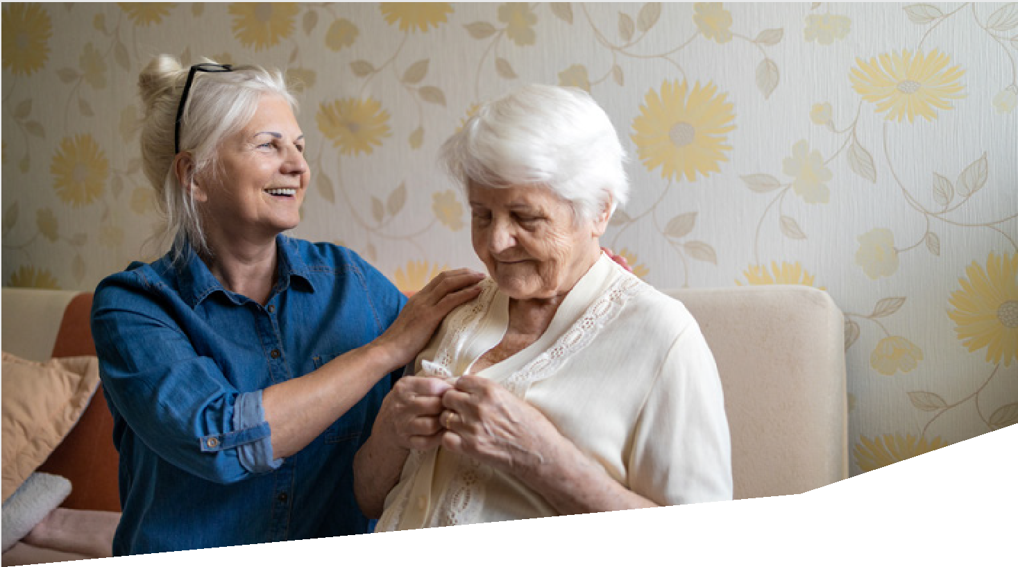

Health

Our pre-existing state of health is often the difference between coping with a hot day or ending up in hospital. Most heat-related mortality is caused by pre-existing health conditions being exacerbated by heat, rather than people directly suffering from heat-induced illnesses like heat stroke.

People are more vulnerable to heat if they ...

… have a health condition
“Heat affects me health-wise.
I get sick every single summer. Sick to the stomach. If it gets too hot, I feel like I need to throw up. The heat is a horrible thing. I’ve got severe anaemia and it’s a really hard thing to deal with.
I’m always tired but it’s so much worse in the heat.”5

People with a chronic cardiac
or respiratory issue are vulnerable during heatwaves because extreme heat can make their illnesses worse.4 Some health conditions can also prevent the body from self-regulating its temperature, including multiple sclerosis, lymphoedema, Parkinson’s disease, fibromyalgia, poliomyelitis, and motor neurone disease.38

Certain medications are disrupted by extreme heat as well.10 This can result in severe side-effects, physical and mental illness, and health conditions worsening due to lack of effective treatment.

We can prevent heat-related harm
A shift is required in the way we address heat vulnerability. Rather than prioritising crisis responses that activate when the forecast hits a certain temperature, we can better prepare communities for heatwaves and reduce their exposure to heat by improving the infrastructure around them.

Many of the following recommendations are not specific to heatwaves, however, and are initiatives that the community sector has been advocating for decades. This includes secure housing, affordable energy and accessible transport, and indicates the co-benefits that can be achieved by equitably adapting to the changing climate.
The actions provide a general blueprint for reducing heat-related harm, and include references to initiatives that have been implemented by community organisations, local councils and government agencies in Victoria.
The desired outcome is for there to be no heat-related deaths in Victoria, and for all households to be able to keep cool and safe during heatwaves.

Fund the community sector to help people cope with heat
Recommendation 1: Establish a grants program for community service organisations to address local heat vulnerability.
Recommendation 2: Provide funding and training for community service organisations to build organisational resilience.
Increase residential energy efficiency
Recommendation 3: Retrofit all social housing with energy efficiency upgrades.
Recommendation 4: Introduce minimum energy efficiency standards for rental properties.
Recommendation 5: Provide subsidies for low-income households to upgrade household energy efficiency.
Improve access to air-conditioning
Recommendation 6: Ensure all rental properties, social housing dwellings and low-income households have an air-conditioner.
Recommendation 7: Improve access to rooftop solar panels to keep air-conditioning affordable.
Recommendation 8: Introduce a medical cooling concession.

Expand access to cool community spaces
Recommendation 9: Establish a formalised network of local heat refuges.
Recommendation 10: Upgrade the energy efficiency of community sector facilities.
Reduce the urban heat island effect
Recommendation 11: Increase urban green space and tree canopy cover.
Recommendation 12: Target urban greening in the areas most vulnerable to heat.
Improve transport infrastructure
Recommendation 13: Ensure all public transport is accessible and heat-smart.
Recommendation 14: Create a network of cool routes by planting trees along walking and cycling routes.
Recommendation 15: Fund community transport.
Provide best-practice health information
Recommendation 16: Invest in best-practice communication with culturally and linguistically diverse communities.
Recommendation 17: Develop targeted heat health information that is relevant to specific audiences with high heat vulnerability.
Protect the people most susceptible
Recommendation 18: Establish vulnerable persons registers in every local government area and give access to community health services.
Recommendation 19: Make all schools heat-smart by introducing new design standards and retrofitting existing buildings and playgrounds.
Empower workers
Recommendation 20: Raise awareness of extreme heat in the workplace.
Measure the problem
Recommendation 21: Add temperature to death records and report on heat-related mortality every year.

WE CAN PREVENT HEAT-RELATED HARM

Fund the community sector to help people cope with heat
RECOMMENDATION 1
Establish a grants program for community service organisations to address local heat vulnerability.

“Planning for and responding to environmental emergencies such as heatwaves, bushfires and floods isn’t funded.”12

CASE STUDY /
cohealth, enliven and IPC Health
Hot Spots9
Community health organisations implemented place-based programs to raise awareness
of extreme heat.
Social workers engaged their communities to identify the people most at risk and then built community networks to communicate important health messages.
cohealth surveyed tenants of inner Melbourne public housing towers and provided practical advice to residents about mitigating extreme heat.
enliven collaborated with aged care services and services for culturally and linguistically diverse people in Dandenong to deliver
co-designed information materials.
IPC Health co-designed health messages with vulnerable communities in Brimbank
and built cross-sector networks with agencies and community groups to prepare for future heat events.
It is uncommon for the community sector to be specifically funded to address heat vulnerability,
but organisations step up regardless of this shortfall because heatwaves harm their clients and communities. Social services participate in the preparation and response phases of extreme weather events, including:
- co-designing translated heat health messages with diverse communities
- assessing the energy efficiency of clients’ homes
- providing practical advice about optimising thermal comfort
- operating heat refuges on hot days
- pairing volunteers with vulnerable community members.
The main barrier to this work is a lack of funding. Community organisations have limited resources and are already stretching their budgets to deliver core services effectively.
A reliable funding stream is needed for the community sector to build local resilience to heatwaves and extreme weather events. Organisations would then be able to dedicate more resources to reducing heat vulnerability and could embed resilience into their core business.

“Our building did not have air-conditioning and it became untenable to work in the space on days over 30 degrees.”12
RECOMMENDATION 2
Provide funding and training for community service organisations to build organisational resilience.

CASE STUDY /
Jesuit Social Services, RMIT and VCOSS Community Climate Change Adaptation for Social Care and Community Organisations39
Community service organisations in Greater Melbourne were interviewed about their resilience to climate change and extreme weather events.
The findings informed training sessions for social workers in Brimbank and Dandenong to learn about the compounding impacts of climate change on their organisations.
The workshops included heatwave scenario planning to assess the risks to their community and outlined a toolkit for gauging their organisation’s resilience.
Community sector organisations are so focused on caring for their clients and communities that these organisations’ own vulnerability to heatwaves can often be overlooked. Impacts include injury to staff members and disruption to service delivery, and these impacts flow on to vulnerable people who rely on the support.
Funding is again a barrier for community service organisations to undertake a risk assessment and build their own resilience to heatwaves and extreme weather events. Organisations are also reluctant to use scant resources for internal purposes when their budget for service delivery is already spread thin.
The community sector would also benefit from accessible and affordable training about preparing for heatwaves and improving business continuity.
Practical advice that can be implemented immediately is particularly useful because staff members are time poor and may not have capacity to develop strategies from scratch.

WE CAN PREVENT HEAT-RELATED HARM

Increase residential energy efficiency

RECOMMENDATION 3
Retrofit all social housing with energy efficiency upgrades.

Thermal upgrades reduce heat stress and financial hardship by keeping homes cooler on hot days without the need for air-conditioning.

CASE STUDY /
Victorian State Government Energy Efficiency in Social Housing Program40
The 2020–21 Victorian State Budget included
$112 million to upgrade the energy efficiency of 35,000 social housing properties.
Upgrades include insultation, draught proofing, and energy efficient appliances.
A retrofit program of public housing should include insulation and draught proofing and could involve partnerships with the community sector to engage and support residents.
The energy efficiency of community housing could be increased by providing grants to providers to upgrade their properties.

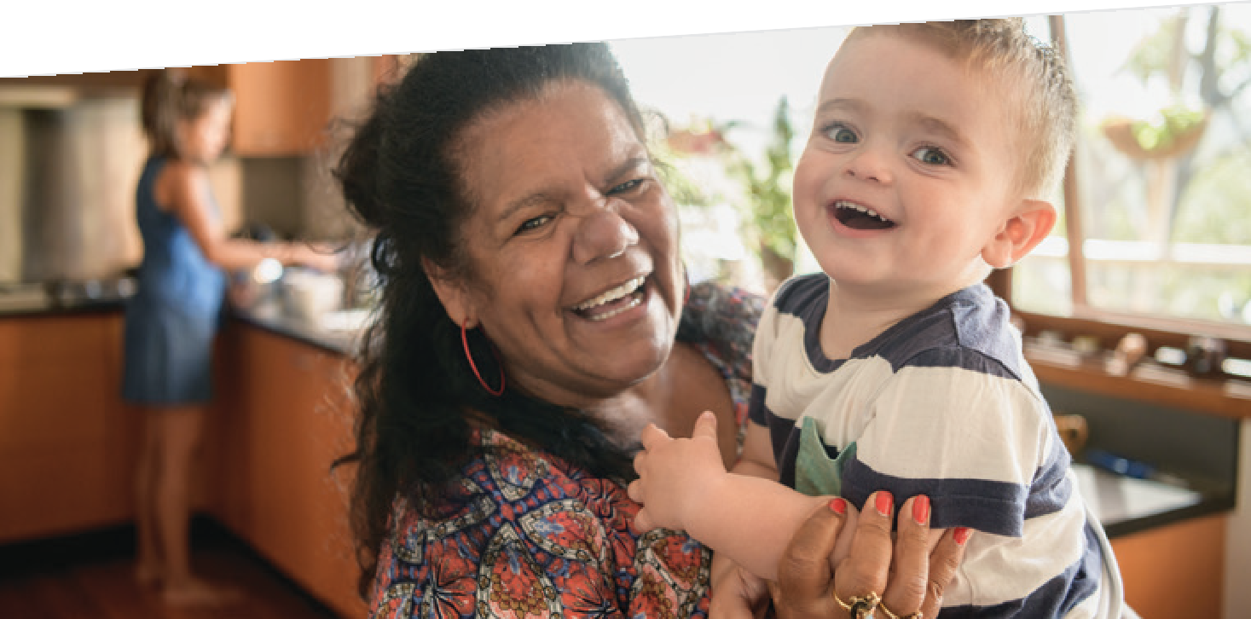
28 FEELING THE HEAT

RECOMMENDATION 4
Introduce minimum energy efficiency standards for rental properties.
RECOMMENDATION 5
Provide subsidies for low-income households to upgrade household energy efficiency.

The thermal comfort of rental properties is usually lower than owner-occupied homes. This gap can be closed by requiring landlords to meet minimum energy efficiency standards before renting out a property.
This can be achieved through a whole-of-home performance standard such as a NatHERS rating, or a series of feature-based standards such as an efficient air-conditioner, sufficient insulation, and so on.
Tenants may not be aware of their rights, and may be reluctant to enforce their rights due to fear of retaliation. The community sector can be
resourced to communicate new standards to tenants, while government agencies must be proactive in enforcing compliance.
Low-income homeowners may be unable to afford energy efficiency upgrades, but subsidies can remove this barrier and improve the thermal comfort of homes.
Market-based retrofit programs are used in Australia and worldwide, but these can exacerbate disadvantage by excluding households who can’t
afford the discounted yet substantial up-front costs.21
Schemes that pair subsidies with a no-interest loan are most effective.

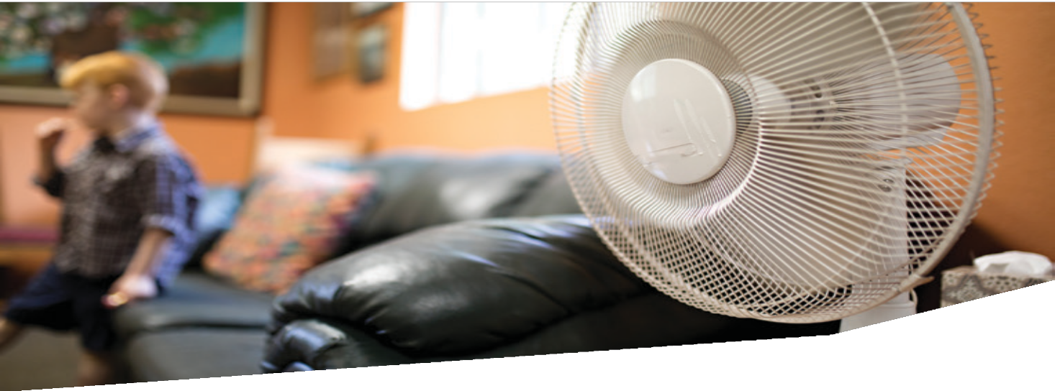
FEELING THE HEAT 29

WE CAN PREVENT HEAT-RELATED HARM

Improve access
to air-conditioning

RECOMMENDATION 6
Ensure all rental properties, social housing dwellings and low-income households have an air-conditioner.

“Before we had air-conditioning it was horrible. My daughter and I would struggle to cope in the heat. All we had back then was a couple of fans. It was a huge, huge, huge struggle.”5

CASE STUDY /
Victorian State Government
Heating and Cooling Upgrades Program41
The 2020–21 Victorian State Budget
included $335 million for 250,000 low-income households to receive a $1,000 subsidy
for replacing an old heater with an efficient
reverse-cycle air-conditioner.
Eligible households include home-owners, renters and community housing tenants.
Ideally every home should be so energy efficient that air-conditioning is not required to keep cool during a heatwave. Until all homes reach that high standard, however, households will have to rely on air-conditioning to maintain a safe temperature at home.
The mechanisms for ensuring equitable access to
air-conditioning are the same as for improving energy efficiency, i.e.:
- installing air-conditioning in all public housing
- providing grants to community housing providers to purchase air-conditioners
- introducing a cooling standard in rental properties
- establishing an air-conditioner subsidy scheme for low-income owner-occupiers with a no-interest loan.

“Solar systems should be subsidised or free for vulnerable households who have air-conditioners so they can use them during extreme heat. Vulnerable people forgo using air conditioners a lot of the time because they’re concerned about the cost.”12
RECOMMENDATION 7
Improve access to rooftop solar panels to keep air-conditioning affordable.

CASE STUDY /
Victorian State Government
Solar Homes43
Solar Victoria provides homeowners and community housing providers with a $1,850 subsidy up to half the cost of installation, which can be repaid through a no-interest loan.
The program was expanded to rental properties but uptake remains low, with only 1,076 rebates provided by April 2021.44
Many low-income households ration their use of air-conditioning, but rooftop solar panels reduce energy costs and allow people to turn on their
air-conditioner on hot days rather than risking harm.
Government subsidies for solar panels can boost uptake among low-income owner-occupiers, particularly when paired with a no-interest loan.
Subsidies are not as effective for rental properties due to the split incentive between landlords and tenants.
Solar gardens are an alternative to rooftop panels and can address renters’ low access to renewable energy.42 Tenants rent solar panels at an off-site location and receive credits on their energy bill, resulting in savings greater than the cost of renting the panels.
Solar panels should also be installed on public housing, requiring a widescale rollout to all eligible properties. And community housing benefits when household subsidies are expanded to providers.

FEELING THE HEAT 31

WE CAN PREVENT HEAT-RELATED HARM

Improve access
to air-conditioning

“Bill stress is always an issue because my electricity bill is so high. During summer, I never turn the
RECOMMENDATION 8
Introduce a medical cooling concession.

CASE STUDY /
Victorian State Government
Medical Cooling Concession38
The Victorian medical cooling concession
in Victoria covers 17.5 per cent of electricity usage and service costs between 1 November and 30 April every year.
It is restricted to people who have a medical condition that hinders their body’s ability to regulate temperature.
air-conditioner off. It’s always on 24/7.”5
A financial concession for cooling costs incurred by low-income households over warmer months can improve the affordability of air-conditioning.
The payments can also be extended to people with a disability or medical condition that exacerbates their sensitivity to heat.

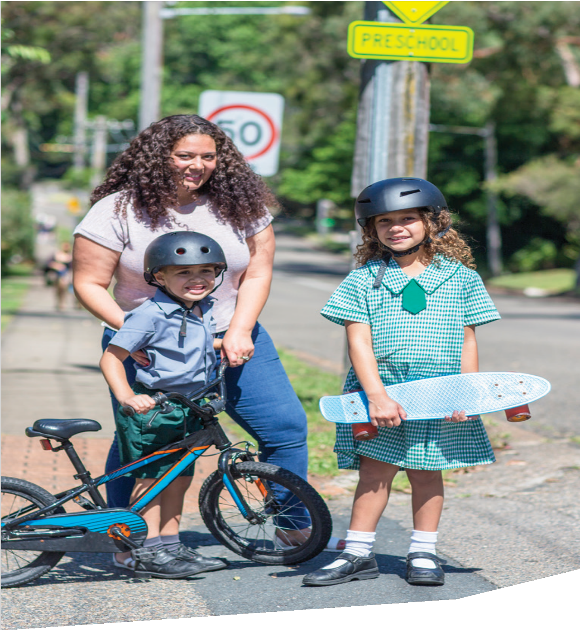

FEELING THE HEAT 33

WE CAN PREVENT HEAT-RELATED HARM

Expand access to cool community spaces

RECOMMENDATION 9
Establish a formalised network of local heat refuges.

“The places I was able to escape to were things like libraries. They’re air-conditioned and have a lot of community. And books fostered a love of poetry for me. A space that helps you survive but also thrive is really beautiful. And I think libraries really did that for me.”5

CASE STUDY /
Indigo Shire Council
Cool Relief Centres45
Forty-three businesses and community organisations operate as Cool Relief Centres on hot days across Beechworth, Chiltern, Kiewa, Tangambalanga, Rutherglen and Yackandandah.
Air-conditioning and seating is provided for community members to shelter from the heat, and stickers are displayed on office windows to let people know they are welcome.
The Indigo Shire Council also opens community spaces as heat refuges on hot days and extends the swimming pool’s opening hours.46
Their locations are advertised on the council’s website, in the local newspaper, on the radio and through social networks.
Cool community spaces are vital for people who live in poor quality housing or can’t afford air-conditioning.
However, these services are often provided on an ad hoc basis and can be unreliable due to limited opening hours and the risk of being harassed by security.
Heat refuges are most effective when they are operated specifically for that purpose with ample advertising, extended hours of operation, and free transport for people experiencing disadvantage. Formalising a network of these facilities across all communities can ensure everyone has a safe and reliable place to shelter from the heat.
Cool spaces also have significant co-benefits when the community is funded to operate them.
Community members can learn new skills, socialise with other residents and be linked with additional services they may not know about. This also encourages uptake because entertaining activities are a stronger enticement for people to leave their homes than the fear of heat-related harm if they stay put.

“We open up a large meeting room on days of extreme heat, providing refreshments and board games. Several residents of a nearby rooming house drop in. We know they struggle in the heat and we try to accommodate them as much as we can during extreme heat.”12
RECOMMENDATION 10
Upgrade the energy efficiency of community sector facilities.

CASE STUDY /
Emerald Community House
Centre of Resilience47
Emerald Community House is a local leader in community resilience and has developed its business continuity in the face of extreme weather and emergencies.
The organisation operates as a heat refuge and has installed solar panels, a battery, and a back-up generator to bolster their energy supply in case of blackouts.
Many community organisations like neighbourhood houses open their doors on hot days for people to shelter from the heat. However, the extra cooling required can result in higher energy bills, especially when offices are kept open outside of normal business hours.
The community sector would be assisted by energy efficiency upgrades to their premises to improve thermal comfort and reduce cooling costs. Budgets are stretched thin as it is, without stepping in to operate as heat refuges.
“If we see people sitting outside in the heat, especially the elderly or those with children, we invite them inside to wait and offer them a cool drink.”12

36 FEELING THE HEAT

Reduce the urban heat island effect

RECOMMENDATION 11
Increase urban green space and tree canopy cover.
RECOMMENDATION 12
Target urban greening in the areas most vulnerable to heat.

The urban heat island effect increases temperature, and is worst in areas with high concrete and low green space. Trees cool our communities through shading and transpiration and can be planted to mitigate urban heat spots.27
But green space in Australia is steadily declining.28 In Victoria, tree cover in urban areas decreased by 2 per cent overall between 2013 and 2017 and
decreased in 92 per cent of local government areas during that time.
The decline must be stopped and reversed. This can be achieved through proactive urban greening programs and greening targets for all local government areas.
The urban heat island effect is not uniform across our cities, while some communities are more vulnerable to heat due to the various factors outlined in ‘Heat affects people differently’.
Urban heat, heat vulnerability, and socioeconomic disadvantage should be analysed in tandem to target urban greening programs at areas most in need. These are areas with low amounts of green space, a high proportion of households who are sensitive to heat, and communities with less resources to keep cool.
RESEARCH SPOTLIGHT
Greener Spaces Better Places
Where should all the trees go?28
The most effective greening opportunities in Australia were determined by rating every local government area based on heat, the heat vulnerability of the local community, and whether green space was increasing
or decreasing.
Fourteen of the top 50 greening opportunities were in Victoria and three of the nine LGAs with the lowest rating (0.5) were in Victoria: the Cities of Ballarat, Darebin and Hume.
Brimbank, Maribyrnong and Moreland received a rating of 1, while at the other end of the spectrum Yarra Ranges, Nillumbik, Knox and Bayside were rated 4.5.

CASE STUDY /
Regional partnership in western Melbourne
Greening the West48
An alliance of local councils, water corporations and government agencies are expanding green space in Melbourne’s western suburbs.
The partnership aims to double tree canopy cover by 2050, increase green space by
25 per cent by 2030, and ensure all residents have access to quality green space within 500 metres of their home.
The 1 Million Trees project planted over a million trees across western Melbourne and covered 1,755 hectares.49

WE CAN PREVENT HEAT-RELATED HARM

Improve transport infrastructure

RECOMMENDATION 13
Ensure all public transport is accessible and heat-smart.
RECOMMENDATION 14
Create a network of cool routes by planting trees along walking and cycling routes.

Accessible public transport allows people to safely adapt to disruptions caused by heatwaves. It means that everyone has the option of using a replacement service or taking a different route if their usual mode of transport is cancelled or delayed due to heat issues.
The information provided by transport services must be inclusive as well. The sudden disruptions caused by heatwaves need to be communicated in an accessible and timely manner that is appropriate
for deaf, hard-of-hearing, blind and partially-sighted people. The information must also be available in easy English for people with an intellectual disability or with low English language proficiency.
In addition to upgrading the accessibility of public transport, the infrastructure must also be heat-smart and protect passengers from heat-related harm.
This includes constructing shelter at all stations and stops, installing reliable air-conditioning in all vehicles, and providing water for passengers on hot days.
Walking and cycling can be dangerous on hot days, particularly when paths are not adequately shaded. Although travelling outside is discouraged during heatwaves, it is the only option for accessing public transport, essential services, and heat refuges for people who do not own a car.
Cool routes are active transport paths lined by
trees to shade pedestrians and cyclists from the sun. They can be integrated into urban greening programs to protect community members from extreme heat when travelling outside on hot days.

CASE STUDY /
RMIT
Shadeways50
Shadeways is a navigation tool in Bendigo that determines the most thermally comfortable route for active transport.
The app allows pedestrians and cyclists to alter their route and avoid extreme temperatures.
It integrates maps with data about surface temperature, green space and tree shading, and could be used to plan the location of future cool routes.

The community sector provides not-for-profit transport for people experiencing disadvantage, but funding is often scarce. Users of community
RECOMMENDATION 15
Fund community transport.

CASE STUDY /
The Regional Association of Neighbourhood and Community Houses The Neighbourhood House Community Transport Project51
A survey of neighbourhood houses in the Loddon Mallee region found that a majority provided community transport.
The services provided by these 30 neighbourhood houses included transport to health appointments, assisted transport for people with a disability, and flexible transport for people without access to a car.
The study found that these services provided regular drivers who learnt the individual needs of their passengers and could adapt to local disruptions.
transport typically face physical accessibility barriers to public transport, can’t afford to own a car or hire a taxi, and/or live in rural areas that lack affordable transport options.
Funding community transport allows people to escape their hot homes and travel to a local heat refuge. Services could be provided on days with a high forecast and cater for community members unable to cool their homes or travel to a cool place without assistance.

WE CAN PREVENT HEAT-RELATED HARM

Provide best-practice health information

“I would love to see some funding to educate local champions who can spread the knowledge among the local refugee communities on how to stay safe, how to stay cool, how extreme heat in Australia can be dangerous for them and their families.”12
RECOMMENDATION 16
Invest in best-practice communication with culturally and linguistically diverse communities.

CASE STUDY /
Bendigo Community Health Services (BCHS)
Cultural Diversity and Relationships Team
BCHS co-designs bushfire and heatwave information in languages used in the community by engaging recent migrants and asylum seekers.
As many channels as possible are then utilised to communicate the messages, including:
- social media apps popular with specific communities, such as Viber
- a multi-language hotline
- audiovisual materials.
Bicultural staff are also hired to reflect the diversity of the community and to communicate directly with culturally and linguistically diverse clients about the risks of bushfire and heatwaves.
BCHS has won several awards for its support of migrants and refugees, including a Migration Council of Australia award for the Coronavirus Refugee Resource Hub.
Heat health information is an important tool for preparing communities for heatwaves, but most resources are only provided in English. This excludes people with low English language proficiency and exacerbates their vulnerability to heat.
Best-practice communication in the community sector involves co-designing translated materials with culturally and linguistically diverse residents to craft messages that are correct and appropriate. Many organisations also hire bicultural workers to help
develop materials, advise non-English-speaking clients directly, and ensure services reflect the needs of community members.
Agencies can start by mapping what cultures and languages are present in the local communities they represent. Co-designed communications should then be targeted through multiple mediums popular in each community.

“We put out information every year on extreme heat. We translate it into other languages and on video.
RECOMMENDATION 17
Develop targeted heat health information that is relevant to specific audiences with high heat vulnerability.
We have information sessions, we remind people on social media platforms, there is information available at all sites.”12
Communication about keeping safe during
heatwaves can be ineffective if it doesn’t take personal circumstances into account. People who cannot afford their energy bills don’t benefit from being told to turn on an air-conditioner, while advice on seeking shelter in a cool public place is no use to people without
any transport options.
Heat health advice is most effective when multiple messages are targeted to different audiences and people are not asked to choose between thermal discomfort, personal harm and financial hardship. The community sector could be funded to co-design these materials and to provide personalised advice to clients.

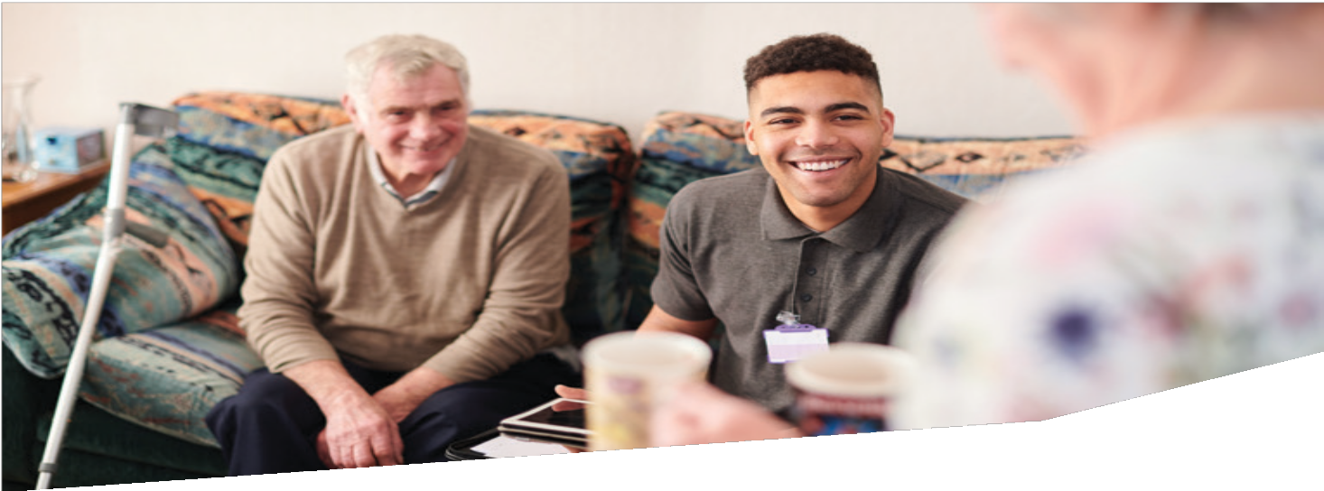
FEELING THE HEAT 41

WE CAN PREVENT HEAT-RELATED HARM

Protect the people most susceptible

“All vulnerable clients receive information about how to stay cool and clients particularly at risk due to heat (co-morbidities, living alone, no air conditioning, etc) have a check-in via phone or in-person to ensure they are OK.”12
RECOMMENDATION 18
Establish vulnerable persons registers in every local government area and give access to community health services.

CASE STUDY /
Recovery Ready Communities
Ready2Go
People with high heat vulnerability are paired with a volunteer who checks in on hot days and can transport them to a cool place to shelter.
The program started in the town of Cockatoo before expanding to five more communities in Apollo Bay, Cann River, Kooweerup, and the local government areas of Upper Yarra and Yarra Ranges.
Lead organisations include local councils, community health services and neighbourhood houses, who manage volunteers and provide fun activities at cool places to encourage uptake.
Participants are mostly older people and people with a disability or health issue, and are often referred by relatives and neighbours.
People sensitive to extreme heat could be added to a register with contact information monitored by
community health services on hot days. This includes older people, people with a disability, and people with a health condition, particularly those who live alone.
Participants can refer themselves or be referred by community service organisations, GPs, friends and family.
A vulnerable persons register allows community organisations to call residents most at-risk during a heatwave to check their wellbeing and provide advice about keeping cool. The register can also be used to provide alerts, information about local initiatives, and a map of nearby heat refuges.

Extreme heat harms students and impedes their learning, but exposure can be reduced by designing school buildings and playgrounds with heat-smart materials and avoiding asphalt and artificial grass.34 Trees should also be planted to shade and cool buildings and outdoor areas.
RECOMMENDATION 19
Make all schools heat-smart by introducing new design standards and retrofitting existing buildings and playgrounds.
Thermal comfort can be improved by retrofitting buildings with energy efficiency upgrades such as insulation and window shading. Air-conditioning and fans should also be installed in every classroom and can be paired with rooftop solar to counter increased energy usage.

FEELING THE HEAT 43

WE CAN PREVENT HEAT-RELATED HARM

Empower workers

Measure the problem

RECOMMENDATION 20
Raise awareness of extreme heat in the workplace.
RECOMMENDATION 21
Add temperature to death records and report on heat-related mortality every year.

Employers are required to provide safe workplaces, and employees can cease work on paid time if there is a risk to their safety, but improved understanding is needed about obligations and responsibilities regarding extreme heat.
Awareness about heat hazards in the workplace could be raised through public education campaigns and subsidised training for employers and employees.
Employers would benefit from learning about practical measures to reduce heat exposure in the workplace, while employees should be empowered to request improvements and cease work if required.
Official death records in Australia underestimate heat-related mortality by as much as 1 in 50.52 When high temperatures contribute to death this information is often overlooked and replaced by the health condition that was exacerbated by the heat.
The most accurate measure would be noting temperature, air quality and humidity on death records, rather than relying on indirect approximations like ‘excess deaths’. This would allow agencies to properly monitor the impact of extreme heat and implement responses based on targeted information.
Data about heat-related mortality should also be reported every year based on state and local government area. These dashboards could prompt action where it is needed most and help measure the success of interventions.

CASE STUDY /
United Workers Union
Occupational Health and Safety Extreme Weather Training
Workers are taught how to recognise the impact of extreme weather on their workplace and are empowered to cease work on paid time whenever there is an imminent threat
to their safety.
Attendees also learn about their employers’ responsibilities, such as providing a safe work environment and mitigating all risks to health.

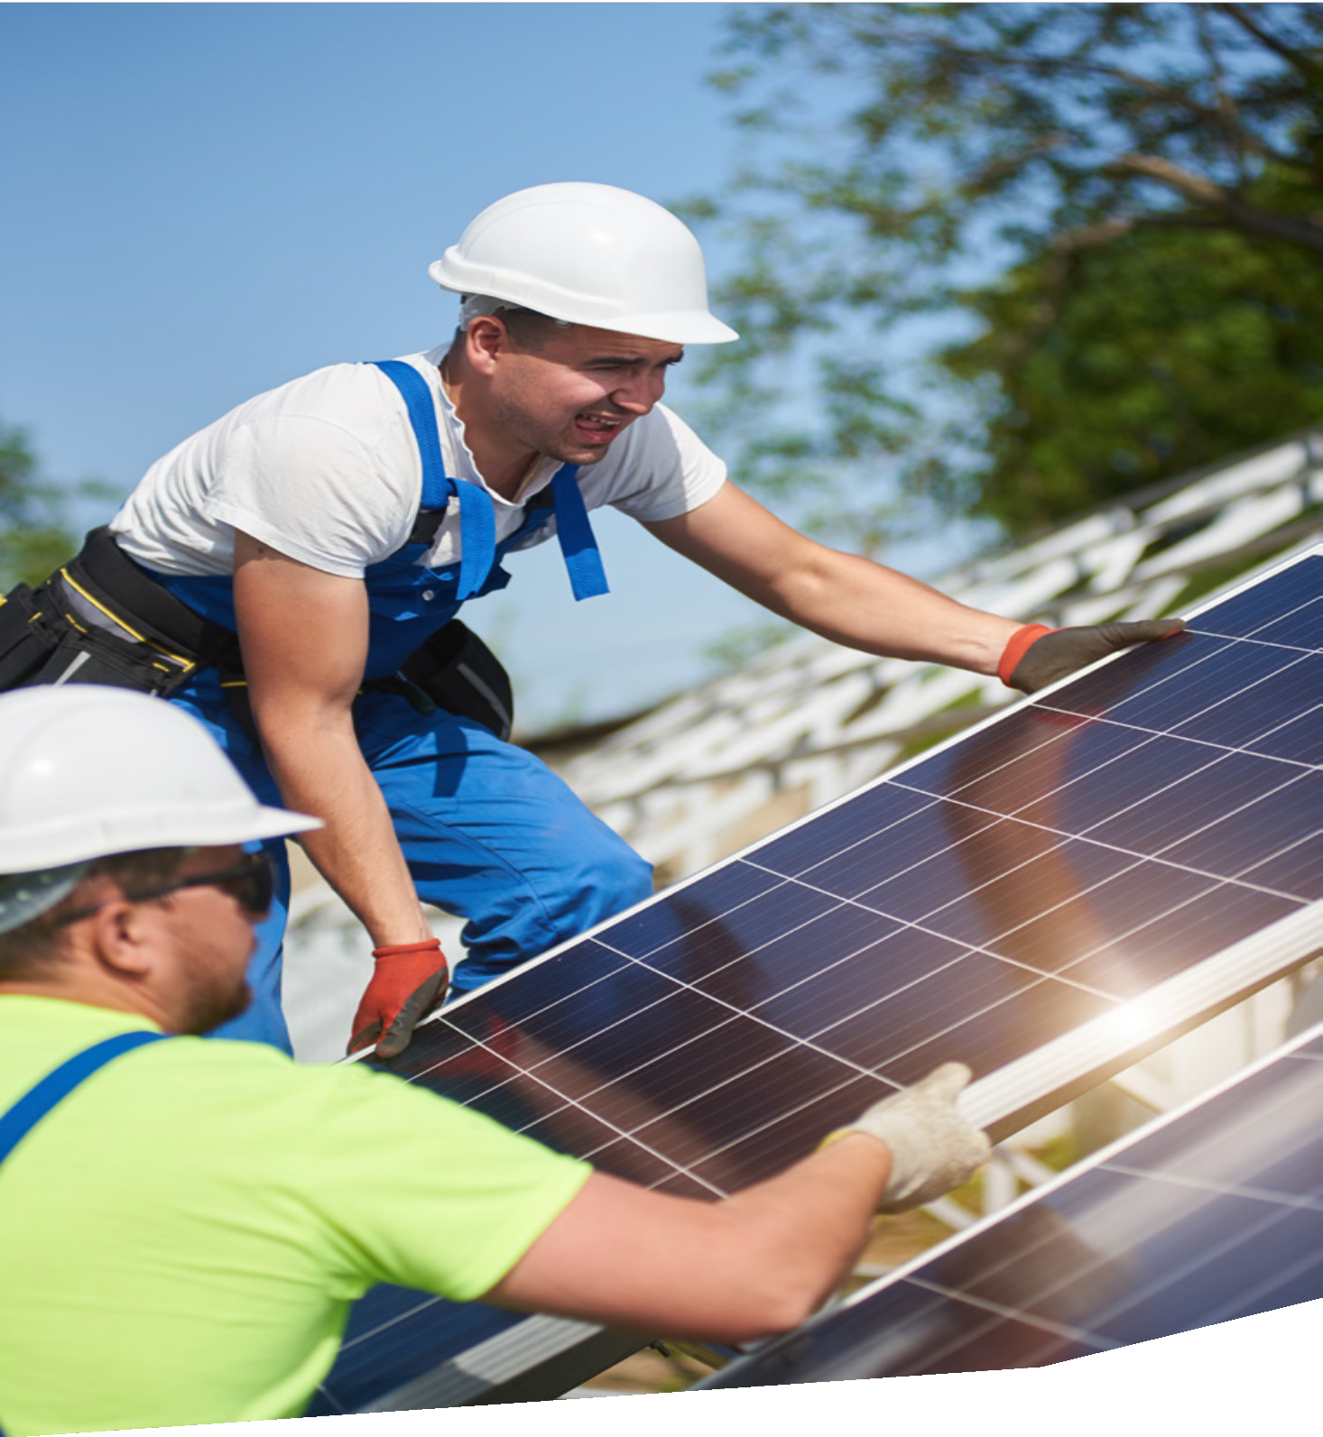

FEELING THE HEAT 45

References

- Climate Council, Heatwaves: Hotter, Longer, More Often, 2014.
- Department of Health,
The health impacts of the January 2014 heatwave in Victoria, State Government of Victoria, 2014.
- Department of Environment, Land, Water and Planning, Victoria’s Climate Science Report 2019, State Government of Victoria, 2019.
- Department of Health and Human Services, Tackling climate change and its impacts on health through municipal public health and wellbeing planning, State Government
of Victoria, 2020.
- Victorian Council of Social Service, Feeling the Heat interview series, 2021: vcoss.org.au/extremeheat
- Department of Health and Human Services, Heat health plan for Victoria: Protecting health and reducing harm from extreme heat, State Government of Victoria, November 2020.
- RN Jones, N Maharaj, B Rasmussen, PJ Sheehan and CK Young, Costs of climate change impacts on the social determinants of health and wellbeing, Victoria University for the Department of Health and Human Services, August 2018.

- T Longden, ‘Heat kills.
We need consistency in the way we measure these deaths’, The Conversation, 31 January 2020.
- K Bosomworth, S Moloney and H Gooder, The Hotspots Initiative: Place-based,
cross-sector collaborations responding to the health impacts of heatwaves, RMIT University, October 2020.
- J Lander, M Breth-Petersen,
R Moait, C Forbes, L Stephens and M Dickson, Extreme
heat driven by the climate emergency: impacts on the health and wellbeing of public housing tenants in Mildura, Victoria, The University of Sydney for Mallee Family Care, December 2019.
- L Nicholls, H McCann, Y Strengers and K Bosomworth, Heatwaves, Homes & Health: Why household vulnerability to extreme heat is an electricity policy issue, Centre for Urban Research, RMIT University, November 2017.
- Victorian Council of Social Service, Survey Report: Extreme Heat, May 2021.
- Z Hope, B Preiss and N Toscano, ‘Brace for a
scorcher: Victoria set for hottest December day on record’, The Age, 19 December 2019.

- Natural Capital Economics for the Department of Environment Land, Water and Planning, Heatwaves in Victoria:
A Vulnerability Assessment, April 2018.
- Red Cross Red Crescent Climate Centre, Heatwave guide for cities, July 2019.
- Council of Australian Governments Energy Council, Report for Achieving Low Energy Homes, December 2018.
- Victorian Council of Social Service, Battling On: Persistent Energy Hardship, November 2018.
- R Tanton, D Peel and
Y Vidyattama, Every suburb, Every town: Poverty in Victoria, Victorian Council of Social Service, November 2018.
- Victorian Council of Social Service, Consultation Report: Extreme Heat, February 2021.
- Sustainability Victoria, Energy Efficiency Upgrade Potential of Existing Victorian Houses, State Government of Victoria, December 2015.
- N Willand, T Moore, R Horne and S Robertson, ‘Retrofit Poverty: Socioeconomic Spatial Disparities in Retrofit Subsidies Uptake’, Buildings and Cities, 1(1): 14–35, 2020.

- L Instone, K Mee, J Palmer, M Williams and N Vaughan, Climate change adaptation and the rental sector, National Climate Change Adaptation Research Facility, 2013.
- L Daniel, T Moore, E Baker,
A Beer, N Willand, R Horne and C Hamilton, Warm, cool and energy-affordable housing policy solutions for low-income renters, Australian Housing
and Urban Research Institute, September 2020.
- Sustainability Victoria, Linking Climate Change and Health Impacts, State Government of Victoria, February 2020.
- M Alam, J Sanjayan and P Zou, Submission 9 to Inquiry into current and future impacts of climate change on housing, buildings and infrastructure, Swinburne University of Technology, August 2017.
- C Sun, J Hurley, M Amati, J Arundel, A Saunders,
B Boruff and P Caccetta,
Urban Vegetation, Urban Heat Islands and Heat Vulnerability Assessment in Melbourne, 2018, Clean Air and Urban Landscapes Hub, April 2019.
- The Nature Conservancy and Resilient Melbourne, Living Melbourne: Our metropolitan urban forest, 2019.
- Greener Spaces Better Places, Where should all the trees go?, 2014.

- E King, ‘Editorial, On the Fringes: Tale of Two Cities’, Insight, (10): 3, Victorian Council of Social Service, July 2014.
- C Cornell, N Gurran and T Lea, Climate change,
housing and health: A scoping study on intersections between vulnerability, housing tenure and potential adaptation responses, NSW Adaptation Research Hub, 2019.
- G Currie, ‘Where the wheels come off: transport poverty and disadvantage’, On the Fringes: Tale of Two Cities, Insight, (10): 30–33, Victorian Council of Social Service, July 2014.
- Environmental Justice Australia, How to learn more about air pollution where you live: www.envirojustice.org.au/
our-work/community/air- pollution/hows-your-air
- Inner West Air Quality Community Reference Group, Air Pollution in Melbourne’s Inner West: Taking direct action to reduce our community’s exposure, March 2020.
- S Pfautsch, S Rouillard,
A Wujeska-Klause, A Bae,
L Vu, K Holmes, M Leishman, L Staas, A Manea, S Tabassum and A Ossola, School Microclimates, Western Sydney University and Macquarie University for the State Government of NSW, 2020.

- H Cook, ‘Nosebleeds, headaches, a hospital visit: The students with no aircon’, The Age, 28 February 2019: www.theage.com.au/national/ victoria/nosebleeds- headaches-a-hospital-visit-the- students-with-no-aircon- 20190228-p510v6.html
- J McInnes and J Ibrahim, ‘Preparation of residential aged care services for extreme hot weather in Victoria, Australia’, Australia Health Review,
(37): 442–448, 2013.
- J Goodman, Heat Stress and On-Demand Work: The Experience of Food Delivery
and Courier Cyclists, University of Technology Sydney, July 2019.
- Department of Fairness, Families and Housing, Medical cooling concession, State Government of Victoria; services.dffh.vic.gov.au/ medical-cooling-concession
- N Rubenstein, S Moloney,
H Gooder and K Dunn, Climate Justice on the Frontline: The role of community service organisations in adapting
to climate change, RMIT University, December 2020.

FEELING THE HEAT 47

REFERENCES

- Department of Environment, Land Water and Planning, Victoria’s Household Energy Savings Package, State Government of Victoria: www.victorianenergysaver.vic. gov.au/victorias-household- energy-savings-package
- Solar Victoria, Home Heating and Cooling Upgrades Program, State Government of Victoria: www.solar.vic.gov.au/ heaters
- J Rutovitz, L McIntosh, N Ison, E Noble, J Hicks and F Mey, Social Access Solar Gardens for Australia, University of Technology Sydney, November 2018.
- Solar Victoria, Solar panel (PV) rebate, State Government of Victoria: www.solar.vic.gov.au/ solar-panel-rebate
- Public Accounts and Estimates Committee, Report on the 2020-21 Budget Estimates, Parliament of Victoria, April 2021.
- Indigo Shire Council,
Prepare for an emergency: www.indigoshire.vic.gov.au/ Residents/Emergencies/ Prepare-for-an-emergency
- Indigo Shire Council, Indigo Shire Heatwave Plan, September 2019.

- Emerald Community House, Centre of Resilience: www.emeraldcommunityhouse. org.au/centre-of-resilience-cor
- Greening the West,
About Greening the West: greeningthewest.org.au/about
- Greening the West, One Million Trees for a greener west!: greeningthewest.org.au/ projects/one-million-trees-for- a-greener-west
- Shadeways, Overview,
RMIT University: https://www. shadeways.net/about
- The Regional Association of Neighbourhood and Community Houses, The Neighbourhood House
Community Transport Project, 2018.
- T Longden, S Quilty,
P Haywood, A Hunter and R Gruen, ‘Heat-related mortality: an urgent need to recognise and record’,
The Lancet Planetary Health, (4): 141, May 2020.

Victorian Council of Social Service
Level 8, 128 Exhibition Street,
Melbourne, Victoria, 3000
e vcoss@vcoss.org.au
t 03 9235 1000
www.vcoss.org.au

