JUNE 2021
VCOSS submission to ESC Getting to Fair draft consumer vulnerability strategy

VCOSS welcomes the opportunity to provide feedback on the Essential Services Commission’s (ESC’s) draft strategy for breaking down barriers and improving consumer access to the essential services the ESC regulates.
VCOSS acknowledges the ESC’s considered and constructive approach to the development of this strategy.
This work has adopted a nuanced understanding of the nature and causes of contemporary consumer vulnerability in electricity, gas, water, and other regulated sectors, and subsequently identified a range of promising projects and practices that the ESC, relevant service providers and other stakeholders can further progress.
It has also adopted a practical, learning-by-doing approach during the 2020 development phase. That approach has produced both new guidance on sensitive and appropriate engagement with consumers experiencing vulnerability, including in relation to family violence, and expanded the ESC’s toolkit through trialing contemporary community engagement
practices (a deliberative panel of representative consumers).
VCOSS also notes the valuable frontline research contained in the work done for the ESC by the Consumer Policy Research Centre, and the data tool developed for this strategy.
Finalising this strategy will be an important milestone in ongoing cross-sector efforts to ensure that all Victorians have equitable access to essential services. VCOSS endorses the ESC’s commitment to ensuring the strategy has a practical positive impact on the ongoing operations of both the ESC and its regulated sectors.
Having actively engaged with the ESC throughout the strategy’s development, including as a member of the community sector Stakeholder Reference Group and in multiple issue-specific workshops, this written submission focuses on a small number of key points on setting the tone for the strategy’s rolling implementation.

Building on statutory authority and firm foundations
The ESC has an explicit statutory requirement to consider questions of consumer vulnerability and low-income in its decision-making.
These issues are well within the ESC’s operational mandate, and the aim of seeing retailers supporting (rather than labelling) consumers has been part of the regulator’s approach for some time. Other recent milestones include the 2016 energy hardship inquiry and the subsequent 2017 payment difficulty framework final decision.

Reconsider the definition of vulnerability
In putting this perspective and approach into practice, both in its own operations and in its multi-dimensional work with regulated entities, the ESC has proposed a working definition of consumer vulnerability – being:
A person experiencing vulnerability is someone who experiences barriers to participating in the essential services we regulate or administer. As a result of those barriers that person experiences economic and social exclusion or harm.
VCOSS supports the intent and rationale underpinning this definition, in that it is primarily the real-world circumstances and socially constructed barriers that create barriers to essential services for households (not a presumed failing or personal characteristic of those consumers).
This definition is intended to highlight the role of regulators and business practices addressing barriers to access. It is also an important reminder that there are systemic factors and structural barriers to equitable access to essential services and ultimately wellbeing (such as adequate income support and minimum housing standards) that require ongoing policy attention but are beyond the ESC’s direct control.
Given the use and emphasis elsewhere in the draft strategy on equitable access, however, we question the focus in the definition on people “participating” in essential services. There are many reasons why some people may never “participate” as theoretical “active consumers”, including their health, complex living situation, or simply not wanting to.
The system should provide a safety net for people who do not engage with their retailers or providers or essential services. Amending the definition to “someone who experiences barriers to accessing or engaging with essential services” would be preferable.
As also noted in the draft framework, many people may not identify as vulnerable, and this language may act as a deterrent or barrier to people getting the help they need. We support the use (as suggested by the deliberative panel and MSEI) of more inclusive language in key communications, including around wellbeing, fairness, accessibility, rights, and entitlements.
Critically, this is not simply a matter of having a “hybrid approach” to navigating sometimes sensitive terminology; rather, it is an important recognition that the ultimate aim of regulatory authority is to promote public wellbeing.

Engage meaningfully with consumers
An overarching positive of the draft strategy is the repeated emphasis (as in initiatives 3.2 and 3.3) on facilitating and better engaging with the lived experience of vulnerability, i.e. real-world consumer voices, in ESC planning.
Meaningful engagement, where there is genuine openness to hearing and including different views and perspectives, leads to better decision making and program design, and more engaged communities.
The framework would be further strengthened by including a clear understanding of the principles of co-designing with people and communities in vulnerable circumstances. Co-design involves more than just consultation.
Co-design means coming alongside people who experience vulnerabilities, to work with them in creating interventions, services and programs that work in the context of their lives and reflect their values and goals.
Too often VCOSS members and stakeholders report that engagement processes by government agencies or regulators are poorly designed and do not place the experiences and perspectives of communities at the centre.
We commonly hear examples where engagement processes:
- Do not clearly articulate the purpose of the engagement or identify where people can influence decisions
- Adopt a starting point that stakeholders disagree with or is misunderstood
- Ask the wrong questions or make incorrect assumptions about communities or needs
- Are overly formal, bureaucratic or confusing
- Fail to identify and therefore engage the right stakeholders and impacted communities.
The framework should not assume that marginalised groups, who often have histories of trauma or past negative experiences with systems and policies, will engage, even where decisions will directly impact on their lives. People might experience stigma around identifying (for example as having a mental illness or being part of the LGBTIQ+ community), fear of speaking up, and mistrust of government and support services.
The framework should emphasise the need for specific strategies to reach communities including Aboriginal and Torres Strait Islander people, refugee and asylum seekers, people with disability and LGBTIQ+ people. Younger people, older people, single parents, rural and regional Victorians, people who are homeless or living with a mental illness may also need targeted consultation strategies.
The draft framework could go further in providing practical information about engaging with all Victorians. Some people have chronic illnesses, allergies or anxieties that make attending and participating in events difficult. Accessibility is not limited to physical venue and materials. A significant number of Victorians have low levels of literacy. Many also do not have access to the internet at home. Online engagement mechanisms or notification of consultations may not effectively engage these groups.
The Victorian Government already provides guidance about accessible communications and documents. In VCOSS’ experience not all staff know about or are familiar with these guidelines.
Meaningful engagement also requires sufficient time. Time for people to become aware of the process, undertake their own research, consultation and thinking, and prepare their responses accordingly.
A minimum of 6-8 weeks should be provided for the preparation of written submissions. Similar notice should be provided for in-person consultations.
An obvious area for implementing this approach is in relation to initiatives 1.1 and 2.2, particularly for the ESC to work directly with First Nations and culturally and linguistically diverse consumers.

Feedback on individual sector initiatives
VCOSS notes that the ESC has run a series of workshops on its proposed
sector-specific initatives, and has indicated that these projects would be subject to further detailed consultation and/or collaboration on planning in due course.
Taken collectively, the proposed initiatives amount to a comprehensive and coherent workplan. VCOSS particularly welcomes further development of projects such as 3.4, 7.3, and 7.5, which emphasise the potential for sharing data and working across sectors to address systemic issues and identify complementary (and preventative) community engagement efforts.
VCOSS also supports the categorisation of initiative 2.5, the review of the effectiveness of the payment difficulty framework, as a critical project. To help ensure the review of this important regulatory mechanism is well-designed, there would be merit in the ESC consulting with stakeholders on its the scope, aims and approach.
Key areas of focus could be exploring how the cultural change anticipated from this framework has been implemented within retailers; how they could better align internal incentives and drive more consistent implementation through better training; and how it might achieve even better early identification and intervention outcomes.

From engagement and lessons to expectations and outcomes
As noted, it is a strength of the draft strategy that so much emphasis has been put on engaging with the diverse voices of consumers experiencing vulnerability. VCOSS also supports the ESC recognising the full range of potential activities that are in-scope for a contemporary essential services regulator in driving better outcomes in its regulated sectors.
Alongside robust compliance auditing and rigorous enforcement, that full range of activity includes creative cross-sector collaborative leadership to share engagement insights, inspire better business practices, and facilitate complementary industry and community education, as is envisaged by initiatives such as 3.4, 4.2 and 4.3.
VCOSS also expects, however, that proven better business practices (identified, for example, through initiative 4.2) should be embedded in higher shared expectations for all regulated entities, whether through relevant rule-making or other forms of locked-in continuous improvement.
This is not ultimately a question of either/or in terms of innovation or regulation,
but – over time – both/and.
In preparing this submission, VCOSS held a member consultation to seek views from Victorian community sector advocates and social service organisations.
Without a doubt, the overarching message from that event was that – while the current formal regulatory requirements are generally sound – there is a real frustration with retailers behaving inconsistently. As a result, people don’t trust them to follow the rules and worry that they aren’t accessing available help because they don’t know the “magic words” to be put through to the right support team.
Finally, cultural change and practical outcomes – in both the ESC and its regulated sectors – will need to be tracked with robust progress and impact measures.
Many of the current “measures of success” for the sector-specific initiatives are quite process and milestone oriented. Given the strategy will be an ongoing priority and includes planning for monitoring, evaluation, and review, further consideration of relevant operational and consumer wellbeing outcomes would be welcome.
---
To discuss this submission, please contact Jarrod Lenne, Energy Policy Advisor on jarrod.lenne@vcoss.org.au
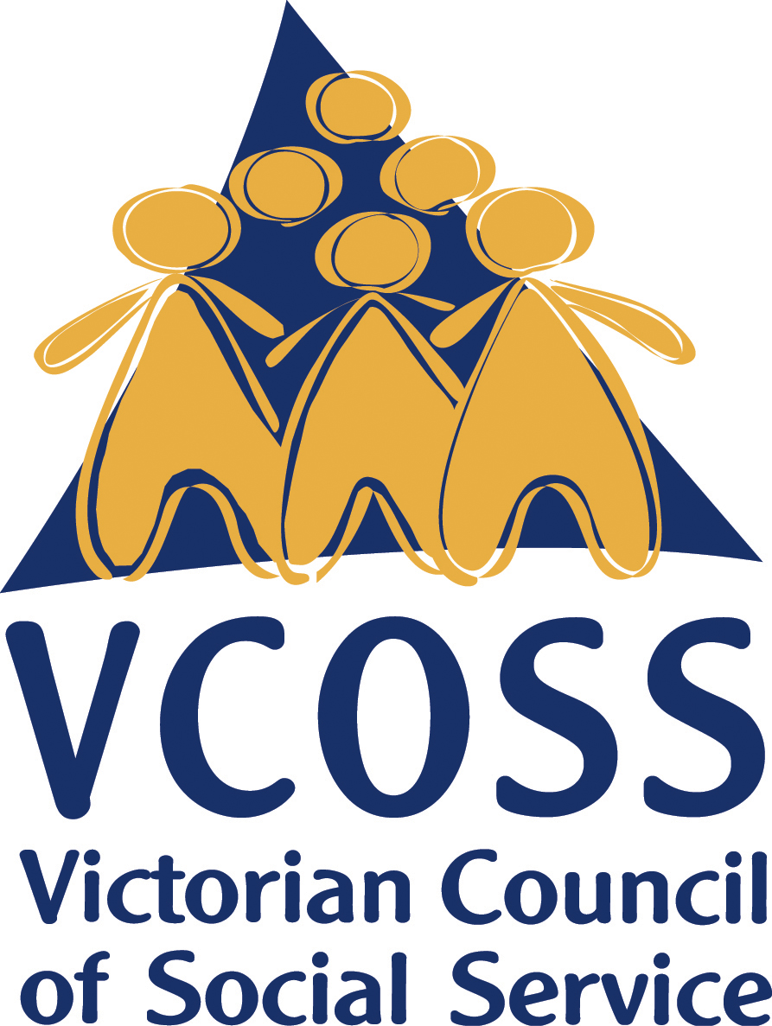

/vcoss
@vcoss
ChannelVCOSS
vcoss.org.au

