JUNE 2021
VCOSS submission on the
ESC’s Victorian Default Offer
2022 approach consultation paper

The VDO is an essential energy fairness measure
VCOSS welcomes the opportunity to provide feedback on the Essential Services Commission’s (ESC’s) proposed approach to determining the Victorian Default Offer (VDO) tariffs to apply from 1 January 2022.
The VDO is a simple, fair and independently-set retail electricity price for all residential consumers, and is a critical measure for driving improved energy affordability in Victoria. It is a key safeguard for consumers who are on retailers’ standing offers or who are unable or unwilling to engage in detailed comparisons of current market offers.
As of 1 September 2020, it is also the maximum price embedded network operators may charge residential and small business customers.
The VDO also serves as a credible reference point for those residential consumers who are able to shop around.
VCOSS strongly supported the development and introduction of the VDO, which saves nearly 130,000 households on standing offers between $310 and $450 per year.

Staying true to reform goals
VCOSS supports the ESC’s overall proposition that it largely use the same approach (updated for the most recent data available, such as falling wholesale electricity prices) in setting 2022 VDO tariffs as it has adopted in past years.
At the same time, however, VCOSS encourages the ESC to be vigilant in maintaining the intent and discipline inherent in the VDO’s methodology.
VCOSS shares the concerns of other community sector organisations that the current approach risks a gradual growth of the cost stack. In particular, the temporary bad debt allowance – if continued – could result in increased costs for VDO customers, alongside a dulling of incentives for retailers.
VCOSS maintains the view that any assertion of pandemic-related additional costs should be robustly justified, and unless a clear case is made the ESC should not extend the temporary bad debt allowance.
The onus for making this case lies firmly with retailers, given that they hold most of the relevant customer information.
At the same time, VCOSS encourages the ESC to continue monitoring the retail margin incorporated in the cost stack.
As the consultation paper recognises, the proposed 5.7 per cent is at the
top-end of comparable regulated retail margins.
As the VDO matures, it is also important the ESC commit to a timeline for incorporating an overarching downward pressure on the cost stack. While noting the ESC’s current embedded operating cost adjustments, an explicit productivity factor would have the benefit of reflecting savings across the VDO as a whole.

Caution required on a new VDO variant
VCOSS is not convinced of the merits in introducing a third type of VDO arrangement to reflect changes in network tariffs. We are concerned it could detract from the core objective of the VDO in providing households who are unable or unwilling to engage with complex retail offers a simple flat tariff option.
In addition, a straight passing through of time-of-use network tariffs to households who can’t adjust their consumption patterns may have unexpected or inequitable outcomes for some households.
Network charges are incorporated into electricity bills to cover residential consumers’ contribution to the operation and maintenance of the “poles and wires” of the electricity grid.
Given that these charges comprise between 35 and 43 per cent of the cost-stack, it is clearly important that they are as accurately reflected in the VDO as possible.
But, as noted above, a fundamental purpose of VDO is to require retailers to provide a no (or low) engagement option, and it is neither as obvious nor as necessarily desirable as the consultation paper presumes that network and retail tariffs should be consistent.
VCOSS encourages the ESC to explore this proposal further from a consumer perspective, particularly to identify any perverse outcomes from more detailed modelling.

Prioritise consumer outcomes when
weighing-up timing options
As noted in the consultation paper, the ESC is also seeking feedback on the length of the next VDO regulatory period.
While these price determinations are currently set on a calendar year basis, the Victorian Government has passed legislation to align the VDO with the regulated prices of electricity distribution network charges (which, from this five-year cycle in Victoria, will run on a financial year basis).
These options include setting either a
6-month or 18-month timeframe for the 2022 VDO tariffs (and updating them in mid-2022 for any major cost stack fluctuations).
As was the case last year, VCOSS does not have a strong view on the most appropriate timeframe.
A shorter period would mean resolving these timing issues sooner while also providing an additional six months for weighing up issues like the bad debts allowance and that rationale for an overarching productivity factor.
A longer period would provide greater price certainty to low-income households who may struggle to meet energy costs. But strategies for supporting households in the events of a large price change at the end of the longer period would need to be considered.
In weighing up options and associated demands on stakeholders, the ESC should have as its paramount consideration ensuring that final VDO tariffs are as fair as possible for low-income households.
---
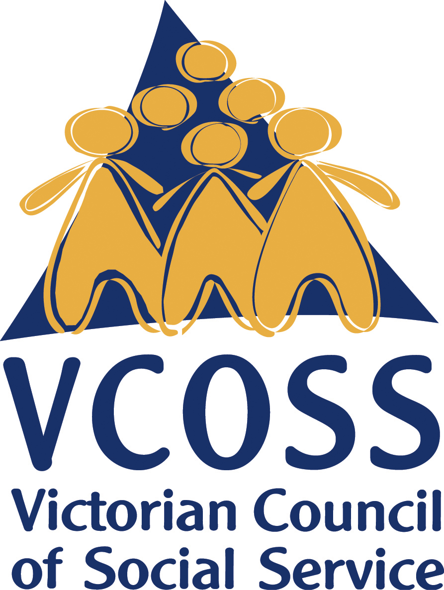
To discuss this submission further, please contact Jarrod Lenne, Energy Policy Advisor on jarrod.lenne@vcoss.org.au

/vcoss
@vcoss
ChannelVCOSS
vcoss.org.au

Essential Services Commission, Victorian Energy Market Report 2018-19 (November 2019), p. 48-49.

