OCTOBER 2021
ESC’s draft decision on Victorian Default Offer price for 2022

VCOSS appreciates the opportunity to provide feedback to the Essential Services Commission (ESC) on its draft decision for the Victorian Default Offer (VDO) tariffs intended to apply from 1 January 2022.
The VDO is a key safeguard for consumers who are on retailers’ standing offers and those who are unable or unwilling to engage in detailed comparisons of current market offers. It also provides a credible reference point for those households who are able to “shop around”.
As an important equity measure in the retail market, VCOSS welcomes the headline anticipated saving of five percent on
VDO-compliant average bills in the first half of 2022.
VCOSS also notes that, with the temporary bad debt allowance removed, the final calculations of this household saving may be even greater.

Staying true to reform goals
VCOSS supports the ESC’s decision to manage the re-alignment of the VDO with the regulated prices of electricity distribution network charges by applying a six-month period for this VDO regulatory period.
Given this shorter period, VCOSS also supports the ESC applying the same underlying methodology in setting 2022 VDO tariffs as it has adopted in past years.
In this vein, VCOSS would encourage a consistent approach to using 12-month forecasts and averages on the wholesale cost and Victorian Energy Upgrade components, consistent with the ESC’s observation in the draft decision that retailers are better placed than consumers to manage short-term price risks.
---
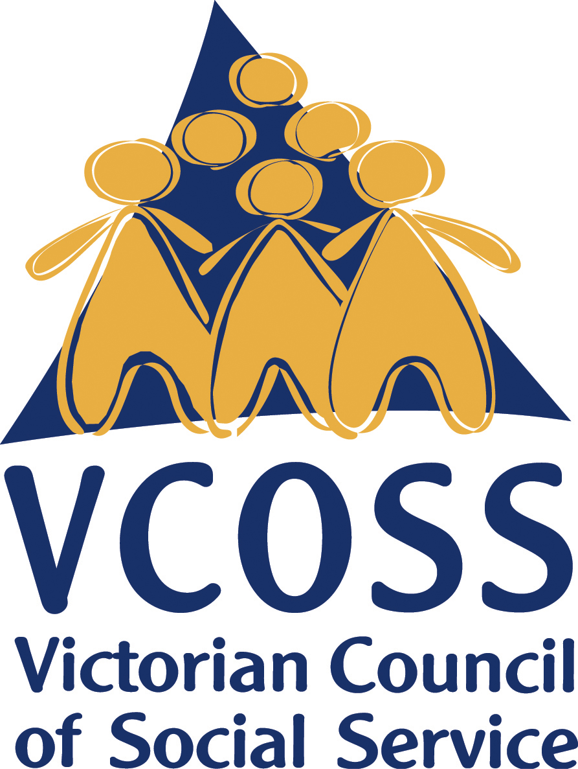
To discuss this submission further, please contact Jarrod Lenne, Energy Policy Advisor on jarrod.lenne@vcoss.org.au

/vcoss
@vcoss
ChannelVCOSS
vcoss.org.au

