APRIL 2022
Feedback on adding home energy rating assessments to the Victorian Energy Upgrades program

Executive summary
VCOSS advocates for all homes to be energy efficient and healthy so Victorians can be thermally comfortable and save money on energy bills. The Victorian Energy Upgrades (VEU) program is working towards this in tandem with rental minimum standards, social housing retrofits, the Home Heating and Cooling Upgrades program, and more.
VCOSS supports adding home energy rating assessments to the VEU program. The activity provides households with tailored advice about improving thermal comfort and the subsidy will increase uptake.
Our concern is that the assessments will still be unaffordable for low-income households and the upfront cost will disincentivise renters. This is problematic because Victorians experiencing disadvantage are more likely to live in homes with poor energy efficiency and have the most to gain from the new activity.
Recommendations
Make assessments free for low-income households and renters.
Add a sub-target to the VEU program for low-income households and renters.
Factor in the age of the property when calculating energy savings from assessments.
Collect data from the assessments and publicly report it each year.
1. Do you think residential home energy rating assessments should become a VEU program activity? Please explain your answer.
VCOSS supports residential home energy rating assessments becoming a VEU program activity because the assessments currently cost between $250 and $500. This is out of reach for low-income households and is a disincentive for renters, but a subsidy will improve their access.
We also support increased uptake of assessments because they:
- give households tailored and practical advice about improving the thermal comfort;
- can boost awareness of other discounts available through the VEU program; and
- can lay the groundwork for introducing a mandatory disclosure scheme down the track.

3. What issues and opportunities do you foresee with providing up-front incentives for a home energy rating assessment?
Although a $180 to $240 discount is positive, households will still be left with an upfront cost of up to $320. This is unaffordable for low-income households, while renters have little incentive to invest in a property they do not own.
This is unfair because low-income households and renters are more likely to live in homes with poor energy efficiency. For example, Energy Consumers Australia surveyed Victorian customers in October 2021 and found that homeowners and financially comfortable households are more likely to have ceiling insulation, wall insulation, and double-glazed windows:

 |  | Financially comfortable | Financially pressured |  | Homeowners | Renters
Ceiling insulation |  | 74% | 42% |  | 73% | 36%
Wall insulation |  | 58% | 30% |  | 53% | 29%
Double-glazed windows |  | 20% | 8% |  | 19% | 6%
Table 1: The proportion of financially comfortable households, financially pressured households, homeowners, and renters in Victoria who have ceiling insulation, wall insulation and double-glazed windows.

Home rating energy assessments should be free for low-income households and renters because they have the most to gain from energy efficiency upgrades. The subsidy could be expanded by introducing a sub-target for low-income households and renters, similar to the priority group established in South Australia’s Retailer Energy Productivity Scheme (REPS).
The priority group in the REPs includes:
- concession card holders;
- renters with rent of $400 or less per week; and
- people participating in an energy retailer hardship program.

5. Do you support the proposed approach to calculating the energy savings resulting from the provision of a home energy rating assessment? Please explain your answer, you are encouraged to provide further data to support this.
The calculation assumes a nine per cent energy saving for all households but does not consider the age or energy efficiency of the home. This is problematic because the 2010 update of the National Construction Code raised the minimum NatHERS rating to 6 Stars and these new homes have much less potential for improvement than homes built before minimum standards were introduced.
For example, CSIRO’s energy rating dashboards show that the average of new homes in Victoria is 6.3 Stars compared to 2.1 Stars for existing homes. Meanwhile researchers from the University of South Australia surveyed 3,756 renters in Victoria and found that:
- 46.2 per cent of renters living in a home built before 1950 had difficulties keeping the house cool or warm, compared to;
- 43.8 per cent of renters in a home built from 1950 to 2000; and
- 26.7 per cent of renters in a home built after 2000.
The approach should estimate higher energy savings for older homes, which would generate more Victorian energy efficiency certificates. This would increase the subsidy for households living in homes with poor thermal comfort and help address the equity issues outlined above.

9. Are there any issues or opportunities to improve the implementation and administration of the proposed activity?
There is an opportunity for assessors to inform residents of the Victorian Energy Compare website. This would help households move to a better deal and save money on their energy bill.
The assessor could also provide cost-effective items like draught snakes, valve cozies, and self-seal covers for ceiling exhaust fans. These minor upgrades are affordable for low-income households and are easy for renters to remove at the end of their tenancy.

Case study: Cosy Homes
The Cosy Homes project is providing energy efficiency assessments and retrofits for 30 low-income households in the South Gippsland and Bass Coast areas.
Common issues observed by assessors included gaps below doors, cracks between walls and the floor, uncovered hot water valves, and leaky ceiling exhaust fans.
These problems were easily remedied by cost-effective solutions such as draught snakes, valve cozies, and self-seal covers for ceiling exhaust fans.
Assessors also notified residents of the Victorian Energy Compare website and provided advice about available discounts.
The program identified barriers to uptake including people who did not see the use in assessing their home if they could not afford further upgrades, and renters who were nervous about approaching their landlord to ask for permission to make changes to the property.
The project received funding via DELWP Gippsland’s Regional Adaptation Strategy.

There is also an opportunity for assessors to understand the minimum standards for rental properties under the Residential Tenancies Act 1997 and to be able to identify and communicate breaches to the renter and the landlord. The standards are currently limited to heaters but will soon be expanded to draught proofing, ceiling insulation, and hot water systems.
The administration of the activity could be improved by thorough data collection. This includes the Star rating of the property, the age of the property, the socioeconomic status of the residents, and whether the residents are renters or homeowners. The data could then be publicly reported each year to measure the progress of upgrading Victoria’s housing stock and to ensure the activity is reaching renters and low-income households.

This submission was prepared by Policy Advisor Ben Latham and approved by CEO Emma King.
For further enquires, please contact ben.latham@vcoss.org.au
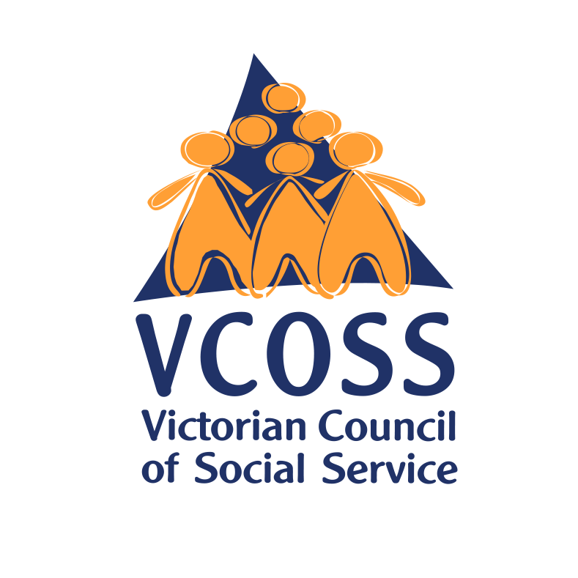

/vcoss
@vcoss
ChannelVCOSS
vcoss.org.au

VCOSS is the peak body for Victoria’s social and community sector, and the state’s premier social advocacy body. We work towards a Victoria free from poverty and disadvantage, where all people and communities experience genuine wellbeing.

Department of Environment, Land, Water and Planning, Victorian Energy Upgrades: Home Energy Rating Assessment Issues Paper and Draft Regulations and Specifications, March 2022.
ibid.
Energy Consumers Australia, Behaviour Survey, October 2021: ecss.energyconsumersaustralia.com.au/behaviour-survey-oct-2021
Essential Services Commission of South Australia, REPS FAQs, accessed 22 April 2022: www.escosa.sa.gov.au/industry/reps/faqs/reps-faqs
CSIRO, Energy Rating Dashboard – States and Territories, accessed 11 April 2022: ahd.csiro.au/dashboards/energy-rating/states
E Baker, A Beer, M Baddeley, K London, R Bentley, W Stone, S Rowley, L Daniel, A Nygaard, K Hulse and T Lockwood, The Australian Rental Housing Conditions Dataset, accessed 4 March 2022: dataverse.ada.edu.au/dataset.xhtml?persistentId=doi:10.26193/IBL7PZ

