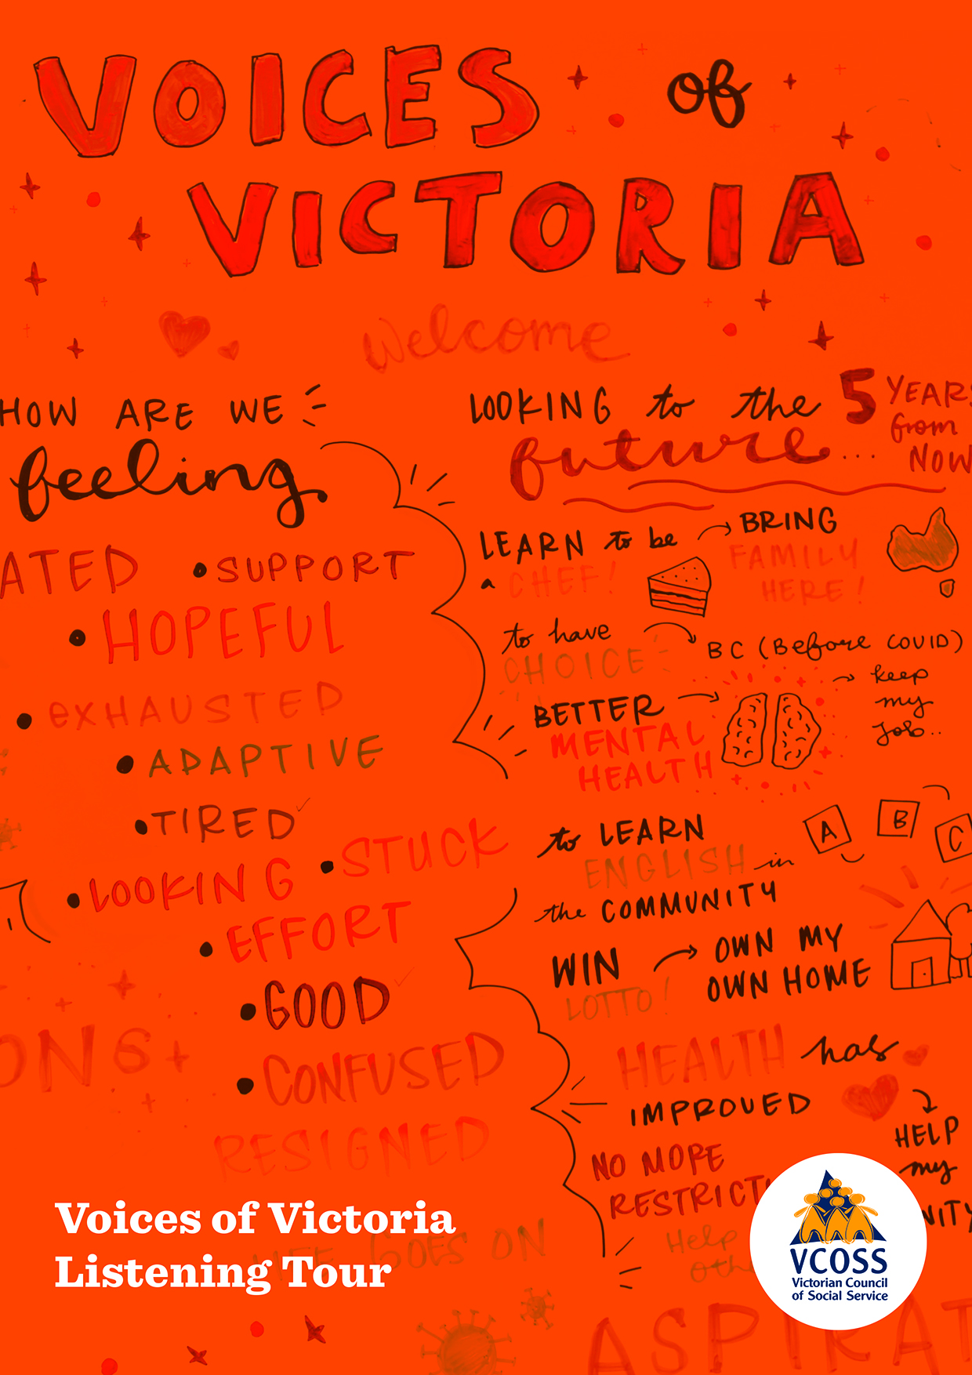
Acknowledgements
Many people and organisations contributed to the design, implementation and report on the Listening Tour. Most importantly, VCOSS thanks the community members who participated in the Listening Tour for their generosity in sharing their voices and stories.
The Voices of Victoria Listening Tour was conducted in partnership with Neighbourhood Houses Victoria. VCOSS would like to thank Cameron MacRae and Victoria Larsson, as well as all of the Neighbourhood House managers, project coordinators and volunteers who recruited, organised and participated in the listening sessions.
VCOSS acknowledges the contribution of the following community organisations in providing input to the Listening Tour:
• Sunraysia Mallee Ethnic Communities Council
• Mallee Family Care
• Commissioner for Senior Victorians
• La Trobe Health Advocate
The VCOSS Voices of Victoria Listening Tour was part funded by the Victorian Department of Premier and Cabinet.
For enquiries please contact vcoss@vcoss.org.au

About VCOSS
The Victorian Council of Social Service is the peak body for the social and community sector in Victoria.
VCOSS members reflect the diversity of the sector and include large charities, peak organisations, small community services, advocacy groups and individuals interested in social policy.
In addition to supporting the sector, VCOSS represents the interests of Victorians experiencing poverty and disadvantage, and advocates for the development of a sustainable, fair and equitable society.
VCOSS acknowledges the Traditional Owners of Country and pays respects to Elders past and present, and to emerging leaders. We conduct our business on sovereign, unceded Aboriginal land. This document was prepared on the lands of the Kulin Nation.
Contributors
Stacey Ong, One Red Step
Joanne Shan, One Red Step
Ph: 0411 618 008
www.oneredstep.com.au

Content warning
This report contains information about mental health challenges, homelessness, suicide and family violence that may be distressing. We have changed the names of people in the case studies to provide protection for their privacy and identity.
If you need to talk to someone, support is available.
Mental health support
Lifeline: Call 13 11 14 anytime for confidential telephone crisis support.
Beyondblue: Call 1300 22 4636 for confidential 24/7 support on depression, anxiety and related disorders.
Kids HelpLine: Call 1800 55 1800 for telephone counselling service for people aged between 5 and 25 available 24-hour service
headspace: Call 1800 650 890 for counselling for young people aged 12–25
Parentline: Call 13 22 89 for parents and carers with children from birth to 18 years
Family violence support
Safe Steps: Call 1800 015 188 for family violence support available 24 hours/7 days

Contents
Executive summary 4
How are communities feeling, two years into the pandemic?... 5
Challenges 8
1. COVID-related challenges 9
2. Worsening inequity 13
Benefits of the pandemic 17
Community hopes for the future 20
Who did we engage with? 22
Young people 23
Multicultural communities 25
Regional and border communities 26
People with a disability 28
Family violence survivors 30
First Nations communities 31
Where to from here? 33
Recommendations 34
Methodology 40
Consultation 45
Appendix 46

Executive Summary
The VCOSS Listening Tour had a simple mission: to engage people in a setting where they felt comfortable and empowered to talk about issues that affect them, and then to listen.
We were conscious not to be prescriptive; not to steer people to the issues we thought they should care about. We wanted to learn about people’s lived experiences and aspirations on their own terms.
What has emerged from this genuine community-led approach is a textured understanding of Victorians’ fears and hopes as they emerge from the worst of the COVID pandemic. The process has also provided valuable insights into the kinds of assistance people most want and need, to help them lead a good life now and into the future.
This report details the feedback we received from 12 diverse communities across the state. We have analysed the contributions of the more than 200 people consulted face-to-face and online and grouped their views thematically according to geographic location, cohort and age. (See page 24)
VCOSS also tested these views against a larger representative group of Victorians, with public phone polling through Essential Media gauging the experiences of a further 550 people. Combining small face-to-face consultations with broad public polling has ensured both depth and breadth. (See appendix)
Across this broad sweep of the Victorian community many cross-cutting themes emerged.
The pandemic hit Victorians hard, especially people from already vulnerable and marginalised communities, and their pain and anxiety continues today.
Participants expressed feelings of disconnection, loneliness and isolation.
People were frustrated with the difficulties and barriers in accessing government services.
Concerns about the ‘digital divide’, about access to decent food and about the rising costs of living also featured heavily.
These challenges were compounded, people told us, by an overwhelming sense of exhaustion after the hard years of 2020 and 2021. A phrase volunteered more than once was, “I’m over it”.
But this report doesn’t just enumerate challenges; it also proposes solutions.
We have combined the insights of community members with the expertise of VCOSS policy analysts to develop four recommendations for change. (See page 40)
Again, common themes have emerged: the need to quickly address immediate community needs, boost inclusion and provide the foundations for community and individual wellbeing.
We are immensely proud of the work behind this report, but we know we’ve only scratched the surface.
VCOSS hopes further engagement in communities can provide an even richer picture of Victorians’ struggles and aspirations, as we all work towards a better future.

How are communities feeling, two years into the pandemic?
After two unprecedented years living with the COVID pandemic, multiple lockdowns, vaccination concerns and finally opening of international borders, community members have complicated feelings about what they have been through.
Victorians are acutely aware that the danger posed by COVID-19 is not over; anxiety about contracting the virus and about broader COVID impacts continues to be felt across the community.
Communities spoke about heightened fear and anxiety, and about their stress being exacerbated by media reporting and government messaging in the first year of the COVID crisis.
Heading into the third year of the global pandemic, some of our communities remain anxious and fearful about opening up. Immuno-compromised and elderly people are particularly concerned, but there is also general community anxiety regarding socialising in person.
Communities spoke about the ‘mental load’ of understanding changing public health advice, restrictions, identifying COVID symptoms, and weighing up the risk to their own health and safety and the health and safety of others when making decisions about where to go and who to see.
Essential Media polling confirmed that Victorians continue to feel isolated and anxious and to have ongoing health issues as a result of the pandemic. For 67 per cent of polled households, poor mental health or loneliness and isolation was their biggest concern.

Figure 1: Community responses about how they are feeling right now
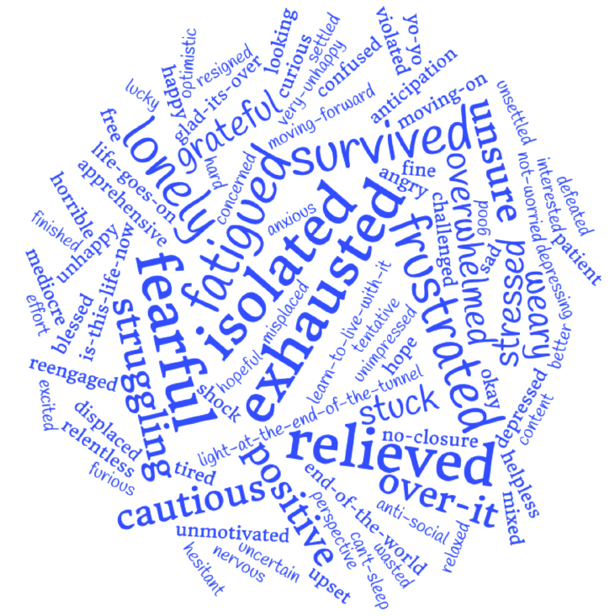
Drained, exhausted and over it
Communities are drained, exhausted and ‘over’ the pandemic.
At the time of consultation, there were also broader stressor contexts in Australia and globally, including catastrophic floods in NSW and Queensland and escalating armed conflict in Ukraine.
The cumulative impacts of consecutive crises have led to a general feeling of overwhelm and apathy, reducing people’s resilience and ability to support one another towards recovery.
“We rebuilt after we lost everything in the bushfires, we dealt with COVID, we are resilient, but there’s only so many times you can bounce back.”
Community member, Whittlesea
“Dealing with the safety issues around the virus and certain situations can be very complex... It has been a real test for me.”
Lonely and isolated
We heard from many community members that the pandemic was characterised by loneliness and isolation, and that this experience persists even though restrictions have eased.
This lived experience of the pandemic was affirmed in the Essential Media poll, where ‘loneliness and isolation’ was identified as the third biggest challenge people faced: reported by 33 per cent of respondents, highest among 18-24-year-olds.
Many people also spoke about their concern for people in aged care and hospitals who at the time were still isolated by visiting restrictions.
“It was just me and my dog for the last two years.”
Community member, Morwell
“I’m 73, I live alone. When I got COVID I thought to myself, I could die here and no one would know.”
Community member, Bendigo
The Neighbourhood House, for many participants, was one of the few places where they felt welcomed, safe and supported.
“We’re finding more and more people coming to the Neighbourhood House just to have someone to talk to.” Springvale Neighbourhood House
67%
of Victorians polled identified poor mental health or loneliness and isolation as their biggest concern.
Anxious, worried and frustrated
Many community members expressed fears and reservations about opening up and connecting with people face-to-face. People are anxious about new variants of COVID and the long-term impacts of COVID, and also about the vaccine.
Management of the virus has not receded as a source of fear for the future: 36 per cent of respondents to the Essential Media poll continue to worry about catching COVID.

“I care for my two elderly parents, and after two years of being at home, they’re scared to go out... I have to drag them out of the door.”
Community member, Ballarat

“I have a chronic disease, my immune system is very low. I am really anxious even about going to the supermarket.”
Community member, Morwell

Community members spoke about the ‘mental load’ of having to stay up-to-date with restrictions, think about their own health and worry about unknowingly transmitting COVID to others. People felt that the role of infection control had suddenly become the burden of every individual, and that it was a heavy mental load to carry without a trustworthy and stable source of information.
“I’m angry that I may have passed COVID onto my mum. No one is to blame, but I’m still just angry and
I have nowhere for that anger to go.”
Community member, Bendigo

36%
of Victorians polled continue to worry about catching COVID.
Grief, trauma and depression
Many community members spoke about how difficult it was to grieve, having lost loved ones during and because of the pandemic. Many had been unable to attend funerals or be at their loved ones’ bedsides due to restrictions.
The impacts of trauma were evident in many communities. People reported that depression and mental health challenges had either been triggered by isolation or were existing conditions that worsened during the pandemic.
Many people also said they were just grateful for the opportunity to be heard, reflecting a sense of not having had an outlet, a ‘listener’ for their thoughts and feelings before.
Community cohesion and division
At many of the sessions, people remarked on the divisions that have opened up within families and communities due to differing views about the pandemic and vaccinations.
“I’m not sure that I’ll be able to forgive my family for not visiting my Aunt in hospital when she was dying as they were not vaccinated. The only person to visit was her Pastor.”
Community member, Bendigo

Some communities pulled together and some were pulled apart during the pandemic.
There were many heartening examples of local community efforts such as food relief, neighbours getting to know each other, and teenagers helping elderly neighbours learn technology.
Equally, we heard about widening fractures in the community, with some people expressing judgement of others for wearing masks or not wearing masks, adhering or not adhering to rules, getting vaccines or remaining unvaccinated.
Relieved, grateful and hopeful
While acknowledging the challenges of the last two years, many community members felt relieved, grateful and privileged to have lived through the pandemic. Many people felt that others were doing it much tougher and that, despite the challenges, they were grateful to have ‘made it through’.
Community members spoke about feeling hopeful for the future. Some, however, said their hope was tentative, accompanied by the worry that the ‘rug might be pulled out from under you’ at any moment.

Challenges
Figure 2: Community responses during the Listening Tour about the challenges the community are facing
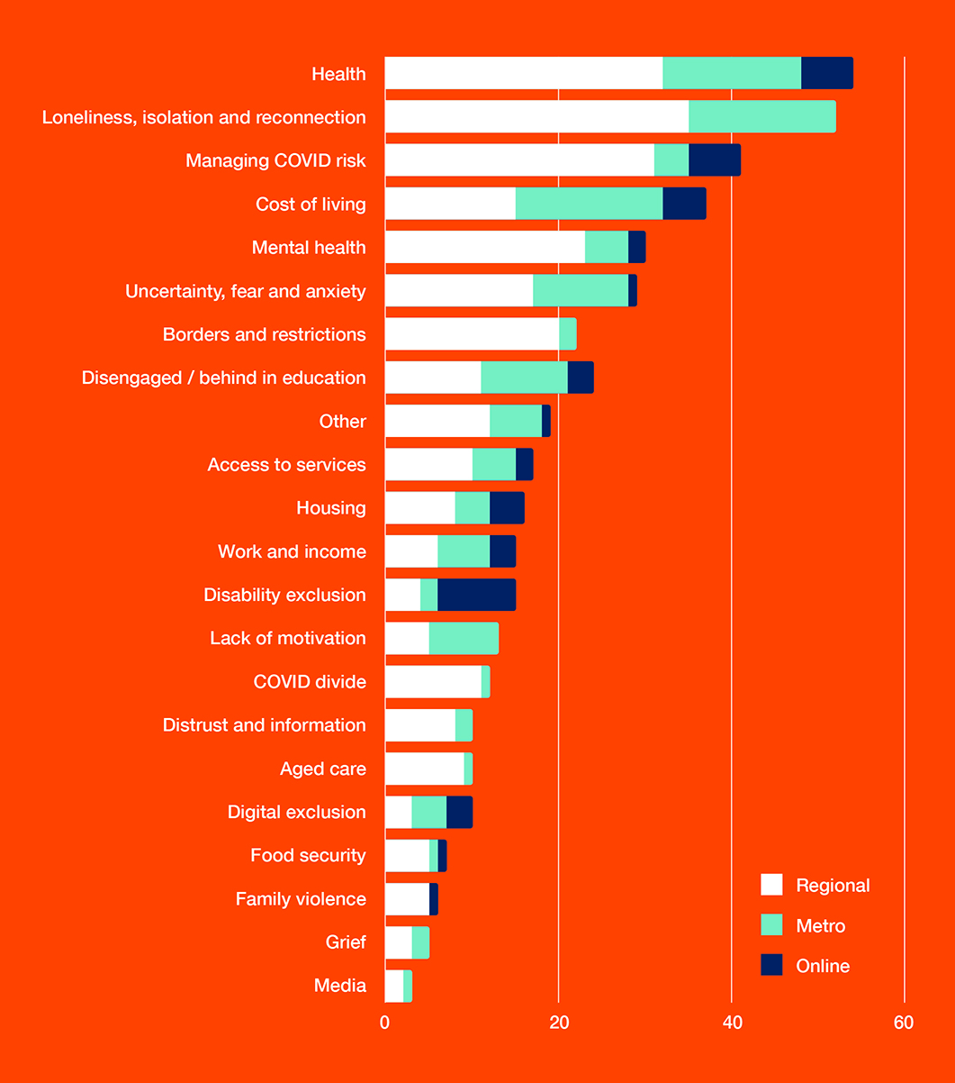

1. Covid-related challenges
The pandemic presented people with a range of new challenges. Communities had to contend with understanding and complying with government restrictions and managing COVID risks to their health, as well as their overall wellbeing, loneliness and isolation. These challenges are not discrete but intersecting and compounding.
The impacts of the pandemic continue to be felt in communities, with new COVID-related challenges including:
1.1 Health
As providers have focused on COVID and essential treatments, many in the community have been struggling with pre-existing conditions, pain or other impacts while they wait for treatment over the last two years.
1.2 Managing risks, managing mental health
After two years of government directives, the COVID response shifted the mental load onto individuals. Community members expressed general feelings of anxiety for the future. Many community members spoke of depression, anxiety and other mental health issues that were experienced during and exacerbated by the pandemic.
1.3 Education
Families are concerned that children and young people have disengaged from childcare, pre-school, school or further education, and/or are significantly behind after two years of interrupted learning.
1.4 Divided and distrusting communities
Differing views about what information to trust have divided communities, with polarising issues including mask-wearing and vaccinations. The pandemic generated and exacerbated fears about whether to trust authorities and
the information they provide.
1.5 Aged care
Community members are concerned for the health and wellbeing of those in aged care, with restrictions on
visiting and residents leading to extended periods in isolation.

1.1 Health
The impact of two years with limited access to preventative and non-emergency health services is being felt across communities.
In the Essential Media poll, 32 per cent of respondents continue to be most concerned about access to healthcare for their household.
The pandemic led to a range of worsening or new health issues for many people, such as loss of fitness, trouble sleeping, weight gain, and of course COVID itself, as well as the risk of long COVID.
People were concerned that there was a loss of early identification of health issues such as cancer and dementia, and a deterioration of pre-existing health conditions due to delayed treatment.
Almost all communities spoke about the long delays and wait times to see healthcare workers, with extra-long waitlists for some specialists.
These issues are exacerbated for those who already experience barriers to healthcare. In some regional communities healthcare clinics have closed and travel to a capital city is the only option for care.

“We were travelling for seven hours and then told we couldn’t go into the hospital.”
Community member, Shepparton
“I understand why elective healthcare has been pushed back, but what do we do now? I’ve been waiting for two years for a back operation and to have kidneys looked at but it keeps getting cancelled.”
Community member, St Albans
With changing restrictions on staying COVID safe, access to telehealth appointments was an extremely valuable alternative for some community members, while others experienced telehealth as an additional barrier.

“Accessing medical services is still a lengthy and difficult process. It’s hard to explain over telehealth what can be wrong.”
Community member, Warrnambool

Delayed access to health services as a result of contracting COVID or for non-emergency healthcare was a particular issue for younger Victorian. Results from the Essential Media poll indicate that 18-24-year-olds were four times more likely to have negative impacts from this kind of delay than older Victorians (12 per cent versus
3 per cent for people aged over 55).
“There are waitlists for dental, hearing, arthritis etc. But the elderly can’t wait that long.”
Community member, Springvale
1.2 Managing risks, managing mental health
As discussed above, many community members have struggled with the challenge of managing COVID-related and other health risks. There has been a heavy load of stress and anxiety associated with assessing and managing risks to people’s own health and the health of others. This ‘mental load’ is taking its toll.
In the Essential Media poll, 66 per cent of respondents reported ongoing negative impacts of the pandemic, including anxiety about catching COVID, feeling more isolated from friends and community, and having lost savings or earnings or employment.

“We’re pretending the pandemic is over when it’s still going. It feels like we don’t care about those in the community who are vulnerable, it’s like they can just die now.”
Community member, Banksia Gardens

“I can’t do hydrotherapy because I’m scared of catching COVID at the public pool, this has slowed my health recovery.”
Community member, Red Cliffs

For many community members, general anxiety about a future with COVID – for themselves, their children, their elderly parents – was compounded by anxiety about other personal and global issues such as economic stress, the war in Ukraine, and the ongoing threat of climate change.
For many in the community, all these stressors exacerbated pre-existing mental illness or caused new mental health challenges.
Mental health was an issue consistently raised at every listening session. People spoke about anxiety, depression, having trouble sleeping and being unmotivated to leave the house. They also spoke about the difficulties of accessing mental health support.
“There were four suicides last year in our local community of people aged under 17.”
Community member, Online forum
“I’m sick of government directions, I’m confused by them. I don’t know what we’re supposed to do now.” Community member, Morwell
66%
of Victorians polled reported ongoing negative impacts of the pandemic.
1.3 Education
Community members discussed how some children and young people disengaged from education during the pandemic and are now significantly behind in their education. This can be even more challenging for people from culturally and linguistically diverse backgrounds for whom English is not their first language, or for young people who had pre-existing challenges with engaging in the mainstream education system.
Education is a major concern for Victorian families since the COVID lockdowns, with one in four parents reporting in the Essential Media poll that they are most concerned about their child being behind in education or disengaged from their education.
Some parents with very young children saw regression in their children’s development due to lack of socialisation and missed opportunities to engage in activities like playgroup and childcare.
COVID had a severe impact on schools and childcare, and some families felt unsupported to handle the difficulties of isolating with dependent children.
“Home schooling was really difficult for us as we don’t have good English. We can’t support children with English online. We need face-to-face learning. Now kids are two years behind.”
Community member, Warrnambool

1 in 4
parents polled report they are most concerned about their child being behind in or disengaged from education.
1.4 Divided and distrusting communities
Some community members expressed concern about trusting COVID information provided by the media and governments.
There was a sense of people being both confused by and hesitant about the reliability of health information, including vaccine efficacy, and a sense of ‘information overload’ and fatigue.
Some community members felt that the media was resorting to scare tactics instead of straightforwardly reporting on COVID. For these people it was difficult to know which messages or platforms to trust.
“There’s distrust for government and politicians as they lie to our faces.”
Community member, St Albans
“COVID is being hyped by the media and that’s why people are scared and unsure about what’s going to happen.” Community member, Bendigo
Diverging views about who to trust on issues related to the pandemic and vaccination efficacy have led to deep community divisions, and many people expressed distress about this.
Some people’s beliefs had the effect of limiting their engagement in their communities and participation in work, as well as their eligibility for essential services.
And some community members felt they received a lack of respect that undermined their dignity when accessing services, particularly COVID relief, even if they were eligible for support.
“We have lost empathy and understanding. We are treating each other poorly.”
Community member, Shepparton

“I don’t feel able to express my concerns for my health when it comes to having to get the vaccine. I can’t get the vaccine for health reasons but everyone assumes I’m anti-vax.“
Community member, Shepparton

As restrictions ease there is also general uncertainty and concern over ensuring COVID safety at events, over whether to trust event organisers to take responsibility for COVID safety, and whether to trust others in the community to comply with non-mandatory recommended restrictions.
“RATs were not enough, and then we only had RATs. We didn’t know if we could go to events because we didn’t know if we could trust the organisers to take the right safety precautions.“
Community member, Bendigo
1.5 Aged care
Many community members expressed intense concerns for people living in aged care. With extended periods of isolation impacting on the mental health and wellbeing of aged care residents, people are concerned about ongoing restrictions in these settings despite restrictions easing everywhere else.
“My father is in aged care. He has missed two years of his life because of the pandemic and has deteriorated a lot in that time.”
Community member, Red Cliffs

2 . Worsening inequity
Some of the challenges people experienced during the COVID pandemic are systemic issues that already existed but were heightened by the conditions of the last two years. These inequities are not singular, but are experienced by individuals, families and communities in ways that intersect and compound.
The pandemic exacerbated existing social inequities and issues including:
2.1 Loneliness, isolation, reconnection
Experiences of loneliness and isolation are widespread, despite easing of restrictions, with some in the community
feeling hesitant and having lost confidence in how to connect.
2.2 Cost of living
At every listening session, the cost of living such as increasing cost of food, petrol and rent was raised as a significant challenge.
2.3 Access to services
Barriers to access government and other services such as income support, housing support and childcare were raised as ongoing challenges, particularly with the move to online access.
2.4 Housing affordability and homelessness
Access to safe housing that is affordable was raised at every listening session. People who have not been in the service system before are entering into homelessness and poverty due to housing unaffordability and high cost of living.
2.5 Digital exclusion
Digital exclusion has worsened due to the pandemic as services have switched to predominantly online delivery, closing face-to-face access.
2.6 Food insecurity
Food security was already an issue prior to the pandemic, but made much worse as supply chains were disrupted, cost of food continues to increase and many have lost jobs and/or income.
2.7 Insecure work
Community members raised the challenge of insecure work that has increased due to COVID, adding to anxiety and insecurity about the future.

2.1 Loneliness, isolation and reconnection
Loneliness, isolation and the desire to reconnect were issues raised at every listening session.
Loneliness was the most frequently raised topic. Many people said they were missing friends or family overseas or interstate. Many also mentioned having missed important milestones including births and deaths.
More than half of young people responding to the Essential Media poll reported loneliness and isolation as challenging.
Community members spoke about the hardship of not being able to see family or friends in hospital or aged care due to COVID restrictions. And they made it clear that challenges continue around safety for immunocompromised relatives.
Community members also spoke about having lost confidence in connecting and socialising. For some, just the thought of getting on the road to see friends and family is daunting after two years of not driving.
People who run social clubs and programs told us of the challenges they face to hold community events. Some of these challenges are around complying with COVID restrictions, while some are about how to encourage people who may be hesitant to attend.
2.2 Cost of living
The last two years had a significant economic impact on households and communities, especially for low-income households contending with the increasing cost of living.
In the Essential Media poll, 22 per cent of responders reported continuing to be impacted by lost savings, earnings or employment as a result of the pandemic. One in three younger Victorians who responded said this was still having a negative effect on their lives. For older Victorians (55 and over), 80 per cent were most concerned about the cost of bills and the impact of bill stress on their household.
In Listening Tour sessions, most people said they were unable to either rely on their savings or to work from home during isolation and lockdowns, meaning they had to put their health at risk for the sake of income.
Many community members lost significant income or lost their jobs and had to rely on financial assistance. Many are still working extremely hard to regain financial security.
At times people in our communities who were financially vulnerable had to put their health at risk against government recommendations
“The reduction of income support made so many lives tougher, raise the rate!”
Community member, Warrnambool

With loss of income and employment sometimes exacerbated by having to pay for hotel quarantine, most Victorian communities took a significant financial hit through the pandemic.
“80 per cent of my part time wage goes on rent. I have to have a second job just to live.”
Community member, Online forum

“Parents are going hungry so they can afford their kids non-PBS prescriptions. They are having to make really tough choices about basic needs and wants.”
Community member, Online forum

“Cost of living is going up for everything – food, petrol, housing, medicine...”
Community member, St Albans
2.3 Access to services
Many community members raised the issue of barriers to accessing services such as income support (Centrelink), food relief, disability support workers and public housing. Barriers to access include:
- not being able to access services face-to-face, only online platforms available
- language and cultural barriers
- long waitlists (>12–18 months)
- strict eligibility
- siloed service delivery
Many community members spoke of waiting on the phone for hours for government services, only to be referred elsewhere. People also spoke about a lack of respect, empathy and compassion from government service staff. Some reported that they experienced outright disrespect and/or discrimination when interacting with services.
“I had to go to Centrelink and wait outside in rain, by the time I got to the front of queue, I had a meltdown, having to discuss all of the things that are happening with my husband and children in the middle of open plan area. Awful.”
Community member, online forum

“Its so hard across all services, Centrelink, housing... you just go from place to place. The only services that have been good are community services.”
Community member, St Albans

“I went to Centrelink to fill out forms after leaving my husband because of family violence. I was told to leave because the kids were running around, but how am I supposed to get support? There was no compassion.” Community member, St Albans
2.4 Housing affordability and homelessness
At every listening event, community members raised serious concerns about being able to access appropriate and affordable housing. There was a general level of concern about increases in rent, house prices and interest rates.
Lack of affordable housing is an issue compounded for many people by insecure and low paid work or unemployment, high cost of living, and other variables like family violence or health issues.
All these stressors have led to people who never before needed assistance from the social services system ending up in poverty and homelessness. Community members we heard from defined themselves as the “new poor” – those who have fallen into poverty because of the pandemic and are accessing services for the first time.
“I can’t afford to eat. At the end of working a 40 hour week there’s $150 left for food and electricity. You don’t have to be unemployed to be new poor.”
Community worker, online forum

“Someone on Newstart can’t afford $240 a week rent. They go to a rooming house where they will probably get beat up going to [the] kitchen or bathroom because they are not ‘savvy’. They are not usual service users and unfortunately are mostly women and children.”
Community worker, online forum

“One guy sleeping rough was a high earner – in IT. He’s had marriage breakdown, can’t afford rent, he can’t afford his own property as well as the property for his ex-partner and child. He was living in his car then became alcoholic. I have to give him blankets when he comes in for breakfast. I have to work on him little by little to build trust. There’s a pride factor for people who have never had to use social services before. I’m watching him deteriorate as we speak.”
Community worker, online forum

“I was in a housing program where I went from homeless to a home. As someone that was forced into a house with another person who I don’t feel safe around, I want to get out of there.”
Young person, Banksia Gardens
2.5 Digital exclusion
Digital exclusion was raised as an issue in many of the listening sessions. People are excluded for a range of reasons, including lack of access to devices such as a mobile phone, laptop or tablet.
Even for those who can access a device, there are challenges around paying for data or for internet connection. Many community members, particularly in regional areas, noted that there was no free Wi-Fi available to them.
For some people, the major issue was capability to use a device. The pandemic was the first time some community members had felt the need to purchase a device, sometimes for the sole reason of being able to show their digital COVID vaccination certificate. And even with a device, some community members found themselves unable to access their online vaccination certificate, meaning they’d been excluded from participating in social activities.
Poor internet coverage was a frequent issue for people in regional and rural areas. People reported that internet access was so poor that families had to use mobile phone data to go online. Further, telecommunications companies have announced that 3G networks will be shut down with the move to 5G, but 3G is often the only network accessible in regional areas.
“One family had to drive to top of the hill to access internet. They had to sit in the car to hotspot from mobile phone so child could do school.”
Community member, Bendigo

“You call mygov and they just direct you to the website, but the reason you called is because you don’t have the skills to navigate the website!”
Community member, Shepparton
“Everything has to be done online – banking, TAFE or education, rental application... everything.”
Community member, Springvale
2.6 Food insecurity
Food security continues to be an issue in many communities despite COVID restrictions easing. Neighbourhood House staff and community workers all pointed to the continuing demand for food relief.
“I’m doing a community grants assessment now, 90 per cent of them are for food relief. They’re just trying to get people fed, do the basics, not the innovation or community engagement.”
Community worker, Online forum

Community workers spoke about how funding for food relief is being reduced now that the pandemic is ‘over’, despite continuing need. Community members also spoke about the shame associated with seeking food relief, and how important it is to be treated with dignity.
“Funding for food is being cut back and it’s left up to services to decide who is deserving, when I believe that everyone deserves to eat.”
Community worker, St Albans
2.7 Insecure work
Insecure employment and workplace discrimination increased during COVID, and ongoing employment inequities have worsened. For example, many women – particularly single mothers – could not afford childcare and had to homeschool, but also couldn’t find suitable work given their unavoidable care responsibilities.
International students and temporary visa holders were also disadvantaged: ineligible for government financial support or benefits, some were also not allowed to work longer hours due to their visa status.
“For parents working casually in insecure work, they have not been supported through the pandemic.”
Community member, Cloverdale

Benefits of the pandemic
Figure 3: Community responses during the Listening Tour about the benefits of the pandemic
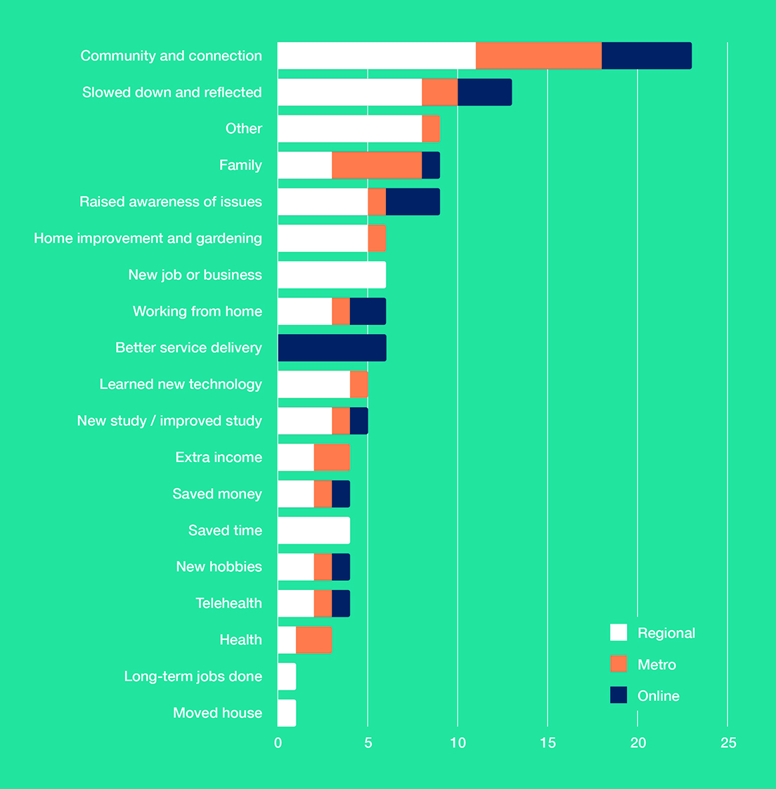
Community & connection
Amongst all the weighty challenges, there were also some positive changes that came about through the COVID pandemic.
Community members spoke about the way local neighbourhoods and communities supported each other during health, economic and social crises.
Local community initiatives such as little libraries, food outreach programs and COVID-safe street gatherings were all positive developments that helped people through tough times.
“Someone built a bench seat on the street and it became a point of connection. If you felt lonely you could sit on the seat and someone would eventually walk past.”
Community member, Bendigo
Slowing down, time with family
Almost everyone spoke about the opportunity that the pandemic provided to slow down and reflect on their lives. For many, this came with more quality time spent with family and/or on home improvement or hobbies.
The additional time with family also meant that some previously unidentified health or education issues were picked up by parents and carers.
“We discovered my child has dyslexia during remote learning. This wasn’t picked up by the school.”
Community member, Shepparton

While time with family was a benefit for many community members, the broad message of this report that pandemic impacts were felt unevenly across the community must be particularly emphasised in relation to impacts of family violence. The Listening Tour heard from many community members about their experiences of family violence, which are outlined in the ‘who did we engage with?’ section of the report below.
Learning, new jobs and opportunities
For some, the pandemic provided opportunities to switch jobs or careers, learn new skills – particularly related to technology – or undertake formal education.
The Listening Tour heard from community members who:
- studied English online with Neighbourhood Houses
- continued existing study, switching from face-to-face learning to online
- learned from neighbours how to use technology, supported by programs that allowed community members to borrow devices
- were given job opportunities to start immediately
- took up new hobbies and learned skills such as creative writing, family history and genealogy research.
We heard positive reflections from one family where teenage children decided to go straight into the workforce rather than undertake further study, because the pandemic provided the opportunity to reflect on what choices were right for their future rather than conforming to societal expectations.
Digital access
Many community members spoke about the benefits of technology, such as telehealth and online meetings –
particularly for those living in regional Victoria – and of the opportunity to work from home.
People told us that employers had adopted a more positive mindset towards working from home or working remotely as a result of the pandemic, and for some people this improved the quality of their working lives.
“Telehealth is so much easier than driving into Melbourne, finding a carpark and going into hospital for an appointment.”
Community member, Cloverdale
Additional income
Many community members said that they saved money during COVID, and were grateful for income support such as additional pension, JobKeeper and Youth Allowance payments.
But many people also struggled with the withdrawal of this support, and reflected that the security provided by the temporarily higher rates of payments had allowed them a rare freedom from financial anxiety.
“With JobKeeper people were able to afford the essentials and had a better quality of life, now it’s been taken away.”
Community member, Warrnambool

Community hopes for the future
The Listening Tour asked community members about their vision for a good life in five years’ time.
For some it was hard to imagine what this might look like, as the pandemic had shifted people’s outlook to the very short-term.

“We haven’t thought beyond the next few months in such a long time, I don’t know what life will be like in five years’ time.”
Community member, Bendigo

In general, people’s hopes for the future are modest and focused on meeting basic needs like having a job, earning money, having affordable and appropriate housing, studying and spending time with family and friends.
“I’d like security – financial and emotional. I would like to not have to check my bank account and fridge when I’m working 40 hours a week.”
Community member, Online forum

“Expectations are not very high. Parents [of children with disabilities] just want their child to go out, have friends, play soccer... the same as other kids.”
Community member, Online forum

“I just want work that brings in money and has meaning.”
Community member, Online forum

What I want for a good life is...
Housing
- Owning a house
- Building my own home
- Living in my own house with family and affordable rent
- Buying my first house
- Moving into retirement village
- Living with mum
Education
- Studying to be a doctor
- Graduating
- Changing careers
Financial
- Being financially secure
- Saved money
- Having more than 20 hours a week paid
Family & friends
- Live near friends
- See family interstate
- Having foster kids
- Starting a family
- Seeing family overseas succeed
- Travelling to see my family overseas
- Getting married
Health
- Better mental health
- Good health
- Stable physical and mental health
- Starting a new business
- Working part-time at the community house
- I lost fitness during COVID, so returning to fitness
- Be a new man – be fighting fit
- Going on a holiday and not having to worry about wearing a mask
- Being able to go to the supermarket with my (immunocompromised) child

Who did we engage with?
Many of the challenges associated with the COVID pandemic are common to everyone, but there are also specific cohorts and places where issues are exacerbated or unique.
Listening sessions were held with specific communities including Aboriginal Victorians, young people, parents and carers, and people with a disability. In addition, the specific experiences of border communities, multicultural communities and people experiencing family violence were raised during listening sessions. What we heard throughout the listening tour sessions was affirmed in the findings of the Essential Media poll.
We listened to:
55 people from multicultural communities
15 people with a disability or caring for a person with a disability
13 First Nations people
25 Young people
26 Parents and Carers
11 Disclosures of family violence

203 people engaged with throughout listening sessions
550 people polled through Essential Media poll

Source: Listening Tour session attendees identified from self-selection into targeted sessions such as people with a disability, parents and carers, First Nations, or voluntarily disclosed.

Young people
Young people who have had critical school years interrupted by the pandemic – particularly years 10, 11 and 12 – are feeling the impacts on study, career and socialisation. Many young people said that they feel lost, adrift and unmotivated, and reported having lost confidence over the last two years.
“We missed all of the important career discussions over the last two years, so when it came to choosing what to study at uni, I just picked anything. No one is helping with this.”
Young person, Banksia Gardens

All of the young people we spoke to said that it has been difficult to make new friends and that they’ve regressed socially over the last two years.

“I need to learn how to connect with people again. I feel a bit socially awkward at times. I don’t know how to make friends out of high school.”
Young person, Banksia Gardens

Young people almost universally said that getting back into face-to-face study was difficult. Almost all identified the need for study support to help students transition back into learning, particularly those who fell behind during the pandemic.
Young people spoke about their aspirations, such as graduating from study, finding a job, being in a long-term relationship, being healthy and buying a house.
“I would like to live independently but the cost of living is way too high. Everything costs more but you can’t earn any more.”
Young person, Warrnambool

“It’s lonely transitioning from school to uni. I don’t know many people at uni and socially, I feel like I’m stuck in Year 10.”
Young person, Banksia Gardens
Beth’s story
Beth is a young person who describes her experience of the last couple of years as “anxiety-ridden”.
Diagnosed with anxiety as a child, she’s also had a slew of other illnesses and challenges to deal with.
During the pandemic she had to go to hospital four times: twice for emergency management of cysts, once after an assault, and once for complications from COVID.
The hardest thing?
“Every time, I had to go alone.”
She also struggled with the uncertainty of the medical system during the pandemic and lockdowns: two years of having appointments cancelled and rescheduled while she was trying to manage her health.
“Obviously I understood,” she says, “but it was very frustrating to never know when I was getting an appointment, or what type of appointment it was.”
At the same time, Beth was dealing with not feeling safe at home with her housemate.
She was in the housing program Homelessness to a Home, but had been told it would take many months to arrange
an ‘emergency transfer’ into a new place.
Asked what kind of support would help her, Beth is unequivocal: money. Money for the health system and medical research, and for housing.
“As someone who was forced into a house with another person I don’t feel safe around, I want to be out of it,” she says.
“There are abandoned properties that could be fixed and used for government housing. There are buildings that could be used for government housing.”
Healthcare and a safe home: it shouldn’t be too much to ask.
Young people aged 18–24 are disproportionately impacted by the pandemic across multiple fronts – mental health, loneliness, housing affordability, insecure work / low wages and family violence.
52%
Poor mental health
People aged 18–24 say poor mental health is a challenge, compared to 34 per cent average.
49%
Loneliness and isolation
People aged 18–24 are experiencing loneliness and isolation compared to 33 per cent average.
37%
Housing affordability
People aged 18–24 are experiencing challenges accessing affordable housing compared to 21 per cent average.
44%
Low wages, insecure work or unemployment
People aged 18–24 are experiencing low wages, insecure work or unemployment compared to 32 per cent average.
15%
Family violence
People aged 18–24 are experiencing family violence compared to 8 per cent average.

Multicultural communities
Multicultural communities experienced many of the same challenges as other communities but with added barriers to accessing services and jobs, and often encountering discrimination in delivery of those services and in the workplace.
“We were far from family, we were studying online, we weren’t eligible for any government benefits but also weren’t able to work.”
International student, Cloverdale

“Multicultural women have to deal with sexual harassment at work, it’s not safe.”
Community member, Warrnambool

“At Centrelink, the woman was so rude to me, implying that I was lying. I’m sure it’s because I have an accent.” Community member, St Albans

“People are waiting 12–18 months to get childcare while they learn English. A colleague resigned because there was no childcare.”
International student, Warrnambool

“I can’t work, look after children, and learn English.”
Community member, Cloverdale

Many people from multicultural backgrounds recognised the critical importance of improving English language skills, to better realise opportunities for themselves and their children. However, community members told us of experiencing multiple barriers to this learning, such as lack of childcare and lack of face-to-face support in schools.
“Multicultural people who are experiencing financial difficulty can’t get their driver’s license. You have to pay $80 per lesson. It costs around $5,000 to get a license. Then you can’t get a job, and be financially independent.” Community member, Warrnambool
People from multicultural communities have also been harder hit by the pandemic on many other fronts, such as losing savings or earnings or employment, experiencing higher rates of family violence or of children struggling at school.

39%
Low wages, insecure work or unemployment
People where English is a second language are experiencing low wages, insecure work or unemployment compared to 32 per cent average.
22%
Children behind in study or disengaged from education
People where English is a second language have children behind at school or disengaged at higher rates compared to 19 per cent average.
16%
Family violence
People where English is a second language are experiencing family violence compared to 8 per cent average.
Source: Essential Media Poll commissioned by VCOSS.
Regional and border communities
People in border communities had to contend with understanding and complying with restrictions from multiple states, and with different restrictions for regional Victoria and metro Melbourne, often resulting in perverse outcomes for communities.
“It was a case of waking up and asking “What are we allowed to do today?” and carrying all of your paperwork around with you so you can live your life.”
Community member, Red Cliffs

“You were allowed to go by the river, but not ‘on’ the river because that was NSW.”
Community member, Red Cliffs

The closure of health services in many regional areas has resulted in lack of access to mental health and health specialist support and the expectation that people should travel to Melbourne or other major cities to access health services.
“I’ve been waiting four years for dentures and they said you have to go to Melbourne to get them. With my chronic disease I couldn’t go, so now I’m back on the wait list.”
Community member, Morwell

“I wasn’t allowed to have surgery in South Australia because we live in Victoria and the whole of Victoria was a ‘red zone’, even though there were no cases in regional Victoria at the time.”
Community member, Red Cliffs

“Usually medical profession would fly in to conduct health clinics but that hasn’t happened over the last two years. People were already vulnerable before COVID and COVID just made it worse.”
Community member, Red Cliffs
44%
Worry about catching COVID
Respondents living in regional Victoria are more worried about catching COVID than those living in Melbourne (35%).
77%
Cost of bills
People living in rural Victoria are more concerned with cost of living than those living in Melbourne (65%).
24%
Disability support
People living in rural Victoria are more concerned with reduction in support for people with a disability than those in Melbourne (18%).
Source: Essential Media poll commissioned by VCOSS.

Max’s story
Max is dealing with a range of challenges including recovering from alcoholism.
But the thing he identifies as his biggest daily challenge is something most of us take for granted: reliable internet access.
Without a computer or a connected smart phone, Max can’t access many of the supports and services that are supposed to help, like Medicare and MyGov.
And during the pandemic lockdowns he couldn’t access his COVID vaccination certificate, which meant he was locked
out of many social opportunities, leading to a vicious cycle of isolation.
“It’s hard for people on the dole or on pensions,” he says. “We don’t have contact with the outside world. I’ve seen two people this week. There should be more people in a life than that.”
The drug and alcohol and mental health services that might help Max recover are also severely limited where he lives. There’s one AA meeting a week, which isn’t enough for him to get the benefits of the program.
“The way the technique with AA goes is you get a buddy and that person is your strength and you’re their strength.”
It’s doable, he says, when he can see his buddy every couple of days. “We need more mental health services out here.
“Without that it’s real hard.”
Mary’s story
Mary is a mother of two teenage children, the older of whom is 16 and gender transitioning.
Living in a regional area meant there weren’t many services available during the pandemic.
Mary’s daughter, who also has autism, ADHD and a history of trauma, was struggling. Unable to engage with online learning, she missed all of years 9 and 10.
Without mental health support she became violent towards her family, leading to the police getting involved. She now faces criminal charges.
Mary says, “There was no one person I could ring and say please help me, please help her, please do something.”
Local services had closed their doors or were only offering online or phone services, which Mary’s daughter couldn’t engage with.
Mary’s younger child also had mental health struggles and disengaged from school, and Mary had to leave her full-time job so she could look after her family.
They’re all still struggling to come out the other side of the ordeal. The kids have not been able to get back into their education.
“It’s hard to describe the feeling of helplessness,” Mary says. “The lack of services, lack of community, being told there’s no funding. It’s just been really hard.”

People with a disability
People with a disability and parents and carers of people with a disability have found the pandemic very challenging. For people with a disability, including children and young people on the autism spectrum, the challenges included:
- significant disruption to routine
- the cessation of face-to-face allied health and disability support during lockdowns
- difficulty studying and learning while often experiencing or being at risk of additional health conditions.
These challenges for people with disability and their loved ones were experienced across Victoria, with 18 per cent of Victorian households concerned about reduced disability services.
However, the situation disproportionally impacted younger Victorians, who were 19 per cent more likely than older Victorians to be most concerned with reduced disability services or support for carers.
“The kids are not able to go to school, the daily routine was disrupted, parents are stressed. It’s taken months for kids to settle down, they are sad, angry, screaming, the whole family is exhausted.”
Community member, Springvale

“Parents struggled, they were beside themselves. They didn’t have a minute of respite. One has three children who are on the spectrum. Even though her children were technically eligible to go to school, they didn’t because it was unfamiliar.”
Community member, Online forum

Families spoke of a lack of understanding in the community about disability, and of feeling excluded and discriminated against when accessing services and going out.
“For parents of kids with high functioning disability, it’s very isolating. We’ve been kicked out of restaurants and cafes for being disruptive, people don’t understand.”
Community member, Springvale

Lack of funding and workforce shortages mean that people with disability do not have enough funding for care. Access to the NDIS is only available through demonstration of medical assessments, which are unaffordable for many in the community.
“I think I am autistic, but can’t get anyone to diagnose. There is no funding for adults with autism and an assessment costs $1,500.”
Community member, Morwell

“This child was forced to reduce school attendance. The school says they were only funded for three days PSD support and for two days the child has to stay at home.”
Community member, online forum

Caroline’s story
Caroline was living an ordinary, middle-class life. Both her and her husband were working in jobs that they enjoyed and living on a property with their child.
Caroline’s husband suffered an accident that left him as an amputee with an acquired brain injury.
Her husband is no longer able to live at home, but the NDIS workers were unable to find him suitable accommodation on his own. He was living in temporary motel accommodation.
Caroline ended up using their savings to build him an appropriate space on their property. She has had to give up work in order to care for him and their child.
Their teenage son is autistic and has an eating disorder. COVID and cost of living challenges have only added to the pressure of caring for two people with health and disability issues, which has impacted Caroline’s work and
the family’s financial security.
“I’m having to work out in the morning what’s the first thing that’s going to go because there’s only so much I can fit in my day. I have $100 in the bank until pay comes in and I have to juggle to make that stretch...”
The sad irony for Caroline is that “we are a wealthy country” but it’s easy to be left behind if something doesn’t go to plan.

Family violence survivors
While family violence was not a specific focus of the Listening Tour or a specific Listening Tour session, it was voluntarily disclosed and discussed multiple times.
We heard that, in some cases, people were able to identify issues such as sexual assault and abuse because of more time spent with families.
The lockdowns, which forced people into closed conditions with abusive family members for long periods of time, escalated and/or increased the frequency of violence, and made accessing services and support very difficult, particularly for those in regional Victoria.
The challenges were exacerbated for people from multicultural communities, who experience barriers
to getting support and safety, particularly through entering the job market and earning money. People from multicultural backgrounds can also experience discrimination from mainstream services that are intended to support them.
For those living with family violence the conditions of the pandemic meant higher incidence of violence with limited opportunity to leave the house for respite and safety.
“A friend of mine before the second lockdown said that I can’t do this again. My husband has been hitting the children. She was being forced into a situation where neither she or her children had a break from an abusive relationship because of lockdowns.”
Community member, Online forum

“My friend was pressured to give in to her ex-husband’s demands by her own lawyer. She wasn’t allowed to have an advocate or a support person. English isn’t her first language and she had to read and respond to all of these demands on her own.”
Community member, Warrnambool
Leigh’s story
Leigh is a victim survivor of family violence and a recovering alcoholic. She has liver disease, so drinking any alcohol would now pose an acute threat to her health.
Her husband went to jail for many years for assaulting her, but he got out during the pandemic lockdowns.
With nowhere else to go, he returned ‘home’ to live with Leigh.
In those claustrophobic conditions he began taking drugs and the abuse started again, including death threats.
He also started leaving bottles of alcohol around the house to tempt her to drink.
Leigh was eventually able to get a police order against him and get him out of the house, but he fled and is now missing.
After all the trauma, Leigh needs safety, security, support.
What she has – what’s keeping her going – is the local Neighbourhood House and her dog.
Asked where she will be in five years’ time, she says, “I won’t be here.”

First Nations communities
First Nations communities have experienced all the same issues as other communities over the last two years, including health challenges and delays in accessing non-emergency care, disrupted schooling, mental health issues, food insecurity and lack of housing affordability.
These issues have been complicated and compounded by mainstream services’ lack of cultural knowledge and sensitivity, and sometimes by outright discrimination and racism.
“We had so many different case workers supporting me and my children but none of them spoke to each other. None of them knew we were from the one family.”
Community member, Willum Warrain

First Nations communities spoke about experiencing barriers to inclusion including discrimination at school, lack of respect and value for Aboriginal knowledges and First Nations culture, and lack of recognition of the history of colonisation.
“The school took aside all the Aboriginal kids in Year 9 and told them that higher education is not for you.” Community member, Willum Warrain
First Nations community members also acknowledged the strength of their communities in pulling together during the pandemic. The message we received was that community knows what it needs and who needs help.
“Mob looking after each other. It’s just the way we do things.”
Community member, Willum Warrain

“I feel grief for the things we have lost, but I also don’t want things to go back to exactly the way they were before. People who were not seen – COVID enabled them to be seen.”
Community member, Willum Warrain

Jarrah’s story
Jarrah is in his second year studying environmental science at university.
As a proud Aboriginal man, he knows he was lucky having a strong Aboriginal leader at his local community centre, which helped pave the way for him and others to continue their studies.
He’s studying at a university named after a white Australian who, among other things, led government during a period of settlement and colonisation.
There is a non-mandatory subject in his course on Indigenous engagement, taught by a non-Indigenous person. It isn’t popular.
Jarrah is frustrated by the opportunities that are wasted by mainstream education systems and industries to engage with and benefit from Aboriginal knowledge and practices, particularly in environmental management.
Kirra’s story
Kirra lost her mum last year. She has been clean for two and a half years and has been rebuilding her life, including looking after her teenage son.
Her son is really feeling the loss of his grandmother, who had primary care of him while his mother was recovering.
It’s not easy to get back on your feet, especially during a pandemic.
For Kirra, looking after her own health and being motivated to be fit and healthy during lockdowns was hard.
It’s also been hard juggling bills. Kirra is studying and encouraging her son to study at TAFE so they can both get jobs. They had some momentum pre-COVID, but her son has a learning disability and studying online didn’t work for him.
“He went for three weeks last year but he struggled to do a building course online. Now that things are opening up, we’re trying to get back into things.”

Where to from here?
The Listening Tour heard from community members, in their own spaces and with their own voices, sharing ‘their hopes for the future’. From both the Listening Tour and the Essential Media poll,
we learned that:
While the lockdowns may have passed, the pandemic is far from over.
- Community members are still feeling the effects of the pandemic. They feel tired, exhausted, stressed and anxious, as well as relieved and hopeful in some cases.
- Many people remain anxious about contracting the virus. The largest proportion of respondents to the Essential Media poll (36 per cent) said concern about contracting the virus was having the greatest negative impact on their lives.
Loneliness and isolation, mental health and cost of living are major challenges.
- The biggest challenges that community members identified in the Listening Tour are health, loneliness, mental health and cost of living. In the Essential Media poll, 72 per cent of respondents identified cost of living as a challenge, 34 per cent identified poor mental health, 33 per cent identified loneliness and isolation, and 32 per cent identified access to healthcare.
Young people have been disproportionately impacted by the pandemic.
- According to the Essential Media poll, young people (age 18–24) feel more isolated and lonely than others, are more likely to have lost savings, earnings or a job during the pandemic, have more insecure or unaffordable housing, and are experiencing higher rates of family violence.
The pandemic has worsened inequalities.
- Many in the community were left behind by government responses to the pandemic, and some experienced direct discrimination.
Community hopes for the future are modest and universal.
- Most community members want simple things for a good life. They want a house, a secure job, enough money
to not have to worry about finances, strong relationships with friends and family, and
a hopeful future for their children.
Communities are a place of resilience and strength. Communities and government must work together for a better future.
- Community members do not want to forget about the inequalities that were highlighted through the pandemic. They also don’t want to forget about the valuable community connections and local initiatives that were created. The pandemic showed how important community was, and is, especially in dealing with life’s challenges.
- Communities want to work together with government to build capacity, and they want decision-makers to continue listening to less-heard voices. They want to increase the power of all community members to have a say in decisions that impact their lives and their futures.

Recommendations
The experiences of the COVID pandemic have varied across the state and in different communities. It has worsened existing inequalities in many ways. There are opportunities to utilise the disruptions of the global pandemic to address systemic inequalities and rebuild a fairer economy and society for everyone.
Recommendation 1
Support people with meeting their immediate and pressing needs such as cost of living pressures, loneliness and isolation, and housing.
Recommendation 2
Empower all people to participate fully in community and economic life, and remove barriers to inclusion.
Recommendation 3
Invest in the foundations of a ‘good life’ that provide everyone with the opportunity to thrive and protect against poverty, homelessness and poor health over the long term.
Recommendation 4
Commit to Victoria becoming a wellbeing economy and undertake further consultations to understand what
Victorians hope for the future and want government to deliver.

Recommendation 1
Support people with meeting their immediate and pressing needs such as cost of living pressures, housing, and loneliness and isolation.
During the Listening Tour, loneliness and isolation was raised as a challenge in every location we visited.
There needs to be investment in community services to expand outreach to people experiencing social isolation.
There needs be a concerted effort to reinvigorate volunteering by guaranteeing adequate and sustainable funding for place-based volunteering support services.
In addition to increased investment, there needs to be innovative and culturally appropriate policy solutions to reach people who are isolated and experiencing loneliness.
Loneliness and isolation was the third highest challenge noted in the Essential Media poll, with 33 per cent of all respondents raising it. The poll found that younger people were particularly affected, with 49 per cent of 18–24-year-olds reporting loneliness and isolation as a challenge.
We heard many people on the Listening Tour describe their struggle to meet their basic needs during the pandemic. We heard families speak of the continuing challenges presented by cost of living pressures, particularly rent, petrol prices and food.
People described having to decide between paying their bills, rent or transport.
Seventy-two per cent of respondents to the Essential Media poll said cost of living is their key challenge. Older people aged 55 and over are being hit particularly hard by the rising cost of living, with 80 per cent saying it is a concern.
Many community members spoke about the benefits of community services providing food relief during the pandemic, and we heard the broad sentiment that this relief is still needed.
Community members spoke of struggling to access and pay for housing, and of multiple households living within the one dwelling.
Twenty-one per cent of Essential Media poll respondents said that access to affordable housing was a challenge, particularly people aged 18–24 (37 per cent).
While these pressures are not new, they have been exacerbated by the pandemic. Immediate support is desperately needed.
Many people who lost work or had other reasons for requiring Commonwealth income support referenced the positive impact of the temporary increased rate of Commonwealth payments such as JobSeeker; others mentioned the positive impact of JobKeeper. Running parallel to State Government investment in programs such as food relief and other cost of living measures such as state concessions, there is a role for the State to advocate to the Commonwealth to strengthen the national safety net and raise the rate of income support.
We heard many people on the Listening Tour describe their struggle to meet their basic needs during the pandemic. We heard families speak of the continuing challenges presented by cost of living pressures, particularly rent, petrol prices and food.

Recommendation 2
Empower all people to participate fully in community and economic life, and remove barriers to inclusion.
Initiatives and approaches to government do best when they treat people with dignity and respect, are locally focused and driven by community members. Policies and service design need to cater for everyone in the community, including diverse cohorts and people who are disadvantaged. This includes delivering services locally and providing face-to-face support.
A common theme we heard throughout the Listening Tour was that policymaking and service delivery is often disempowering for the people that need to access services. People expressed their perception that policies are primarily designed for middle-class, English-speaking families living in Melbourne. A key enabler of access to services is community participation and engagement in the design and of services and policies.
Communities told the Listening Tour that government services are often not set up to support individuals and families with intersecting and compounding complex needs. Services are siloed within governments and between federal, state and local governments. Many spoke about getting ‘bumped’ from service to service.
We heard that people are frustrated that often the only way to obtain information and access services is online, which does not work for many parts of the community. This is a barrier to participation.
There needs to be investment in initiatives that provide access and expand current digital skills training programs including for seniors, people on low income, those living in regional areas, culturally and linguistically diverse Victorians, young people and carers.
Additionally, governments, community services and businesses should provide face-to-face or phone access to services, and use a wider array of communication channels to communicate essential information.
There’s an opportunity for government to sustain and scale examples of innovative practices that were tried and tested during the first two years of the pandemic. For example, for multicultural and multifaith communities, social, cultural and religious communication channels were essential for government health messaging. Similarly, the pandemic demonstrated the value of service users designing and leading services and programs for their own communities. Bicultural workers are a large part of effective service delivery. Communities want to see these approaches sustained, not wound back, and adapted for other groups.
Throughout the Listening Tour, community members expressed gratitude at being able to contribute to the policy development process. Many in the community remarked that it was the first and only time they have been engaged in the policy process. Communities know their needs and their strengths, and have a deep understanding of what has and hasn’t worked well in their context.
First Nations people spoke of the importance of self-determination in their dealings with government, to determine their own future. There are opportunities to work with First Nations communities on how to better meet current policy challenges – particularly climate change.
A critical enabler of multicultural inclusion in service delivery is inclusion in the provision of advice and participation in decision-making for government and community services.
Communities told the Listening Tour that government services are often not set up to support individuals
and families with intersecting and compounding complex needs. Services are siloed within governments and between federal, state and local governments. Many spoke about getting ‘bumped’ from service to service.

Recommendation 3
Invest in the foundations of a ‘good life’ that provide everyone with the opportunity to thrive and protect against poverty, homelessness and poor health over the long term.
While Recommendations 1 and 2 address immediate needs and barriers to inclusion, this recommendation focuses on how to help individuals and communities build a ‘good life’. Listening Tour participants articulated the foundations of a good life as:
- Affordable and accessible housing
- Job and economic security
- Strong communities
Investments in the foundations of a ‘good life’ will not only protect against risks of poverty and other forms of disadvantage, but also provide critical support in recovering from adverse life events.
Community members spoke about multiple life events that ‘added up’ to push them into housing and financial insecurity. These events could involve physical injury, natural disasters such as bushfires, experiences of family violence, onset of a health condition, or a death, marriage break-up or loss of a job by one or more members of the family.
Community members spoke about having the resilience to manage and respond to one event, but struggling to manage – let alone thrive – when issues intersect and compound. Overwhelmingly, the people who are caring for family members with health concerns, disability and mental health issues, and are often pushed out of employment to care
for others, are women.
Community members reflected on the importance of safety nets – government support and support from community services – to help them get through and recover from tough times.
Community members’ aspirations for the future are modest. They want to have good health, secure housing that is affordable, family and friends, a meaningful and secure job and financial security.
Listening Tour participants told us that housing costs are their largest living cost and housing has a direct link to their quality of life. They described stable housing as the key enabler to getting a job and accessing other services.
While emergency measures for Victorian renters (such as a ban on evictions and rental increases) were welcome and bolstered by complementary Commonwealth measures such as the introduction of JobKeeper and an increased rate of JobSeeker, the pandemic brought into sharp relief significant, long-standing challenges in our housing market – including the high cost of housing, a shortfall in housing that is affordable for low-income households, contraction of the rental market in regional Victoria, the prevalence of poor quality housing that is expensive to heat and cool throughout the state, and the dearth of housing options for large families which leads to overcrowding.
Government needs to build on the significant investment in social and affordable housing through the Big Housing Build, continue to invest in a pipeline of new social and affordable housing, and continue to advance rental fairness measures.
The Listening Tour heard from community members that in many cases of hardship, what would have made the most difference was not only services, but a stable job and income.
We heard that for women in abusive relationships, employment and income helps prevent economic harm and meet basic needs during crisis and beyond. Financial issues are often key factors in decisions about whether a woman chooses to leave or stay in a violent relationship.
For some people in regional Victoria, their savings and financial safety net has been wiped out by multiple natural disasters. Bushfires, drought and the COVID-19 pandemic have pushed some in the community to the point where they have no buffer should another adverse event occur.
For parents and carers, especially those who are pushed out of work due to their caring responsibilities, having an income is critical to their wellbeing and future.
Short-term boosts to the rate of income support during the emergency phase of the pandemic showed the positive impact of income support payments such as JobSeeker in enabling people to stay afloat during the worst of the pandemic and keeping the economy going.
While housing affordability and job and income security are critical foundations for individuals to live a good life, the pandemic has shown that we cannot live in isolation; we need our communities.
Throughout the Listening Tour, people spoke of the invaluable support and connection provided by community during the worst of the pandemic. Community members spoke about people leaving food at the doorstep, checking in on their physical and mental health and teaching them how to use technology. Conversely, others in the community
felt isolated and wanted greater connection and support during the pandemic.
In all the stories, community connection was a critical factor in supporting people’s resilience to recover from adverse events, not only in relation to the pandemic but also health events and natural disasters such as bushfires and floods.
Throughout the Listening Tour, people acknowledged a general feeling of anxiety and uncertainty about the future. This includes uncertainty about the impact of the pandemic and future lockdowns, and also global issues such as the war in Ukraine and the impact of climate change. While we know the future is uncertain, we also know that community strength and resilience is a key enabler for individuals, families and communities to respond effectively to uncertainty and change.

Recommendation 4
Commit to Victoria being a wellbeing economy and undertake further consultations to understand what Victorians hope for the future and want government to deliver.
Victorians do not think about their problems and their hopes in terms of government silos. Many of the issues raised throughout the Listening Tour fall between levels of government, ministerial portfolios and government departments and will continue to worsen if they keep slipping through the cracks.
For example, Victorians want the government to tackle loneliness, improve resilience, and help people use and access technology. None of these fit neatly into a single portfolio; a whole-of-government approach is required to start making progress.
A wellbeing economy would help address this shortcoming of the current model of government. Victorians would be consulted on their wellbeing priorities and, rather than delegating each one to a single department, a wellbeing economy tasks every portfolio with contributing to every priority.
It is far more constructive for departments to ask ‘how can we help solve this problem?’ rather than ‘does this problem fit into our remit?’
A wellbeing approach also broadens government decision-making beyond just economic growth. It measures what matters and does not assume that high GDP is the be all and end all if people’s wellbeing is stagnating.
It values the things that the participants of the Listening Tour prioritise – the foundations of a good life.
And Victoria would not be going it alone. New Zealand, Iceland, Scotland and Wales have all adopted a wellbeing approach to the economy and, closer to home, the ACT has embedded a Wellbeing Framework into government decision-making and Tasmania is getting the process started.
After committing to a wellbeing economy, the Victorian Government could introduce a Minister or Commissioner for Wellbeing to progress the reforms.
It is then important to listen to Victorians about their wellbeing priorities by having conversations with communities across the state about their hopes for the future and what they want government to deliver.
These priorities could be captured in a Victorian Wellbeing Framework that government uses when investing money budgeted for the wellbeing economy, as specified in legislation that protects the wellbeing approach for future generations.
Throughout the Listening Tour, people acknowledged a general feeling of anxiety and uncertainty
about the future... While we know the future is uncertain, we also know that community strength and resilience is a key enabler for individuals, families and communities to respond effectively to uncertainty and change.

Methodology
Background and objectives
The Victorian Council of Social Services (VCOSS) first proposed the Listening Tour in early 2021 to inform an inclusive social and economic recovery from the pandemic. The Listening Tour was delayed due to the subsequent lockdowns in 2021 and restarted in February 2022.
The purpose of the Listening Tour was to listen to lesser-heard voices in the policy process. It was an opportunity to engage with communities in their own spaces and hear about their experiences of the pandemic and their hopes for the future.
Overview
VCOSS, in partnership with Neighbourhood Houses, conducted listening sessions in 12 areas in Victoria – eight in regional Victoria and four in metropolitan Melbourne. In addition, one online session and four ‘deep dives’ were held to provide further insight into specific cohort experiences.
Over 200 people were listened to during online and face-to-face sessions. An Essential Media poll was also conducted, exploring the experiences of a
further 550 people across Victoria.
The Listening Tour asked three open-ended questions:
1. How are you feeling right now?
2. What challenges are you facing?
3. What are your hopes for the future?
Figure 4: Locations of community listening sessions
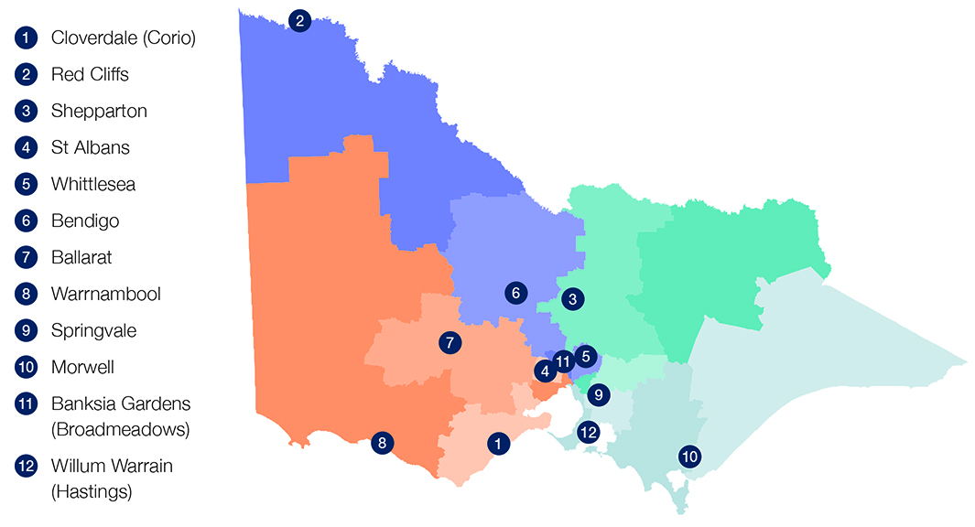
Design of the Listening Tour
The Listening Tour was intended to listen to lesser-heard voices in the policy process. It was important that individuals had the opportunity to tell their stories directly in their own words, in their safe spaces.
Deep consideration was given to power, safety and choice in the design of the Listening Tour. As much as possible, the Listening Tour aimed to recognise power imbalances and inequality and provide choice for a diverse range of participants to engage in spaces
that were safe.
In order to do this, VCOSS considered:
- Partnership – Partnering with trusted community organisations
- Method – Offering multiple options to engage, both online and face-to-face
- Location – Ensuring that there was a mix of locations chosen across Victoria
- Space – Holding listening sessions in diverse community spaces
- Food – Providing culturally appropriate food including food prepared by the community such as Thai and Halal food
- Privacy and confidentiality – Ensuring privacy and confidentiality in the report
- Compensation – Providing supermarket vouchers for time and contribution
- Timing – Considering appropriate timing for holding the listening sessions
- Feedback – Offering participants opportunity to provide feedback, and ensuring that the report is provided back to communities who engaged
- Language – Enabling a diversity of languages spoken by facilitators and participants
- Safety – Supporting safety of participants
Partnership
VCOSS partnered with Neighbourhood Houses Victoria, as a key community resource with deep networks and connections in communities across Victoria. VCOSS also used its local networks and members, such as local community health services, to advertise and encourage participation in the listening sessions.
Choice of engagement method
The Listening Tour offered both online and face-to-face options to engage with people and allow them to be heard. The primary method for engagement was face-to-face sessions. This method was chosen deliberately, recognising that many who already engage with government processes do so online.
Face-to-face sessions were intended to provide opportunity for people who do not have access online or would prefer not to engage online, such as older people or people for whom English is not their first language. Face-to-face sessions, in community spaces, offer participants the opportunity to engage in spaces where they feel safe. Participants were also invited to share their stories via video.
Location and timing
Twelve Neighbourhood Houses were selected around Victoria – four in metropolitan Melbourne and eight in regional Victoria – to advertise and recruit participants for face-to-face listening sessions. The listening sessions were held during business hours (9:00am – 5:00pm) on weekdays. The sessions were held in Neighbourhood House and community spaces.
“At the start I was super nervous and felt like I was the odd one out having a disability but I was warmly welcomed and felt included and heard with what I was saying.”
Community member, Morwell
Safety
Strong consideration was given to safety in the design of the listening sessions. Safety started with clear communication about the purpose of the listening session, who would be attending and what would be discussed. Support people were identified throughout the session to provide support to scribe or to talk. Experienced external facilitators were used and confidentiality prioritised.
Diversity, equity and inclusion
Participants were not asked to share their demographic / identity information on the basis that this could become a barrier to participation. Instead, demographic data was collected only if participants voluntarily shared this during the session.
From this basis, VCOSS identified that there were gaps in the participation of particular cohorts and scheduled deep dive sessions for:
- First Nations peoples
- parents and carers
- people with a disability
Compensation
Supermarket vouchers were provided to participants to thank them and value their time and contribution.
Feedback and evaluation
Participants were asked to provide their formal feedback after the session. Over 98 per cent of participants were satisfied with the session overall and over 95 per cent felt safe to share their story.
Figure 5: Demographic snapshot
Women 78%
Multicultural communities 27%
First Nations 6%
People with a disability 7%
Young people 12%
Older people 38%

Figure 6: How satisfied were you overall with the session?
Extremely 59.2%
Very 39.4%
Somewhat 1.4%

Figure 7: How comfortable, safe and support did you feel to share your story?
Extremely 74.6%
Very 21.1%
Somewhat 4.2%

Learnings for the future
Partnership
Partnership with community organisations is an effective model for engagement, recognising that these organisations have built trusted relationships over a long time. Future consultation should consider partnership with community organisations and services with large and diverse reach such as community health services.
Scale
The Listening Tour engaged 190 people in face-to-face listening sessions and 13 people online. The primary method of engagement – face-to-face listening – was successful in engaging lesser-heard voices in policy consultation.
Compensation
Supermarket vouchers were a practical and tangible incentive for community members to participate in the sessions. The vouchers were well received as community members remarked on the increasing cost of living.
For future engagement, there is potential to offer different support to participants. For example, participants identified challenges such as finding jobs and seeking funding for community programs. Future sessions could offer information about services/programs post-session and how to access them, with warm referrals where possible.
Diversity, equity and inclusion
While the Listening Tour succeeded in engaging many lesser-heard voices, there is still opportunity to improve diversity through the following considerations.
Crisis
Community workers in the online session spoke about their clients who are at the point of crisis in the homelessness and income support systems and would not have capacity to engage in these type of sessions. Future consultation should consider the role that community organisations and workers provide to share the experiences of their clients in crisis.
Language / bicultural facilitation
The sessions were facilitated by external facilitators with significant expertise in community engagement and utilised bicultural workers at Neighbourhood Houses where available. Future consultation should expand on this model, providing access to bicultural workers at more sessions.
Timing
Listening sessions were held during the day; however, future listening tours should consider after business hours timing to be accessible to people who are working or not available during the day. Similarly, sessions ran for two hours which may have been a barrier for some people to attend.
Parents and carers
Future consultation should consider providing childcare or other caring arrangements to enable parents and carers to attend.
LGBTIQ+, gender fluid and transgender people
Future consultation should consider explicitly welcoming gender fluid and transgender people and potentially offering targeted engagement sessions.
Agency and participation
At every session, participants thanked VCOSS and facilitators for listening to them, highlighting how much community members value feeling seen and heard. It also highlighted the trauma that has been experienced in some communities and the therapeutic benefits of listening.
“I’m forever grateful.”
Community member, Morwell

“Thank for you for the opportunity to be heard. Very much appreciated.”
Community member, St Albans

“I think the VCOSS service should be done quarterly at all Neighbourhood Houses as it
was a counselling service in itself. Well done!”
Community member, Shepparton

Communities know what they want for themselves, and know what the barriers are. During the Listening Tour, community members offered practical solutions that can inform policy making and service delivery to best meet their needs.

Consultation
Below is a table that outlines the consultation undertaken, the mode of engagement, date, location
and attendees.
Location/focus | Date | Mode | Regional/Metro | Number  of  participants
Cloverdale | 21 February 2022 | F2F | Regional | 16
Red Cliffs | 7 March 2022 | F2F | Regional | 13
Shepparton | 11 March 2022 | F2F | Regional | 15
St Albans | 22 March 2022 | F2F | Metro | 23
Bendigo | 24 March 2022 | F2F | Regional | 11
Ballarat | 25 March 2022 | F2F | Regional | 6
Morwell | 30 March 2022 | F2F | Regional | 13
Whittlesea | 31 March 2022 | F2F | Metro | 23
West Warrnambool | 6 April 2022 | F2F | Regional | 20
Springvale | 8 April 2022 | F2F | Metro | 13
Banksia Gardens | 22 April 2022 | F2F | Metro | 26
Online forum | 29 April 2022 | Online | NA | 6
Parents and carers | 4 May 2022 | Online | NA | 3
People with a disability | 4 May 2022 | Online | NA | 4
First Nations | 20 May 2022 | F2F | Regional | 11
Total |  |  |  | 203

Appendix
Essential Media poll snapshot
Impacts from COVID-19
72%
were most concerned about their cost of bills including food and utilities.
36%
continue to have anxiety and concerned about catching COVID-19.
People want…
55%
of Victorians think lower cost of living or wage growth would improve their lives most.
71%
want government to address the causes of inequality rather than react to problems.
66%
think investment in social assistance would not only help people’s wellbeing, but provide jobs
and boost the economy.
64%
want the government to invest more in social assistance that prevent isolation and loneliness.

Lower income households are
1.3 times
more likely to be concerned about reduced disability services and support.

Listening to younger and older Victorians
Young and Older Victorians feel lonely and isolated and have poorer mental health since COVID-19.

48% of young people and 26% of older people struggle with poor mental health

45% of young people and 29% of older people feel lonely and isolated

Young people (18–24 yo)
84%
continue to have negative impacts.
1 in 3
continue to be impacted by lost savings or income or a job.
3 times
more likely to be worried about access to affordable and appropriate housing. (37% vs 12% for 55+ yo)
Young people are more likely to not be able to access care and support they need compared to older Victorians.
39%
think better access to social services would make the biggest positive difference to their lives.
Older people (55+ yo)
80%
of older Victorians are concerned about cost of bills including food and utilities.
Retirees are most concerned about cost of bills including food and utilities (compared with those in paid employment).
37%
think more affordable food and essentials would make the biggest positive difference to their lives.

