

April 2022
VCOSS submission to the National Strategy to Achieve Gender Equality

VCOSS welcomes the Commonwealth Government’s commitment to advancing gender equality in Australia through this new Strategy and its commitment to Gender Responsive Budgeting.
Gender equality is a fundamental human right and is essential to achieving a fairer and more prosperous Australia.
The COVID-19 pandemic has demonstrated that women continue to shoulder an unequal burden of unpaid work and care. Women are more likely to take time out of the workforce to care for children, elderly parents and friends and family members with disabilities. They are also more likely to work part time or in casual roles to meet their caring responsibilities. As a result, they earn less, are less likely to advance in their careers, and have lower superannuation balances on retirement.
The new National Strategy should focus on the following priority areas:

Prioritise women’s economic security
Women’s economic security is critical to reducing gender inequality and as a preventative measure against family violence.
Access to secure and decent work, alongside improvements to Australia’s social security system, is critical if we are to improve gender equality, better value care work, and ensure that victim-survivors of family violence can leave unsafe relationships.
Inadequate social security payments are causing harm in our community. VCOSS supports ACOSS’ recommendation to lift the rate of income support payments including the JobSeeker Payment, Youth Allowance, parenting payment, Austudy, Abstudy, and Special Benefit to at least $76 a day to be in line with the pension. These payments must be indexed in line with wages, as well as price increases, at least twice per year.⁶
In addition, eligibility for the Parenting Payment Single should be amended to enable single parents access until their youngest child turns 16 years old.
Currently, single parents are moved from the Parenting Payment Single ($949.30 a fortnight) to JobSeeker Payment ($745.20 a fortnight) when their youngest child turns eight. While this was intended to encourage more single mothers into work, there is little evidence to suggest this has succeeded, and it has resulted in more women and children living in poverty.

Accessible and affordable childcare
One of the biggest barriers to advancing gender equality and increasing women’s workforce participation is lack of access to affordable, high-quality childcare.
The Mitchell Institute has reported that lower socioeconomic areas have less access to childcare. Childcare also remains unaffordable to many families.
Rural communities face additional challenges. Demand is spread across wide geographic areas making services unprofitable, families face higher travel costs, and workforce shortages are acute.
While the Commonwealth Government’s changes to childcare subsidy rates will benefit more families from July 2023, VCOSS recommends that Australia moves towards free and universal access to childcare.
In the interim, targeted action is urgently required to support viable childcare services in rural areas. For example, Regional Development Australia et al have recommended the Commonwealth Government increase the subsidies for rural areas in its Child Care Subsidies Program by 9% to improve wages, conditions, retention of educators and fund service leadership and administration. The Commonwealth should also ensure the Additional Child Care Subsidy for disadvantaged families (over and above the 9%) is maintained at its current rate and promoted in rural areas.

A fairer paid parental leave scheme
Improvements to Australia’s paid parental leave scheme will mean that by 2026, families will be able to access 26 weeks of paid parental leave at the national minimum wage.
Whilst welcome, Australia’s scheme lags leading comparative OECD nations.
In line with the Productivity Commission recommendations that parents need 6-12 months to support the best outcomes for their child, VCOSS recommends that the Commonwealth introduce 26 weeks of paid parental leave under the National Employment Standards accessible by each parent. Twenty-six weeks is also in line with the World Health Organisation’s recommendation around breastfeeding. This will help increase men’s uptake of parental leave and primary caring responsibilities.
Employers do not currently have to pay superannuation on paid or unpaid parental leave. The Commonwealth’s paid parental leave scheme also does not attract the superannuation guarantee. Given the low superannuation balances of women, this should be rectified with a requirement that superannuation be paid on top of both employer and government funded paid parental leave payments.

Prevention and elimination of all forms of violence against women
Gender inequality is a key factor underpinning violence against women.
The new National Strategy should reinforce the existing National Plan to End Violence Against Women and Children, with complementary measures that help to eliminate and prevent violence against women.
Migration status can impact how and whether women seek support and intervention when experiencing family violence. Consideration should be given to implementing the Blueprint for Reform, which details a pathway forward for achieving better safety outcomes for women on temporary visas and their children. This should include expanding eligibility and access to social security (including Medicare) for women on temporary visas who are experiencing family violence.

Equity in women’s health and wellbeing
Gender impacts women’s health and wellbeing outcomes.
Australia’s National Women’s Health Strategy has five priority areas: maternal, sexual and reproductive health, healthy ageing, chronic conditions and preventive health, mental health and health impacts of violence against women and girls.
Health equity is an important issue, with the Jean Hailes National Survey 2022 showing that 44% of women could not afford to see a doctor or other health professional when they needed it.
The new National Strategy should recognise and complement the existing National Women’s Health Strategy. It should proactively identify opportunities to enable the National Women’s Health Strategy.

A gender-responsive approach to housing
Women are more vulnerable to housing insecurity and homelessness.
The Commonwealth Government has committed to delivering 50,000 new social and affordable homes over five years from 2024.
While welcome, the Commonwealth Government should establish a more ambitious plan to deliver 500,000 social housing dwellings over the next decade to meet current and projected demand.
This new plan, together with the National Strategy, and the new National Plan to End Violence against Women and their Children Action Plans, should work together to address the gendered drivers of women’s housing insecurity and homelessness, including:
- Addressing women’s economic security to relieve extreme rental stress, overcome barriers to home ownership and prevent homelessness in retirement.
- Investing in the provision of both housing and support to victim-survivors of family violence.

Improve the pay and conditions for essential social services workers
The COVID-19 pandemic has highlighted the essential role played by the care sector including aged care, disability care and childcare workers.
This work however remains undervalued in Australian society. Whilst aged care workers will receive a 15% pay rise, more needs to be done to increase wages in other low-paid female dominated industries like childcare and disability care to better reflect worker’s skills, experience and qualifications.

Undertake Gender Impact Assessments
VCOSS welcomes the commitment by the Commonwealth Government to undertake gender responsive budgeting and its pilot of Gender Impact Assessments on select items in the 2022-23 October Budget.
This should be scaled up, with the new National Strategy including a commitment to integrate Gender Impact Assessments across all levels of Commonwealth policy, program, services and decision-making processes.

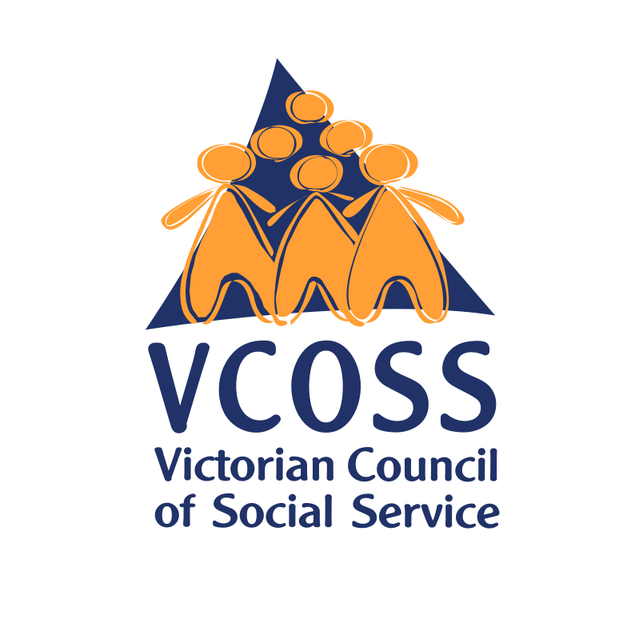

 | /vcoss
 | @vcoss
 | ChannelVCOSS
 | vcoss.org.au

VCOSS is the peak body for Victoria’s social and community sector, and the state’s premier social advocacy body. We work towards a Victoria free from poverty and disadvantage, where all people and communities experience genuine wellbeing.

ACOSS, “It’s hell”: how inadequate income support is causing harm, March 2023, https://www.acoss.org.au/wp-content/uploads/2023/03/ACOSS-cost-of-living-report2-March-2023_web_FINAL.pdf
https://endpolicyinducedpoverty.good.do/actnow/I-care/, Matthew Gray and Ben Phillips, Analysis of the impact increasing the rate and extending eligibility of Parenting Payment Single on financial living standards, Centre for Social Research and Methods, https://apo.org.au/node/321554
ACOSS, “It’s hell”: how inadequate income support is causing harm, March 2023, https://www.acoss.org.au/wp-content/uploads/2023/03/ACOSS-cost-of-living-report2-March-2023_web_FINAL.pdf; Luke Henriques-Gomes, Majority of Australians on jobseeker and parenting payments live in poverty, study finds, 22 March 2023 https://www.theguardian.com/australia-news/2023/mar/22/majority-of-australians-on-jobseeker-and-parenting-payments-live-in-poverty-in-study-finds
Mitchell Institute, Victoria University, Deserts and oases: How accessible is childcare in Australia? March 2022, https://www.vu.edu.au/mitchell-institute/early-learning/childcare-deserts-oases-how-accessible-is-childcare-in-australia
Regional Development Australia, Regional Partnerships Loddon Campaspe, Regional Partnerships Mallee, Creating iable childcare services in rural areas, September 2022
Minister Amanda Rishworth, Parents to benefit from Paid Parental Leave changes to support gender equality, Media Release, 6 March 2023 https://ministers.dss.gov.au/media-releases/10531#:~:text=Single%20parents%20will%20now%20be,from%20the%20end%20of%20March.
OECD Family Database, https://www.oecd.org/els/soc/PF2_1_Parental_leave_systems.pdf
Australian Government Productivity Commission, Paid Parental Leave: Support for Parents with Newborn Children No 47, 28 February 2009.
World Health Organisation, Breastfeeding, https://www.who.int/health-topics/breastfeeding#tab=tab_1
National Advocacy Group on women on temporary visas experiencing violence, Blueprint for reform: Removing barriers to safety for victim/survivors of domestic and family violence who are on temporary visas, 2022, https://awava.org.au/wp-content/uploads/2022/12/Blueprint-for-reform-2022-v071222.pdf
Jean Hailes, 2022 Jean Hailes National Women’s Health Survey, https://www.jeanhailes.org.au/uploads/Research/2022-Jean-Hailes-Survey-Report.pdf
Equity Economics, Rebuilding for women’s economic insecurity, October 2021, p 7.
A pay rise for aged care workers, Media release, 7 November 2022 ,https://www.health.gov.au/ministers/the-hon-mark-butler-mp/media/a-pay-rise-for-aged-care-workers
Department of Education (2016) 2016 National Early Childhood Education and Care Workforce Census Report, p. vii and p 16.
National Disability Services (2020) NDS Workforce Census Key Findings, June 2020, p 6.

