

April 2023
VCOSS Submission to the Inquiry into Land Transfer Duty Fees

Introduction
VCOSS is the peak body for Victoria’s social and community sector, and the state’s premier social advocacy body. We work towards a Victoria free from poverty and disadvantage, where all people and communities are supported to thrive. We champion wellbeing and inclusive growth. VCOSS supports and advocates on behalf of its members.
VCOSS welcomes the Legislative Council Economy and Infrastructure Committee Inquiry into Land Transfer Duty Fees (known commonly as “stamp duty”) as an opportunity to explore the relationship between land taxes and the housing market.
VCOSS’ primary interest is reform that can improve housing affordability, create a fairer, more sustainable housing system, and free government revenue from the volatility of the property market so governments can continue to deliver essential services to all Victorians.

Phase out stamp duty
A number of reviews, independent bodies and a diverse range of economists recommend governments remove stamp duties. This is because:
- Stamp duty is highly inefficient and an unstable source of revenue for states.
- It discourages transactions, which disincentivises highest value land use and leads to land being retained for relatively unproductive purposes.
- It discourages people from moving when their personal circumstances change (eg employment opportunities) or their current housing is no longer fit for purpose (eg downsizing or family breakdown).
- It is inequitable, as people who need to move more – such as young people as they are getting established – bear more tax irrespective of income or wealth.
- It contributes to housing unaffordability, by increasing the upfront cost of housing, especially for first home buyers, and increasing the cost to investors, who pass those costs on to renters in higher rent costs.
- It discourages institutional investors from large-scale investment in the private rental housing market (such as build-to-rent programs), contributing to the shortage of affordable, long-term rental housing.

Switch to a broad-based land tax
Replacing stamp duty with a broad-based land tax can improve housing affordability, mobility and land use.
Some jurisdictions, including Victoria, have taken steps towards removing stamp duty to improve housing affordability by establishing exemptions for eligible first home-buyers. However, an unintended consequence of targeted or narrow exemptions is that they provide more economic benefit to home sellers rather than anybody needing assistance to access housing.
The Productivity Commission also notes that this can lead to an ‘assistance spiral’, where:
“Government assistance makes house prices more expensive by increasing demand, prompting governments to increase assistance, pushing up prices further, and on it goes”
This underscores the need for reform to be comprehensive, albeit carefully enacted.
On that point, VCOSS recognises that stamp duty is currently a critical revenue source for state governments. In Victoria, stamp duty makes up at least 30 per cent of the total Victorian government tax revenue base. This means stamp duty would need to be carefully replaced to ensure governments have sufficient revenue to maintain essential services and provide targeted housing assistance – such as social housing – to those in most need.
Much of the research indicates that a broad-based land tax is the best replacement for stamp duty. Benefits of a broad-based land tax include:
- Less of a distortionary effect on decision making and mobility.
- Stabilisation of government revenue because it is not exposed to the volatility of the housing market.
- Increased government revenue – for example, in 2018, the Grattan Institute found a national shift from stamp duties to land tax would add up to $17 billion per year to gross domestic product.
- Can influence growth in housing supply, particular higher density development in already established and well serviced locations.
- Contributes to a fairer and more sustainable housing system.
Noting that sudden changes to property taxes can risk causing housing market instability and can reduce government income in the short term, VCOSS acknowledges government would need to proceed with a slow transition and careful implementation from stamp duty to a broad-based land tax. For example, the ACT is transitioning from stamp duty to a broad-based land tax progressively over 20 years.
VCOSS also observes that, if the Victorian Government enacted such reform, in the early transitional phase it may require bridging finance from the Commonwealth Government, until more housing joins the universal tax base.
The Productivity Commission recommends the following key elements to ensure a fair shift to broad-based land tax and to prevent the inequity of tax burdens falling disproportionately on people who need to move for work or lifestyle reasons:
- Replacement of stamp duties on property transfers with a broadly-based tax based on land values. The shift to a broad base is essential to ensure that revenue is raised efficiently, and the tax burden is not disproportionately imposed on a few groups.
- Provision for tax deferral for certain low-income groups, so that taxes do not force people with less capacity to move.
- A shift to land-based taxes should include provision for low-income households to defer property taxes and fund them from their estate at death or on the sale of the asset (whichever comes first), with low interest rates applying to debts.
VCOSS concurs with this assessment and endorses this approach.
In making the switch from stamp duty to a broad-based land tax, Victoria can leverage insights from the ACT and New South Wales who have both already gone down this path.

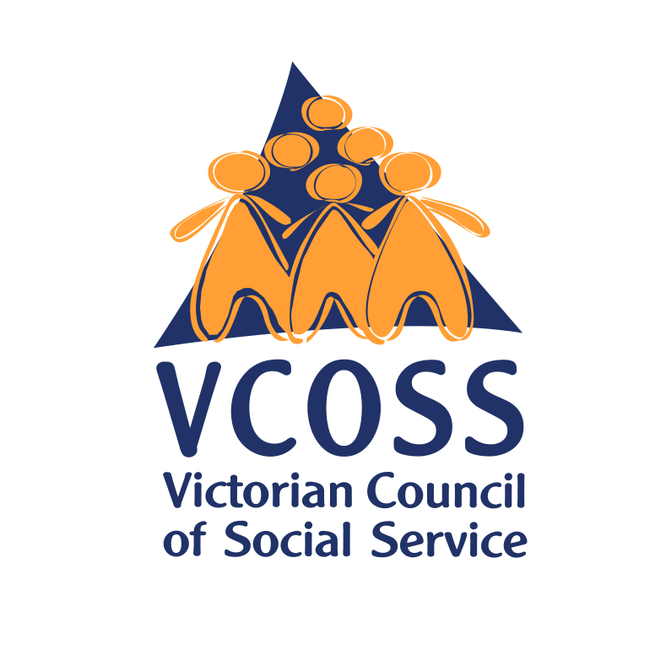

 | /vcoss
 | @vcoss
 | ChannelVCOSS
 | vcoss.org.au

VCOSS is the peak body for Victoria’s social and community sector, and the state’s premier social advocacy body. We work towards a Victoria free from poverty and disadvantage, where all people and communities experience genuine wellbeing.

K Henry, Australia’s future tax system: Report to the Treasurer, December 2009, p 49.
Ibid.
Productivity Commission, Shifting the dial: 5 year productivity review, 3 August 2017, p 149.
K Henry, Australia’s future tax system: Report to the Treasurer, December 2009, p 49.
AHURI, Scrap stamp duty, replace with a land tax – what are the impacts?, 21 June 2022.
J Moloney & B Coates (Grattan Institute), Stamp duty isn’t going anywhere until we can agree on the tax to replace it, The Conversation, 13 January 2023.
Productivity Commission, Shifting the dial: 5 year productivity review, 3 August 2017, p 149.
Infrastructure Victoria, How more housing options can make better use of Victoria’s infrastructure, March 2023, p 32.
AHURI, Scrap stamp duty, replace with a land tax – what are the impacts?, 21 June 2022.
Ibid.
AHURI, Scrap stamp duty, replace with a land tax – what are the impacts?, 21 June 2022.
Productivity Commission, In need of repair: The National Housing and Homelessness Agreement, August 2022, p 32.
J Moloney & B Coates (Grattan Institute), Stamp duty isn’t going anywhere until we can agree on the tax to replace it, The Conversation, 13 January 2023.
Ibid.
Productivity Commission, Inquiry report – Shifting the Dial: 5 year productivity review, August 2017, p 151.
Grattan Institute, State Orange Book 2018: Policy priorities for states and territories, October 2018, p 88.
Infrastructure Victoria, Our home choices:How more housing options can make better use of Victoria’s infrastructure, March 2023, p 32.
AHURI, Scrap stamp duty, replace with a land tax – what are the impacts?, 21 June 2022.
Productivity Commission, Inquiry report – Shifting the Dial: 5 year productivity review, August 2017, p 151.

