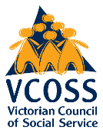


Ripple Effects: Spatial injustice and the 2022 Victorian floods

February 202DRAFT: NOT FOR DISTRIBUTION

Ripple Effects: Spatial injustice and the 2022 Victorian floods

March 2026

February 2026

About VCOSS

VCOSS is the peak body for Victoria’s social and community sector, and the state’s premier social advocacy body.
We work towards a Victoria free from poverty and disadvantage, where every person and community is supported to thrive. We work relentlessly to prioritise wellbeing and inclusive growth to create prosperity for all.
We achieve these goals through policy development, public and private advocacy, supporting and increasing the capabilities of the state’s social service bodies, forging strong coalitions for change, and explaining the true causes and effects of disadvantage.
VCOSS’s strength comes from its members and the people they serve. Our members include frontline service groups, peak bodies, advocacy organisations and individuals passionate about a fair, sustainable and inclusive Victoria.
Primary author: Lucy Manne
Supervising Director: Deborah Fewster
Authorised by CEO: Juanita Pope
Please send enquiries to vcoss@vcoss.org.au
You can browse more VCOSS reports and submissions at vcoss.org.au/PolicyLibrary
Acknowledgement of Traditional Owners.
VCOSS acknowledges the Traditional Owners of Country, and pays respect to Elders and ancestors. Our office is located on the sovereign, unceded lands of the Wurundjeri people of the Kulin Nation.
Lived experience statement
VCOSS thanks all those who shared with us their personal stories, experiences and insights
in the development of this work. Every person is shaped by their history and environment. Many people have endured trauma or hardship. For some, this trauma and its effects continue today. When somebody shares their experiences and insights with VCOSS, they enrich both our understanding of the issues and our recommendations for change. Thank you for your courage and generosity.

Cover image
Murray River near Swan Hill. Photo by Rob Deutscher via Wikimedia, Creative Commons.

Contents
Executive summary 3
Interpreting the findings 8
Spatial injustice before the floods 10
Spatial injustice after the floods 19
Recommendations 28
Methodology 34

Executive summary
This report presents the first comprehensive quantitative analysis of spatial injustice – the unequal opportunities and resources that exist due to location – and the impacts of the 2022 Victorian floods.
The findings in this report have implications that go far beyond a single emergency. Learning the lessons from the 2022 floods will support Victorians hardest hit by the 2026 bushfires, and ensure we can better prepare for future emergencies.
In October 2022 Victoria experienced its wettest month on record and major floods devastated communities across our state. The consequences of the floods were deep and long-lasting, causing ripple effects for communities that are still being felt today.
Sixty-three of Victoria’s 79 local government areas were affected. Two people tragically lost their lives, 5,017 homes and businesses were destroyed or damaged, and more than 5,000 known Aboriginal cultural heritage sites were impacted.
Disasters like the 2022 floods affect everyone, but not equally.
Victorians experiencing poverty and disadvantage were more likely to live in the hardest hit areas, and this inequity was exacerbated after the floods.
This report finds that certain Victorians were more likely to live in areas affected by the floods:
- People experiencing socioeconomic disadvantage were more likely to live in regional flood-affected areas.
- A majority (59%) of regional flood-affected areas had rates of poverty above the regional average.
- Aboriginal and Torres Strait Islander people were more likely to live in regional flood-affected areas.
- In regional Victoria, culturally and linguistically diverse people were more likely to live in the flood-affected areas. In Melbourne, almost one in two people in hard-hit Maribyrnong were culturally and linguistically diverse.
This report also considers community-level outcomes after the floods, and finds that living in an affected area exacerbated inequality:
- After the floods, disposable income was $22,818/year lower for households in affected areas compared with similar households in unaffected areas.
- Poverty increased after the floods, with one in five people experiencing poverty in affected areas in 2023, and poverty 6.1% higher compared with unaffected areas.
- After the floods, unemployment and nonparticipation in the labour force increased along with the need for government income support.
- The floods had negative impacts for social, physical, and mental health outcomes.
Following the 2022 floods, the Australian Government, Victorian Government and local governments put in place a number of supports for Victorians impacted by the floods, with $1.66 billion spent on flood relief and recovery by June 2023. Supports for households included relief and reestablishment payments as part of the Personal Hardship Assistance Program and the Flood Recovery Support Program. However, this report shows that more needs to be done to support those most impacted.
We know that climate change will continue to drive more intense and frequent extreme weather events. As Victoria experiences a season of devastating bushfires, this report highlights the increasing risk that natural disasters will further entrench inequality, poverty and disadvantage across Victoria. Our recommendations to all levels of government aim to address that risk.

Recommendations
It is vital to learn the lessons from the 2022 floods to prepare for future flooding events and all future emergencies.
Recommendation 1: All levels of government should invest in risk reduction and preparedness programs for people experiencing poverty and socioeconomic disadvantage in high flood-risk areas.
  - The Victorian Government should establish a Resilient Homes Program in flood-prone areas, co-designed with communities.
  - The Victorian Government should strengthen planning regulations to make new developments safe from future climate impacts, including flooding.
  - The Commonwealth Government should increase investment in risk reduction programs such as the Disaster Ready Fund (DRF) and in projects that prioritise equity for people experiencing poverty and disadvantage.
  - The Victorian Government should invest in an ongoing disaster resilience workforce in the community and ACCO sectors, including initial investment in co-design of this workforce.
Recommendation 2: Local emergency management planning should meaningfully involve communities experiencing spatial injustice and higher risk of disasters.
  - Municipal Emergency Management Planning Committees (MEMPCs) should increase representation to involve a range of organisations and community members, including First Peoples and multicultural communities.
  - MEMPCs, local governments and the Victorian Government should actively plan with cohorts at higher risk from emergencies.

Recommendation 3: All levels of government should support self-determination for First Peoples in emergency preparedness, response and recovery.

In the short term, the Victorian Government should commit to and fund implementation of Yoorrook Justice Commission Recommendation 46 to support First Peoples-led disaster resilience.

Recommendation 4: All levels of government should support multicultural communities to lead emergency preparedness, response and recovery.
  - The Victorian Government should provide ongoing funding to multicultural community organisations to build and maintain their capacity to prepare for, respond to, and recover from emergencies.
  - Local governments and the Victorian Government should support multicultural communities to be involved in planning committees and ensure plans reflect the needs and priorities of multicultural communities.
  - The Commonwealth Government and Victorian Government should provide specific funding during emergency response and recovery for multicultural community leaders and organisations.

Recommendation 5: The Commonwealth and Victorian governments should increase financial support for people who experience disasters.
  - The Commonwealth Government should, at a minimum, increase the Australian Government Disaster Recovery Payment from $1,000 to $3,000, and from $800 per child to $1,200 per child for people who have been adversely affected by disasters.
  - In line with Recommendation 62 of the Parliamentary Inquiry into the 2022 Flood Event in Victoria, the Victorian Government should evaluate the criteria and funding arrangements for financial assistance post disaster.

Recommendation 6: The Commonwealth and Victorian Government should provide additional supports to address loss of income and employment during recovery.
  - The Commonwealth Government should reform the Disaster Recovery Allowance and Jobseeker payments so that they provide adequate income support following disasters. Rent assistance should be made available to those receiving the Disaster Recovery Allowance.
  - The Commonwealth Government should suspend mutual obligations for those receiving income support payments for a suitable period following disasters and heatwaves.
  - The Victorian and Commonwealth governments should scale up programs that boost employment and skills during disaster recovery.

Recommendation 7: The Commonwealth and Victorian governments should increase investment in psychosocial recovery after disasters.
  - The Victorian Government should increase investment in social infrastructure, including neighbourhood houses and ACCOs, particularly in regional areas.
  - The Commonwealth and Victorian governments should provide flexible funding for community-led programs aiming to improve psychosocial wellbeing and connection as part of disaster recovery packages.
  - The Victorian Government should develop a framework for community-led flexible social recovery funding to guide investments and ensure funds reach communities as quickly as possible following disasters. This should be used to guide existing funding streams, such as Disaster Recovery Funding Arrangements (DRFA) and the Disaster Ready Fund (DRF).
  - The Victorian Government should increase funding to key agencies to support delivery of trauma-informed psychosocial supports following emergencies.
For more detail, see the Recommendations chapter.

Interpreting the findings

Introduction to the research

What is spatial injustice?
Spatial injustice refers to the unequal distribution of resources, hazards and opportunities based on location.
Research shows that where people live impacts everything from healthcare access to education. Regional geographies often experience spatial injustice in Victoria, as do some parts of Melbourne.
Spatial justice strives to distribute resources more equitably across geographies.
The aim of this research is to increase understanding of the relationship between spatial injustice and the 2022 floods in Victoria, and identify policy responses to support those impacted and at future risk.
The analysis identifies flood-affected areas across the state and asks:
- Which communities and cohorts in Victoria were most affected by the 2022 floods?
- What were the social, physical, mental health and financial impacts of the floods for affected communities?
- What policy responses are needed to support greater flood resilience for Victorians experiencing poverty and systemic disadvantage?

The analysis that forms the basis of this report was commissioned by VCOSS and prepared by Dr Ang Li and Mathew Toll from the University of Melbourne’s School of Population and Global Health. An accompanying dataset and interactive maps are available on VCOSS’s website.

Data sources
The analysis draws on multiple data sources including:
- Emergency Management Victoria’s flood extent map for the 2022 floods;
- 2021 Australian Census results;
- VCOSS’s Poverty Maps dataset;
- The 2021 ABS Index of Household Advantage and Disadvantage (IHAD);
- The 2021 ABS SEIFA Index of relative socioeconomic advantage and disadvantage (IRSAD); and
- The Household, Income and Labour Dynamics in Australia (HILDA) Survey.

Definition of flood-affected areas
The report uses the term ‘flood-affected areas’ to refer to areas that were found to overlap with the 2022 flood extent map.
- The baseline analysis before the floods identifies Statistical Areas Level 2 (SA2s) that overlap with the flood map. SA2s represents a community that is integrated socially and economically, with average populations of about 10,000 people.
- The analysis of trends after the floods identifies HILDA respondents within Statistical Areas Level 1 (SA1s) found to overlap with the flood map. SA1s are the smallest statistical area that can be matched with HILDA, with populations of 200–800 people.
Analysis of baseline spatial injustice
The flood-affected areas included in the baseline analysis of spatial injustice before the floods includes 49 SA2s, including five metropolitan Melbourne and 44 regional SA2s, with ‘regional’ referring to any areas outside metropolitan Melbourne.
The baseline analysis of spatial injustice before the floods compares metropolitan and regional areas separately. This is to aid accuracy in comparisons, given regional Victoria experiences higher levels of disadvantage overall when compared to metropolitan Melbourne, whereas Melbourne has a small number of very disadvantaged areas.

Analysis of spatial injustice and impacts after the floods
The analysis of spatial injustice after the floods uses HILDA data to compare outcomes for people in flood-affected areas compared with similar people in unaffected areas.
The analysis uses a statistical matching approach, where the group of respondents in affected SA1s are matched with respondents with similar sociodemographic characteristics in unaffected SA1s. This is a causative approach, meaning findings can be attributed to the floods.
The analysis of spatial injustice after the floods in affected areas is unique as it looks at community-level impacts, including households that haven’t reported housing damage. This means that the findings in this report capture community-level impacts that could be due to factors such as trauma, cultural impacts, regional economic impacts, pressure on local service systems, or disruptions to work and education.
More details can be found in the Methodology chapter.

Spatial injustice before the floods
This chapter considers patterns of spatial injustice that existed in 2021 in the areas that were then affected by the floods in 2022.
This is based on data from the 2021 Census and associated products including ABS Indexes of socioeconomic disadvantage and VCOSS’s poverty maps data.

Key findings in this chapter
- People experiencing socioeconomic disadvantage were more likely to live in the regional flood-affected areas.
- Some regional flood-affected areas had very high rates of poverty.
- Aboriginal and Torres Strait Islander people were more likely to live in regional flood-affected areas.
- In regional areas, culturally and linguistically diverse people were more likely to live in flood-affected areas compared with unaffected areas.
- In Melbourne, high rates of culturally and linguistically diverse people were affected, with close to one in two people in Maribyrnong speaking a language other than English at home.

The impacts of floods compounded existing crises that provide context for the baseline data. In 2021, Victorians were still experiencing the acute impacts of the Covid-19 pandemic. Previous VCOSS research has found that young people, women and families were particularly impacted by Victoria’s second wave of the pandemic and tough lockdown restrictions. For communities in the northeast of the state, floods occurred not only in the context of the pandemic, but also recovery from the 2019–20 bushfires.
The findings presented are significant based on the data available. They do not aim to provide a complete picture of local diversity or experience in the many communities affected by the 2022 floods.

People experiencing socioeconomic disadvantage were more likely to live in regional flood-affected areas
Before the floods, people experiencing socioeconomic disadvantage were more likely to live in regional flood-affected areas compared with unaffected regional areas.
This is important context because people experiencing socioeconomic disadvantage may have less capacity to adapt and recover from emergencies such as floods.
The analysis uses two ABS indexes: the Index of Household Advantage and Disadvantage (IHAD), and the SEIFA Index of Relative Socioeconomic Advantage and Disadvantage (IRSAD). These incorporate variables such as levels of education, household composition, income and employment, and the need for assistance with core activities.
In 2021, more than one in three (33.96%) households in regional flood-affected areas were experiencing the highest levels of disadvantage according to IHAD. The percentage of households who were most disadvantaged was almost 6% higher than in unaffected regional areas.
According to IRSAD, in 2021 regional flood-affected areas were experiencing significantly higher socioeconomic disadvantage than unaffected areas.
Socioeconomic disadvantage in regional flood-affected areas:
 | Flood-affected regional areas | Unaffected regional areas | Difference
Percent of households experiencing most disadvantage (IHAD quartile 1) | 33.96% | 28.06% | 5.90%
Percent of households experiencing more disadvantage (IHAD quartiles 1&2) | 60.91% | 55.35% | 5.56%
Average IRSAD rank (decile) within Victoria | 2.59 | 3.98 | -1.39
In metropolitan areas affected by the floods, baseline levels of socioeconomic disadvantage were found to be lower than or similar to surrounding unaffected metropolitan areas.

Flood-affected rural areas experiencing the most disadvantage:
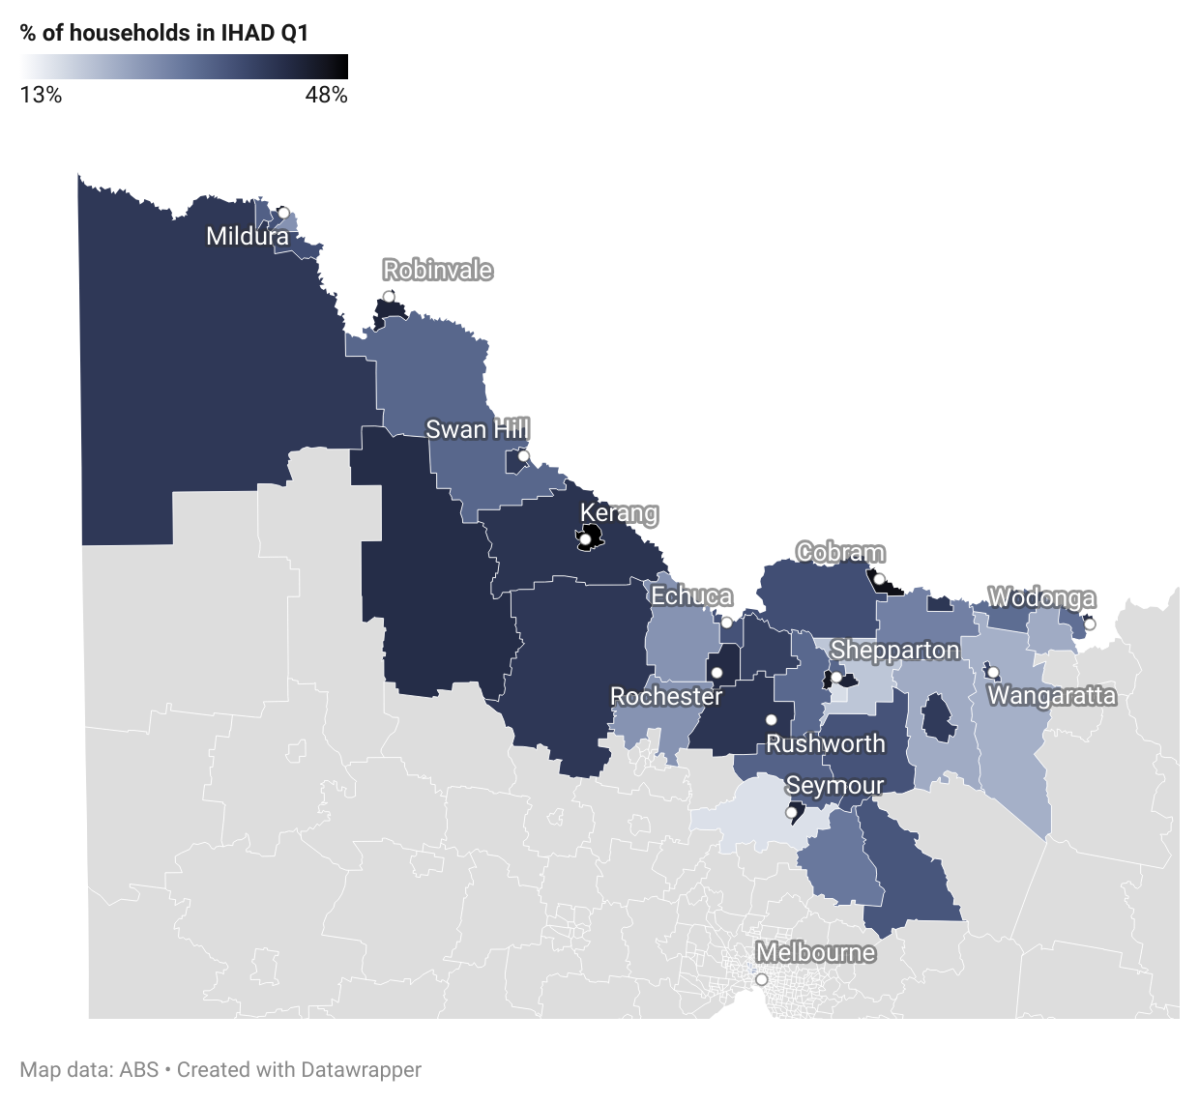

Some regional flood-affected areas had very high rates of poverty
Before the floods, 59% of regional flood-affected areas had higher levels of poverty than the regional Victorian average, and almost one-third had very high poverty rates of more than 15%.

Poverty in Victoria
The root causes of poverty are systemic, and a consequence of decisions made by governments and other institutional actors about policies, laws and the distribution of power, resources and opportunity.
Previous VCOSS research on poverty in Victoria has found that Aboriginal and Torres Strait Islander people, people of culturally and linguistically diverse backgrounds and people living with a disability are more likely than other Victorians to experience poverty.
This is because factors such as race, ethnicity, language, faith, health (and more) may intersect and compound disadvantage.
This analysis uses the 2021 VCOSS Poverty Maps dataset, developed by NATSEM, which models when a household’s disposable income falls below a level considered adequate to achieve an acceptable standard of living.
Our mapping identified that a majority of regional flood-affected areas (59%) had higher-than-average rates of poverty.
Almost one-third (32%) had very high rates of poverty of more than 15%. In Shepparton South East and Mildura North, for example, approximately one in five people were experiencing poverty in 2021.
In Rushworth, Wodonga, Mooroopna, Robinvale, and Seymour, more than one in six people were experiencing poverty.
This finding reinforces previous research suggesting that given people experiencing poverty can be at high risk from disasters because they are likely to have constrained housing options, and housing is more affordable in hazard-prone areas.
People living in poverty may also have less capacity to cope with disasters due to limited financial capacity and a higher likelihood of renting, experiencing homelessness, unemployment and lack of insurance.

Regional flood-affected areas with poverty rates higher than 15% in 2021:
Regional area (SA2) | Poverty rate (%)
Shepparton - South East | 22.29
Mildura - North | 19.47
Rushworth | 18.09
Wodonga | 17.50
Mooroopna | 17.38
Robinvale | 17.37
Seymour | 17.01
Kerang | 16.22
Cobram | 16.05
Kyabram | 15.97
Loddon | 15.97
Red Cliffs | 15.96
Buloke | 15.75
Numurkah | 15.22

Households experiencing poverty prior to the floods:
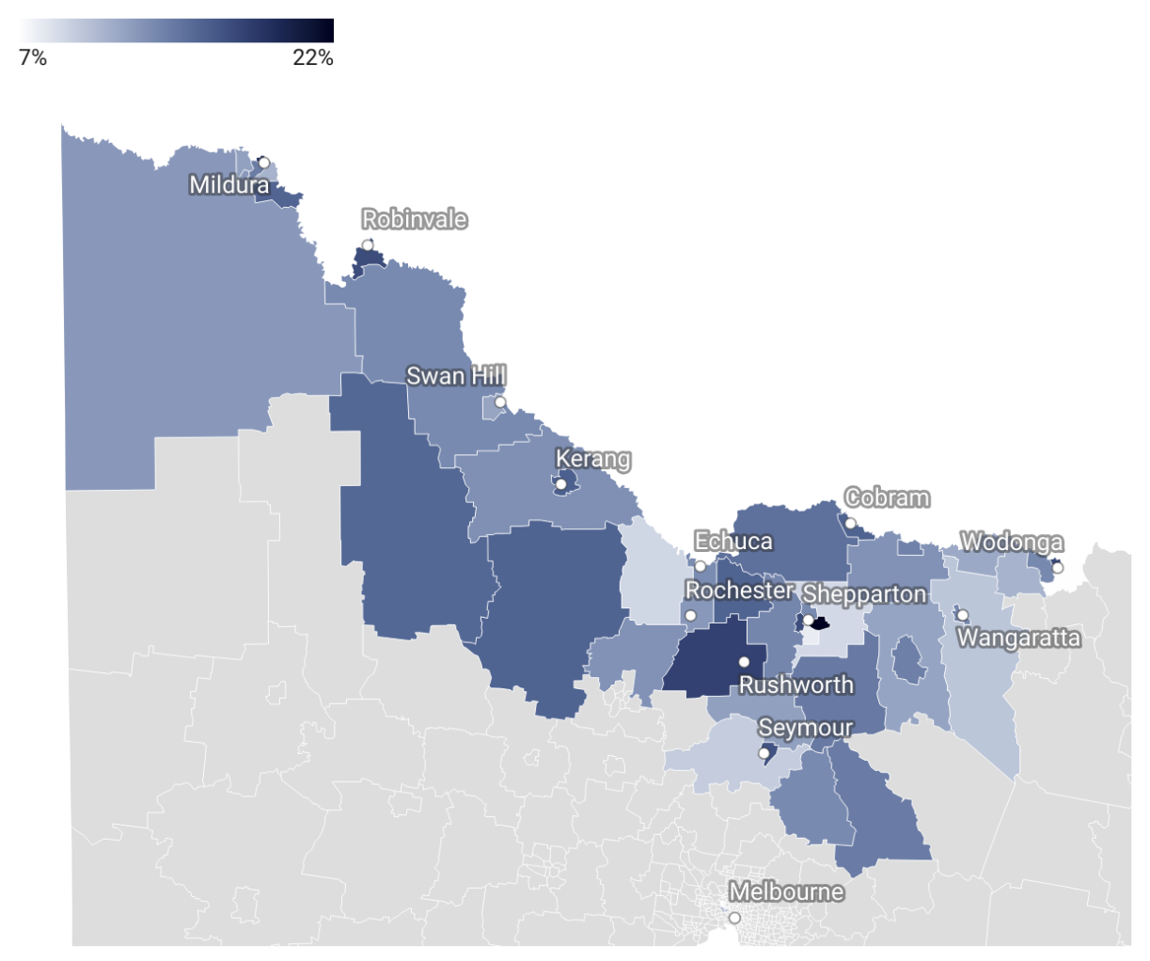

Aboriginal and Torres Strait Islander people were more likely to live in regional flood-affected areas
Aboriginal and Torres Strait Islander people were significantly more likely to live in regional flood-affected areas compared with unaffected areas.
Overall, 2.93% of people in flood-affected regional areas identified as Aboriginal and Torres Strait Islander, compared with 1.65% in unaffected regional areas.
People in flood-affected areas identifying as Aboriginal and/or Torres Strait Islander:
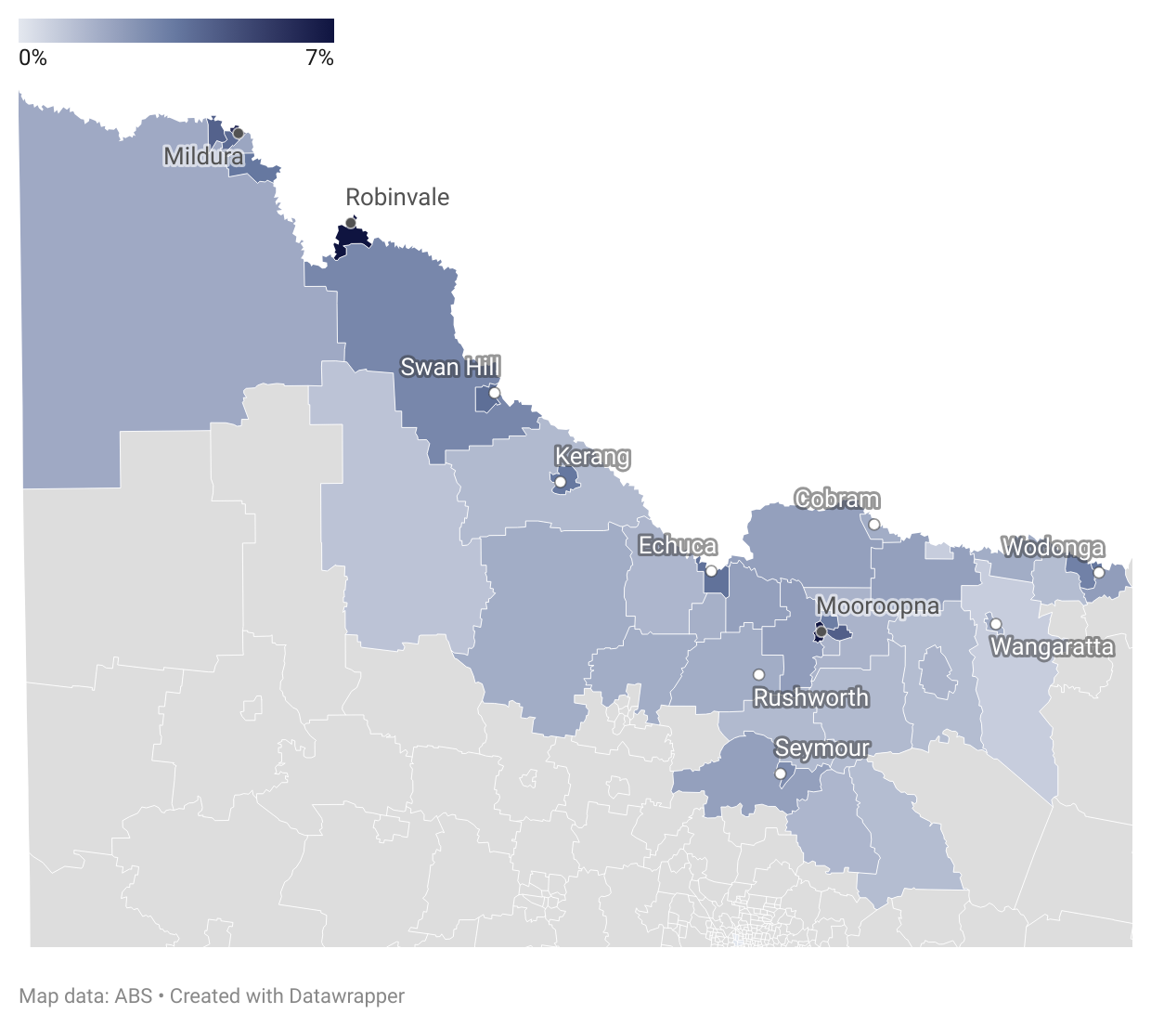
The Aboriginal and Torres Strait Islander population was higher in 93% of flood affected regional areas compared with unaffected areas. This included many regional flood-affected areas with significant Aboriginal and Torres Strait Islander populations, such as Robinvale (7.4%), Mooroopna (7.4%), and Mildura North (6.5%).
First Peoples are uniquely placed to lead disaster resilience efforts. As explained by the National Indigenous Disaster Resilience program, “Indigenous healing knowledges forms part of a distinctly Indigenous resilience.”
However, due to the ongoing impacts of colonisation, First Peoples experience disproportionate and distinct impacts from disasters. For example, Aboriginal people in Victoria have faced racism and culturally unsafe practices during emergency response and recovery, and the 2022 floods had a major impact on known cultural heritage sites.
These findings reinforce the urgent need highlighted by Traditional Owner groups and First Peoples organisations for self-determination to be embedded in emergency policy, including in planning, preparedness, response, and recovery. This has been recommended by the Yoorrook Justice Commission. For more detail, see Recommendations.
It is important to note that these figures do not capture the full impact of the floods on Aboriginal peoples, as impact of the floods on Country and cultural heritage may be felt by Traditional Owners regardless of their place of residence.

Culturally and linguistically diverse people were more likely to live in regional flood-affected areas and Maribyrnong
Before the floods, people who spoke a language other than English at home were more likely to live in flood-affected regional areas compared with unaffected areas.
In regional flood-affected areas, 7.43% of people spoke a language other than English at home, which was 2.78% higher than unaffected areas.
In Maribyrnong, almost half (47.9%) of the population spoke a language other than English at home, compared to one-third (33.75%) in unaffected metropolitan areas.
Culturally and linguistically diverse (CALD) communities have historically faced barriers to safety and support in emergencies. For example, communities raise issues such as a lack of trust in emergency services and a lack of appropriate, translated emergency warnings.
Of 44 regional flood-affected areas, 20 had a percentage of households that spoke a language other than English at home higher than the percentage in unaffected regional areas. Robinvale had the highest percentage (41.7%), followed by other regional centres and towns such as Shepparton, Kialla, Mildura, Cobram, Swan Hill, Mooroopna and Wodonga.
Top 10 flood-affected areas by households speaking a language other than English at home:
Area (SA2) | (%)
Maribyrnong | 47.9
Robinvale | 41.7
Shepparton - South East | 29.3
Ascot Vale | 25.4
Moonee Ponds | 24.5
Essendon (West) - Aberfeldie | 24.1
Niddrie - Essendon West | 21.4
Kialla | 19.3
Shepparton - North | 19.1
Mildura - South | 17.3

Multicultural communities have a critical role to play in directly supporting people of diverse backgrounds before, during and after emergencies. Their expertise can be more effectively leveraged to strengthen capability in the state’s emergency management system and to create more planning and response capacity at a local level. Refer to Recommendations for more detail.

Spatial injustice after the floods
This chapter considers spatial injustice after the floods by identifying community-level financial, health, and employment impacts following the emergency.
This analysis compares HILDA survey responses from 2021 and 2023 across key variables. The analysis uses a statistical matching approach, comparing respondents from flood-affected areas to a group of statistically matched respondents from unaffected areas. Using this approach allows us to identify the floods as a primary cause for community-level impacts, rather than other factors.

Key findings in this chapter
- After the floods, disposable income reduced by $22,818/year for households in affected areas.
- Poverty increased after the floods, with one in five people experiencing poverty in affected areas in 2023.
- After the floods, employment and participation in the labour force reduced, and the need for government income support increased.
- The floods had negative impacts for social, physical, and mental health outcomes.

The floods reduced disposable income and increased poverty
After the floods, disposable income for households in affected areas was $439/week, or $22,818/year, lower than similar households in unaffected areas (the matched group).
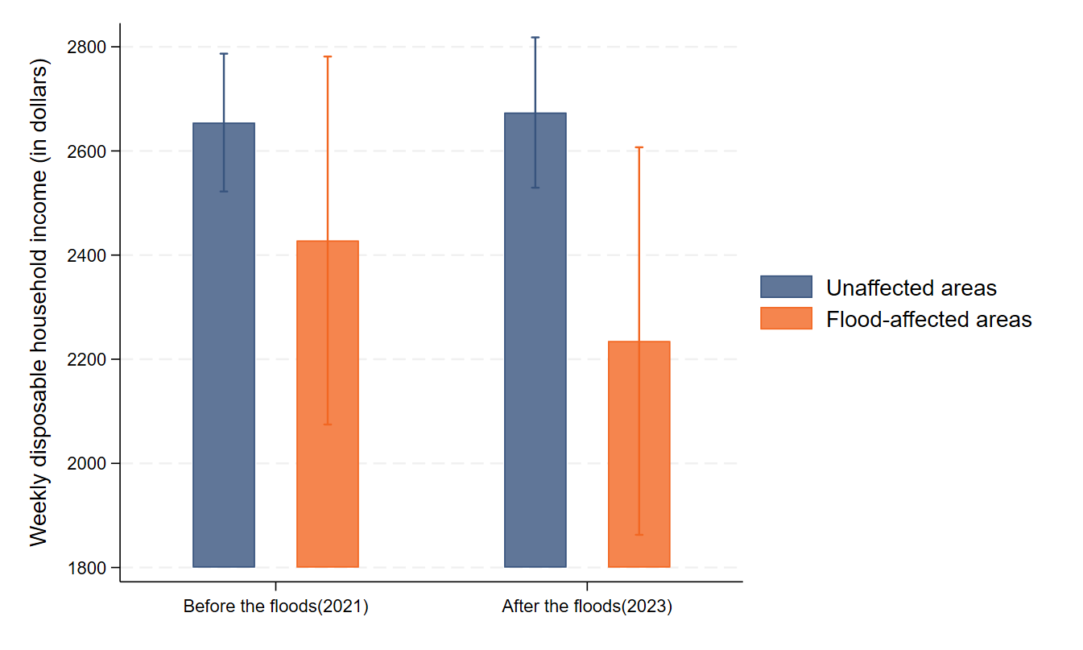
There was also a significant reduction in weekly disposable income for people in affected areas. After the floods, individuals saw a reduction of $290/week or $15,080/year compared with the matched group.
One in five people in affected areas were likely to be experiencing poverty after the floods, with poverty rates 6.1% higher than the matched group.
Affected areas saw an increase in poverty rates after the floods, from 15.2% in 2021 to 21.8% after the floods.
Among people who had similar rates of poverty before the floods, the matched group had relatively unchanged rates of poverty after the floods, compared with a significant increase in flood-affected areas.

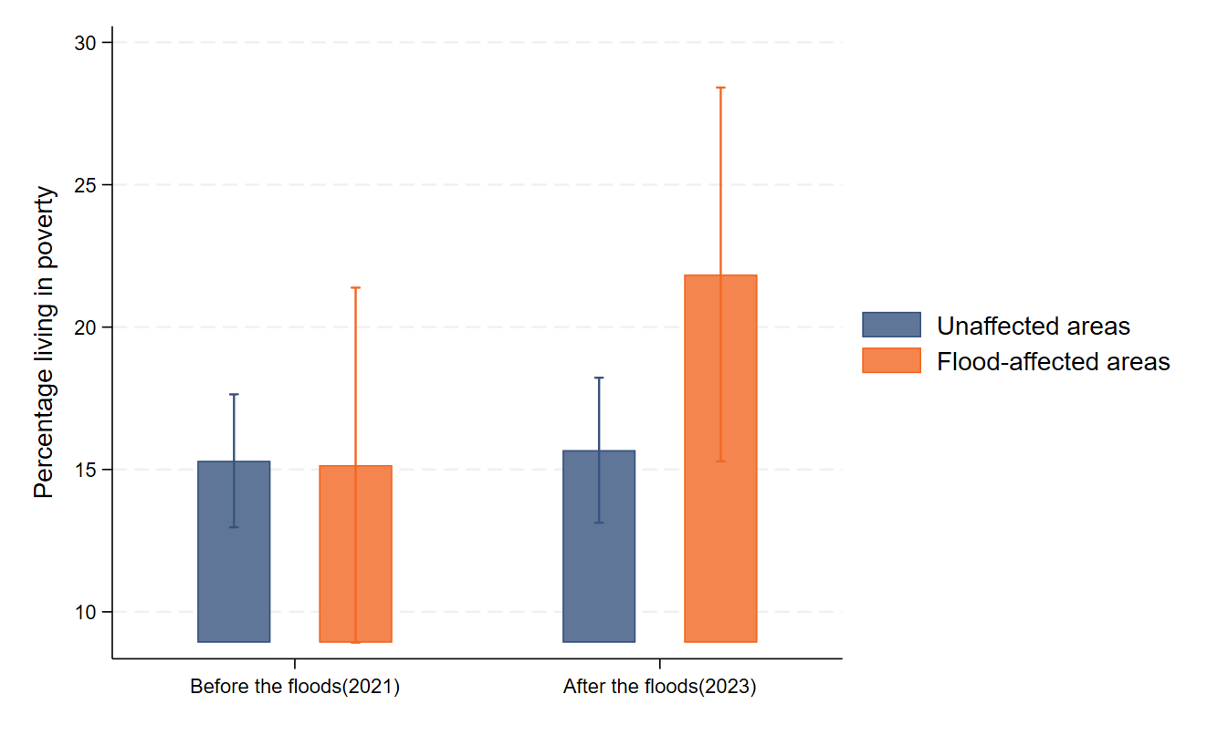

The floods reduced employment and increased the need for income support
After the floods, more than one in three people in affected areas were unemployed or not participating in the labour force. This is 9.6% higher than the matched group.
In flood-affected areas, unemployment and nonparticipation in the labour force increased from 31.1% in 2021 to 34.5% in 2023. This compares with a reduction of the unemployment and labour force nonparticipation rate in the matched group.
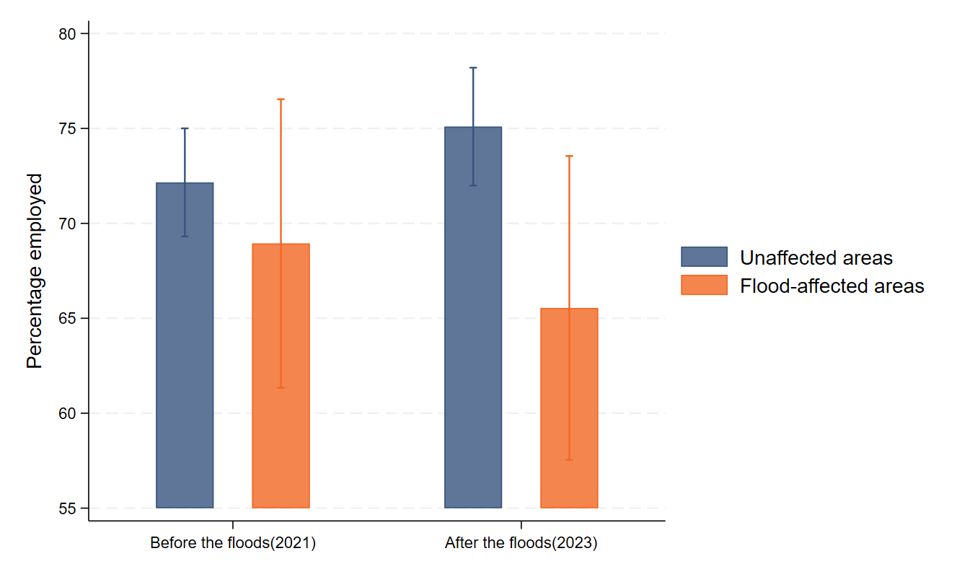
After the floods, close to one in four people in affected areas were receiving government income support payments. This is 8.3% higher than the matched group.
In flood-affected areas, the percentage of people receiving government income support payments increased from 21.2% before the floods to 24.4%. This compares to a decrease in the matched group from 19% to 15.7%.
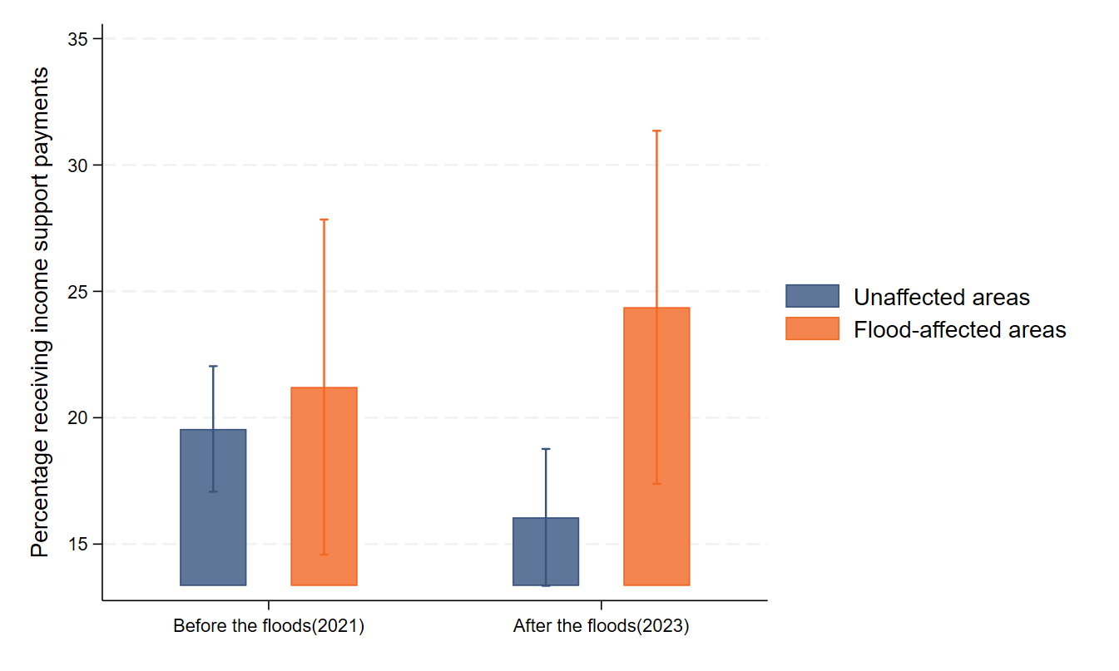

The floods negatively impacted social and physical functioning and increased the risk of depression

Social functioning worsened in flood-affected areas
In the HILDA survey, social functioning refers to the extent to which people’s physical and emotional problems interfered with their normal social activities with family, friends, neighbours or groups. Scores are given on a scale of 0 to 100, with 0 indicating lower social functioning and 100 indicating higher social functioning.
After the floods, social functioning for people in flood-affected areas worsened and was 5.4 points lower than would be expected when compared to the matched group.
Social connectedness and social capital are critical for building community resilience, and are often disrupted by disasters. Loneliness, lack of social support, and isolation are significant issues during the recovery period after disasters. The importance of supporting community connectedness is recognised in Victoria as one of eight priorities under the Wellbeing in Victoria strategy for 2025–2035.
For people in flood-affected areas, social functioning decreased from an average score of 82.4 in 2021 to 78.2 in 2023. In the matched group, social functioning increased over the same period from an average of 82.2 to 83.5.
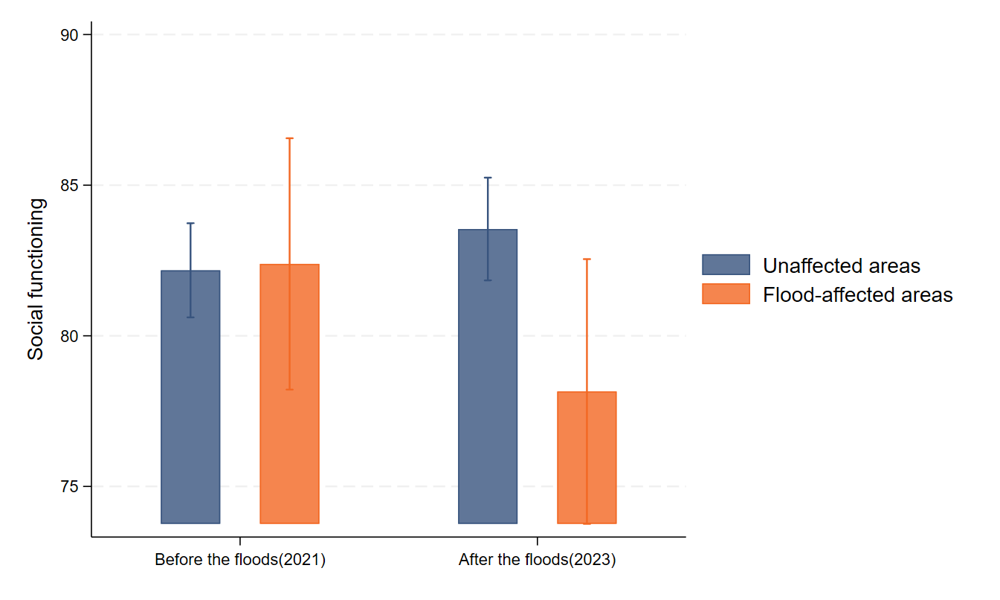

The risk of depressive symptoms increased in flood-affected areas
In this analysis, a high risk of depressive symptoms was derived using the five-item Mental Health Inventory (MHI-5), which measures feelings of nervousness and depression. Scores above 52 are commonly used to identify people who are at high likelihood of experiencing depressive disorders.
After the floods, more than one in five people in affected areas were at high risk of depressive symptoms. People in these areas had an 8% higher risk of depressive symptoms when compared to the matched group.
This is consistent with existing research that shows high mental health risks following disasters. The mental health impacts of disasters can extend well beyond the initial recovery period and be compounded by significant stressors during the rebuilding period, such as negotiations with insurance companies.
After the floods, the percentage of people in affected areas with a high risk of depressive symptoms increased from 16.8% to 21.8%. For the matched group, the percentage with high risk of depressive symptoms decreased during this same period, from 17.5% in 2021 to 13.8% in 2023.
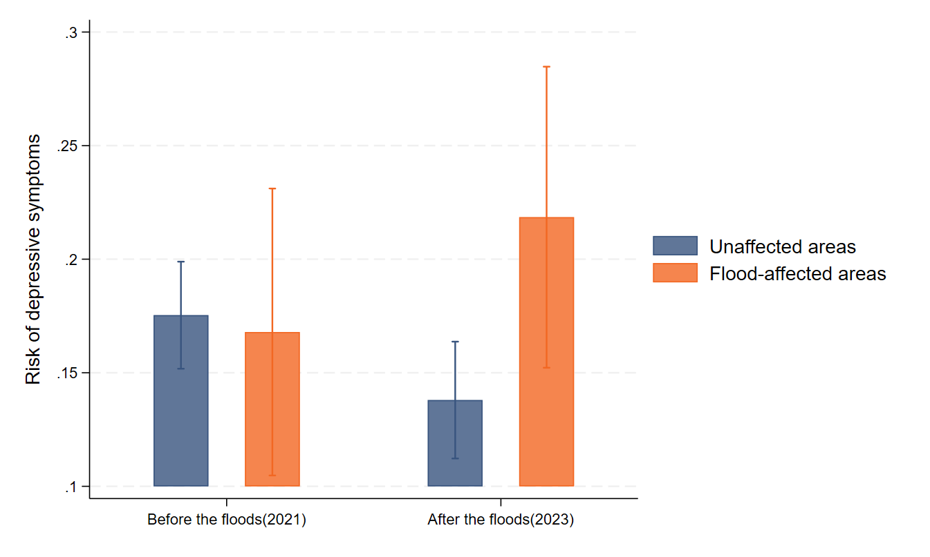

Physical functioning worsened in flood-affected areas
In the HILDA survey, physical functioning refers to the extent that someone reports their physical health interferes with performing daily activities. This is based on a series of questions, and scored from 0 to 100, with 100 indicating optimal functioning.
After the floods, physical functioning for people in affected areas worsened and was 6.1 points lower than would be expected when compared to the matched group.
Worsening physical functioning could be linked to injury incurred during the events, deteriorations in social and mental health in flood-affected areas, and the physical toll of rebuilding after disasters.
In flood-affected areas, physical functioning reduced from an average of 84.8 in 2021 to 80.1 in 2023. In unaffected areas, average physical functioning was relatively stable, at 86.6 in 2021 and 86.2% in 2023.
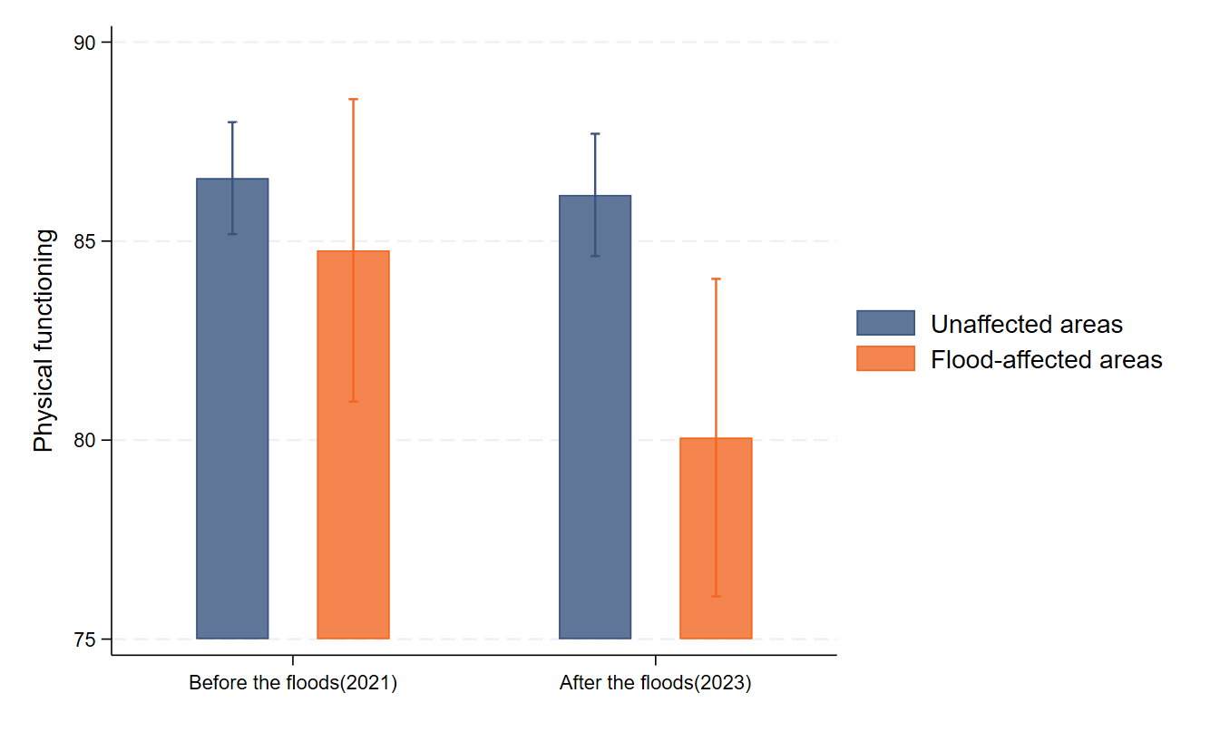

Recommendations
It is vital to learn the lessons from the 2022 floods to prepare for future emergencies.
This report shows that to build community resilience, patterns of spatial injustice must be addressed. This includes targeted interventions to support those at higher risk from disasters in disaster-prone locations, and support for community cohorts in these locations to lead disaster resilience efforts.
The findings in this report have implications that go far beyond future floods, with impacts on poverty, employment, finances, and social and physical functioning relevant to a range of emergencies. All disasters disproportionately impact people experiencing poverty and disadvantage, and implementing the recommendations in this report will support recovery from the January 2026 bushfires.

Reducing the risk before disasters strike

Recommendation 1: All levels of government should invest in targeted risk reduction and preparedness programs for people experiencing poverty and socioeconomic disadvantage in high flood-risk areas.
Investment in disaster risk reduction and preparedness provides significantly greater return on investment compared with spending on recovery, yet an estimated 87% of Commonwealth disaster funding in Australia goes towards recovery.
To address this, VCOSS recommends:
  - The Victorian Government co-design a Resilient Homes Program with Victorian renters, owner-occupiers and housing providers in flood-prone areas, to enable those with the greatest disadvantage and greatest climate risk to strengthen the resilience of their homes. This is consistent with Recommendation 23 of the Final Report of the Parliamentary Inquiry into the 2022 Flood Event in Victoria and Recommendation 46 of the Final Report of the Parliamentary Inquiry into Climate Resilience in the Built Environment.
  - The Victorian Government strengthen planning regulations to make new developments safe from future climate impacts, including flooding. This should include requiring the use of up-to-date climate projection data in the planning system, and consideration of areas that should be off-limits for future development by progressing the building and planning reforms announced in October 2024. It is critical that these changes are accompanied by supports for low-income owner occupiers whose existing homes are impacted by updated planning schemes, such as changes to insurance premiums or house values.
  - The Commonwealth Government increase investment of the Disaster Ready Fund (DRF) in projects that prioritise equity for people experiencing poverty and disadvantage. This should include increasing the overall funding allocated to the DRF, and allocating specific funding to projects that focus on equity for people experiencing poverty, disadvantage and higher risk from disasters.
  - The Victorian Government invest in the establishment of an ongoing disaster resilience workforce in the community and ACCO sectors, including initial investment in co-design of this workforce. This should include funding for a core workforce of disaster resilience specialists within place-based, specialist, statewide and cohort-specific services for people at higher risk from emergencies. While co-design is underway, agencies with existing recovery programs should be funded to retain at least 1 FTE between emergencies to ensure continuity of institutional knowledge and skills, and readiness for future disasters.

Recommendation 2: Local emergency management planning should meaningfully involve communities experiencing spatial injustice and higher risk of emergencies in their areas.
No community is the same, and this report reinforces the need for community-led, place-based planning to ensure that local emergency management planning is responsive to a diversity of community needs.
Current guidance only requires Municipal Emergency Management Planning Committees (MEMPCs) to involve a single community organisation and a single community representative.
To address this gap, VCOSS recommends:
  - MEMPCs increase representation to involve a range of organisations and community members, including First Peoples and multicultural communities. Membership of MEMPCs should be responsive to specific patterns of local spatial injustice.
  - MEMPCs, local governments and the Victorian Government should actively plan with cohorts at higher risk from disasters. This could include establishment of lived experience advisory groups and utilisation of the Victorian Emergency Management Planning Toolkit for People Most at Risk.

Supporting self-determination for First Peoples

Recommendation 3: All levels of government should support self-determination for First Peoples in emergency preparedness, response and recovery.
This report finds that First Peoples in Victoria were disproportionately likely to be impacted by the floods. This is significant in the context of the Yoorrook Justice Commission report and recommendations, and research from the National Indigenous Disaster Resilience Program, which finds that First Peoples in Victoria face distinct and disproportionate impacts from emergencies and are often excluded from emergency management processes.
All levels of government must continue to work towards self-determination for First Peoples in Victoria across all phases of emergency management. Initiatives such as the Strategy for Aboriginal Community Led Recovery are important first steps, but much more needs to be done.
3.1 In the short term, the Victorian Government should commit to and fund implementation of Yoorrook Justice Commission Recommendation 46 to support First Peoples-led disaster resilience. This includes:
- conducting a full review of all emergency management legislation in relation to priorities for Victorian First Peoples;
- providing ongoing funding for Traditional Owner Groups, ACCOs and ACCHOs to prepare for, respond to and recover from emergencies; and
- giving weight to Traditional Owner voices regarding the protection of Country and cultural heritage.

Supporting leadership by multicultural communities

Recommendation 4: All levels of government should support multicultural communities to lead emergency preparedness, response and recovery.
This report confirms that the 2022 floods had a disproportionate impact on multicultural communities. These communities experience barriers to and exclusion from emergency management planning, response and recovery processes that urgently need to be addressed.
The Victorian Government has supported initiatives which enabled stronger connections between government and multicultural communities. However, additional investment is needed to address the higher risk experienced by multicultural communities:
  - The Victorian Government should provide ongoing funding to multicultural community organisations to build and maintain their capacity to prepare for, respond to and recover from emergencies.
  - Local governments and the Victorian Government should support multicultural communities to be involved in Municipal, Regional and State Emergency Management Planning Committees and ensure all plans reflect the needs and priorities of multicultural communities. At a local level, this includes ensuring culturally appropriate and accessible services before, during and after emergencies, such as bicultural works in Emergency Relief Centres and recovery hubs. This is in line with recommendations from the Ethnic Communities Council of Victoria.
  - The Commonwealth Government and Victorian Government should provide specific funding during emergency response and recovery for multicultural community leaders and organisations to provide culturally appropriate and accessible services for their communities.

Building back better and fairer after disasters

Recommendation 5: The Commonwealth and Victorian Government should increase financial support for people who experience emergencies.
This research demonstrates the long-lasting financial consequences for households impacted by disasters, and the increased risk of poverty after disasters. Financial assistance for people affected by disasters should be increased, including:
5.1 The Commonwealth Government should, at a minimum, increase the Australian Government Disaster Recovery Payment from $1,000 to $3,000, and from $800 per child to $1,200 per child for people who have been adversely affected by disasters. The payment should also be reviewed annually and adjusted in line with changes to the Consumer Price Index, as is the case for the Victorian Government’s Emergency Relief Assistance payment.
  - In line with Recommendation 62 of the Parliamentary Inquiry into the 2022 Flood Event in Victoria, the Victorian Government should evaluate the criteria and funding arrangements for financial assistance post-disaster with a view to better aligning support with costs of recovery. Updated funding arrangements should include:
- Increasing the Emergency Relief Assistance payment to match the recommended level of the Australian Government Disaster Recovery Payment, to $3,000 per person and $1,200 per child.
- Expanding and clarifying eligibility for the Victorian Government’s Emergency Reestablishment Assistance program. This program currently supports people who cannot live in their home due to damage or cannot return to their homes for seven days after floods, do not have building or contents insurance, and are experiencing financial hardship. This should be expanded to include people who are underinsured and people whose homes are damaged but inhabitable, and criteria should be clear and publicly available.

Recommendation 6: The Commonwealth and Victorian Government should provide additional supports to address loss of income and employment during recovery from disasters.
This report reveals that unemployment after disasters is a significant issue that has been insufficiently addressed by existing policy. Unemployment and labour force nonparticipation was found to increase not just in the immediate aftermath of the floods, but 12 months into the recovery process.
VCOSS recommends that the Commonwealth and Victorian Government work together to ensure that income support is adequate, and employment opportunities are boosted following disasters.
Initial priorities include:
6.1 The Commonwealth Government should reform the Disaster Recovery Allowance and Jobseeker payments so that they provide adequate income support for those who need it following disasters. Rent assistance should also be made available to those receiving the Disaster Recovery Allowance.
  - The Commonwealth Government should suspend mutual obligations for those receiving income support payments for a suitable period that allows time for recovery and continuity of payments following disasters and heatwaves. This would recognise the significant disruption, trauma and financial stress experienced during this period.

  - The Victorian and Commonwealth Government should scale up programs that boost employment and skills during disaster recovery, such as recovery programs that train and hire local workforces and provide participants with transferable skills and certifications for those working in recovery roles. For example, YACVic’s Future Proof project provided paid traineeships and qualification pathways for young people impacted by disasters.

Recommendation 7: The Commonwealth and Victorian Government should increase investment in psychosocial recovery after disasters.
Only 11% of Commonwealth disaster funding is spent on the social domain. This is despite significant evidence of the importance of social infrastructure and connectedness for building resilience, and the long-term psychosocial impacts of disasters. In regional areas, this can be compounded by the lack of available mental health services.
The Commonwealth and Victorian Government should invest more in social recovery programs and psychosocial supports for communities experiencing disasters, particularly in regional areas. This should include:
  - The Victorian Government should increase investment in social infrastructure, including neighbourhood houses and ACCOs, particularly in regional areas.
  - The Commonwealth and Victorian Government should provide flexible funding for community-led programs aiming to improve psychosocial wellbeing and connection as part of disaster recovery packages. This would support delivery of community and family supports in line with the Victorian Government’s Guide to emergency psychosocial supports and the Australian National Disaster Mental Health and Wellbeing Framework.
  - The Victorian Government should develop a framework for community-led flexible social recovery funding to guide investments and ensure funds reach communities as quickly as possible following disasters. This should be used to guide existing funding streams, such as the DRFA and DRF where relevant, as well as additional investments.
  - The Victorian Government should increase funding to key agencies to increase delivery of trauma-informed psychosocial supports following emergencies. This will ensure the right evidence-based interventions are delivered at the appropriate level, are put in place at the right time and in the right location.

Methodology

Identifying the flood-affected areas
The flood-affected areas have been identified by layering a publicly available flood extent map over 49 Statistical Areas Level 2 (SA2s) (487 Statistical Areas Level 1 (SA1s)) using the sf spatial data package in R.
SA2s represents a community that is integrated socially and economically, with average populations of about 10,000 people. The design of SA2s is organised around the ‘functional centres’ such as regional towns where people access services.
These characteristics make SA2s suitable for understanding community-level exposure to the 2022 floods, such as understanding local economic vulnerabilities. This approach provides a high-level understanding of areas impacted but does not capture the detailed and varied impacts of the flood over space and time. For example, it does not show where floodwaters may have taken more or less time to recede, or where flood height was greatest.
The 49 SA2s include areas with partial overlap with the flood extent. The strength of this approach is that it is more inclusive of areas that may have been threatened by the floods and would have experienced local impacts beyond direct inundation. However, it also means that these key findings should not be interpreted as directly relating to the experience of people whose houses were lost or damaged due to the floods – this group may have experienced greater impacts than the findings in this report suggest.

Baseline analysis of socioeconomic and demographic characteristics
Following identification of flood-affected areas, the research analysed results and modelling based on the 2021 Census to consider how the baseline socioeconomic and demographic characteristics of these areas compared to the rest of Victoria.
This data included the 2021 Census release, as well as models built from the 2021 Census results, including IRHAD, SEIFA, and VCOSS Poverty Maps which are based on a model developed by NATSEM.
The variables chosen for comparison were based on existing literature regarding communities that may experience disproportionate or distinct impacts from the 2022 floods, and emergencies in general. The variables considered are included in a publicly available dataset on the VCOSS website. ABS data can be accessed through the ABS website, and the Poverty Maps dataset is publicly available on the VCOSS website and on NATSEM’s website.
Results from flood-affected SA2s were compared to unaffected SA2s and differences tested for statistical significance using two-sample t-tests. Metropolitan SA2s and rural and regional SA2s were compared separately since rural and regional SA2s can vary significantly.

Analysis of the impact of the floods on affected areas
The analysis sources data from the Household, Income and Labour Dynamics (HILDA) Survey to assess the impact of the floods on the affected areas identified using the flood extent at the SA1 level. The HILDA Survey is a nationally representative, longitudinal study, with a stratified multistage, clustered sampling design.
The 2021 HILDA Survey results are used to establish the baseline levels of social, economic and health variables of interest for respondents in the flood-affected areas. The 2023 HILDA Survey results provide the outcomes for these variables after the floods.
In 2021 there were 132 respondents identified in the flood-affected areas, and in 2023 there were 119. Because the HILDA Survey is not necessarily representative at small statistical areas, the findings should be taken to relate to flood-affected areas across the state as a whole rather than each local area considered.
To demonstrate that the results are due to impacts of the floods, rather than other factors, the analysis uses a matching approach. This involves comparison of people in flood-affected areas to a group of people in Victoria who are similar in terms of demographic, socioeconomic, and health status prior to the disaster but reside in the rest of Victoria outside of the flood-affected areas. A ratio of 10 people outside of the flood-affected areas for every 1 person in the flood-affected areas was used.
The differences between the affected and unaffected areas were tested for significance both in 2021 and 2023. No significant differences were found in 2021, supporting the robustness of the matching approach. Only significant differences in 2023 between the flood-affected group and matched group have been reported. These are significant to the 5% level unless otherwise indicated.
This is a causative approach, meaning findings can be attributed to the floods rather than other factors.






Legislative Council Environment and Planning Committee, Inquiry into the 2022 flood event in Victoria, Final Report, July 2024, p. 25.
Ibid., p. 27
Australian Institute for Disaster Resilience, Major Incidents Report 2022-23, p. 33.
Legislative Council Environment and Planning Committee, Inquiry into the 2022 flood event in Victoria, Final Report, July 2024, p. 26
Victorian Auditor General’s Office, Relief and Recovery Funding for the 2022 Floods, October 2025.
Victorian Government, October 2022 Victorian floods, https://www.vic.gov.au/2022-flood-recovery
K Hayes et al., ‘Rural and remote health care: the case for spatial justice’, Rural Remote Health, January 2025.
K MacDonald et al., ‘The spatiality of economic maldistribution in public-school funding in Australia’, Journal of Educational Administration and History, October 2021.
SA1s were not used for the baseline analysis due to a perturbation process by the ABS, which means that small random adjustment has been made to protect individuals’ identities.
Jesuit Social Services Centre for Just Places, Dropping off the Edge, 2021.
VCOSS, Stories into Evidence: Covid-19 adaptations in the Victorian community services sector, p. 9-11.
AIDR Knowledge Hub, ‘Black Summer bushfires’, https://knowledge.aidr.org.au/resources/black-summer-bushfires-vic-2019-20
A Li et al., ‘Mapping social vulnerability to understand the health impacts of climate change’, Lancet Planetary Health, November 2023.
ABS, Socio-Economic Indexes for Areas, https://www.abs.gov.au/websitedbs/censushome.nsf/home/seifa; ABS, Index of Household Advantage and Disadvantage, https://www.abs.gov.au/statistics/people/housing/index-household-advantage-and-disadvantage/latest-release
Differences were found to be significant at the 1% level.
VCOSS, Mapping Poverty in Victoria, August 2023, https://vcoss.org.au/cost-of-living/2023/08/povertymaps/
VCOSS and NATSEM, Mapping Economic Disadvantage in Victoria, 2023, https://storymaps.arcgis.com/stories/8a33eb4e552f4b32bbd5314b8e98943b
Overall, statistically significant differences were not found between average levels of poverty across all regional flood-affected areas compared with regional unaffected areas at baseline.
J. Plass and J. Zinn, “The Australian housing affordability trap – How environmental, institutional, and structural factors can immobilize Australian households in the face of extreme weather events – A case study on flooding”, Climate Risk Management, 2025.
Legislative Council Environment and Planning Committee, Inquiry into the 2022 flood event in Victoria, Final Report, July 2024, p. 402, 427.
P. Quinn, B. Williamson, L. Gibbs, “Indigenous informed disaster recovery: Addressing collective trauma using a healing framework”, Progress in Disaster Science, 2022, p. 9.
B. Williamson, F. Markham, and J Weir, “Aboriginal Peoples and the Response to the 2019–20 Bushfires”, Centre for Aboriginal Economic Policy Research, 2020, p, 13.
Legislative Council Environment and Planning Committee, Inquiry into the 2022 flood event in Victoria, Final Report, July 2024, p. 26.
Yorrook Justice Commission, Land, Sky and Waters Recommendations, https://www.yoorrook.org.au/reports-and-recommendations/recommendations
VCOSS, Communities at the Centre: Insights from the Multicultural Resilience Project, 2023, p. 10; 12.
Significant at the 5% level, 95% Confidence interval (CI) of -$31.4 to -$846.3/week.
Significant at the 5% level, 95% CI of -$39.90 to -$540.20/week.
This difference was found to be significant at the 10% level, with a 95% confidence interval of -1.7% to 14%, suggesting that a more significant effect may be confirmable with a larger sample size and lower variability.
The variation of the affected area baseline of 15.2% in 2021 rather than 13.4% is due to these results which are derived from the HILDA survey (a subset of affected areas) rather than VCOSS Poverty Maps (based on ABS surveys and census).
Significant at the 5% level with a 95% CI of 0.5% to 18.6%.
Significant at the 5% level with a 95% CI of 1.9% to 16.4%.
Significant at the 5% level, with a 95% CI of -9.8 to -1 points.
Australian Red Cross, The hidden power of community: Unveiling social capital’s role in Australia’s disaster resilience, 2024.
J Lam & A Li, (2025). Effects of climate-related disasters on loneliness, social support, social functioning, and social contacts: longitudinal analyses of impact and recovery. Scientific Reports, 15(1), 10799.
Department of Health, Wellbeing in Victoria: a strategy to promote good mental health 2025-2035, August 2025.
Significant at the 5% level, with a 95% Confidence Interval of 0.2% to 15.9%.
Li, A., Toll, M., & Bentley, R. (2023). Health and housing consequences of climate-related disasters: a matched case-control study using population-based longitudinal data in Australia. The Lancet Planetary Health, 7(6), e490-e500.
GenWest, Our Community, Our Voice: Lessons from the 2022 Maribyrnong Flood, 2024, p. 35.
Significant at the 1% level, with a 95% CI of -10.4 to -1.8.
M. Zacher, E. J. Raker, M. C. Arcaya, S. R. Lowe, J. Rhodes, & M. C. Waters, ‘Physical health symptoms and Hurricane Katrina: individual trajectories of development and recovery more than a decade after the storm,’ American journal of public health, 111(1), 2021, 127-135; A. Li et. al., ‘Vulnerability and recovery: long-term mental and physical health trajectories following climate-related disasters,’ Social Science & Medicine, 320, 2023.
UN Office for Disaster Risk Reduction, https://www.undrr.org/our-work/our-impact, accessed 31 January 2025.
Andrew Colvin, Final Report: Independent Review of Commonwealth Disaster Funding, April 2024, p. 23.
Department of Transport and Planning, Updating maps and planning and building controls to better manage flood risk, October 2025, https://www.planning.vic.gov.au/news/articles/new-flood-risk-tools-to-make-homes-more-climate-resilient
Emergency Management Victoria, Victorian Emergency Management Planning Toolkit for People Most at Risk, https://www.emv.vic.gov.au/responsibilities/emergency-management-planning/emergency-management-planning-resource-library-0/victorian-emergency-management-planning-toolkit-for-people-most-at-risk
Emergency Recovery Victoria, Strategy for Aboriginal Community-led Recovery, 2023.
Department of Premier and Cabinet, Victorian Government Report on Multicultural Affairs 2023-2024, 2025, p. 13.
Ethnic Communities Council of Victoria, Multicultural Communities Experience of the 2022 Victorian Floods, 2023.
ACOSS, Disaster Response, Recovery and Resilience Plan, 2022.
DFFH, Personal Hardship Assistance Program, 2025 https://services.dffh.vic.gov.au/personal-hardship-assistance-program, accessed 3 Nov 2025
ACOSS, Disaster Response, Recovery and Resilience Plan, 2022.
ACOSS, Disaster Response, Recovery and Resilience Plan, 2022.
YACVic, Future Proof: Young People, Disaster Recovery and (Re)building Communities, https://www.yacvic.org.au/get-involved/future-proof/, accessed 9 Oct 2025.
DFFH, A guide to emergency psychosocial support, 2025.
Ibid.

