


Community-led climate adaptation:
Case studies from
Victorian communities
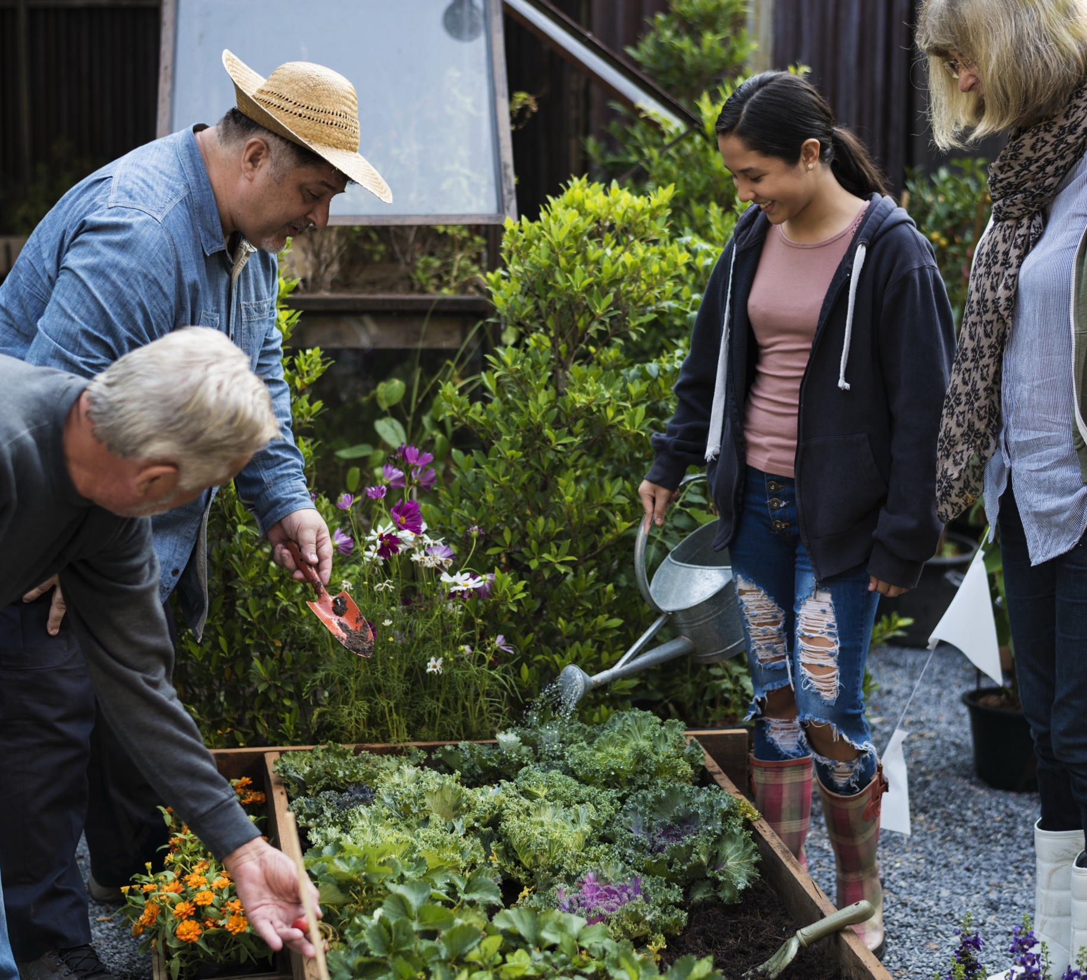
May 2026
About VCOSS
VCOSS is the peak body for Victoria’s social and community sector. We activate collective power and influence change to achieve social and economic justice for current and future generations. Our goal is a Victoria free from poverty and disadvantage, where every person and community is supported to thrive.
We work to achieve our goal through policy development, public and private advocacy, supporting and increasing the capabilities of the state’s social sector organisations, forging strong coalitions for change, and explaining the true causes and effects of disadvantage.
VCOSS’s strength comes from our members and the people and communities at the heart of their work. Our members include frontline social services, peak bodies, advocacy groups and community associations, all passionate about an inclusive, caring and resilient Victoria.
Primary author: Julianne Tice.
Supervising Director: Jonathon Gurry.
Authorised by VCOSS CEO Juanita Pope.
VCOSS welcomes the opportunity to provide this input.
Please send enquiries to vcoss@vcoss.org.au
You can browse more VCOSS reports and submissions at vcoss.org.au/PolicyLibrary

The Equitable Responses to Climate Change Project is supported by the Victorian Government.
Acknowledgement of Traditional Owners.
VCOSS acknowledges the Traditional Owners of Country and pays respect to Elders and Ancestors. Our office is located on the sovereign, unceded lands of the Wurundjeri Woi-Wurrung people of the Kulin Nation.

Community-led climate adaptation: Case studies from Victorian communities
Contents
Introduction 3
A holistic approach to climate adaptation 5
Community garden strengthens climate resilience 6
Multicultural Heat Heroes in Action provide tailored heat health information 7
Social connection is the key to climate resilience 8
Enabling communities to flourish in their climate response 9
Conclusion 10
Key terms 13
References 14

Introduction
Climate change is here. Adapting to its impacts is not an optional extra – it is a social and economic imperative. Already in Australia, disasters cost the economy a combined $38 billion a year, along with unquantifiable human and animal suffering, and ecological destruction.
Regardless of what actions are taken to address climate change, significant harms are already locked in, including risks to people’s lives, livelihoods, health and wellbeing. In the currently projected 2.6°C warming scenario, there will be more frequent and intense disasters and around four times as many heatwaves by 2050. Water and food security will be undermined, and First Peoples’ cultural connections with land devastated.
There is still a wide array of possible emissions pathways and climate futures, so climate mitigation is, rightfully, a priority for government and interested groups across our communities.
However, given what is already here and what is coming, climate adaptation must also be non-negotiable.
The focus of adaptation matters enormously. This is because, while everyone will be impacted by climate change, not everyone will be impacted equally.
The same groups who are hardest hit by climate change are those facing the greatest limitations on their capacity to adapt to it, because of systemic barriers such as:
- Location, which affects access to education and employment opportunities, and exposure to heat and disasters
- Gender, with women often taking on greater caring roles and having less capacity and resources to adapt
- Experiences of disability, which often put households in financial precarity and at greater physical risk.
Recent research by VCOSS and the University of Melbourne sheds light on the underlying inequities that affect who is hardest hit – including people experiencing poverty, First Peoples, and culturally and linguistically diverse communities. It also reveals how inequities are entrenched and exacerbated by climate change and disasters, creating a feedback loop of disadvantage.
Adaptation to climate change will not work unless it addresses the needs of the most imperiled groups. What is needed is transformative adaptation, which means dismantling those barriers to adaptation, and shifting the burden of adapting away from individuals and towards systems-level adaptation.
Victoria’s community services sector plays a vital role in creating the conditions for exactly this kind of community-led, transformative adaptation. They do this by working with people experiencing systemic disadvantage, involving community members as active partners in the projects, building capacity and enabling people to take actions that work for them in their context.
The case studies in this report explore some of the models the community sector already has in place for this vital capacity- and resilience-building work, with a view to providing guidance, inspiring broader adoption at the community and sector levels, and catalysing funding, systemic planning and upscaling at the government level.
Each project has resulted in multi-faceted outcomes for health, wellbeing, empowerment and environmental outcomes, demonstrating how transformative adaptation can simultaneously strengthen adaptive capacity and improve people's lives. These models shed light on the transformative adaptation that can be achieved through partnerships between all levels of government and the community services sector.
The case studies are also contextualised through an exploration of the learnings emerging from each project, as well as a brief analysis of as well as how the adaptation activities work within and further the objectives of Victorian legislation and policy priorities around climate adaptation. This context is provided for funders, and for community sector workers seeking to implement or upscale their own initiatives.
Climate adaptation must look different depending on the where, who and what: the location of adaptation initiatives, the people involved, and the climate impacts being addressed. These case studies show what this can look like in practice, where the community services sector is adequately resourced to support communities.

A holistic approach to climate adaptation
Banksia Gardens Community Services, Broadmeadows, Vic
Banksia Gardens Community Services works towards climate adaptation in its community by empowering young people, strengthening the circular economy, and connecting its efforts for a holistic approach to adaptation.
The organisation
Located in Broadmeadows – one of Victoria’s most disadvantaged areas – Banksia Gardens is a neighbourhood house that delivers programs largely focused on training and mentoring local young people in preparation for workforce participation. This focus is strongly connected with sustainability initiatives and the circular economy through Banksia Gardens’ social enterprises, with the ultimate goal of reducing social disadvantage and creating opportunities for young people in the area.
The approach
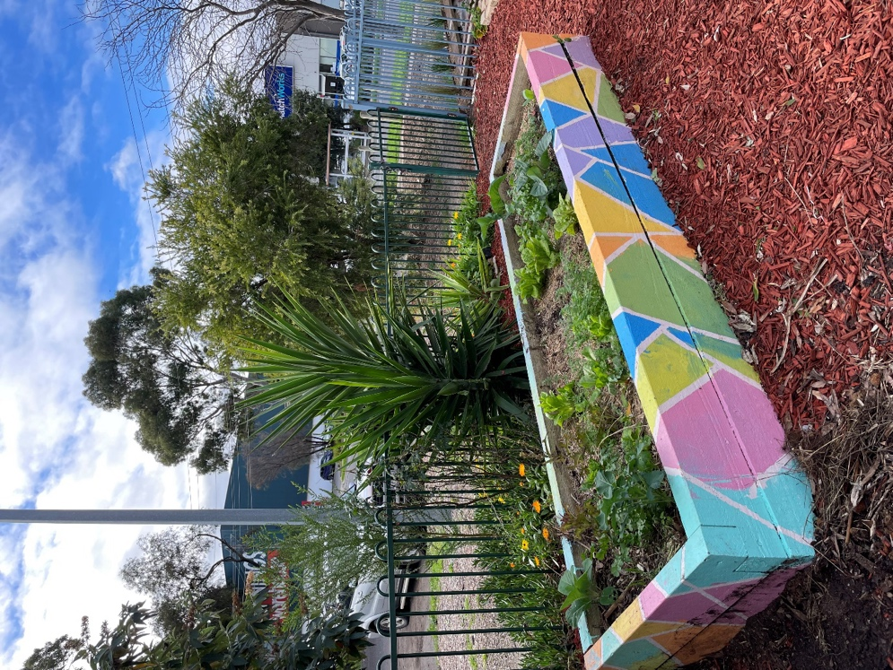
Banksia Gardens takes a holistic approach to adaptation that integrates education, evidence-based climate action, and economic links.
The Climate Action Requires Youth Action (CARYA) program at Banksia Gardens provides local students with opportunities for hands-on education by encouraging them to demand change in the climate change and social arena. In a new iteration of the program, Banksia Gardens has partnered with the local Kangan Institute to run the CARYA Breakfast Club with year 10 VCE/VET students, providing education on climate change and related topics, including gender equity, soil and composting, and gardening.
The local area around Banksia Gardens has a high urban heat island effect due to an abundance of concrete and hard surfaces. The organisation has planted six gardens, with the goal of increasing biodiversity to reduce the impact of heat and strengthen social wellbeing in the local area.
Figure 1: A garden bed at Banksia Gardens Community Services.

Community garden strengthens climate resilience
Wellsprings for Women, Dandenong, Vic
Wellsprings for Women co-designed a climate resilience project with a group of multicultural women in Melbourne’s southeast. The resulting project was a community garden that empowers local leadership and facilitates social connection.
The organisation
Wellsprings for Women is a women-only neighbourhood house and Learn Local based in Dandenong. Wellsprings provides programs and services tailored to meet the needs of women who face social, cultural, economic and political barriers to participation in society.
The approach
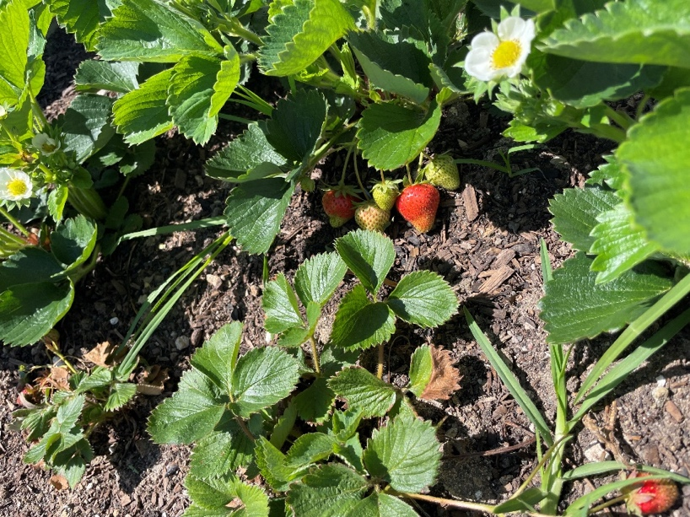
In 2023, Wellsprings recruited a group of 8 women, the participation of whom was supported through a stipend, to create a climate resilience project. Through a co-design process, the group decided to build a community garden.
In the initial phases of the project, the group learned about climate change and how it impacts people, including impacts to water availability, health and food – and reflected on changes and climate disasters they had witnessed in their home countries. They also discussed heat and ways of keeping the local area cool through planting. Workshops were also held around confident speaking and leadership skills to prepare the group of women to participate in the project and strengthen their connections with their community.
Using their new skills, the team has developed a presentation on staying safe in the heat and presented it to women in classes at Wellsprings; promoted the garden and recruited members; organised and facilitated working bees and events; and led school groups with garden activities.
Figure 2: Strawberries growing at Wellsprings for Women’s climate resilience community garden.

Multicultural Heat Heroes in Action provide tailored heat health information
enliven Victoria, Ringwood, Vic
enliven Victoria has trained bi-cultural community leaders to share information about heat health with their networks in Melbourne’s southeast. The project has resulted in multicultural communities having heat preparedness information tailored to their needs.
The organisation
enliven supports the use of plain language, leads community engagement and strengthening initiatives within multicultural communities, and leads planetary health literacy work. enliven Victoria is part of Each, an organisation that helps fill the gaps in health and support services.
The approach
enliven established the Multicultural Heat Heroes in Action project (‘Heat Heroes’) for 12 months in 2024 to build climate resilience within multicultural communities in Melbourne’s southeast. The project aims to increase climate resilience by improving heat health knowledge and behaviour, provide culturally relevant resources and support, and create collaboratives and partnerships in the region.
Through the project, five multicultural Heat Heroes were recruited from a network of multicultural organisations that was established in the area in response to COVID.
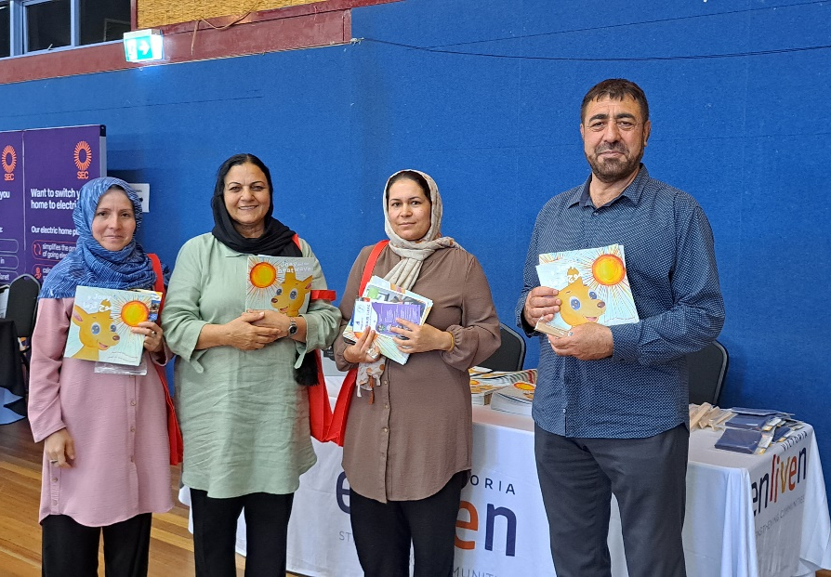
The five Heat Heroes are community leaders including a Turkish-Australian woman, two African-Australian women and two Afghan women. Messaging to help prepare people for staying well during heatwaves was co-designed with the Heat Heroes, who are paid to share this information with their personal networks.
As part of the Heat Heroes project, enliven has also held community education sessions around heatwaves and focus groups to identify barriers and facilitators of heatwave resilience.
Figure 3: Community members at enliven’s ‘Be Well, Stay Well in the Heat’ event.

Social connection is the key to climate resilience
Women’s Health Goulburn North East, Wangaratta, Vic
Women’s Health Goulburn North East held a series of events to enable social connection and support the health and wellbeing of women working in agriculture in rural and regional Victoria. Social connection and improved health and wellbeing are critical for climate adaptation.
The organisation
WHGNE is a feminist organisation, leading change towards women’s empowerment, women’s health, the prevention of violence against women and ultimately, gender equality, in north-eastern Victoria.
The approach
Throughout 2023, WHGNE supported a series of events for women working on farms in rural and regional Victoria with funding received for recovery from the 2022 floods.
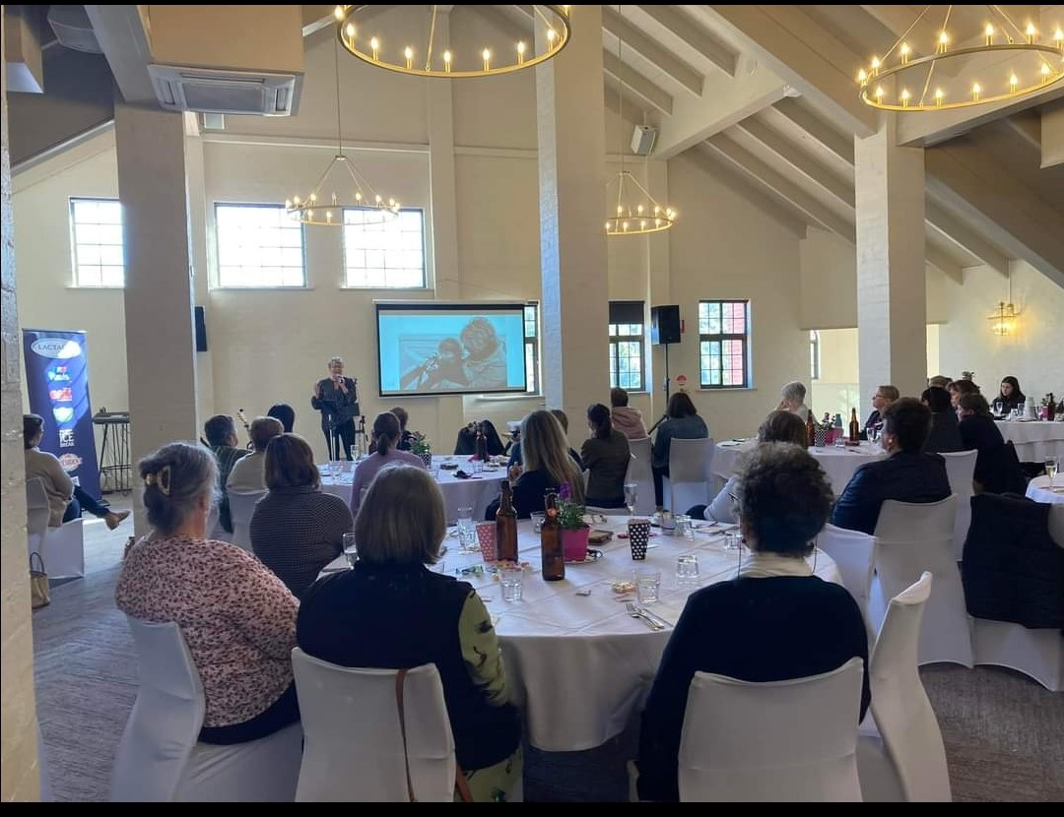
The events were organised in consultation with local women with the aim of providing opportunities for education and social connection for women who had experienced multiple disasters, including the 2020 fire season and 2022 floods. These disasters led to a surge of work on local farms while also having a personal impact for local women and their families.
An initial event held lunch for local women and had a guest speaker, musician Melinda Schneider, share her story, which inspired hopefulness in attendees. Further smaller events were also held for women working in agriculture across north-east Victoria. During the events, women spoke about their many roles on the farm, including juggling families and farm work.
Figure 4: A group of women convened by WHGNE for lunch and social connection.
Importantly, these events facilitated relationships and connections between the women, which is critical for adapting to climate change.

Enabling communities to flourish in their climate response
Network West, Spotswood, Vic
Through their A Local Approach to Climate Resilience Project, funded by the Greater Melbourne Foundation, Network West supported neighbourhood houses in Melbourne’s West to identify opportunities to strengthen climate resilience. The Project drew upon a number of local community initiatives under the banner of Flourish, which aimed to improve knowledge and capacity around climate change response by building on existing priorities within the community.
The organisation
Network West provides support to 54 neighbourhood houses and community centres across the Western local government areas of Melbourne.
The approach
The Flourish project brought together four neighbourhood houses in Wyndham. The project aimed to foster local connections and provide practical information on emergency preparedness and climate resilience to communities.
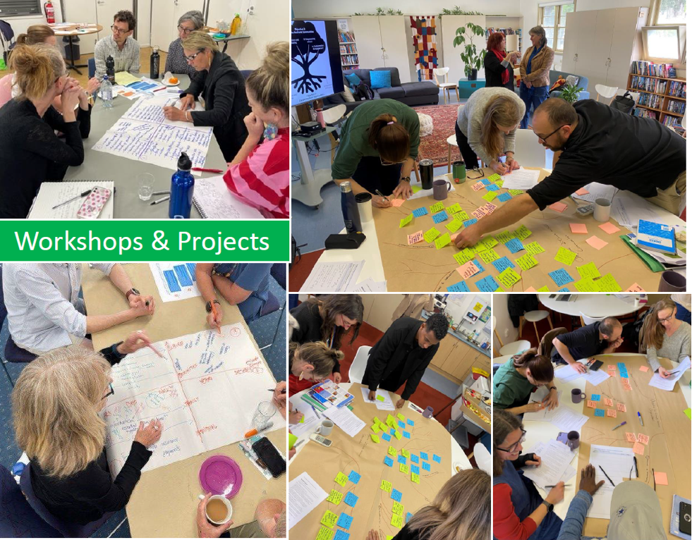
The Flourish project was one of the initiatives developed within Network West’s member organisations through the A Local Approach to Climate Resilience (ALACR) project. The ALACR project aimed to improve knowledge around climate resilience and justice, and to co-develop climate responses, within Network West’s members.
Through the Flourish project, each neighbourhood house held their own event to build on their existing work while applying a climate change lens. Four events were held with the aim of strengthening climate resilience, including a heatwave-ready gardening workshop, a tour of sustainability projects, including a tool library, a repurposing workshop, and a food security discussion with a cooking demonstration.
Figure 5: Workshops held as part of the Flourish project through Network West.

Conclusion
Lessons emerging from case studies
These community-led adaptation initiatives can teach us a great deal about how to approach adaptation that works for communities, particularly those experiencing poverty and disadvantage:
- Sufficient time is required to build and maintain relationships, and for decisions to be made within groups of community members.
- Adaptation initiatives should build on community strengths. Projects should include an element of capacity-building to empower community members to lead.
- Language matters. Climate adaptation, climate justice and climate resilience are complex topics that involve language that can be abstract. Time must be spent from the outset of adaptation projects in making these concepts tangible for those involved. In some communities, references to climate change might be avoided altogether.
- Different cultures have different attitudes towards certain tasks, such as growing vegetables. These attitudes should be discussed with the group and the tasks connected with the broader goals.
- Community networks that already exist should be utilised for adaptation projects, particularly where these networks are strong and trusted by the community.
- Community organisations should connect with trusted community leaders, who can provide links to community members.
- Community members should be properly remunerated for their involvement in adaptation projects.
By employing these lessons, future climate adaptation initiatives in Victoria can support transformative, community-led action.
Connection to Victorian climate adaptation policy and legislation
The adaptation initiatives detailed here are critical in advancing Victoria’s legislative and policy priorities around climate adaptation.
Victoria’s Climate Action Act
Victoria’s response to climate change is guided by the principles of equity and community engagement, as set out in the Climate Action Act 2017.
Policy objectives of the Act include:
- Supporting vulnerable communities and promoting social justice and intergenerational equity.
- Building resilience of the state’s infrastructure, built environment and communities through adaptation and disaster preparedness action.
- Promoting and supporting the state’s regions, industries and communities to adjust to the transition.
Each of the adaptation initiatives were created through co-design with local communities, which align with the Act’s principles of equity and community engagement. This approach engenders a sense of stewardship and provides an opportunity for education, inclusion and social connection.
By focusing on communities that experience barriers to adaptation, each of these case studies contributes towards the objective of supporting vulnerable communities and promoting social justice and intergenerational equity.
Each of these adaptation initiatives work towards improving the wellbeing and resilience of communities by providing education, capacity-building and social connection – a critical component of climate and disaster resilience. By focusing on rural and regional women, the events hosted by Women’s Health Goulburn North East also supported the state’s regions, industries and communities.
Adaptation Action Plans and Regional Adaptation Strategies
Victoria’s plans and strategies to address climate adaptation include:
- Adaptation Action Plans (AAPs) across seven sectors: the built environment, health and human services, education and training, the natural environment, primary production, transport, and the water cycle.
- Regional Adaptation Strategies to address the unique challenges presented by climate change in Victoria’s six regions. These strategies were developed with communities in the Gippsland, Barwon South West, Hume, Grampians, Greater Melbourne and Loddon Mallee regions.
The adaptation case studies detailed in this report contribute towards the objectives of the AAPs.
Each of the initiatives provides education and community empowerment towards the objective of Victoria’s Education and Training Adaptation Action Plan of preparing learners to understand climate change and its impacts on them and their world.
The adaptation initiatives also contribute towards the actions of the Health and Human Services AAP:
- enliven’s Multicultural Heat Heroes initiative works towards action H7 of managing the impacts of urban heat on health.
- Through facilitating social connection, each of the adaptation initiatives contribute towards action H14 - develop mental health and wellbeing support tailored to climate change impacts.
The adaptation initiatives presented in these case studies also make strong contributions towards Victoria’s Regional Adaptation Strategies.
The initiatives based in Greater Melbourne deliver on the Greater Melbourne Regional Adaptation Strategy principle of understanding, informing, advocating and empowering decisions at all levels. These projects bolster confidence and leadership skills to empower community members to advocate for systemic change. These initiatives also work towards creating a more equitable and sustainable society, another Greater Melbourne Regional Adaptation Strategy principle.
Women’s Health Goulburn North East’s events delivered on the Hume Regional Adaptation Strategy theme of improving health and wellbeing by expanding programs that link sustainability and health, and the theme of strengthening the economy and workforce by providing professional development.
Municipal Health and Wellbeing Plans
Municipal Public Health and Wellbeing Plans are prepared every four years by local councils. Under the Climate Action Act 2017, councils are required to have regard to climate change when preparing these plans. These case studies of adaptation make important contributions towards the themes and objectives of these Plans.
The range of adaptation initiatives at Banksia Gardens contribute towards the Hume Health and Wellbeing Plan 2021-25 priority of a healthy environment, climate action and community resilience by facilitating social connection and empowerment and improving the local environment.
By facilitating relationships, trust and mutual respect across a range of cultures within the area, enliven and Wellsprings for Women promote the Dandenong Council Plan 2025-29 objectives of a socially connected, safe and healthy city and a city that respects and celebrates diversity.
Network West’s support for adaptation leads to better health outcomes, which delivers on the Wyndham Council Plan 2025-29 focus area of climate change and health impacts. These health outcomes include positive mental health outcomes, fostered through social connection.
Women’s Health Goulburn North East’s events for women working on farms contribute towards the Rural City of Wangaratta’s Council Plan 2025-29 theme of community wellbeing by bringing community members together.

Key terms
Climate adaptation is the process of adjusting to the impacts of climate change.
Climate mitigation refers to actions taken to reduce greenhouse gas emissions, or climate pollution, to reduce the effects of climate change.
Climate resilience is the ability to respond to, and recover from, the impacts of climate change.
Climate vulnerability is separate from social vulnerability. It’s a function of exposure to a climate hazard, sensitivity to that hazard, and capacity to adapt. Some Victorians are more vulnerable to the impacts of climate change because their capacity to adapt is limited by structural barriers.
Circular economy is an economic system based on the reuse and regeneration of materials and products with the goal of eliminating waste and improving environmental and climate change outcomes.
Disaster resilience is the ability for a person, community or system to ‘bounce back’ after a disaster.
Maladaptation is an action to adapt one area or system that increases vulnerability to climate change impacts elsewhere.
Transformative climate adaptation changes the systems that place people in poverty and therefore reduce the adaptive capacity of individuals and communities.

References

Deloitte Access Economics 2021, Special report: Update to the economic costs of natural disasters in Australia, p. ii.
Climate Action Tracker n.d., Emissions pathways.
Under a 3-degree warming scenario. Australian Climate Service 2025, Australia’s National Climate Risk Assessment, Australian Government, Canberra, p.35, 54, 106.
Climate Action Tracker n.d., Emissions pathways.
See VCOSS 2024, Melbourne’s hot divide: the link between disadvantage and urban heat.
See VCOSS 2024, Adaptation for all: Addressing Victoria’s widening inequality with transformative adaptation, for further detail.
VCOSS 2026, Ripple effects: Spatial injustice and the 2022 Victorian floods.
Victoria Climate Change Act.
Victoria Climate Change Act.
Australian Red Cross 2024, The Hidden Power of Community: Unveiling Social Capital’s Role In Australia’s Disaster Resilience.
Victorian Department of Energy, Environment and Climate Action 2022, Adaptation Action Plans. Accessed 5 March 2026.
Department of Education and Training, Education and Training Adaptation Action Plan, Victorian Government, Melbourne, p.10.
Coast Adapt n.d., What is adaptation to climate change?, National Climate Change Adaptation Research Facility, Gold Coast, accessed 26 June 2025.
UNFCCC 2024, Defining and understanding transformational adaptation at different spatial scales and sectors, and assessing progress in planning and implementing transformational adaptation approaches at the global level, p.6.

