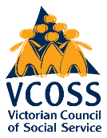


Placing communities at the centre of climate adaptation

July 2026

VCOSS submission to Victoria’s draft Adaptation Action Plans 2027-31

About VCOSS
VCOSS is the peak body for Victoria’s social and community sector. We activate collective power and influence change to achieve social and economic justice for current and future generations. Our goal is a Victoria free from poverty and disadvantage, where every person and community is supported to thrive.
We work to achieve our goal through policy development, public and private advocacy, supporting and increasing the capabilities of the state’s social sector organisations, forging strong coalitions for change, and explaining the true causes and effects of disadvantage.
VCOSS’s strength comes from our members and the people and communities at the heart of their work. Our members include frontline social services, peak bodies, advocacy groups and community associations, all passionate about an inclusive, caring and resilient Victoria.
Primary author: Julianne Tice.
Supervising Director: Jonathon Gurry.
Authorised by VCOSS CEO Juanita Pope.
VCOSS welcomes the opportunity to provide this input.
Please send enquiries to julianne.tice@vcoss.org.au
You can browse more VCOSS reports and submissions at vcoss.org.au/PolicyLibrary

Acknowledgement of Traditional Owners.
VCOSS acknowledges the Traditional Owners of Country, and pays respect to Elders past and present, and to emerging leaders. Our office is located on the sovereign, unceded lands of the Wurundjeri people of the Kulin nation.
Lived experience statement
VCOSS thanks all those who shared with us their personal stories, experiences and insights
in the development of this work. Every person is shaped by their history and environment. Many people have endured trauma or hardship. For some, this trauma and its effects continue today. When somebody shares their experiences and insights with VCOSS, they enrich both our understanding of the issues and our recommendations for change. Thank you for your courage and generosity.
Placing communities at the centre of climate adaptation

Contents
Support for the adaptation that occurs outside of government 4
Support for adaptation of people and communities in government strategy 4
Centre justice, equity and human rights, and self-determination for Aboriginal and Torres Strait Islander people 6
Enable community and social service organisations to adapt and build resilience 9
A climate resilient community and social services sector 11
Recognise the role of the community services sector across all adaptation systems. 11
Establish an ongoing disaster resilience workforce in the community ACCO sectors 14
Climate resilient, just communities 16
Safe, healthy and climate resilient homes for all Victorians 16
Shift from reactive emergency management to proactive disaster resilience 19
Heat-safe communities across Victoria 22
Food security and resilience for all Victorians 23
Justice and self-determined climate adaptation for First Peoples 25
Align the AAP actions with recommendations from Yoorrook for Transformation and National Indigenous Disaster Resilience 25
Enable First Peoples to genuinely lead on adaptation while actively supporting Treaty 27
The groundwork for effective implementation 29
Further information, research and data to support adaptation decision-making 29
Public, transparent progress reporting 30
Coordination of implementation action 31

Executive summary
VCOSS welcomes the opportunity to provide feedback on Victoria’s draft 2027-31 Adaptation Action Plans (AAPs).
Climate adaptation is a social justice issue. Without explicit and sustained focus on actions targeted towards people experiencing poverty and disadvantage, the 2027-31 AAPs will miss a golden opportunity to address these systemic challenges. Ignoring the opportunity climate adaptation presents for local economic advancement also condemns the most vulnerable cohort of Victorians to being left behind along Victoria’s path to net zero. Therefore, climate adaptation is also a vital economic and investment issue. Executed effectively, climate adaptation can be a powerful lever for inclusive economic development. This submission provides insights on how Victoria’s adaptation agenda can act as that lever, with locally led decision-making and community service engagement as its key pillars.
VCOSS is pleased to see discussion of self-determined climate adaptation for First Peoples in Victoria embedded across the AAPs. We are also pleased to see the integration of adaptation with emergency management and disaster resilience agendas.
However, we are concerned that the draft AAPs focus primarily on Victorian Government operations, leaving out the ‘on the ground’ adaptation that happens within communities and throughout the community services sector. We are concerned that, without focus on these areas and without centring justice, equity and self-determination in concrete actions, the AAPs have the potential to entrench poverty and disadvantage.
The draft plans include a number of positive actions that we are pleased to see. This submission makes recommendations to ensure these actions are done equitably and with justice at the centre.
This submission focuses primarily on the following AAPs, noting VCOSS member priorities:
- Health and Human Services
- Built Environment
- Education and Training
- Transport

Summary of recommendations:
- Provide support for the adaptation that occurs outside of government
  - Include support for adaptation of people and communities in government strategy
  - Centre justice, equity and human rights, and self-determination for Aboriginal and Torres Strait Islander people
  - Enable community and social service organisations to adapt and build resilience
- Ensure a climate resilient community and social services sector
  - Recognise the role of the community services sector across all adaptation systems
  - Establish an ongoing disaster resilience workforce in the community and ACCO sectors
- Enable climate resilient, just communities
  - Ensure safe, healthy and climate resilient homes for all Victorians
  - Shift from reactive emergency management to proactive disaster resilience
  - Support heat-safe communities across Victoria
  - Ensure food security and resilience for all Victorians
- Embed justice and self-determined climate adaptation for First Peoples
  - Align the AAP actions with recommendations from Yoorrook for Transformation and National Indigenous Disaster Resilience
  - Enable First Peoples to genuinely lead on adaptation while actively supporting Treaty
- Establish the groundwork for effective implementation
  - Further information, research and data to support adaptation
  - Public, transparent progress reporting
  - Coordination of implementation action

Our current context: Climate change does not impact everyone equally
Climate adaptation is a social issue. It’s not just science or infrastructure.
The choices we make about adaptation now have the potential to address or entrench disadvantage for many years to come. The 2027-31 Adaptation Action Plans offer a pivotal opportunity to change course and direct adaptation action towards people facing the greatest barriers.
In our current context, adaptation is left up to individuals. This approach exacerbates inequality.
Poverty, disadvantage and marginalisation are systemic problems that are accelerated by climate change. Rather than relying on individuals, climate adaptation requires systemic action that addresses and alleviates disadvantage.
Victoria has made some progress to support people experiencing disadvantage to adapt. The Energy Efficiency in Social Housing Program is an important investment that has already seen upgrades to a significant proportion of Victoria’s social housing stock, which will improve thermal safety for Victorians at greatest risk from increasing and extreme heat. More adaptation action like this, which directly benefits people experiencing poverty and disadvantage, is needed.
Many communities are now facing overlapping disasters, which compounds the effects of each. This creates additional complexity in recovery, and impacts are exacerbated when short disaster recovery funding cycles end.
Similarly, people rarely face one form of disadvantage or marginalisation. These intersect, causing barriers to adaptation to compound.
In Victoria there is a strong relationship between inequity and climate impacts. Rural and regional communities are hit first and worst due to their location in areas with higher risk of flood, bushfire and extreme heat. These areas tend to have higher levels of poverty. For example, in 2021, more than one in three (33.96%) households in regional areas affected by the major 2022 flood were already experiencing the highest levels of socioeconomic disadvantage (see figure 1). This is almost 6% higher compared with unaffected regional areas.

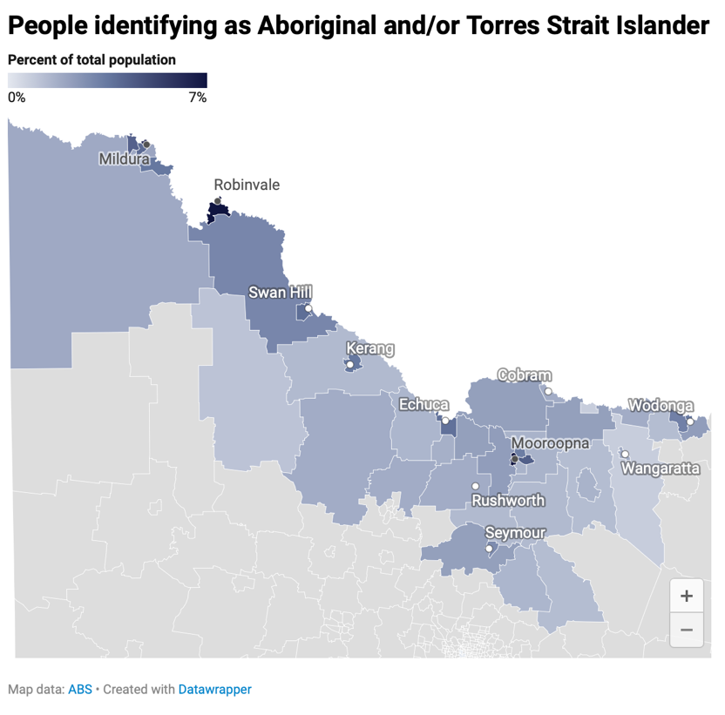
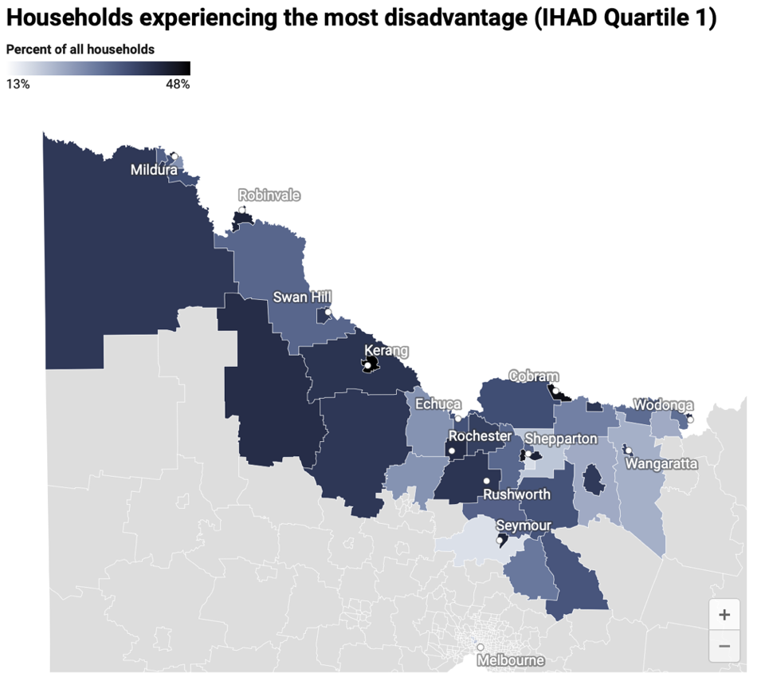
Figure 2: Aboriginal and Torres Strait Islander people were more likely to live in regional areas impacted by the 2022 Victorian floods. Source: Manne, L 2026, Ripple effects: Spatial injustice and the 2022 Victorian floods, VCOSS.
Figure 1: Households experiencing the greatest disadvantage overlap with areas impacted by the 2022 Victorian floods. Source: Manne, L 2026, Ripple effects: Spatial injustice and the 2022 Victorian floods, VCOSS.

Aboriginal and Torres Strait Islander people are more likely to be living on Country in rural and regional areas, putting them at higher risk of climate impacts. The Aboriginal and Torres Strait Islander population was higher in 93% of flood-affected regional areas than in unaffected regional areas (see figure 2).
Many Victorian homes are not resilient to heat, flood or bushfire. This puts renters and households on low incomes at greater risk. People with disabilities may face disproportionate health and wellbeing impacts from extreme heat, and experience transport barriers to moving to cool spaces. In Melbourne, the western and south-eastern suburbs have a higher urban heat island effect due to less green space. These areas also have higher rates of disadvantage (see figures 3 and 4).
The combination of rent increases and low wage growth is pushing more Victorians into rental stress and housing insecurity, particularly in rural and regional areas. The waiting list for social housing is long and growing, meaning an increasing number of Victorians are at risk of having no housing to shield them from the increasing impacts of climate change.
Older and younger people, women, and culturally and racially marginalised people tend to be disproportionately impacted by climate change due to systemic barriers. Family violence, including elder abuse, increases after disasters.
Victoria’s action on adaptation has the potential to address these inequities. Without this, inequality will continue to widen, resulting in devastating impacts to wellbeing and social cohesion. The recommendations in this submission provide a blueprint for transformative adaptation – adaptation that addresses poverty and disadvantage.

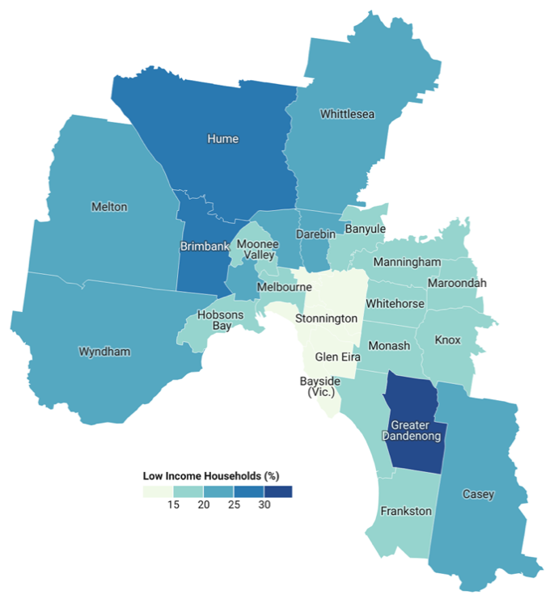
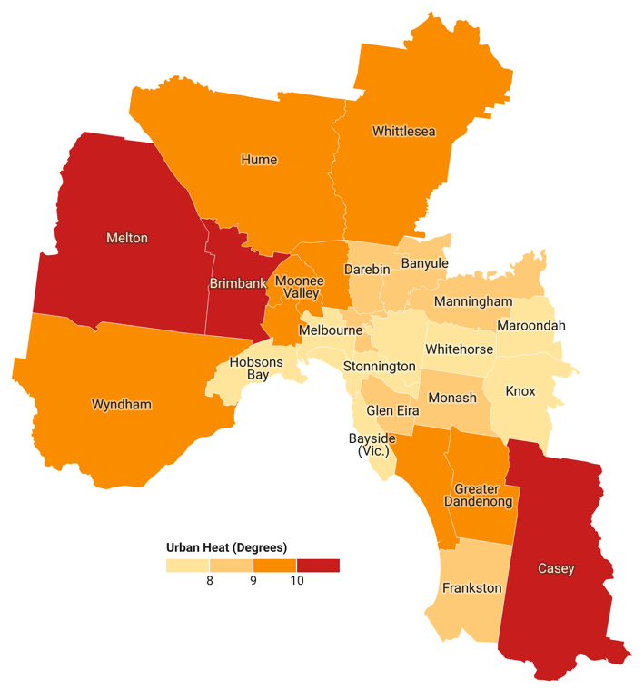
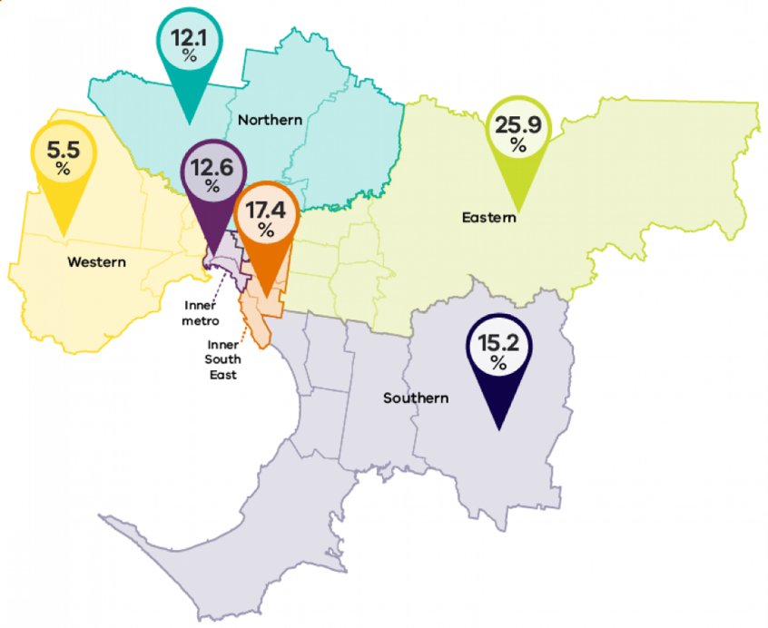
Figure 1: Poverty and urban heat. Source: VCOSS 2023, Poverty and the urban heat effect.
Figure 2: Percentage of urban tree cover by region, Melbourne, 2018. Source: Victorian Department of Planning 2023, Melbourne’s vegetation, heat and land use data.

Victoria’s Adaptation Action Plans must deliver transformative adaptation
The 2027-31 Adaptation Action Plans present a critical opportunity for transformative adaptation.
The Victorian community sector works every day towards socially connected, climate resilient communities and addresses the structural drivers of inequity by working towards transformative adaptation. Victoria’s action on adaptation should also work towards this end.
The following sections set out the Victorian social and community services sector’s vision for transformative adaptation in Victoria. This submission puts forward 14 recommendations so that Victoria’s Adaptation Action Plans deliver:
- Support for the adaptation that occurs outside of government
- A climate resilient community and social services sector
- Climate resilient, just communities
- Self-determined climate adaptation for First Peoples
- The groundwork for effective implementation
Each section begins with the Victorian community and social services sector’s vision for adaptation in that area, followed by recommendations for action. Throughout the submission, case studies are included that demonstrate the sector’s support for community-led adaptation.

Support for the adaptation that occurs outside of government
The community and social services sector’s vision for adaptation in Victoria
Adaptation action focused on communities and people experiencing poverty, disadvantage and marginalisation is centred in the Adaptation Action Plans. These actions are sufficiently resourced to achieve transformative adaptation.
Victoria’s adaptation approach is gender‑responsive, age‑inclusive, disability‑inclusive, and supports self-determination. Adaptation actions actively reduce, rather than reproduce, social disparities and resulting disadvantage.
To ensure the adaptation of people and communities is supported through the 2027-31 Adaptation Action Plans (AAPs), VCOSS recommends:
- Including support for adaptation of people and communities in government strategy
- Centring justice, equity and human rights, and self-determination for Aboriginal and Torres Strait Islander people
- Enabling community and social service organisations to adapt and build resilience

Support for adaptation of people and communities in government strategy
Victoria’s draft 2027-31 AAPs centre on adaptation of government systems. While these systems cover many of the ways in which society is governed, this misses much of the adaptation action taken on the ground: within communities and through community and social service organisations. An explicit focus on adaptation of people and communities – and the support to back this up – will help address disadvantage.
The Victorian Government’s approach to incorporate adaptation into business as usual is welcomed. If done well, this will mean that our systems and decision-making shifts over the long term to be more responsive to changing climate conditions.
However, this must be done with equity and justice for people and communities at the centre – shifting resources and power to the people who face systemic barriers – not solely a focus on government-run infrastructure and programs.
VCOSS research has shown that many people experiencing poverty, disadvantage and marginalisation in Victoria face systemic barriers to supporting their own adaptation – meaning people may adopt coping mechanisms that negatively impact their long-term health and wellbeing. This has the potential to erode adaptive capacity over the long term, leading to a widening gap between those with and without the resources to adapt.
Australian Red Cross research demonstrates the value of social capital in building climate resilience – which happens within communities, facilitated by community service organisations. This is not acknowledged in the draft 2027-31 AAPs.
To ensure community-led adaptation can be adequately supported, the AAPs require a commitment for funding through a Community Climate Adaptation Fund. Investment could begin at $25m per year and incrementally scale up over 10 years to $200m per year. This level of investment would not address all adaptation needs across Victorian communities, but would be a significant improvement on the current situation.
Such investment would result in at least $250 million in social and other co-benefits. Implementation that focuses on communities and cohorts at highest risk of climate impacts and with the greatest disadvantage has the potential to be transformative, meaning poverty is alleviated and adaptive capacity is strengthened.
Investment in Victoria’s adaptation action should be ongoing and adequate, and responses must be community-led. A climate adaptation fund could be used for:
- Adaptation and disaster resilience planning in community orgs and communities;
- Implementation of these plans;
- Adaptation projects like those in VCOSS’ case studies – including those that address disadvantage and build social resilience.
To create an adaptation fund, an adaptation financing strategy for those actions beyond government BAU should be developed. This could include Victorian Government funding streams, Commonwealth funding, private equity, and other sources. As part of this, a methodology to determine the return on investment, including co-benefits, of adaptation investment in people and communities should be developed.
Recommendations for the 2027-31 AAPs
Across all AAPs
- Incorporate actions focused on adaptation with people and communities throughout the draft 2027-31 AAPs, including recommendations made throughout this submission.
- Establish an ongoing Community Climate Adaptation Fund, beginning at $25m per year and incrementally scaling up over 10 years to $200m per year.
- Develop an adaptation financing strategy that sets out how community-centred adaptation could be funded.
- Recognise the critical nature of social capital in building climate resilience.

Centre justice, equity and human rights, and self-determination for Aboriginal and Torres Strait Islander people
The 2027-31 AAPs must centre justice, equity and human rights for all Victorians, as well as self-determination for Aboriginal and Torres Strait Islander people. Actions with these principles at the centre must be prioritised for implementation.
Without this focus, the AAPs risk entrenching disadvantage – a risk that is not currently acknowledged across all AAP systems.
People experience climate change differently: First Peoples, women and gender diverse people, younger people, older people, people with disabilities, multicultural people and people on low incomes experience climate impacts first and worst due to structural inequities and marginalisation. This must be recognised and accounted for across the AAPs. Broad language of ‘vulnerability’ obscures who faces barriers to adaptation and where people are most at risk – and prevents the ability to identify responses to support these groups.
Justice and equity were acknowledged in the 2022-26 AAPs and centred in some actions across the plans (e.g., Actions H11 and H14 of the Health and Human Services AAP, and Actions 4 and 6 of the Built Environment AAP). This recognition is inconsistent across the draft 2027-31 AAPs.
As part of finalisation of the 2027-31 AAPs, draft actions should undergo an intersectional impact assessment to identify potential unintended consequences, avoid the potential for disadvantage to be entrenched, and to avoid maladaptation. Reporting could follow a similar approach to the approach of Victoria’s Gender Equality Commission or the Pride in our future outcomes framework.
VCOSS is pleased to see in the draft 2027-31 AAPs:
- The Health and Human Services AAP includes the risk of the social determinants of health being adversely impacted. This should include acknowledgement of the climate risk that people’s adaptive capacity is reduced, potentially resulting in more support being required. This risk should be acknowledged across all AAP systems.
- Some of the AAPs are guided by key principles, such as a commitment to support self-determination for Aboriginal and Torres Strait Islander people in the Health and Human Services AAP. These guiding principles should also include equity and justice for all people experiencing disadvantage and marginalisation.
- The clear focus on working towards self-determined adaptation responses for Aboriginal and Torres Strait Islander people. Relevant actions must be implemented and adequately resourced (see Justice and self-determined climate adaptation for Aboriginal and Torres Strait Islander people).
- Specific mention of the groups who are disproportionately impacted by climate risks in the draft Health and Human Services AAP. This acknowledgement should be made across all AAPs.
Recommendations for the 2027-31 AAPs
Across all AAPs
- Recognise that entrenching disadvantage is a risk across all AAP systems, if responses are not appropriately targeted.
- Acknowledge who is at greatest risk of climate impacts and how they are at risk across the AAPs – and be specific.
- Include key principles guiding each of the actions across all eight AAPs: justice, equity and human rights, and self-determination for Aboriginal and Torres Strait Islander people. Align actions with these principles.
- Assess the actions across all AAPs to identify potential unintended consequences, avoid the potential for disadvantage to be entrenched, and to avoid maladaptation.

Case study: Strengthening place-based climate resilience through community sector partnerships
Climate Partnerships is a three-year initiative strengthening local adaptive capacity and climate resilience in the Campaspe and Yarra Ranges communities. The project demonstrates how community organisations can act as critical social infrastructure within Victoria's adaptation system by building cross-sector partnerships that support communities before, during and after climate-related emergencies.
Delivered through a partnership between Jesuit Social Services' Centre for Just Places, ARC Justice, Eastern Community Legal Centre and the Federation of Community Legal Centres, the project brings together community organisations to strengthen place-based adaptation through collaboration, shared learning and coordinated action.
Using an equity and climate justice approach, the project has increased understanding of how climate change interacts with existing social and economic disadvantage, while strengthening adaptive capacity and local resilience. Participating organisations have collectively identified both vulnerabilities and strengths within the local service system, and developed practical strategies to improve preparedness, continuity and coordinated responses to climate-related hazards.
Released in March 2026, the Campaspe Climate Partnership Collaborative Action Plan provides a shared roadmap for strengthening local resilience across six priority areas: collaboration and coordination; community; evidence; leadership and advocacy; information and communication; preparedness and planning; and workforce capability.
The Action Plan includes practical, locally led actions such as improving community preparedness, strengthening trusted communication networks before emergencies, supporting organisational continuity planning and building stronger partnerships across community services, local government and emergency management. Similarly, in the Yarra Ranges, an action plan to strengthen resilience to climate related disaster events and to support local collaborative action has been developed and is due to be launched in the second half of 2026.
The project demonstrates how investing in community organisations and place-based partnerships can strengthen adaptive capacity, improve coordination across the health and human services system, and build resilience for communities experiencing the greatest climate risks.

Enable community and social service organisations to adapt and build resilience
Community and social service organisations (CSOs) must be resilient in their operations to be able to respond to increasing demand and case complexity as heat and disasters increase. However, planning and implementing organisational adaptation plans requires staff capacity and financial resources – resources for which CSOs face systemic funding barriers.
CSOs need dedicated support to adapt their service delivery to respond to increasing demand and complexity. For example, CSOs may need to create organisational heatwave plans to ensure continued care during heatwaves, power outages and other emergencies.
The below case study of philanthropically funded resilience-planning is an example of how this could work in practice. VCOSS would be delighted to see the support made available to Aboriginal Community Controlled Organisations for climate risk assessments and adaptation planning scaled up and made available to other community and social service organisations.
Action 11 of the 2022-26 Health and Human Services AAP speaks to the need to support the health and community services sector’s climate change adaptation, and to support smaller funded organisations, including Aboriginal Community Controlled Organisations (ACCOs). This action should be rolled into the 2027-31 AAP.
Recommendations for the 2027-31 AAPs
Actions: Health and Human Services
- Adequately fund community service organisations to develop and implement organisational adaptation plans. Reinstate – and fund – action H11 from the 2022-26 Health and Human Services AAP.

Case study: Adaptation planning in community service organisations
Resilience In-House is a program that resources neighbourhood houses and community centres in Melbourne's West to collaboratively develop climate resilience action plans for each neighbourhood house with their communities. The program is coordinated by Wyndham Park Community Centre in partnership with Jesuit Social Services’ Centre for Just Places and Network West. It is funded by Greater Melbourne Foundation.
The Resilience In-House coordinator engages staff, volunteer and other community members at each neighbourhood house in a series of strengths-based and participatory workshops to define what climate resilience looks like for them, understand their local risks and opportunities, and co-design a shortlist of actions.
Actions in the plans include:
- Encouraging community activism around biodiversity
- Hosting educational events around First Nations knowledge
- Audits of energy and water usage
- Embedding climate resilience learning into existing programs
The project has been successful in attracting and retaining a diverse group of enthusiastic participants, resulting in strong foundations for action. Program evaluation demonstrated that participation increased overall group alignment in knowledge and increased confidence in ability to act. Neighbourhood houses are now in a better position to act collectively on climate adaptation.
Most encouragingly, working groups are excited by the actions they’ve come up with, and broader community representatives are asking to continue to be involved.

A climate resilient community and social services sector
The community and social services sector’s vision for adaptation in Victoria
Victorian community and social service organisations, health organisations, and ACCOs are climate resilient in their operations. They have sufficient capacity and resourcing to support communities facing disproportionate risk of climate impacts, whose support needs will increase as climate change progresses.
To achieve the sector’s vision for a climate resilient community and social services sector through the 2027-31 Adaptation Action Plans (AAPs), VCOSS recommends:
- Recognising the role of the community services sector across all adaptation systems
- Establishing an ongoing disaster resilience workforce in the community and ACCO sectors

Recognise the role of the community services sector across all adaptation systems.
Victoria’s community and social services sector plays a role across each of the eight adaptation systems – however it is not adequately recognised across the draft 2027-31 AAPs.
The potential for equitable adaptation and disaster resilience in communities is weakened without a strong community services sector. The community services sector supports climate resilient communities through building social capital, strengthening adaptive capacity, and supporting disaster preparedness and recovery. These organisations are trusted, accessible and embedded in communities – but they are not formally resourced or positioned as an ongoing part of Victoria’s adaptation and disaster resilience systems.
Through this role, the community sector is the climate workforce: it plays a critical role in supporting people experiencing poverty, disadvantage and marginalisation to adapt to climate change and build disaster resilience. Without their support, inequality widens and adaptive capacity is eroded.
Recommendations for the 2027-31 AAPs
Actions: Across all AAPs
- Acknowledge social infrastructure – neighbourhood houses, community centres, libraries, etc – as vital in building social capital.
- Embed the community services sector across plans and actions.
- Include the community and social services sector in ‘roles and responsibilities’ of all AAPs and note the role they play in building social capital and addressing disadvantage.
- Recognise that the climate workforce isn’t just energy – the community sector is at the heart of climate adaptation.
Actions: Health and Human Services
- Acknowledge the role of community health services in the Health and Human Services AAP:
  - Include community health infrastructure in Action 1.
  - Include community health in Actions 4 and 5.
- Expand access to mental health and wellbeing locals, particularly in rural and regional Victoria (Action 6).
Actions: Education and Training
- Include education and training around climate change in the Diploma of Community Services to build capacity of future community sector workers. (Action 5)
- Ensure efforts to build a skilled workforce address barriers to participation faced by many. (Action 5)
- Include independent schools and community education infrastructure within the community services sector across actions. Expand climate risk assessments to cover these assets.

The critical role of community and social service organisations in climate adaptation
Community and social service organisations play an indispensable role in supporting people and communities to adapt:
- Aboriginal Community Controlled Organisations support Aboriginal and Torres Strait Islander peoples to access culturally safe health care, wellbeing support, and create strong Aboriginal communities who are resilient to climate impacts.
- Community health services enable access to healthcare for those facing barriers to mainstream services. This is critical in a context where people are increasingly foregoing healthcare due to cost, transport and other barriers, even while health impacts become acute with extreme weather.
- Community legal services support people with the legal needs arising from climate change such as tenancy issues, family violence support, insurance issues and much more.
- Disability advocacy organisations protect the rights of people with disability, which is critical for those experiencing greatest risk from extreme heat and disasters.
- Financial counselling services assist those experiencing financial hardship with insurance claims, negotiating with banks and creditors, explain grant processes and advocate across often complex and fragmented systems.
- Housing and homelessness organisations link people with emergency accommodation, help people connect with long-term housing in the private rental market or in social housing, and provide community housing.
- Multicultural organisations build resilience by brokering relationships with authorities, sharing in-language information with communities, provide culturally safe material aid and support people to access services.
- Neighbourhood houses develop community resilience through social connection and provide cost-of-living relief. They are often the first ones providing support to the local community when disasters occur.
- Women’s health organisations work to prevent and respond to family violence risk, including elder abuse, which is likely to increase due to climate change. Women’s health services are also active in increasing the capacity of workforce and community to understand the gendered experiences and impacts of climate change and disasters.
- Youth services advocate for and facilitate a young person’s independence, participation and connectedness. They elevate the voice of young people to the institutions where decisions about climate adaptation and disaster resilience are made.

Establish an ongoing disaster resilience workforce in the community ACCO sectors
Victoria’s approach to adaptation must meet the challenge of compounding disasters, which are being experienced by many communities, particularly in rural and regional areas. Sustained investment in the capacity of the community sector and Aboriginal Community Controlled workforce would provide significant gains in adaptation and disaster resilience for communities at highest risk through resilience-building outside of acute relief and recovery efforts.
Strengthened capacity for the community sector would mean activities could be undertaken such as:
- Person-centred emergency planning programs for people at higher risk;
- Building and maintaining relationships at a local, regional and state level;
- Greater capacity for adaptation planning;
- Increased capacity to build psychosocial supports and community connection for people at higher risk from climate impacts; and
- Delivery of community-led resilience initiatives.
Investment should include resourcing for co-production of the workforce. The workforce should include funding for a core workforce of disaster resilience specialists within place-based, specialist, statewide and cohort-specific services for people at higher risk from emergencies. While co-production is underway, agencies with existing recovery programs should be funded to retain at least 1 full-time equivalent between emergencies to ensure continuity of institutional knowledge and skills, and readiness for future disasters.

Recommendations for the 2027-31 AAPs
Actions: Health and Human Services
- Establish an ongoing disaster resilience workforce in the community and ACCO sectors, including initial investment in co-production of this workforce.

Case study: Upskilling the legal sector around climate change
South-East Monash Legal Service (SMLS) is a community legal centre operating in Melbourne’s south-eastern suburbs, an area with a high level of cultural diversity that experiences disproportionate heat.
SMLS received two years of funding from the Federation of Community Legal Centres for the South-Eastern Climate Justice Program. The program aimed to empower communities in Melbourne's South-East that are affected by the impacts of climate change and related legal challenges.
As part of the project, a broad review of client matters was undertaken to identify legal issues with potential climate-related impacts. While many matters were explored, 18 were identified as having clear climate-related links, involving 11 lawyers across tenancy, employment, family violence, migration and consumer law.
The link between climate change and legal needs isn’t consistently made across legislation and policy, for example in family law, making supporting people a challenge. To build the capacity of the community legal sector in making these links, SMLS trained 207 lawyers across the community legal sector. They also reached 508 Victorians through community legal education and events.
With these learnings, SMLS contributed to research papers on extreme heat and human rights and rights to equitable adaptation. SMLS also designed a climate toolkit and contributed towards a textbook chapter around climate conscious lawyering.
A longer funding period would enable SMLS to scale up this work and continue to engage with community members to make the link between legal needs and climate change.

Climate resilient, just communities
The community and social services sector’s vision for adaptation in Victoria
The strengths and expertise of communities are recognised. Adaptation is done with communities, not for them. Communities have a voice and lived experience is centred in adaptation responses.
To achieve the sector’s vision for climate resilient, just communities through the 2027-31 Adaptation Action Plans (AAPs), VCOSS recommends:
- Ensuring safe, healthy and climate resilient homes for all Victorians
- Shifting from reactive emergency management to proactive disaster resilience
- Supporting heat-safe communities across Victoria
- Ensuring food security and resilience for all Victorians

Safe, healthy and climate resilient homes for all Victorians
Everyone should be safe from climate impacts at home.
Victoria’s housing stock – spanning owner-occupied housing, privately rented housing, and social housing – must be able to withstand all climate hazards. Millions of homes already exist that do not consistently protect against extreme heat and other disasters. New-build homes better protect against extreme heat and bushfire, but still leave people exposed to flood and sea-level rise. Victorians without a consistent place to call home are potentially placed directly in harm’s way from climate impacts.
Victoria’s initiatives around climate resilient housing have so far focused on heat. This is crucial, as extreme heat is felt across the state, disproportionately impacts people experiencing disadvantage, and is getting worse.
However, with disasters now becoming much more frequent, and repeatedly impacting some communities, we must now seriously consider the disaster resilience of housing. All existing housing facing extreme risk of flood, bushfire and sea-level rise must be supported to become more resilient.
Victoria has made substantial progress towards addressing existing housing for heat resilience, which is acknowledged in Action 1 of the draft 2027-31 Energy AAP. These supports can be expanded to ensure all Victorians can benefit by:
- Proactively enforcing minimum energy efficiency standards for rental homes;
- Upgrading all social housing that requires it, and making information about the state of the existing social housing stock public; and
- Increasing incentives for owner-occupied households on low to no income to overcome upfront cost barriers through the Victorian Energy Upgrades program.
Victoria has also made progress towards building new heat-resilient social housing. More social housing must be urgently built to house those on growing waitlists. The need is acute and increasingly worsening due to low historic investment in social housing and an increase in climate-driven disasters. An increase in family violence, accelerated by climate-driven disasters, is exacerbating housing needs for victim-survivors. The location of new social housing must be carefully considered to ensure people experiencing the greatest disadvantage are not at risk of disaster.
VCOSS is pleased to see in the draft 2027-31 AAPs:
- The continuation of actions focused on social housing in the Health and Human Services AAP (Actions 8-10). Increased transparency of the climate risks faced by social housing, and the progress towards energy efficiency and other climate resilience upgrades, would help provide confidence that these actions are fit for purpose.
- Reference to climate resilience as an objective of the National Construction Code in the Built Environment AAP (Action 4). This is an important structural change that will help ensure all new homes are resilient to all climate hazards.
- Discussion of disaster risk reduction and un-insurability for households in the Built Environment AAP (Action 4). Disaster risk reduction and insurance access must go hand in hand.
- Enhancing the resilience of energy infrastructure in the Energy AAP (Action 2). Power outages can be life-threatening for older people and those with disabilities, who depend on life-support equipment or medications that require refrigeration.
- Provision of energy resilience information in the Energy AAP (Action 4). While provision of information is an important first step, structural barriers prevent many people from acting. Information must be coupled with financial and navigational support to act.

Recommendations for the 2027-31 AAPs
Actions: Health and Human Services
- Set an ambitious social housing target of 7,990 social housing units per year for the next 10 years to catch up with the national average and invest to meet this target.
- Make climate risk assessments of the social housing stock publicly available so tenants and advocates understand where the highest-risk properties are located. (Action 8)
- Ensure all social housing – new and existing – can withstand climate-related hazards beyond heat. (Actions 8-10)
- Build on the EESHP to reach the older social housing units that won’t be upgraded through current levels of investment. Transparently report against upgrade needs across the social housing stock. (Action 9)
- Ensure community housing providers are supported to upgrade their properties to withstand heat and other climate-related hazards. (Actions 8-10)
Actions: Built Environment
- Establish a resilient homes program to improve the resilience of existing homes to disasters and extreme heat. See VCOSS’ forthcoming report about flood resilient housing, and the Housing Resilience Action Plan 2030. Ensure private and social housing renters are included in such a program.
- Fund tenancy advocacy services to proactively educate renters about their post-disaster rights. (Action 2)
- Couple climate risk information with financial and navigational support to act (Action 2). Fund the community sector to provide information and navigational support.
- Advocate to the Commonwealth Government for insurance policy and regulatory reform. (Action 4)
Actions: Energy
- Proactively enforce minimum energy efficiency standards for rentals to ensure all renters benefit from life-saving thermal upgrades. (Action 1)
- Amend minimum energy efficiency standards regulations to include Specialist Disability Accommodation. (Action 1)
- Remove up-front costs for owner-occupied households facing financial barriers to adopt thermal upgrades through the VEU. (Action 1)
- Ensure adequate supports for life-support customers. (Actions 1 and 2)

Shift from reactive emergency management to proactive disaster resilience
Victoria’s emergency management system requires reform to ensure arrangements are fit for purpose for our current context.
The emergency management system currently treats disasters as discrete, ad hoc events, resulting in greater investment in recovery than in preparedness and risk reduction. Recovery funding cycles address each disaster individually through short-term recovery funding cycles.
However, we’re now in an era where disasters are recurring and overlapping. Greater preparedness and the ability to build back better post-disaster is needed to meet the challenges Victorians are experiencing now.
These challenges are not unique to Victoria – an estimated 87% of Commonwealth disaster
funding in Australia goes towards recovery rather than risk reduction.

A shift to preparedness and resilience has the potential to reduce the impacts and costs of disasters, with investment in disaster risk reduction and preparedness providing significantly greater return on investment compared with spending on recovery.

VCOSS is pleased to see in the draft 2027-31 Built Environment AAP:
- Improved emergency management guidance and information (Action 2). This should include investment in preparedness in addition to information provision.
- Inclusion of continued review of priority emergency management initiatives that support improved recovery and risk reduction (Action 3). This should include:
  - Review of all emergency management legislation and related plans to ensure they are fit for purpose for climate change. For example, these plans should better resource and integrate hazards such as drought and heatwaves, and recognise that disasters are often overlapping, compounding and cascading;
  - A shift from focusing on recovery from individual events to sustained investment in community-led adaptation, resilience, and preparedness. This should include support for place-based, community-led adaptation and disaster resilience planning in communities facing the greatest disadvantage and climate risk in addition to an ongoing workforce;
  - Increased representation of communities in formal emergency management arrangements and planning committees;
  - Recognition that disaster recovery takes a decade or more, and that short-term recovery funding is insufficient for full recovery.
- Reference to investment in emergency preparedness through the Disaster Ready Fund (DRF) (Action 4). The community services sector currently faces barriers to funding through the DRF due to intensive application and reporting requirements, and the small proportion of funding earmarked for community projects.

Recommendations for the 2027-31 AAPs
Actions: Built Environment
- Expand Action 2 to include investment in emergency preparedness.
- Expand Action 3 to include:
  - Reform of Victoria’s emergency management arrangements to ensure they are fit for purpose for our current context.
  - Community-led preparedness and recovery, including through the community services sector.
  - Representation of communities in formal arrangements and planning committees.
  - Recognition that disaster recovery takes a decade or more.
  - Support collaborative place-based planning and coordination between organisations, recognising that CSOs don’t act alone in supporting communities.
  - Embed young voices in disaster decision-making.
- Advocate to the Federal Government to direct a greater share of Disaster Ready Fund funding towards community-led adaptation and disaster resilience. (Action 4)
Actions: Education and Training
- Expand training pathways for young people in disaster resilience. (Action 5)

Case study: Community sector’s support for disaster recovery and preparedness
GenWest is an organisation working toward gender equity in Melbourne's west.
After the 2022 floods that impacted Maribyrnong, GenWest received funding from the Victorian Department of Families, Fairness and Housing (DFFH) to support community recovery. This was used to provide spaces for women from migrant and refugee backgrounds to connect and share their stories in a safe and empowering environment, and to support community members to access flood recovery services.
GenWest also interviewed women from migrant and refugee backgrounds for the report Our community, our voice: Lessons from the 2022 Maribyrnong Flood, which makes recommendations to improve disaster responses in the future.
With additional funding through the North Western Primary Health and a partnership with Maribyrnong City Council, GenWest delivered numerous mental health and wellbeing activities including school holiday activities for women and children, gardening working bees and an award-winning Flood Insurance Guide for flood-affected families.
Drawing on the lessons from the Maribyrnong flood recovery work, GenWest is now supporting migrant and refugee communities across Melbourne’s West to prepare for future climate disasters and build long-term resilience with support of the Greater Melbourne Foundation.
Grounded in a comprehensive demographic and hazard analysis, GenWest focused engagement on the local Indian community, who were identified as the largest diaspora cohort at high risk of heat and flooding in Melton and Wyndham.
A bilingual Hindi- and Punjabi-speaking Community Engagement Officer was recruited, and a 6-member paid Community Advisory Group was developed to guide local delivery. Thirteen stakeholder organisations were engaged in an intensive needs analysis, which informed a pivot from a narrow flood scope to an inclusive all-hazards framework featuring heatwave and flash flood preparedness.
Two 1-hour disaster preparedness modules, developed by GenWest, were delivered to 11 distinct community groups across both LGAs in both English, Hindi & Punjabi. The modules achieved a total reach of 479 community members for Module 1 and 461 for Module 2. Group evaluations demonstrated that 80% to 100% of participants reported a substantial increase in disaster preparedness knowledge and formal support networks.

Heat-safe communities across Victoria
Extreme heat threatens every Victorian, but not all Victorians are affected equally. The 2027-31 AAPs should elevate the significance of extreme heat in Victoria and create a coordinated and prepared response plan.
People with disabilities and health conditions, older people, renters, people experiencing homelessness, and people living in areas with a high urban heat island effect are at greatest risk. A 1°C increase in temperatures correlates to a 4.7% increase in intimate-partner violence.
While heat disproportionately impacts certain groups, demand for the community and social service organisations that support them will increase, placing further stress on already-stretched services.
Homes should be people’s safest option for sheltering from the heat. But not everyone has a stable or safe home, and extreme heat shouldn’t prevent people from being able to safely go about their lives.
In addition to making homes resilient to heat and other climate hazards (see above), the 2027-31 AAPs present an opportunity to act on heat at the community level in a way that targets those at greatest risk.
Recommendations for the 2027-31 AAPs
Actions: Across AAPs
- Develop a coordinated response to heat in Victoria. This should include:
  - Improving messaging and advice around heat health, including awareness-raising campaigns around the impacts of heat on human health and ways to keep safe.
  - Enabling person-centered emergency planning for heat.
  - Ensuring people with disabilities can access air conditioning to enable heat adaptation.
  - Ensuring access to heat safe spaces for people experiencing homelessness and those whose homes are not safe in the heat, in partnership with neighbourhood houses.
  - Use of shading around homes and buildings for natural cooling.
  - Supporting community and social service organisations to prepare for increases in demand experienced during extreme heat days and heatwaves. Provide adequate funding to respond to demand and support the development of service delivery continuity plans.
Actions: Transport
- Make all public transport stops heat safe through shading and use of reflective materials. (Action 2)
- Upgrade public transport to ensure services can continue to run on extreme heat days. (Action 2)

Case study: Neighbourhood houses as spaces of cool and care
Neighbourhood houses are well-placed to serve as cooling centres. They are trusted, hyperlocal, community-governed, and experienced in outreach and co-design. During COVID-19, they demonstrated exactly the kind of flexible, embedded response that heatwave adaptation requires.
In March 2026, SPAN Community House opened a 24/7 self-serve misting system, providing a cool place on hot summer days. The front gate at Span was unlocked, a vibrant mural painted, and landscaping refreshed to become a place of welcome and joy for the Thornbury community.
Cooling centres work when they are places of care, not just places of cool. Neighbourhood houses already are places of care. With sustained investment and policy recognition, they could anchor a distributed, dignified, and scalable network of heat resilience across Victoria.

Food security and resilience for all Victorians
The number one issue VCOSS hears about from community members around climate change is that climate change is accelerating the cost of living and having a disproportionate impact on those living in poverty. One of the areas where this is felt most strongly is for food costs.
Poverty is the primary driver of food insecurity, with more than 215,000 Victorian children (17.6%) living in poverty. The current cost of living crisis is exacerbating this issue, affecting previously food-secure families.
Actions in the Primary Production AAP will be an important part of adapting Victoria’s food production to ensure all Victorians can access nutritious, culturally relevant food. However, this AAP doesn’t recognise the critical link between Victoria’s agriculture system and food security.
Recommendations for the 2027-31 AAPs
Actions: Primary Production
- Link this system to food security for people and communities – not just a focus on agriculture.
- Enable local food resilience, including community-owned food resilience hubs and connection to local food production.
- Future-proof the food distribution system by electrifying food distribution trucks.
- Support the development of a Victorian Food Security Strategy to address the drivers of food security and drive long-term investment in building a resilient, sustainable food system (Recommendation 15 of the Victorian Parliamentary Inquiry into Food Security).

Justice and self-determined climate adaptation for First Peoples
The community and social services sector’s vision for adaptation in Victoria
Victoria takes an approach to adaptation that actively supports the outcomes of Treaty. Gellung Warl plays an active role in ensuring self-determination in the adaptation of First Peoples to climate change.
To achieve self-determined climate adaptation for First Peoples, VCOSS recommends:
- Aligning the AAP actions with Yoorrook for Transformation and National Indigenous Disaster Resilience
- Enabling First Peoples to genuinely lead on adaptation while actively supporting Treaty

Align the AAP actions with recommendations from Yoorrook for Transformation and National Indigenous Disaster Resilience
VCOSS is pleased to see that each of the AAPs has a strong focus on First Peoples. The current actions must be strengthened and aligned with existing calls for First Peoples-led climate justice and disaster resilience.
The needs and priorities of First Peoples are often overlooked or minimised across the emergency management cycle. The Victorian Aboriginal Legal Service’s response to Yoorrook Justice Commission states the case for First Peoples-led disaster resilience:

Aboriginal and Torres Strait Islander people are uniquely and disproportionately affected by disasters, and in light of this disaster preparedness, response and recovery activities need to be guided by, and be respectful of, cultural heritage, knowledges and expertise.
We are pleased to see in the draft 2027-31 AAPs:
- The draft Energy plan includes an action dedicated to supporting Traditional Owners and First Peoples to self-determine and lead energy resilience initiatives (Action 5).
- The draft Built Environment plan includes a point under Action 3 to work with First Peoples to increase inclusion in energy management.
These actions would benefit from greater specificity to understand exactly how First Peoples will be supported, or at minimum explicit confirmation that these actions align with the relevant recommendations in Yoorrook for Transformation:
- Recommendation 44: enable, support and prioritise the development of a First Peoples' Renewable Energy Strategy for Traditional Owner groups underpinned by UNDRIP principles;
- Recommendation 45: enable and support the development of a First Peoples-led Climate Justice Strategy for Traditional Owner groups underpinned by UNDRIP principles;
- Recommendation 46: conduct a review of all emergency management legislation in partnership with First Peoples.
The actions should also align with recommendations from National Indigenous Disaster Resilience to embed Traditional Owner voices and authority in emergency management decision-making at every level, such as:
- Embed Caring for Country in disaster risk reduction frameworks and strategies;
- Partner with Aboriginal leaders when developing Emergency Management Plans at all levels;
- Ensure Aboriginal Community Controlled Organisations have the support and resources to provide relief through their own frameworks;
- Establish partnerships early that can be activated in response and sustain these into recovery.

Recommendations for the 2027-31 AAPs
Actions: Built Environment
- Expand Action 3 to:
  - Support First Peoples-led disaster resilience – not just inclusion of First Peoples into existing emergency management processes.
  - Fund and implement a First Peoples’ Climate Justice Strategy for Traditional Owner groups (recommendation 45 of Yoorrook for Transformation).
Actions: Energy
- Include details of how First Peoples will be supported to self-determine and lead energy resilience initiatives (Action 5), including alignment with Yoorrook recommendation 44.

Enable First Peoples to genuinely lead on adaptation while actively supporting Treaty
VCOSS is pleased to see a strong focus on First Peoples in the draft 2027-31 AAPs. Actions focusing on First Peoples should be included in each AAP, and these actions must genuinely enable First Peoples to lead.
Victoria now has a Treaty in place with First Peoples. Outcomes for First Peoples resulting in strengthened representation following this process will be deeply embedded with adaptation outcomes. The two must actively support each other.
Genuinely self-determined action on adaptation can be achieved by:
- Inclusion of actions focused on First Peoples in each of the AAPs. For example, the actions of the Education and Training AAP do not mention First Peoples;
- Enabling Gellung Warl to play an active role in supporting the climate adaptation of Victoria’s First Peoples, including being involved across the lifecycle of adaptation response design, implementation, operation and monitoring;
- Integrating First Peoples’ leadership across AAPs actions, building on broad statements such as “adaptation must support self-determination”;
- Engaging with First Peoples, ACCOs and Traditional Owner Corporations to co-design adaptation responses, not just consult on later stages. Remunerate these groups for participation and build ongoing relationships;
- Adequately resourcing First Peoples on an ongoing basis to be involved in efforts to adapt, and to protect and heal Country.
Some of the actions from the 2022-26 AAPs that specifically support First Peoples have not been carried over to the draft 2027-31 plans, such as:
- Develop a program to support the self-determination of Traditional Owners and Aboriginal Victorians in finding support measures needed for their communities. (2022-26 Built Environment AAP Action 6)
- Embed Aboriginal self-determination in our approach to climate change adaptation and seek guidance on Aboriginal adaptation knowledge. (2022-26 Health and Human Services AAP Action 13)
VCOSS, the community services and ACCO sectors, and other advocates would benefit from understanding the status of these actions to target future action and advocacy.
Recommendations for the 2027-31 AAPs
Reporting on 2022-26 AAPs
- Report on the status of actions from the 2022-26 AAPs that focused on the adaptation of First Peoples.
Actions: Across all AAPs
- Include actions in each AAP that supports First Peoples to self-determine adaptation resilience initiatives.
- Support Gellung Warl to play an active role in self-determined climate adaptation.
- Engage with and remunerate First Peoples, ACCOs and Traditional Owner Corporations to co-design adaptation responses.
- Commit to funding of First Peoples-led adaptation and resilience initiatives.

The groundwork for effective implementation
To achieve people-centred climate adaptation through the 2027-31 AAPs, VCOSS recommends:
- Further information, research and data to support adaptation
- Public, transparent progress reporting
- Coordination of implementation action

Further information, research and data to support adaptation decision-making
The climate, and our understanding of climate change and its impacts, is constantly evolving. Further information, research and data is needed to support adaptation decision-making and to avoid maintaining and entrenching disadvantage.
We encourage the collection of data to improve our understanding of how disasters, including extreme heat, impact different groups of people. For example, improving our understanding of how disasters impact women and gender diverse people, particularly in relation to family violence, and what actions can be taken to reduce such impacts (Health and human services 2022-26 Action 2).
Greater data and information are required around the social impacts of climate change. Data and information needs include:
- Adaptation options that are responsive to local risk profiles;
- A social and economic lens on near-term climate projections;
- Post-facto data on the impacts of recent climate events, such as data related to family violence and mental health impacts following extreme heat and disasters;
- Climate-driven demand for community, social and health services.
Current climate-health data sets often treat populations as homogenous, which masks specific vulnerabilities. Data collected should be gender-sensitive and age- and disability-inclusive, and should include the experiences of older people, women, gender-diverse people and multicultural people. Data should be made publicly available to support adaptation planning.
Another iteration of the Victorian Centre for Climate Change Adaptation Research (VCCCAR) is also needed for up-to-date research on adaptation options and decision-making. Research projects should involve researchers from universities and the community services sector, as well as Victorian Government stakeholders.
The Victorian Government holds resources for local action on climate change, especially adaptation, however these resources have fallen out of date.
Recommendations for the 2027-31 AAPs
Across all AAPs:
- Re-instate the Victorian Centre for Climate Change Adaptation Research (VCCCAR) for up-to-date research on adaptation options and decision-making.
- Update resources for local action on climate change.
Actions: Health and Human Services
- Collect data to improve our understanding of how disasters, including extreme heat, impact different groups of people. (Action 2).

Public, transparent progress reporting
The progress of the actions contained in all AAPs should be publicly and transparently reported.
While significant progress has been made towards delivery of the 2022-26 AAPs, this information is not easily publicly accessible, and reporting from responsible departments is inconsistent.
Progress towards the 2022-26 actions focused on people and communities experiencing poverty and disadvantage, and community and social service organisations, lags behind many of the actions focused on infrastructure. In particular, according to 2025 public reporting, the majority of the actions of the Built Environment AAP 2022-26 have not commenced.
Progress against the actions of the Health and Human Services AAP 2022-26 is not transparent, so determining the degree of implementation is difficult. The actions from the 2022-26 that have not been completed should be carried over to the 2027-31 AAPs.
The webpage for each AAP has a ‘work already underway’ section which, in 2026, is well out of date. These webpages would be an accessible source of information for those interested. Progress should be publicly reported on these web pages regularly, for example every six months.
In the draft 2027-31 AAPs, VCOSS is glad to see indications of adaptation types (e.g., direct action; embedding climate change in Victorian Government decision-making and operations). These indicators should be utilised in progress reporting to enable the progress on direct adaptation action to be understood.
Recommendations for the 2027-31 AAPs
Across all AAPs
- Publicly and transparently report against the 2022-26 AAP actions, including funding commitments and progress against each action.
- Transfer the incomplete 2022-26 AAP actions to the 2027-31 AAPs.
- Create and implement a plan to regularly report against the progress of the 2027-31 AAPs, such as through the AAP webpages, using adaptation type indicators.

Coordination of implementation action
Coordination between the Victorian Government departments responsible for development and implementation of the AAPs is needed to ensure effective and timely implementation.
VCOSS is pleased to see departmental leads designated for each action across the AAPs. We are concerned that, without one overarching coordinating department or agency, accountability for implementation will be stymied. The team ultimately responsible for coordination at the Victorian Government level should be sufficiently resourced to play this role.
Coordination and accountability should also involve community service organisations, local governments and Victoria’s Greenhouse Alliances, as well as the Commonwealth, as set out in the National Adaptation Plan and associated action agenda.
As part of coordination, Victoria’s legislation should be reviewed to ensure actions in the AAPs are not contradicted or undermined, and to ensure links to climate change are acknowledged. For example, Victoria’s Housing Statement is an important policy that sets the direction for the supply of housing in Victoria to 2034. Despite the strong link between climate change and housing, this connection is not made in the Statement.
Actions to include in the 2027-31 AAPs
Across all AAPs:
- Designate a coordinating body for implementation of the 2027-31 AAPs and adequately resource this entity. Make coordination arrangements public.
- Review Victorian legislation to ensure AAP actions are supported, and to ensure links to climate change.

Key terms
Term | Definition | Real-world outcome
Betterment/building back better | Communities and structures recover from a disaster in a way that makes them more resilient to future events, rather than returning to the pre-disaster state. | Homes are rebuilt post-flood to be more resilient to future floods, for example by raising the home above flood level or replacing wall and floor materials with waterproof versions.
Climate adaptation | The process of adjusting to current or expected effects of climate change. It involves adjusting behaviour, social systems and laws; and altering the built and natural environment to prevent climate risks. | Incorporating local knowledge into adaptation planning, and awareness-raising of local climate risks and solutions, are examples of adaptation.
Climate justice | Recognising climate change as a social justice issue, in addition to an environmental/ecological issue. Ensuring decisions and actions address the intersecting crises of climate change, ecological degradation, and widening inequalities, with mutually beneficial solutions that do not perpetuate or exacerbate those injustices now or into the future. | Solutions to climate adaptation are targeted towards people experiencing poverty, disadvantage and/or marginalisation.
Climate resilience | Ability to anticipate, prepare for, respond to and adapt to acute and long-term climate impacts | People and communities are able to withstand climate impacts such as heat, flood and bushfire. Poverty and disadvantage is not entrenched. Communities have the ability to ‘build back better’ to be more resilient in the aftermath of disaster.
Community-led | People in a particular area are adequately resourced to take charge of their responses to climate change. | Local knowledge and values are centred in adaptation responses. Adaptation is not ‘done to’ communities by governments and other entities. People are able to choose how they participate in these processes, and they are adequately remunerated for their time.
Disaster recovery | Disaster recovery takes many years, and psychosocial recovery takes years beyond physical recovery (up to 10+ years). | Disaster recovery funding acknowledges the long timeframe required for full recovery and is provided for multiple years, instead of 1-2 years (with renewals, in some cases).
Intersectionality | A complex, cumulative way in which the effects of multiple forms of identity and experience combine, overlap or intersect, especially in the experiences of marginalised individuals or groups. It recognises that people’s lives are shaped by their identities, relationships and social factors, resulting in intersecting forms of privilege and oppression. | Climate adaptation responses are designed for the multiple forms of disadvantage and marginalisation people face. For example, green spaces are built in areas like Melbourne’s western suburbs, which has a greater proportion of hard surface area. These spaces are built to be accessible by people with disabilities and are safe for women and children.
Maladaptation | Adaptation responses for one group, or in one area, that exacerbates vulnerability in another group or area. | Focusing adaptation responses on wealthier or middle-class people is likely to result in maladaptation for people already experiencing disadvantage.
Physical/hard/grey infrastructure | Human-engineered structures such as commercial buildings, roads, bridges, hospitals, energy grids. | While important for society to function, adaptation responses should focus on social infrastructure and community-led responses in addition to investment in physical infrastructure. Investment in adapting physical infrastructure shouldn’t come at the expense of adaptation for people and communities.
Place-based | Community-led, relational and strengths-based responses that empower local people to address complex, interrelated issues in a specific geographic location. | The needs and values of people in a specific area are addressed through adaptation responses.
Social adaptation | Adaptation that prioritises the needs of people facing structural barriers that limit their adaptive capacity. | Adaptation processes are developed by communities to address their needs and values.
Social housing | Social housing refers to both public housing (government owned and operated) and community housing (owned and/or managed by not-for-profit housing providers).
Social infrastructure | Spaces that enable people to connect. This is critical for building social capital, which has social cohesion, as well as climate and disaster resilience benefits. This may also include social housing. | Community and social service organisations are critical pieces of social infrastructure. Neighbourhood houses in particular are an important site of social connection, particularly for people experiencing disadvantage.
Transformational/  transformative adaptation | Adaptation that changes the fundamental attributes of a socioecological system in anticipation of climate change and its impacts. | Poverty and disadvantage are addressed through adaptation. For example, the thermal quality of homes is improved to enable resilience to extreme heat.


A


Brodie, M 2023, Mapping poverty in Victoria, VCOSS.
According to the ABS Index of Household Advantage and Disadvantage; see Manne, L 2026, Ripple effects: Spatial injustice and the 2022 Victorian floods, VCOSS.
Manne, L 2026, Ripple effects: Spatial injustice and the 2022 Victorian floods, VCOSS.
Manne 2026.
Latham, B 2024, Melbourne’s hot divide: the link between disadvantage and urban heat, VCOSS.
Tenants Victoria 2026, Submission to the Inquiry into the January 2026 bushfires.
VCOSS 2025, Growing social housing: Data, insights and targets.
Tice, J 2025, Adaptation for all: Addressing Victoria’s widening inequality with transformative climate adaptation, VCOSS.
Parkinson, D 2011, ‘The way he tells it…’: Relationships after Black Saturday, Women’s Health Goulburn North East.
Tice, J 2025, Adaptation for all: Addressing Victoria’s widening inequality with transformative climate adaptation, VCOSS.
Ulubasoglu, M, Pullabhotla, H, Tong, L, Nicholas, A 2024, The hidden power of community: Unveiling social capital’s role in Australia’s disaster resilience, Australian Red Cross.
Based on ROI figure from World Resources Institute 2025, Strengthening the investment case for climate adaptation: A triple dividend approach.
Friends of the Earth Melbourne 2025, 2026/27 budget submission – adaptation funding vital.
Tice, J 2026, Community-led climate adaptation: Case studies from Victorian communities, VCOSS, Melbourne.
Ulubasoglu, M, Pullabhotla, H, Tong, L, Nicholas, A 2024, The hidden power of community: Unveiling social capital’s role in Australia’s disaster resilience, Red Cross.
Tice, J 2025, Adaptation for all: Addressing Victoria’s widening inequality with transformative climate adaptation, VCOSS.
Draft 2027-31 Health and Human Services Adaptation Action Plan, p. 9.
VCOSS adaptation case studies
VCOSS Adaptation for all
Feeling the heat
Source: VCOSS Growing Social Housing
For recommendations, see ARC Justice 2026, Impossible decisions: Community insights into access to affordable insurance in north central Victoria.
See VCOSS’ 2026 submission to Essential Services Commission’s (ESC) draft decision on better protections for life support customers in Victoria for further information.
Colvin, A. 2024, Final Report: Independent Review of Commonwealth Disaster Funding, p. 23.
UN Office for Disaster Risk Reduction, https://www.undrr.org/our-work/our-impact, accessed 31 January 2025.
See Youth Affairs Council Victoria (YACVic) 2025, Future Proof: Young people, disaster recovery and (re)building communities 2022-25 impact report.
See YACVic 2025.
VCOSS Feeling the heat
‘Colliding Crises: How the climate crisis fuels gender-based violence’, United Nations Study, April 2025
Hatcher, J, 2024, ‘Joining the dots’ between food insecurity and student learning and wellbeing: VCOSS submission to the Parliamentary Inquiry into Food Security in Victoria, VCOSS, p. 4.
Victorian Aboriginal Legal Service, response to Yoorrook Justice Commission, as quoted in Yoorrook for Transformation, Volume 2, p. 395.
See more recommendations from National Indigenous Disaster Resilience and Fire to Flourish, 30 May 2025, Communique: Victorian policy roundtable on Aboriginal disaster resilience.
Yoorrook for Transformation Vol 2
draft 2027-31 Health and Human Services AAP, p. 15
Victorian Department of Transport and Planning 2026, 2025-26 Budget Estimates Questionnaire, Parliament of Victoria Public Accounts and Estimates Committee, p. 219, accessed 9 July 2026.
Federation of Community Legal Centres Climate justice field guide
Jesuit Social Services Centre for Just Places Lessons in Resilience; Climate justice field guide
Lessons in Resilience
Climate justice field guide
Climate justice field guide
IPCC Adaptation needs and options
Tice, J 2025, Adaptation for all: Addressing Victoria’s widening inequality with transformative climate adaptation, VCOSS.

